AMAKOMAYA

PROVIDING INFORMATION VIA MOBILE DEVICES TO PREGNANT WOMEN

IN RURAL NEPAL

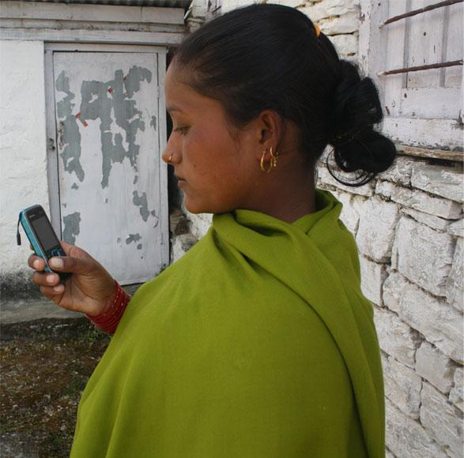An Amakomaya user in Nepal. Photo credit: Amakomaya

# Executive Summary

Amakomaya is a web and mobile application to help women in Nepal address the challenges of prenatal care, pregnancy, and maternal mortality. A team of local engineers and healthcare professionals developed Amakomaya after being awarded a US$ 4,000 grant from the Internet Society (ISOC) in 2011. Once a woman sets up her free profile on the application, she receives audio, video, and text content suited to her stage of pregnancy. These materials are accessible through mobile phones and can be downloaded. So far, Amakomaya has reached 11 communities, and 1,077 women have taken advantage of its materials. Amakomaya is an example of leveraging ICTs to improve public health of a vulnerable population.

Keywords: mobile monitoring, mhealth, pregnant women, rural Nepal

# Context

Nepal has significantly lowered the number of maternal deaths during childbirth in the last decade. However, pregnancy and delivery-related causes are still among the top reasons for maternal mortality in Nepal. Communicable diseases during pregnancy and maternal, prenatal, and nutrition conditions accounted for 24 percent of the causes of death for the country’s annual mortality rate in 2015, which is a drop from 46 percent in 2000, but remains higher than the world’s average rate of 21.2 percent.

Nearly 68.3 percent women received prenatal care in 2014, the highest rate over two decades. Traditionally, prenatal care is underrated in Nepal as pregnancy is considered natural. Most children are delivered at home, especially in rural areas. Only a fraction of these deliveries had the presence of skilled birth attendants. Poverty, lack of transportation, lack of knowledge, prevailing norms and superstitious beliefs, and gender inequality are some of the main reasons for inadequate prenatal care.

Little information is available on how pregnant women access health information in Nepal. There is a wide gap in utilizing prenatal care services between women of more educated and affluent backgrounds in urban areas and women of lower socio-economic status living in rural areas, as the distribution of information among these groups of women is uneven. Improving access to delivery care and enhancing women’s knowledge about health issues has been recommended by researchers and policymakers to improve maternal health care in Nepal.

|  |  |  |  |
| --- | --- | --- | --- |
| Nepal | | | |
| Population  (UN, 2015) | 28,440,629 | Fixed broadband subscriptions (%)  (ITU, 2016) | 0.78 |
| Population density  (people per sq.km)  (UN, 2015) | 193.24 | Mobile cellular subscriptions (%)  (ITU, 2016) | 111.7 |
| Median household income  (Gallup, 2006-2012) | US$ 2,718 | Individuals using the Internet (%)  (ITU, 2016) | 19.7 |
| Education  (Mean years of schooling) (UNDP, 2013) | Male: 4.2  Female: 2.4 | Individuals using the Internet by Gender (%) (ITU, 2016) | N/A |

# Project Description

Named after a Nepali phrase for *a Mother’s Love,* Amakomaya is an application that focuses on maternal and newborn health and provides pregnancy- and prenatal care-related information using the Internet and mobile technologies. The platform seeks to inform low-income women during and after their pregnancy and child delivery period. Once a woman creates a free profile and enters her approximate conception date, she is provided with audio, text, and video materials. Currently, this includes five videos dubbed in Nepali language, 19 audio recordings, and several text-based messages. All of these materials can be downloaded. The application also encourages the participation of family members by focusing certain materials toward them.

Amakomaya has a built-in button for women to connect and speak to emergency services. Amakomaya maintains a 24-hour call center to ensure that women can receive a live response during an emergency. The center uses Google Maps to triangulate the location of the woman and identify the health center nearest to her.

Amakomaya has both local and international partnerships to support its program. The project is funded predominantly through community grants in 2012 and 2013 by Internet Society and Information Society Innovation Fund (ISIF) Asia respectively. In addition, a local nonprofit organization, The Patan Academy of Health Science (PAHS), which aims to improve the health conditions in rural areas by training health workers, developed and provided pregnancy-relevant information for Amakomaya. Furthermore, Amakomaya has a partnership with the Washington DC based nonprofit organization VaxTrac, which focuses on improving the quality of vaccine data through the use of technology. This pilot project is also supported by World Health Organization and UNICEF as well as by the Child Health Division under the Ministry of Health and Population in Nepal.

|  |  |  |  |
| --- | --- | --- | --- |
| **Project details** | | | |
| Technology | Mobile and web application | Training | Yes |
| Year program started | 2011 | Cost to users | Free |
| Geography | Rural | Total cost of program | US$ 120,000  15 volunteers |
| User profile | 1,500 pregnant women  4,000 children  90 female community health volunteers | Associated organizations | Internet Society,  ISIF Asia,  ENRD,  Ministry of Health,  Patan Academy of Health Science,  UNICEF,  VaxTrac Inc.,  World Health Organization,  Yagiten Pvt. Ltd. |

# Progress and Results

Amakomaya is currently available in 11 communities with 1,100 users. It has trained 90 female community health volunteers (FCHVs). These FCHVs have reported that the women they work with have been more receptive to their teaching with the aid of the application.

The number of women seeking prenatal care at community health posts has increased dramatically after the launch of the application. One such location, the Jhuwani Community Library, showed an increase in the number of women seeking antenatal care. Because the content can be downloaded and is accessible on mobile, it is available at all times and accessible offline.

Data from the Amakomaya application is available to local public health officials for targeted action. Amakomaya’s success has brought it to the attention of the Nepalese government and the creators of the application have been invited to contribute to the nation’s first e-health strategy.

# Challenges

**Low-level of access –** Many health clinics are a day’s travel from a pregnant woman’s community. Coupled with rugged terrain and lack of transportation, it can be very difficult for women to access these clinics. Access to the Internet within these regions is easier comparatively, although there are still challenges to consistent coverage.

**Lack of awareness –** Because pregnancy is considered a natural part of the life cycle and a gift from a deity, many women do not believe they need prenatal or pregnancy care. This poses challenges to Amakomaya’s adoption. Further, cultural traditions and practices situate women as low status in Nepali society, and one-in-three married women do not make their own healthcare choices.

# Amakomaya’s Suggestions for Future Projects

**Public-private partnerships are key –** Amakomaya’s deployment is cost-efficient and the project’s low operating expenses makes scalability a realizable intention with government support.

**Accommodating cultural variances is important for improving take-up –** Due to the cultural conventions of Nepal, many women are unaware of the necessity of prenatal care. Many community health volunteers report that local women are skeptical of their instruction as well. When face-to-face conversations have been preempted or supported by the educational materials on Amakomaya, however, workers report that women are more receptive.

# Sources

Poudel, R. (2017, July 31) Personal Interview.

Project website: <http://www.amakomaya.com/>

Project videos: <https://www.youtube.com/watch?v=FVdbqAu0_kk>

<https://www.youtube.com/watch?v=KjFAQ-CO2ls>

<https://www.youtube.com/watch?v=-VbsPJyFRMQ>