mClinica

CONNECTING PHARMACIES THROUGH MOBILE APPLICATION ACROSS SOUTHEAST ASIA

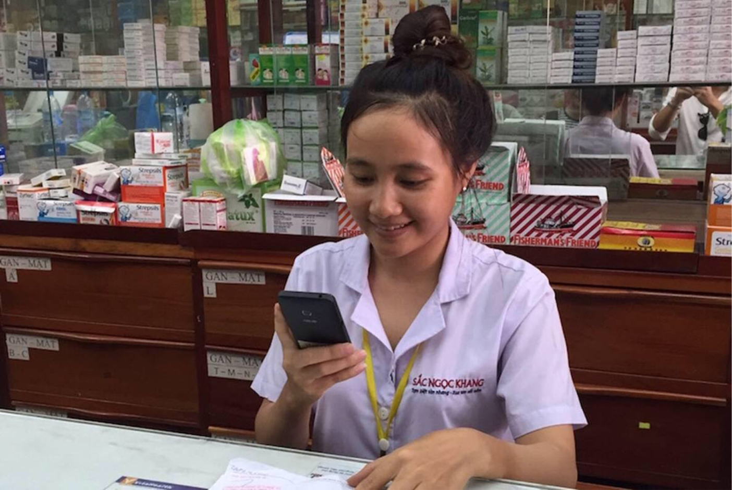*Photo credit: mClinica*

# Executive Summary

mClinica has developed a smartphone application called SwipeRx that serves pharmacy professionals across South-East Asia as the only mobile accredited continuing professional education platform, as well as a social network and drug information database. Pharmacists in countries across the region rely heavily on smartphones in their day-to-day practice, using them to look up dosing information, side effect profiles, and drug interaction data. However, they are hindered by a lack of reputable resources available in local languages. Furthermore, required continuing education trainings for pharmacists are expensive and difficult to attend in person, especially when traveling from rural areas. SwipeRx allows them the convenience of conducting trainings on their phone. Despite the fact that pharmacy professionals' numbers have swelled in recent decades, and more and more frequently patients' first point of contact with the healthcare system is via pharmacists, pharmacy professionals have traditionally been overlooked by public health interventions. The rapid uptake of SwipeRx - 100,000 users in 6 countries in under two years - demonstrates a successful intervention and scale-up.

*Keywords: mhealth, pharmacy, peer-to-peer network, South East Asia*

# Context

Pharmacy professionals are playing an ever-larger role in healthcare in South East Asia. Due to large economic and health changes in the region over the past decade, health professionals must now contend with twin epidemics of chronic and infectious diseases. Doctors and nurses throughout this period have remained in short supply; however, pharmacy professionals' numbers have skyrocketed. In Vietnam, for example, the number of pharamacists nearly doubled from 7800 to 13900 between the years 2000 and 2008. The scope of practice of pharmacists is changing too, as professionals move from merely dispensing medications to administering medical services, such as screening/monitoring tests, and sharing of medical advice.

When examined in aggregate, the gender breakdown of pharmacists in South East Asia skews male. However, this is due almost entirely to India, a county where the profession is very much male-dominated. In Indonesia, the Philippines, Vietnam and elsewhere, the overwhelming majority of pharmacists are women. For example, in the Philippines, due to sociological changes and education reform dating back to the early 20th century, women have played a prominent role in the pharmacy field for almost a century.

Pharmacists regardless of gender rely heavily on smartphones to assis their daily practice. One study from Malaysia indicates that 95% of pharmacy professionals were active users of smart phones in their day-to-day work, to look up dosing recommendations, adverse drug reactions, and drug interactions. Pharmacy professionals look to international resources of drug-related medical information, but are often hampered by language barriers, as these resources are in English. When that fails, pharmacists consult Facebook groups and pages in their local language, but these sources are limited by misinformation and advertisements.

|  |  |  |  |
| --- | --- | --- | --- |
| Indonesia | | | |
| Population  (UN, 2015) | 255,708,785 | **Fixed broadband subscriptions (%)**  **(ITU, 2016)** | 1.89 |
| Population density (people per sq.km)  (UN, 2015) | 134.26 | **Mobile cellular subscriptions (%)**  **(ITU, 2016)** | 149.13 |
| Median household income  (Gallup, 2006-2012) | US $2,199 | **Individuals using the Internet (%)**  **(ITU, 2016)** | 25.4 |
| Education  (Mean years of schooling)  (UNDP, 2013) | Male: 8.1  Female: 6.9 | **Individuals using the Internet by gender (%) (ITU, 2016)** | N/A |

# Project Description

SwipeRx is a project of mClinica, a social enterprise that builds digital networks of pharmacies in Asia. SwipeRx is a platform where pharmacy professionals can pursue continuing accredited education as well as a professional social network with content all provided in local language(s). As a continuing education platform, mClinica pays fees to whichever entity in a country is responsible for administering the training. Once the training content is hosted on SwipeRx, pharmacists are able to access it on their mobile devices, saving them expensive and logistically challenging travel to complete training in person. SwipeRx validates pharmacists' identification details, permits the use of multimedia training, and finishes with an assessment, providing the pharmacist with a certificate if they pass. The social network component of SwipeRx includes features such as a news feed where public health organizations, NGOs, and academic institutions can issue announcements and share reputable sources relevant to pharamcists' practice. It also includes features such as a "community questions" forum where pharmacists can post anonymous questions about their day-to-day practice, and receive real-time advice and feedback from their professional peers. Finally, SwipeRx also includes a drug database that includes information on indications, dosing, and avenues by which pharmacy professionals can notify local government of certain mandatory reporting diseases.

There are several ways by which SwipeRx can be monetized in the current business model. Partners can sponsor continuing professional development modules around the topics of their choice. They can also sponsor content on the news feed feature of the app. NGOs and private organizations can deploy surveys on pharmacy professionals' knowledge of certain diseases, disease burden, professional or prescribing practices. SwipeRx has offered incentives to users for filling out such surveys, such as a small amount of phone credit as a reward for completing the most questions correctly. Currently, SwipeRx is free for users.

|  |  |  |  |
| --- | --- | --- | --- |
| Project details | | | |
| Technology | Mobile application | **Cost to users** | Free |
| Year program started | 2017 | **Training** | None |
| Geography | Cambodia, Indonesia, Malaysia, Philippines, Thailand, Vietnam | **Total cost of program** | Undisclosed,  currently 64 full-time employees |
| User profile | (Majority female) pharmacists | **Associated organizations** | Bayer HealthCare, Clinton Health Access Initiative, Pfizer, The Rockefeller Foundation, UCSF, UKAID, USAID |

# Progress and Results

SwipeRx now has approximately 125,000 users in six countries: the Philippines, Indonesia, Thailand, Vietnam, Malaysia, and Cambodia. One out of every 2 pharmacists in the Philippines utilizes the application, and 1 out of 4 pharmacists in Indonesia does the same. SwipeRx launched in Vietnam in March of 2018, and 20% of the countries' pharmacists are already using the application.

Different features on SwipeRx are particularly appreciated by its user base. For instance, within news feed content, condensed infographics with brief accompanying text prompt the most interaction from users. Moreover, the community questions component is very active - users posts pictures of prescriptions they do not understand, crowd-source the identification of medicines that clients have brought without labels, and ask questions about situations that come up in daily practice, such as how to address drug-seeking behavior. Of note, there was a twenty-fold increase in use of the community questions feature once SwipeRx modified it so that users could post anonymously. Some users have even taken to using it as sort of a confessional outlet, sharing their insecurities and doubts about their profession with their peers.

Particularly surprising is the enthusiasm for continuing professional education, which SwipeRx attributes to pharmacists traditionally being overlooked by public health interventions. Pharmacists in Vietnam, which has no legal requirement for continuing accredation, have demonstrated a significant appetite for further training. Users often print out certificates from SwipeRx training modules and hang them in their pharmacies where clients can see them.

Having experienced a significant amount of private interest thus far, SwipeRx plans to pursue more public partnerships to expand upon their original goal of providing convenient, affordable continuing professional education to pharmacy professionals. In light of their success, SwipeRx remains committed to the needs of their user base and has no plans to expand into other professional fields, such as nursing or physicians.

# Challenges

**Attitudes toward e-learning (and therefore use of SwipeRx platform for continuing education) vary by country.** Accrediting institutions that provide the continuing education content to SwipeRx have been very enthusiastic in countries such as Cambodia, Malaysia and Thailand. However, universities in Vietnam are much more conservative when it comes to e-learning. SwipeRx reports that professors are concerned that having the material available for free (even though they are compensated for its production) devalues the learning material.

**Local regulations are in flux and are possibly adversarial.** Operating in multiple countries means adapting to multiple regulatory environments, a challenge posed should SwipeRx choose to pursue incorporating advertements onto the application, for example. Furthermore,Vietnam recently enacted a piece of cybersecurity legislation that requires companies to establish servers in the countries and provide the government their data. It remains to be seen whether this means the Vietnamese government then has ownership of that data.

# mClinica’s Suggestions for Future Projects

**Peer-to-peer communication is a key driver of social media's power.** SwipeRx identifies the social network component of the application as the key reason for its success and why they have been able to scale up so rapidly. They point to the informative content, which users can interact with and share, as well as the community questions component as unique features that establishes SwipeRx as more than just a continuing professional education platform.

**Pharmacy professionals are eager for opportunities to improve their practice.** Pharmacy professionals are traditionally overlooked in favor of other medical professions, such as physicians or nurses, when it comes to public health and health systems interventions. SwipeRx points to the rapid uptake of their application and users' enthusiastic interaction with its content and training modules. They take it as a sign that pharmacy professionals are curious and interested in new ways to better advise and care for their patients, often their first and decisive interaction with the healthcare system in many locations across south-east Asia.

# Sources

Lopez, B. (2018, July 18). Personal interview.

*Project website:* [*http://www.mclinica.com/*](http://www.mclinica.com/)