INCoDe.2030

STRENGTHENING THE DIGITAL LITERACY SKILLS OF CITIZENS

IN PORTUGAL

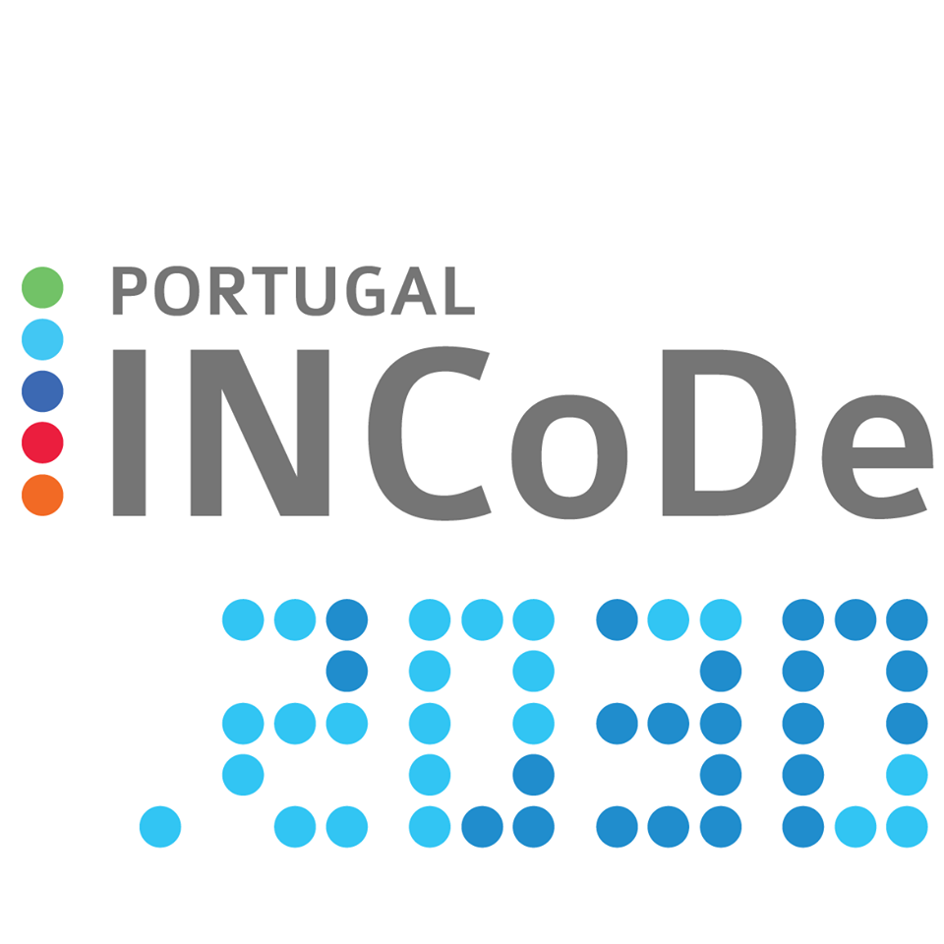

*The InCoDe logo. Photo credit: INCoDe.2030*

# Executive Summary

InCoDe.2030 is a broad initiative for improving access to and advancing the use of digital technologies in Portugal. In response to the problem of Portugal lagging behind in European Union (EU) averages for information and communications technology (ICT) adoption, the program outlines multi-step targets for digital education and research. By 2030, the initiative aims to increase digital inclusion for universal exercise of citizenship, to expand digital opportunities in qualifying for and seeking employment, and to produce new knowledge through international collaboration. Portugal has previously deployed contained programs in digital literacy and education. Over the course of 20 years, these programs have had measured success. With the experience and knowledge gained from these projects, this new broader initiative is able to apply lessons learned as well as overcome the limitations of discrete ICT outreach by providing more systemic support.

*Keywords: digital literacy, access, Portugal*

# Context

The Europe's Digital Progress Report (EDPR) showed that Portugal ranked 15th out of 28 EU Member States in the 2017 Digital Economy and Society Index (DESI). In 2016, 26 percent of Portuguese citizens never used the Internet, which was much higher than the EU average of 14 percent. Furthermore, 52 percent of the Portuguese population does not have basic digital skills and 30 percent have no digital skills at all, compared with the EU average of 44 percent and 19 percent, respectively. The share of adults in the active labor force with no digital skills in Portugal is twice as high as the EU average as well – at 22 percent. According to the same report, the digital gap remained among the elderly, lower income, and less educated groups of the population. Thus, raising its population’s digital skills has become one of the key challenges for Portugal to overcome in order to catch up with other EU nations.

The Government of Portugal established the National Strategy for Digital Inclusion and Literacy and enabled several initiatives to promote digital inclusion and improve digital literacy skills. One of the initiatives is the ICT and Society Network, a multi-stakeholder national platform with more than 500 members that promotes the adoption of computers and improvement of digital literacy to reduce the digital divide. The Choices Program, created in 2001 with a goal to promote social and digital inclusion, has served a great number of children and youth in the most vulnerable communities. The Portuguese Coalition for Digital Jobs also launched the Digital Employability Strategy and Action Plan 2015-2020 to increase the number of ICT specialists and promote digital skills of the labor force.

|  |  |  |  |
| --- | --- | --- | --- |
| Portugal | | | |
| Population  (UN, 2015) | 10,610,014 | **Fixed broadband subscriptions (%)**  **(ITU, 2016)** | 31.82 |
| Population density (people per sq.km)  (UN, 2015) | 115.35 | **Mobile cellular subscriptions (%)**  **(ITU, 2016)** | 109.09 |
| Median household income  (Gallup, 2006-2012) | US$ 16,186 | **Individuals using the Internet (%)**  **(ITU, 2016)** | 70.4 |
| Education  (Mean years of schooling)  (UNDP, 2013) | Male: 8.5  Female: 8 | **Individuals using the Internet by gender (%) (ITU, 2016)** | Male: 72  Female: 69 |

# Project Description

InCoDe.2030 is an initiative that seeks to improve digital competencies in Portugal, as well as advance the country’s capacity for advanced research in and through the use of digital technologies. Six government ministries are collaborating in the organization and deployment of the constitutive programs: The Ministry of Science, Technology, and Innovation; the Ministry of Education; the Ministry of Economics; the Ministry of Administrative Modernization; and the Ministry of Infrastructure. These ministries – along with other public and private institutions and organizations in Portugal, across Europe, and elsewhere in the world that are involved in the initiative – work along five axes to achieve set goals of digital literary and development:

The initiative aims to create an accessible Internet commons, increasing access through fixed and mobile sites to guarantee widespread connectivity. It also aims to build an easy-to-use platform where people can navigate available resources.

**Education –** ICT curricula are in development for both teachers and students.

**Qualification –** The initiative qualification is aimed widely at the entire population and narrowly at certain sectors of the workforce that could benefit specifically from ICT training. With access to e-government resources and online qualification programs, anyone will be able to benefit. With specialty training in digital methods and platforms, government employees andprivate businesses can both improve their economic practices and service relationships.

**Specialization –** By offering short courses as well as digitally oriented post-graduate degrees, educational institutions will collaboratively advance professionalization with ICT skills.

**Research –** The initiative works to promote new advances in research and development in advanced computing. Major projects include MACC, a Portuguese supercomputing resource installed by the Foundation for Science and Technology at the University of Minho in Braga, as part of collaboration with the University of Texas at Austin.

|  |  |  |  |
| --- | --- | --- | --- |
| Project details | | | |
| Technology | Connectivity, devices | **Training** | Digital literacy programs |
| Year program started | 2017 | **Cost to users** | Free |
| Geography | Varied | **Total cost of program** | Not disclosed |
| User profile | Varied | **Associated organizations** | Carnegie Mellon Portugal,  Indian Institute of Technology,  MIT Portugal,  Six government ministries,  University of Minho,  University of Texas-Austin |

# Progress and Results

In late 2017, InCoDe.2030 held its first forum, bringing together various parties in the public and private sectors in order to deepen and refine understandings of the motivations and challenges involved in the initiative. The project is fully funded for its goals reaching to 2020. They are currently seeking funding for the 2020-2030 segment of the initiative.

The initiative is building on decades of findings, putting into practice lessons learned about the varying needs and conditions across the diverse demographics and geographies of Portugal.

# Challenges

**Perceived need for ICT skills –** In a country where a quarter of the population has never used the Internet, it can be a challenge to some who do not think they need those skills.

**Inter-ministry cooperation –** While the program draws a great deal of its strength from its support from a variety of government ministries, it is also challenged by the difficulty of coordinating priorities among disparate branches of government.

# InCoDe.2030’s Suggestions for Future Projects

**Broader initiatives should learn from past programs –** Portugal has previously deployed programs in digital literacy and education. Over the course of 20 years, these programs have had measured success. With the experience and knowledge gained from these projects, this new broader initiative is able to apply lessons learned as well as overcome the limitations of discrete ICT outreach by providing more systemic support.

# Sources

Neves, A. (2017, December 12) Personal Interview

Project website: [www.incode2030.gov.pt](http://www.incode2030.gov.pt)