MAKAIA

PROVIDING DIGITAL LITERACY PROGRAMS

IN COLOMBIA

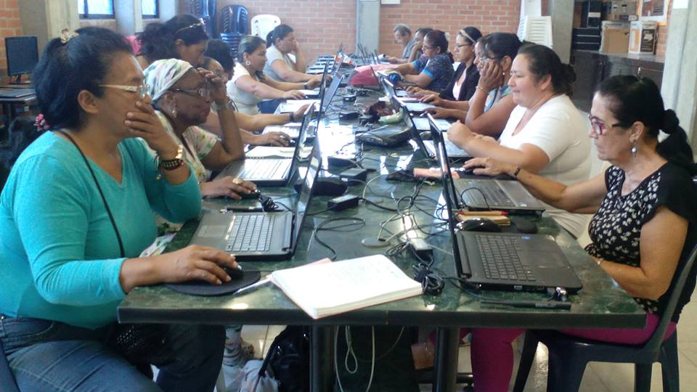*Beneficiaries of the teacher training program. Photo credit: Makaia*

# Executive Summary

Makaia is a nonprofit organization that has been using technology to advance projects for social development since 2006. Founded by Colombians Catalina Escobar, Camilo Mondragón, and Maria Claudia Camacho, MAKAIA draws its name from one of the region’s indigenous languages. In Miskito, “makaia” means both “to do*”* and “to build.” This active ethos and social awareness inform Makaia’s mission to create innovative local development projects at the institutional, social, and economic levels. Along with this mission, Makaia focuses on improvement of digital skills and technology adoption of various communities, including teachers and coffee growers, through digital literacy programs.

*Keywords: digital literacy, education, agriculture, Colombia*

# Context

Colombia seeks to utilize information and communication technologies (ICTs) to promote a knowledge society and modernize the country. The National ICT Plan 2008-2019 proposed a set of policies, actions, and projects to bring about efficient and productive use of ICTs among all Colombians, with the aim to improve social inclusion and increase competitiveness.

Due to the lack of competition, both fixed-line and mobile Internet services in Colombia are among the most expensive compared to other Organisation for Economic Co-Operation and Development (OECD) countries. Meanwhile, the average Internet speed in Colombia in 2013 was only 3 megabits per second (Mbps), according to the OECD. Additionally, the connectivity inequity that exists is severe between urban and rural areas. This is largely because most Colombians live in the cities where the country’s major Internet service providers (ISPs) hold significant market power, yet are not interested in expanding the network to rural areas. These issues combined with gender inequalities further discriminate women to access the Internet.

The Ministry of Education has launched several initiatives to address the digital literacy issue, including a pilot project to train teachers, students, and parents with 1,500 donated Intel computers in 2007, or a project called “Path of ICTs Appropriation” aiming at teachers’ professional development beginning 2008. Through the 899 Puntos Vive Digital (community Internet centers), 100,771 people have received digital literacy training.

|  |  |  |  |
| --- | --- | --- | --- |
| Colombia | | | |
| Population  (UN, 2015) | 49,529,208 | **Fixed broadband subscriptions (%)**  **(ITU, 2016)** | 11.79 |
| Population density (people per sq. km)  (UN, 2015) | 43.49 | **Mobile cellular subscriptions (%)**  **(ITU, 2016)** | 117 |
| Median household income  (Gallup, 2006-2012) | US$ 6,544 | **Individuals using the Internet (%)**  **(ITU, 2016)** | 58.1 |
| Education  (Mean years of schooling)  (UNDP, 2013) | Male: 7.1  Female: 7.0 | **Individuals using the Internet by gender (%) (ITU, 2016)** | Male: 58.1  Female: 58.2 |

# Project Description

MAKAIA currently hosts a number of different programs in different stages of development – some continuing sustainably (e.g., ICT in education); some successfully completed (e.g., access in libraries); some in the planning and assessment stages (e.g., disability and access, and digital security and ethics for schoolchildren); and some in their initial implementation phase (e.g., digital literacy for coffee growers). Below are some highlighted projects:

**Education –** MAKAIA provides a yearlong training program to teachers at the middle and high school levels.Their intervention consists of working with teachers to strengthen their capacity to incorporate ICTs in education. These efforts are not limited to classroom pedagogy – the 72-hour training program also seeks to support teachers in better harnessing the value of technology in their own lives and for their own professional development.

**Agriculture –** MAKAIA provides digital literacy training to coffee growers, focusing their efforts in one of the former epicenters of the conflict in Colombia. Ensuring not only training in digital competency but also high-quality connectivity, the organization helps provide farmers with technological solutions to agricultural problems.

|  |  |  |  |
| --- | --- | --- | --- |
| Project details | | | |
| Technology | Mobile phones, tablets, desktops; broadband and TV white space | **Training** | 72 hours of training/year for teachers, 20 hours of training for coffee growers |
| Year program started | 2006 | **Cost to users** | Free |
| Geography | Varied | **Total cost of program** | US$ 150,000 dollars/year for the teachers’ training program |
| User profile | Middle school and high school teachers,  Coffee farmers | **Associated organizations** | Autodesk,  Carcafé,  Google ,  Lavazza Foundation,  Microsoft,  Ministry of Education,  Symantec |

# Progress and Results

More than 1,200 teachers in 60 schools across Colombia have been trained in the effective use of technology in the classroom. Results and effect assessments show that the program has improved educational outcomes and engagement of students, while anecdotal feedback from teachers measures the overwhelmingly positive impact that ICTs have on the quality of education.

After completing a needs assessment in the area, MAKAIA discovered that their training program would need to take a temporary backseat to connectivity problems. They provided TV white space connectivity and began offering their program for coffee growers in rural Colombia in early 2017. The training in digital literacy and access for farmers has so far educated thirty coffee growers in the use of mobile technology to strengthen their agricultural practices.

# Challenges

**Lack of Internet access –** MAKAIA’s work highlights the problematic public-sector tendency to overstate connectivity in developing nations. While national leadership may wish to claim a higher position in e-government ratings, this overstatement of usable Internet access can be a stumbling block for development projects that seek to realistically identify resources and needs.

**Funding –** Funding for ICT development can be difficult to advocate for successfully in developing areas where more fundamental issues tend to be prioritized (i.e., housing, nutrition, security, etc.).

**Physical safety –** While MAKAIA is committed to providing connectivity and training to rural residents who are digitally underserved, political instability can preempt implementation in certain regions where the organization cannot ensure the safety of its staff.

# MAKAIA’s Suggestions for Future Projects

**Needs assessment should preempt technology roll-out –** Their experience demonstrates how it is essential that the project begin with a development needs assessment. While MAKAIA focuses on technological solutions, they stress that development needs must come before technology needs.

**Flexibility of funders helps with the development process –** MAKAIAnotes the importance of flexibility from their funders. Often, the exact needs of the people each project serves are not identified until after the budget and timelines have been populated. Donors who recognize the unique planning needs of social development work are also the most effective.

**Technology should be considered as a means rather than an end –** MAKAIA fundamentally disagrees with the concept of teaching about ICTs and widely distributing devices without training. They insist that technology is a means rather than an end. They emphasize that ICTs are an invaluable tool, but only when it is directed toward thoughtfully identified needs and goals. This challenge to the laptop-and-tablet-distribution ethos prioritizes successful adoption and problem-solving power over device saturation.

# Sources

Escobar, C. (2017, December 5) Personal Interview.

Project website: [www.makaia.org](http://www.makaia.org)