CENTER FOR INFORMATION AND EDUCATION FOR THE PREVENTION OF DRUG ABUSE

PROVIDING FINANCIAL INCLUSION PROGRAM FOR WOMEN

IN PERU

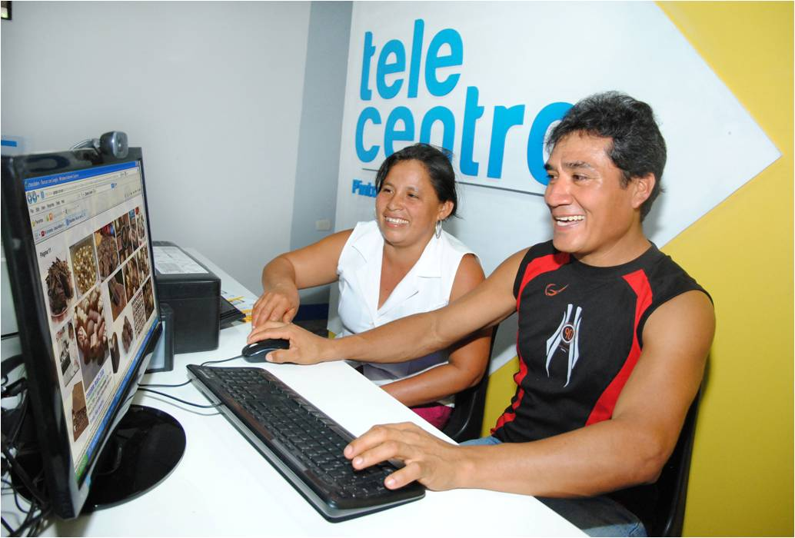*A beneficiary of the program. Photo credit: CEDRO*

# Executive Summary

From 2016 to 2018, the Center for Information and Education for the Prevention of Drug Abuse (CEDRO) in Peru ran a financial inclusion program for 5,000 women for information and communications technology (ICT) literacy and economic training, as well as a select group of 380 women specifically for entrepreneurial training. With support from the United States Agency for International Development (USAID) and Comités de Pobladores, the program trains women who then train others in groups of 20-25. The programs equip women with business and financial organizational skills, as well as a solid foundation in digital literacy and e-commerce. They have initiated 38 technology centers in three regions in Peru

*Keywords: women, financial inclusion, e-commerce, electronic banking, Peru*

# Context

Banking and finance continue to be a vexing developmental challenge in Peru. Only 29 percent Peruvian adults had a formal financial account in 2014, despite being ranked the best enabling environment for microfinance and financial inclusion, according to the World Bank. Furthermore, Peru is committed to empowering at least 75 percent of its adult citizens with access to an electronic transaction-enabled bank account by 2021. In line with this goal, the government launched its National Financial Inclusion Strategy in 2015, which promotes the use of electronic transaction instruments, access to savings, insurance and financing, consumer protection, and financial education programs. Financial inclusion is a priority because it helps mitigate the shocks and risks that households might face, as well as increases productivity and assets for businesses.

According to the Thunderbird School of Global Management, 98 percent of all businesses in Peru were micro, small, and medium-sized enterprises (MSMEs) – 40 percent of which were owned and operated by women. Their need for credit is substantial, and many have not previously engaged in electronic banking or possessed sufficient digital literacy skills. Of the 83,000 new Peruvian customers added in 2016, for instance, 51 percent were women, while 43.5 percent were accessing banking services for the first time, according to the BBVA Microfinance Foundation.

Various agencies have created programs to provide digital literacy and financial inclusion training to Peruvians. In 2010, the Thunderbird School of Global Management, in collaboration with other government and private sector institutions, implemented the Strengthening Women Entrepreneurs in Peru that benefited 100,000 women micro-entrepreneurs and 700 women-led small enterprises. Financiera Confianza, a leader of microfinance sector in Peru, provides financial education to entrepreneurs through its group credit that serves 30,000 customers, Woman’s Word, and its Savings for Everyone (Ahorro para Todos) program.

|  |  |  |  |
| --- | --- | --- | --- |
| **Peru** | | | |
| **Population**  **(UN, 2015)** | 31,161,167 | **Fixed broadband subscriptions (%)**  **(ITU, 2016)** | 6.72 |
| **Population density**  **(people per sq. km)**  **(UN, 2015)** | 24.25 | **Mobile cellular subscriptions (%)**  **(ITU, 2016)** | 117.06 |
| **Median household income**  **(Gallup, 2006-2012)** | N/A | **Individuals using the Internet (%)**  **(ITU, 2016)** | 45.5 |
| **Education**  **(Mean years of schooling)**  **(UNDP, 2013)** | Male: 9.6  Female: 8.5 | **Individuals using the Internet by gender (%)**  **(ITU, 2016)** | Male: 48.3  Female: 42.6 |

# Project Description

The project is designed to empower women through education in ICT, business, and finance. The goal is to reform economic participation at the household level, and to empower women to make money and create opportunities for themselves, each other, their families, and the region.

The program consists of three areas of education. First is the digital literacy program, which includes 100 hours of training, and three modules: basic, intermediate, and advanced. The second area is financial education, which includes eight hours of training on topics including savings, budget, how to manage debts, and financial services. The third area is entrepreneurship training, which includes 12 hours of instruction covering topics such as how to create competency, initiatives of ideas, how to create a business plan and implement it, and how to legally set up businesses. The curricula across these branches also involve topics on gender empowerment and leadership. The pre-condition to participate in the program is that women are already part of Peru’s social inclusion program, so the financial inclusion and digital inclusion programs target women who are under-served and marginalized geographically and economically.

|  |  |  |  |
| --- | --- | --- | --- |
| Project details | | | |
| Technology | Digital inclusion training | **Training** | 100 hours of digital literacy program, 8 hours of financial education, 12 hours of entrepreneurship |
| Year program started | February 2016 (- January 2018) | **Cost to users** | Free |
| Geography | Rural – San Martin, Huanuco, Ucuyali | **Total cost of program** | US$ 30 million |
| User profile | 18-55 years old women, mainly primary school graduates | **Associated organizations** | Cisco,  Intel,  Microsoft,  USAID |

# Progress and Results

The program operates 38 technology centers equipped with Wi-Fi and eight-to-10 computers each, in the cities of San Martin, Huanuco, and Ucuyali. The site has 29,000 unique users, and 30,000 followers on social media.

The program monitors its impact with user surveys, where 95 percent of users report that they use ICTs in their daily lives and are satisfied with the service. Moreover, 85 percent of women trained report changes in their financial wellness and leadership capacity.

The program has developed a successful model for sustainability. After programs are developed and initiated, they are transferred to local governments, Comités de Aliados, financial replicators, and women themselves. The Comités de Pobladores supports the implementation beyond the intervention of USAID, and support is maintained through two teleconferences held each month in each region.

# Challenges

**Low take-up –** Support for the program is strong among the women who have participated, but adoption and user acquisition remain challenging. Advertising the program has limited impact on changes in behavior as well, as it has been difficult to convincingly convey to women the potential benefits of the program on their life quality and financial stability.

**Coordination challenges –** While the program has a strong model for sustainability in place, it involves the initiative and cooperation of many different parties. It can be difficult to coordinate the efforts of the various government ministries and persons involved to keep the project going, despite its demonstrably positive outcomes.

**Rigid social norms on gender roles –** The program is designed to empower women in a social system in which men are in control. Husbands are consequently often resistant to the idea of their wives participating in the program and are resistant to the larger concept of their wives having autonomous control over family finances.

# CEDRO’s Suggestions for Future Projects

**Private sector contribution is useful and should be actively solicited in order to ensure sustainability –** Donated licenses, software, hardware, and electronics from private sector technology companies make initiatives like these possible. Further, the ability of corporate social responsibility initiatives to fund such initiatives makes them a natural collaborative partner to advance mutually beneficial outcomes.

# Sources

Queirolo, C. (2017, November 29) Personal Interview.

Project website: [www.cedro.org.pe/#158](http://www.cedro.org.pe/#158)