FONATEL

CONNECTING RURAL COMMUNITIES

IN COSTA RICA

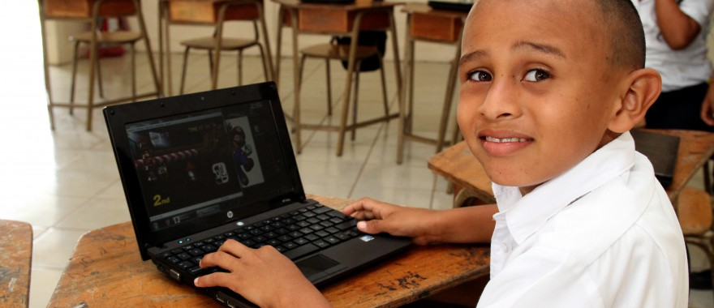*A beneficiary of FONATEL’s programs in Costa Rica. Photo credit: Fonatel*

# Executive Summary

The National Telecommunications Fund (FONATEL) is part of Telecommunications Superintendence (SUTEL), the Costa Rican telecommunications regulator. FONATEL was created in 2009 as a consequence of legal provisions that arose from the ratification of the Free Trade Agreement with the United States in 2007 and the end of Costa Rica’s state monopoly in the telecommunications sector in 2008. The Universal Service Fund is financed by mandated contributions from telecommunications operators as well as spectrum allocation tenders. FONATEL develops and executes a variety of programs to reduce the digital divide and universalize access to Internet connectivity in Costa Rica.

*Keywords: deployment, rural, schools, Costa Rica*

# Context

Costa Rica is a highly concentrated country, with a majority of its population centered in the city of San Jose, its capital. One-fourth of the total population continue to live in poverty. As of 2015, 49.4 percent of Costa Ricans are Internet users. Among the poorest households, only 19 percent have a computer according to the Encuesta Nacional de Hogares (Enaho)—National Household Survey published in July 2015. For rural populations, connectivity is scarce or non-existent. Internet penetration is 41 percent lower in rural regions when compared to urban areas.

Despite the breakup of the Costa Rican Internet service provider (ISP) monopoly after the signing of the Central American Free Trade Agreement that allowed other providers to potentially service rural regions, a high cost of service still hampered access to many rural Costa Ricans. While the number of Internet users increased to 56.4 percent in 2016, nearly all of this growth is centered among urban areas. In fact, these numbers are indicative of a widening gap between the wealthiest and poorest citizens. Even when connectivity is available, speeds are slow. No area of Costa Rica has at least 5 percent of its connections with speeds over 15 megabits per second (Mbps), compared to a standard of approximately 50 percent in developed nations.

|  |  |  |  |
| --- | --- | --- | --- |
| Costa Rica | | | |
| Population  (UN, 2015) | 5,001,657 | **Fixed broadband subscriptions (%)**  **(ITU, 2016)** | 11.59 |
| Population density (people per sq.km)  (UN, 2015) | 97.88 | **Mobile cellular subscriptions (%)**  **(ITU, 2016)** | 159.23 |
| Median household income  (Gallup, 2006-2012) | US$ 8,923 | **Individuals using the Internet (%)**  **(ITU, 2016)** | 66 |
| Education  (Mean years of schooling)  (UNDP, 2013) | Male: 8.3  Female: 8.4 | **Individuals using the Internet by Gender (%) (ITU, 2016)** | Male: 66.3  Female: 58.2 |

# Project Description

FONATEL runs five major programs across the country, three of which are currently active.

The first program focuses on bringing telecommunications infrastructure to rural areas of Costa Rica and has been active since 2012. These sparsely populated, low-income areas have been neglected by industry for their lack of profitable prospects. FONATEL conducts subsidy auctions among telecom operators in different project areas around the country to install the necessary infrastructure for individuals to be able to purchase Internet access. Also part of this program is FONATEL’s provision of free Internet connectivity to rural schools.

The second program, Connectedos Hoagares, has been active since 2016. This program provides low-income households with significantly subsidized Internet connections and computers. The Connected Homes program is an initiative that brings together different state institutions, including the Vice Presidency, the Rector and Regulator for Telecommunication. It is implemented by telecommunication companies and supported by NGOs and is part of the “Bridge to Development Strategy” of the country. The Universal Service Fund provides the financial support for the subsidy. The telecommunications service providers provide both the Internet service as well as the computer resources and software licenses, engage in program promotion, as well as provide the requisite e-government applications and digital literacy training.

The government determines eligible households using criteria such as whether the household is at or below poverty level, as well as whether they belong to groups in the fourth and fifth deciles of income but have specific social needs in order to include the indigenous, differently abled, female-headed households and self-employed. It provides three levels of subsidy at 80 percent, 60 percent and 40 percent depending on their income and special needs, using the ratio of household income to the cost of internet service and a basic to determine subsidy amounts.

The program, which officially started disbursing subsidies in June 2016, will invest US$ 128 million over the course of five years. The subsidy lasts three years, and covers the cost of a basic computer and an Internet service at 2 Mbps. FONATEL, the universal service fund, covers both the cost of the subsidy as well as the service.

The main goal of the Connected Homes program is to combat poverty and inequity, and promote job creation and economic growth through increasing access to information technology in vulnerable groups. The objective is to provide up to 80 percent of subsidy for computer and broadband to almost 150,000 low income families, around 15 percent of Costa Rica homes.

The third program is hardware-focused, providing information and communications technology (ICT) consultation and equipment to public institutions since early 2016.

The fourth program will provide free public Wi-Fi in public spaces, including parks, train stations, city centers, and libraries, and a fifth aims to develop and deploy a fiber-optic network in larger and more centralized schools.

|  |  |  |  |
| --- | --- | --- | --- |
| Project details | | | |
| Technology | Variant | **Training** | In progress |
| Year program started | 2009 | **Cost to users** | Free |
| Geography | Varies – mountains, forests, wetlands, plains, and valleys) | **Total cost of program** | Undisclosed |
| User profile | Women-headed households, 8,000 students in 400 rural schools | **Associated organizations** | Costa Rican federal and local governments,  Private ISPs |

# Progress and Results

Approximately 400 rural schools have been provided with Internet connectivity paid for by FONATEL. Schools reports that Internet capabilities have not only streamlined and organized their administrative capabilities, but also have provided rich supplementary materials and methods in the classroom. FONATEL has provided 16,000 computers, printers, and network equipment to schools.

As of 2017, 30,000 households have been provided with subsidized Internet and computers. The long-term goal is to extend this service to 140,000 households.

Not only has the infrastructural development been successful, but rates of subscription have also has exceeded expectations. FONATEL also notes that demand for mobile connectivity is much higher than fixed connectivity.

# Challenges

**Bureaucratic state structures –** As an independently operated fund, but state-affiliated, FONATEL must navigate a fragmented set of bureaucratic institutions in order to operate according to government policies and laws. This coordination – between, for example, the Ministry of Education, the Ministry of Science and Technology, social security institutions, as well as different local governments ­– can be difficult and often slows the place of progress.

**Difficulties in data collection –** FONATEL has made robust efforts to collect data on the impact of their programs and meticulously reports outcomes. Certain obstacles can impede their ability to collect data, however. For example, the demographic database that supports their second program is not always updated or accurate. In addition, FONATEL is still in the process of brainstorming and experimenting with certain quantitative/qualitative data collection methods and metrics.

# FONATEL’s Suggestions for Future Projects

**Partial subsidies are a better way forward for Universal Funds –** FONATEL advocates the provision of partial rather than total subsidies for connectivity and equipment in their program serving low-income households. The sliding scale system ensures that the service be sustainably affordable for families, while the financial contribution creates value relationships between individuals and services.

**Computers and connectivity resources are highly valued by under-resourced communities and maintained well –**Families to which FONATEL provides Internet and computers maintain their devices and connections incredibly well. These low-income families, 95 percent of which are headed by women, take exceptional care of their computers. While FONATEL expected a high rate of lost, sold, or stolen computers, it turns out that this rate is very low. Ethnographers deployed to observe a selection of these households report that the resources have been seriously incorporated as educational tools within the home and are maintained according to the instructions provided with each unit.

# Sources

Mazon, A. (2017, June 28) Personal Interview

Project website: <https://sutel.go.cr/pagina/que-es-fonatel>