BALSAPUERTO NETWORK

CONNECTING RURAL COMMUNITIES WITH Wi-Fi LONG DISTANCE NETWORKING (WiLDNet)

IN THE AMAZON RAINFOREST

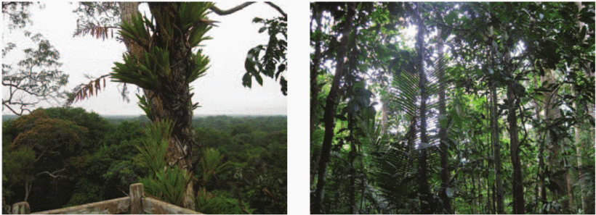*Areas connected by the Balsapuerto Network in South America. Photo credit: TUCAN3G*

# Executive Summary

The Balsapuerto Network was constructed in 2012 in an effort to improve healthcare in the upper Amazon through low-cost 3G wireless connectivity. Four healthcare centers in the district were connected with 5.8 gigahertz (GHz) point-to-point links: Balsapuerto, Varadero, San Juan, and Yurimaguas. Led by Professors Alan Mickelson from the University of Colorado Boulder and Martin Murillo from Notre Dame University, the initiative yielded successful results and experiences related to specific issues of infrastructure, technology, and implementation in remote jungle regions. Too-late attention to network sustainability stymied the project’s potential, however.

*Keywords: WiLDNet, deployment, telemedicine, Amazon, Peru*

# Context

Balsapuerto is located in the heart of Amazonian Peru and is one of the poorest regions in the world. Balsapuerto is the poorest district of the poorest Peruvian province. The dense Amazon rainforest makes it very difficult to build infrastructure, including roads. As a result, the village is reachable only by boat from nearby Yurimaguas, which is the nearest town with a hospital as well as telephone and Internet service. Due to its extreme isolation and low population density (less than 10 people per square kilometer), major telecom operators do not serve the area. As a country, Peru lags behind, both regionally and globally, when it comes to fixed broadband subscriptions and mobile subscriptions. In recent years, however, the country has boasted the fifth-fastest Internet user growth worldwide – only behind India, the Philippines, Indonesia, and South Africa, according to eMarketer.

In 2011, the Peruvian government implemented a National Broadband Plan that aims to provide Internet connectivity to remote regions of Peru. The plan includes the construction of a national fiber optic backbone network as well as connecting all municipalities and health and education centers in rural zones. Even with this plan and the government’s telecommunications investment fund (FITEL), which promotes service in isolated regions, however, barriers such as extensive poverty and economic inequality, expensive service, little competition, and a harsh landscape of mountains and jungles has resulted in slow, expensive, and inaccessible broadband Internet access.

|  |  |  |  |
| --- | --- | --- | --- |
| **Peru** | | | |
| **Population**  **(UN, 2015)** | 31,161,167 | **Fixed broadband subscriptions (%)**  **(ITU, 2016)** | 6.72 |
| **Population density**  **(people per sq.km)**  **(UN, 2015)** | 24.25 | **Mobile cellular subscriptions (%)**  **(ITU, 2016)** | 117.06 |
| **Median household income**  **(Gallup, 2006-2012)** | N/A | **Individuals using the Internet (%)**  **(ITU, 2016)** | 45.5 |
| **Education**  **(Mean years of schooling) (UNDP, 2013)** | Male: 9.6  Female: 8.5 | **Individuals using the Internet by Gender (%) (ITU, 2016)** | Male: 48.3  Female: 42.6 |

# Project Description

The Balsapuerto network was built in 2012 as a collaborative project between the Institute of Electrical and Electronics Engineers (IEEE), the Grupo de Telecommunicaciones Rurales (an affiliate of the Catholic University of Lima), and a collection of expert volunteers. The network connects four health posts in the upper Amazon using low-cost, high-speed Internet connectivity with Wi-Fi Long Distance Networking (WiLDNet). The technological aspects of the network were very successful, but the project suffered from little-to-no planning for the network’s financial sustainability. The network as it was originally conceived ceased to function in mid-2014 and was rebuilt and re-oriented by international research funding that stripped the local stakeholders of ownership and did little to improve the long-term prospects for sustainability.

|  |  |  |  |
| --- | --- | --- | --- |
| **Project details** | | | |
| **Technology** | Wi-Fi Long Distance Networking (WiLDNET) over 5.8 GHz spectrum | **Training** | None |
| **Year program started** | 2012 | **Cost to users** | Free |
| **Geography** | Upper Amazon with population density of 10 users per square kilometer and poor roads | **Total cost of program** | Fixed cost: US$ 12,000 |
| **User profile** | 10 to 100 users | **Associated organizations** | Catholic University of Lima,  City of Madrid,  EU,  IEEE,  GTR,  The Global Fund  University of Colorado |

# Progress and Results

In 2014, the program managers wrote a Humanitarian Activities Committee grant to organize a workshop focused on sustainability. Participants included the network’s local stakeholders and invited experts in information technology and developmental economics. The two-day meeting resulted in agreements that would produce a for-profit business model able to sustain the network’s maintenance in all the concerned villages. However, these agreements were never put into action. The networks were taken over and re-equipped by the European Union under a research aegis, and slipped out of the ownership and purview of the original research team.

The network continues to support health post connectivity, improving the efficacy of record keeping and care in the area, though there is little available data on exactly how its improvements have been impactful or how long the network will be maintained. The project’s instigators are currently at work building a similar network in Bolivia using the lessons learned from their experiences in Balsapeurto.

# Challenges

**Uneven terrain –** This upper Amazon district is difficult to access. Roads are underdeveloped and the river tributary that leads to the local port is often dry, making the area doubly inaccessible.

**Lack of a business model –** Though a sustainable model was eventually developed, it could not be implemented because it was developed after the network had already exhausted its resources, which were only intended for the network’s creation.

**Regulatory Ambiguity –** Certain rhetorical choices on the part of the project managers made their regulatory position ambiguous. Because of some grey areas in the status of voice of Internet Protocol (VoIP), the telecommunications sector was also concerned that connectivity might be infringing on phone service competition without the proper licensing.

**Lack of social integration and encouragement –** Once the network was taken over by international funding sources, the funding agents instituted a healthcare-only mindset for the network’s use. With amplification, the WiLDNet technology could easily support many users pursuing a variety of online activities, but this was needlessly discouraged.

# Balsapuerto Network’s Suggestions for Future Projects

**Local maintenance support can help maintain network resources –** The project team notes that costs were reduced and network capabilities improved by training local community members in the maintenance and protection of the network infrastructure. Local trainees can assist by handling basic functional tasks: lightning rod construction and battery replacement, microgrid maintenance, etc.

**Local ownership and planning might help sustainability –** The project team notes that local network ownership is beneficial to sustainable networks. Originally, the health centers and local stakeholders privately owned the network. After the transition to internationally based research funds, the infrastructure was replaced and ownership reverted to the State, as is common when funding is sourced from global charitable organizations. The project team notes that State ownership backed by charitable/research funding can be detrimental to such projects. With the right development plan, a network of this type can be sustainable. The key is to consider sustainability from the outset. Even in areas as low-income as the upper Amazon, there are still opportunities for generating profit and maintaining long-term sustainability.

**Publication for knowledge-sharing is key –** The network’s initiators noted the need for researchers to publish the work they are conducting in the region. While there is a great deal of relevant research relating to jungle network construction being conducted, its high rate of failure is preventing publicity that could be helpful to future projects.

# Sources

Mickelson, A. (2017, July 5) Personal Interview.

Urillo, M. (2017, July 5) Personal Interview

Murillo, M. J., Paco, J. A., & Wright, D. (2015, March 23). Long-Distance Telecommunication in Remote Poor Areas: From Partnerships and Implementation to Sustainability. *IEEE Technology and Society Magazine*.