JAMAICA TV WHITE SPACES PILOT

EXPANDING INTERNET ACCESS USING TV WHITES SPACES

IN RURAL JAMAICA

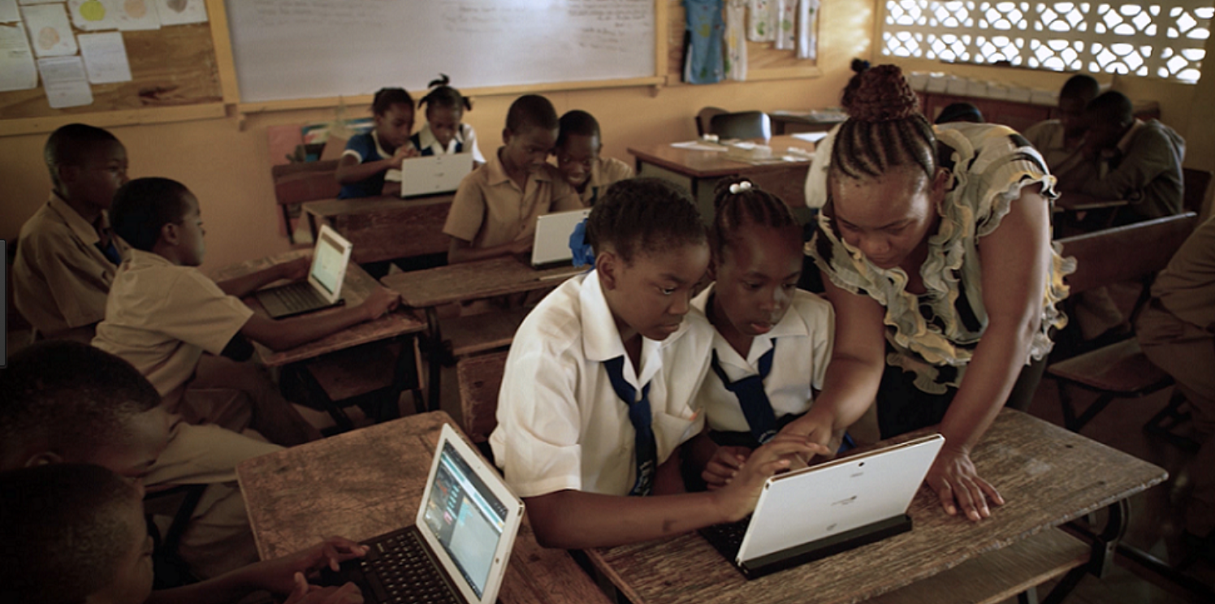*School connected by Jamaica’s TV White Spaces Project. Photo credit: Microsoft*

# Executive Summary

The Jamaica TV White Space Pilot project extends affordable broadband in rural communities in Jamaica using Television white space (TVWS) spectrum. The program seeks to address socio-economic inequities by implementing broadband networks to extend connectivity to schools, health clinics, and community centers in rural areas. The pilot aims to provide Jamaica’s rural residents with educational opportunities, access to business optimization tools, employment opportunities in the information and communications technology (ICT) sector, and facilitate delivery of e-government services. The pilot deployed in partnership with the United States Agency for International Development’s (USAID) Global Broadband and Innovations Program, with support from the Jamaica Universal Services Fund (USF). The pilot currently connects 31 sites across seven parishes with 2,000 users and aims to reach an additional 5,000 users.

*Keywords: TV white space, rural connectivity, Jamaica*

# Context

Vision 2030, Jamaica’s National Development Plan, envisages a technologically enabled society as one of six key determinants of a prosperous economy. Jamaica determined that connectivity and technological infrastructure plays a central role in building strong economic infrastructure. As a consequence, e-readiness is an outcome indicator in Vision 2030.

In 2007, Jamaica scored 3.8 (out of 10) on the e-readiness index. The government set a goal of achieving an index score of 4.9 in 2015 and 7.5 by 2030. As a measure of comparison, 7.5 was the minimum score for the top 20 countries in 2008.

|  |  |  |  |
| --- | --- | --- | --- |
| Jamaica | | | |
| Population  (UN, 2015) | 2,813,276 | **Fixed broadband subscriptions (%)**  **(ITU, 2016)** | 10.12 |
| Population density  (people per sq.km)  (UN, 2015) | 255.96 | **Mobile cellular subscriptions (%)**  **(ITU, 2016)** | 115.57 |
| Median household income  (Gallup, 2006-2012) | N/A | **Individuals using the Internet (%)**  **(ITU, 2016)** | 45 |
| Education  (Mean years of schooling)  (UNDP, 2013) | Male: 9.2  Female: 9.8 | **Individuals using the Internet by Gender (%)**  **(ITU, 2016)** | Male: 39.4  Female: 44.9 |

# Project Description

This pilot connects schools, health clinics, and community centers to the Internet using TVWS – unused parts of the spectrum of radio frequencies originally set asidefor analog television. It provides rural residents access to educational opportunities through online books, distance learning programs, and other essential educational resources at schools. The pilot also supports economic empowerment by providing access to market information at community centers and reducing information asymmetries, and enables access to responsive e-government services.

Thirty-one rural sites received broadband connectivity using TVWS spectrum. Pilot sites did not have prior connections to the Internet. They include nine base stations, nine health centers, seven libraries, six police stations, and 17 schools. Each of these 31 sites has an Adaptrum radio and wireless access point for local connectivity. Nine towers spread across seven parishes with existing broadband connectivity were used to anchor the installation of additional antennae. FLOW, a major partner in this effort, owns the towers, and each tower was fitted with four sector radios for unidirectional coverage. Microsoft supported this deployment by providing education and community-focused software to enable users to find relevant content online.

|  |  |  |  |
| --- | --- | --- | --- |
| Project details | | | |
| Technology | TV white spaces | **Training** | N/A |
| Year program started | 2013 | **Cost to users** | Free |
| Geography | Rural and peri-urban | **Total cost of program** | Undisclosed |
| User profile | University students and teachers | **Associated organizations** | Adaptrum,  Broadcasting Commission of Jamaica,  Cisco systems,  DEKAL Wireless,  FLOW,  Jamaica USF,  Microsoft Jamaica,  Ministry of Science, Technology, Energy and Mining,  Office of Utility Regulation,  Spectrum Management Authority,  USAID |

# Progress and Results

The Jamaica TVWS Pilot connected 31 rural sites, and has since been transitioned to the Jamaica Universal Service Fund project manager to add an additional 5,000 users to the current 2,000.

In June 2015, FLOW worked through a series of acquisitions and mergers. Adaptrum, Cisco Systems, and Microsoft trained the pilot’s management and technical teams in system deployment and management. By November 2015, 31 schools, libraries, and other community locations were fitted with broadband equipment. Microsoft continues to provide technical support for network deployment to this pilot, and has helped to expand it to other rural locations through other education and community-focused technology grants.

Jamaican partners of this pilot, the USF, FLOW, and government ministries, have plans to extend the reach of the network to bring connectivity to 5,000 more people, and to continue to invest in affordable broadband access to underserved rural communities. There is discussion concerning commercializing TVWS in Jamaica in the future, as well as replicating this model in other countries.

# Challenges

**Lack of sufficient and affordable TVWS equipment** – TVWS radio availability is a key determinant of project success, as there are currently a small group of companies manufacturing TVWS radios at small volumes. Owing to the lack of scale in this industry, pricing for these radios is currently high.

**Regulatory uncertainty –** A great risk to the long-term success and scalability of these TVWS pilot projects is getting governments to adopt regulations enabling unlicensed or license-exempt access to TVWS.

# Jamaica TVWS Pilot’s Suggestions for Future Projects

**New technological solutions can help in areas with severe infrastructure limitations –** Broadband delivered through TVWS is able to propagate over a longer distance compared to traditional Wi-Fi or cellular signals, and is significantly less affected by hilly terrain. This makes TVWS a more practical and affordable option for hilly rural areas where homes, businesses, and community buildings can tend to be far apart.

**TV White Spaces can provide affordable connectivity for sparsely populated areas –** TVWSsolutions are comparatively low-cost due to their use of unlicensed frequencies, and can be powered by solar power due totheir low energy requirements. Their use of lower frequencies allow thesignal to reach distances of up to 10 kilometers, even in areas with rough terrain, heavy rainfall, and dense foliage. This combination of low costs and coverage allows providers to provide fast broadband at affordable rates for rural populations. This helps bridge the affordability barrier for digital inclusion.

# Sources

Owen, D., Metzger, J., and Jones, N. (2013) Broadband Partnership of the Americas (BPA):Jamaica TV White Space (TVWS) Trial. White Paper USAID.

USAID. (2016) Jamaica Broadband Rollout: GBI Close-out Report.