VIRGINIA BROADBAND

PROVIDING CONNECTIVITY TO UNCONNECTED COMMUNITIES

IN CENTRAL VIRGINIA

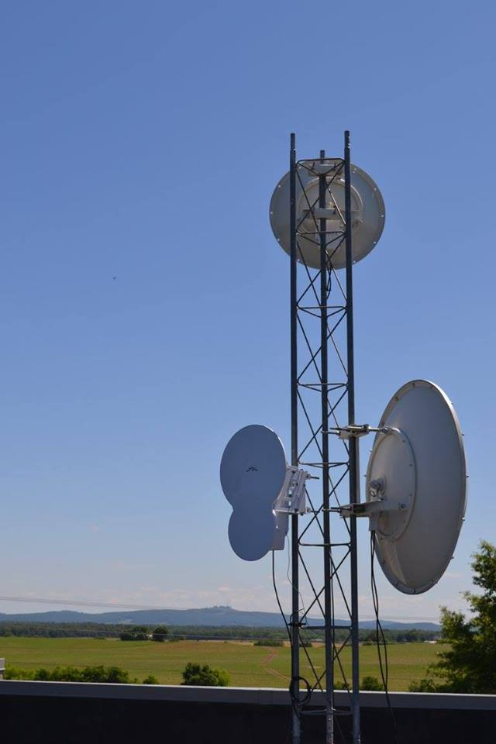

*A VABB Tower. Photo credit: Virginia Broadband*

# Executive Summary

Virginia Broadband (VABB), founded in 2003, seeks to close the Internet gap in central and eastern Virginia, a sparsely populated area with hilly terrain. They deliver fixed terrestrial wireless Internet service using stand-alone utility poles called “microspots,” or wireless broadcast locations. They use existing vertical structures to support this technology to repeat its Internet signal and reach remote rural areas, and build VABB serves large agri-business and tourism farms, federally employed telecommuters and households living below the poverty level. They have 30 microspots currently installed, and they have received an Microsoft Affordable Access grant for nine utility poles.

*Keywords: TV white space, connectivity, deployment, rural, Virginia*

# Context

The United States is one of the countries with the highest amount of Internet users, with a wide disparity between urban and rural users. Additionally, demographic groups with higher levels of education and income are more likely to go online than other groups. According to the National Telecommunications and Information Administration (NTIA), the persistence of the urban-rural divide, even with the increasing availability of smartphones and social media, suggests that the barriers for Internet adoption in rural areas are complex.

In 2015, 78.2 percent of households in the eastern coastal U.S. state of Virginia accessed the Internet through a broadband subscription. Yet, a 2016 Virginia Chamber of Commerce study found only 55 percent of homes had access to high-speed broadband in rural areas. The national broadband map recently created by the NTIA showed that Virginia ranked 40th in terms of the percentage of residents in proximity to access points with broadband speeds of 3 megabits per second (Mbps) or greater, down from 37th in 2013. There have been some initiatives to extend coverage in rural Virginia, however, both by local institutions – such as the telecommunications company Mid-Atlantic Broadband Communities Corporation (MBC) – and technology companies like Microsoft via its Affordable Access Initiative – which aims to support, grow, and scale innovative businesses that are developing technologies such as television white space (TVWS) to close the digital divide globally.

|  |  |  |  |
| --- | --- | --- | --- |
| United States | | | |
| Population  (UN, 2015) | 325,127,634 | **Fixed broadband subscriptions (%)**  **(ITU, 2016)** | 32.37 |
| Population density (people per sq. km)  (UN, 2015) | 33.77 | **Mobile cellular subscriptions (%)**  **(ITU, 2016)** | 127.16 |
| Median household income  (Gallup, 2006-2012) | $43,585 | **Individuals using the Internet (%)**  **(ITU, 2016)** | 76.2 |
| Education  (Mean years of schooling)  (UNDP, 2013) | Male: 12.9  Female: 13 | **Individuals using the Internet by gender (%) (ITU, 2016)** | Male: 74.2  Female: 74.9 |

# Project Description

VABB is a wireless Internet service provider (WISP) utilizing fixed wireless technology in both unlicensed and licensed radio frequencies. Their mission is to provide high-speed Internet to the un-served and under-served rural areas of central and eastern Virginia. VABB employs 14 full-time employees serving more than 1,500 customers in 14 predominantly rural Virginia counties.

VABB’s headquarters and main Network Operation Center (NOC) is located in Culpeper, VA. Professional network engineers, field technicians, certified tower climbers, and a customer care team staff the VABB NOC. The VABB management team (CEO, director of operations, and director of sales) consists of the three original founders of the company. The VABB NOC also acts as the network hub of the VABB wireless network. All Internet traffic from their Central Virginia network wirelessly travels to the VABB NOC’s rooftop. From there, fiber-optic internal cabling delivers the Internet traffic to three diverse fiber-optic carriers with three diverse routes that terminate in VABB’s data center.

VABB utilizes a variety of Microspot broadcast structures to reach deep into rural Virginia. Microspots are any willing vertical structure with standard electricity nearby that is tall enough to clear the 70-foot trees, and the top is able to see another VABB broadcaster. In many areas of VABB’s service area, a total of only five-to-10 houses within reach of the wireless technology is common. Creative use of existing local vertical assets, such as silos, barns, houses on hills, and grain elevators, helps to reach many of these remote homes. When these vertical structures do not exist, however, the best Microspot option is a stand-alone utility pole, which offers a service radius of 1-2 miles. The Microsoft grant the project recently received will support installing nine such poles.

Sites are supplied by standard power utilities and must be located within 300 feet of an electrical source. They do not use solar power because it is still too expensive within Virginia to implement. There are currently 30 microspots, and they are adding nine more with the funding from Microsoft. Microspots are strategically placed to reach the maximal amount of users, with a minimum of five homes per microspot, an average of 10 homes, and a largely untapped capacity for serving up to 120 houses. They offer service on various use-based plans to individual households as well as business campuses.

The primary service counties are Culpeper, Orange, Madison, Richmond, Westmoreland, Lancaster, and Northumberland. They also serve the fringes of Fauquier, Rappahannock, Greene, Louisa, Spotsylvania, Essex, and Middlesex counties.

|  |  |  |  |
| --- | --- | --- | --- |
| Project details | | | |
| Technology | 30 wireless microspots, TVWS, Unlicensed spectrum | **Training** | None |
| Year program started | 2017 | **Cost to users** | $80 per month |
| Geography | Rural – Central Virginia: mountainous | **Total cost of program** | Fixed cost: US$ 9,000 per microspot  Operational cost: US$ 10 per customer; US$ 15,000 for 30 micro spots per month |
| User profile | Varied; predominantly low-to-middle income populations | **Associated organizations** | Microsoft |

# Progress and Results

There are currently 30 microspots with nine more on the way serving 105 locations. The program serves seven primary counties and seven additional counties. Most recipients of service are members of low-to-middle income populations. The program serves people of all ages, but especially households with school-aged children who are expected to use the Internet for homework, as well as elderly and/or disabled individuals who want to access telemedicine services online. VABB’s pricing plans are use-based, rather than speed-based. A majority of users access the Internet for streaming and television purposes. They provide free limited-speed Internet service to a few schools, with aims to expand to more pending sufficient funding. The Microsoft grant generated some publicity for the project, and landowners in the region have stepped forward to offer their resources and location to host additional poles.

# Challenges

**Geographical barriers –** As a rural WISP, VABB faces many technical, geographic, and marketing challenges when trying to reach deepinto rural areas they serve. The majority of homes and businesses are nestled within tree forests, behind rollingmountains, on hilltops, and in deep hollows.

**Sparse population** – The microspots have a capacity to serve up to 120 houses per pole, but they typically serve between 5-10 only. The extremely sparse population numbers make it difficult to optimize service, with a high overhead to acquire only a few customers.

**Economic diversity –** There is a wide range of economic diversity among the clientele, from very high- to very low-income levels living side-by-side. So, devising a service that can meet the needs of all the interested users makes for a challenging business model.

# Vabb’s Suggestions For Future Projects

**Planning and prioritizing community engagement is important –** Their experience suggests its advantageous to prioritize happy customers and community engagement, rather than upsetting clients, by having a system in place before implementing the technology. Some people are in great need while others are in higher density areas, and so it is a constant quandary as to whether to prioritize the most numerous or the most needy. Making direct human connections is an important business strategy as well as a pleasant interpersonal engagement philosophy.

**Collaborations with various stakeholders is useful –**VABB has relationships with local organizations, as well as with national, regional, and international organizations. This includes the Wireless Internet Service Providers Association, which is a useful information source for cost effective hardware and equipment.

**Backhaul is a limiting factor** – The cost of backhaul for the project is so high that it limits the sustainability and scalability of the project.

# Sources

Lenig, J. (2017, November 8). Personal interview.

Project website:www.vabb.com