MID-ATLANTIC BROADBAND COMMUNITIES CORPORATION

TV WHITE SPACE PILOT PROJECT TO PROVIDE FREE INTERNET ACCESS TO HOUSEHOLDS WITH KIDS

IN VIRGINIA

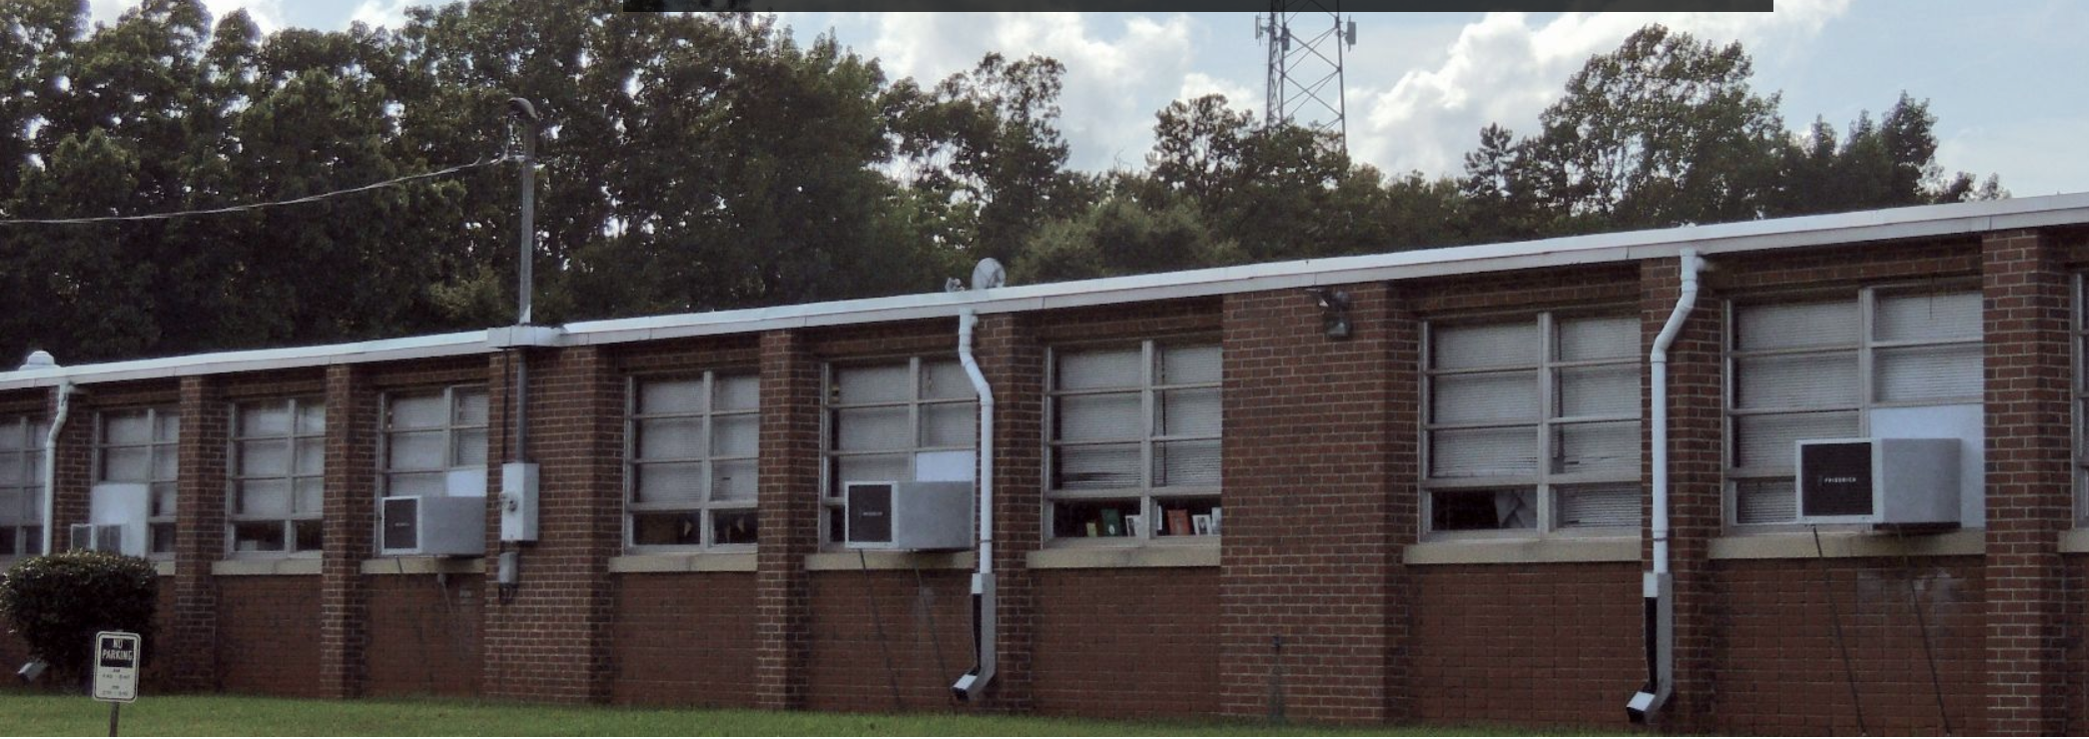

*An MBC connected school. Photo credit: MBC*

# Executive Summary

The Virginia TV White Space (TVWS) Pilot Project, the largest of its kind in the United States, delivers critical at-home Wi-Fi access and educational content to K-12 students in Charlotte and Halifax counties in Virginia. In May 2017, the Mid-Atlantic Broadband Communities Corporation (MBC) and Microsoft, with support from the Virginia Tobacco Region Revitalization Commission, launched an innovative “homework network” to deliver broadband Internet access at home to thousands of students in southern Virginia at no cost to their families. Partnering with local school districts, the program is designed to serve the 50 percent of students in Charlotte and Halifax counties who currently lack broadband access at home. MBC deploys Adaptrum’s high-power TVWS base-stations at existing school and tower locations along with ACRS2.0 client radios at student’s homes. This services students with a filtered selection of educational content that mirrors school curricula and enables at-home learning and educational advancement. Currently, the project is providing coverage to approximately 200 homes across the two counties, and paid service options subsidize this free service to students. As it is a pilot project, it plans to expand to other counties in Virginia pending its ability to secure additional funding.

*Keywords: TV white space, deployment, United States, broadband, access*

# Context

The U.S. is one of the countries with a high amount of Internet users. While there is not as much variation in terms of Internet adoption between genders, the disparity between urban and rural users has long existed. Additionally, demographic groups with higher [levels of education](https://www.statista.com/statistics/327138/internet-penetration-usa-education/) and [income](https://www.statista.com/statistics/327146/internet-penetration-usa-income/) are more likely to go online than other groups. According to the National Telecommunications and Information Administration (NTIA), the persistence of he urban-rural divide, even with the increasing availability of smartphones and social media, suggests that the barriers for Internet adoption in rural areas are complex. When lower education and household income are coupled with rural location, the disadvantages of accessing the Internet worsens.

In 2015, 78.2 percent of households in the eastern coastal U.S. state of Virginia accessed the Internet through a broadband subscription. Yet, a 2016 Virginia Chamber of Commerce study found only 55 percent of homes had access to high-speed broadband in rural areas. The national broadband map recently created by the NTIA showed that Virginia ranked 40th in terms of the percentage of residents in proximity to access points with broadband speeds of 3 megabits per second (Mbps) or greater, down from 37th in 2013. There have been some initiatives, however, both by local institutions like MBC and technology companies like Microsoft via its Affordable Access Initiative – which aims to support, grow, and scale innovative businesses that are developing technologies such as TVWS to close the digital divide globally – to extend coverage in rural Virginia.

|  |  |  |  |
| --- | --- | --- | --- |
| United States | | | |
| Population  (UN, 2015) | 325,127,634 | **Fixed broadband subscriptions (%)**  **(ITU, 2016)** | 32.37 |
| Population density  (people per sq.km)  (UN, 2015) | 33.77 | **Mobile cellular subscriptions (%)**  **(ITU, 2016)** | 127.16 |
| Median household income  (Gallup, 2006-2012) | US$ 43,585 | **Individuals using the Internet (%)**  **(ITU, 2016)** | 76.2 |
| Education  (Mean years of schooling)  (UNDP, 2013) | Male: 12.9  Female: 13 | **Individuals using the Internet by gender (%) (ITU, 2016)** | Male: 74.2  Female: 74.9 |

# Project Description

The project currently serves two counties in Virginia with free educational content-filtered Internet access for the homes of K-12 students in Charlotte and Halifax. After evaluating and piloting various equipment options, MBC selected Adaptrum’s TVWS solution based both on the performance and reliability of the TVWS network as well as Adaptrum’s focus on innovating to further improve coverage and speeds to connected families. TVWS works by providing Internet access via unused TV spectrum frequencies that exist between live TV channels. Leveraging TVWS technology, the network wirelessly extends existing broadband from local schools to students’ homes. Using TVWS equipment from Adaptrum, Internet access is delivered via base stations installed on towers at or near fiber-connected schools along with client radios installed at students’ homes. TVWS technology is ideal for delivering broadband service to areas such as rural southern Virginia, as it can cover large geographic areas, even with the hilly terrain and dense tree cover of the region. Additionally, the local Internet service provider B2X Online is responsible for installing the network.

The project currently serves approximately 200 homes with customer-provided equipment (CPE) via 16 broadcast sites, 14 of which are currently operational. The tower locations are split evenly between the two counties; all of the towers are owned by their respective county, with the exception of one Halifax tower, which is owned by MBC. The project utilizes existing broadcast structures in order to cut down on cost and optimize service provision.

The content available for access through the project is filtered to reflect only those sites that teachers are using at school, enabling students to continue their schoolwork from home. The service is provided free-of-charge, but some qualifying households decline it anyway in favor of unfiltered pay service that allows wider access to the Internet and other content. The free service is supported in part by a paid service model consisting of two paid subscriptions, an Internet light package (US$ 9.99 per month) and full package (US$ 34.99 per month). Other services are available ranging from US$ 30 to US$ 70.

|  |  |  |  |
| --- | --- | --- | --- |
| Project details | | | |
| Technology | TV white space,  16 towers (14 sites are operational) | **Training** | Information flyers, pamphlets provided through schools |
| Year program started | May 2016 (Charlotte)  September 2017 (Halifax) | **Cost to users** | Free for those households with children in K-12 |
| Geography | Rural – Charlotte and Halifax counties in Virginia, U.S. | **Total cost of program** | MBC: US$ 2.5 million  Microsoft grant: US$ 2.5 million  State of Virginia: US$ 500,000 |
| User profile | 200 homes with 238 children, mixed socio-economic levels | **Associated organizations** | Adaptrum,  Microsoft,  State of Virginia |

# Progress and Results

The network has been successfully piloted in 100 households across both counties, and aims to reach more than 3,000 students in 1,000 homes by the end of 2017. Students have free access to their schools’ online networks where assignments and education resources are posted, extending their learning time beyond the school day. To extend coverage to the vast majority of the students, the project is focused around central locations, partnering with the schools the students attend to mirror their educational content online at home. MBC and Microsoft work with Charlotte and Halifax County Public Schools to place the TVWS equipment on the vertical assets already in place at many of the school locations.A few additional towers have been constructed to cover populations where a tower was not available, and in one location, a local water tower is being used to broadcast the signal. Radios are mounted on each of the towers located throughout the counties; these radios are used to broadcast signal to individual student homes. To date, seven towers have been equipped with radios and are providing service. The antenna and CPE are wired to a router inside the home, which provides a Wi-Fi signal that can be used by any device that is equipped with Wi-Fi capabilities such as smartphones, tablets, and laptops.

The first phase of the program was launched in two counties, in partnership with Halifax and Charlotte County public school districts, which both have a general lack of widespread affordable broadband options. The first phase of the network was comprised of 14 sites, each with typically three sectors using Adaptrum High Power Base Station radios. Providing long-range, none-line-of-sight coverage from school and tower locations, the network has the capacity to reach more than 1,000 homes, which will receive Internet using Adaptrum’s ACRS2.0 client radios.

Following the success and positive impact of the initial phase, MBC plans to expand the TVWS network with Adaptrum equipment to surrounding counties. The expansion of the service includes and is in part supported by a service option where MBC will sell commodity-based Internet for students and their families set up by third-party provider partners. The paid option offers full web access, not restricted solely to educational content.

# Challenges

**Population Density –** The rural populations, hilly terrain, and an abundance of trees make Virginia a difficult region to supply with Internet connectivity. Since potential users tend to live far apart from one another, selecting centralized broadcast locations that can reach more than one household at a time is a challenge. Current sites have been selected to optimize service to the most people most directly, but this leaves out many of the most in need of service.

# Virgina TVWS’ Suggestions for Future Projects

**Proper planning on tower selection can help increase user base –** The project is able to optimize its user base through proper planning to select sites with relatively higher population density so that the broadcast reaches as many people as possible.

**Pre-existing infrastructure can be utilized in new ways –** While the concept of TVWS is itself already premised on making better use of services and information and communications technology (ICT) infrastructure that already exist, this project benefits further by broadcasting service from towers that are county-owned and already present at schools whose students it aimed to serve at home.

**Multiple messages in multiple modalities are key to reach all potential users –** The schools whose students were the target users acted as a key player in distributing information. Materials must convey the capability of the system as clearly and concisely as possible. Multiple messages in multiple modalities have potential to address these issues and reach all potential users. This project first used a long flyer sent to each home, then shorter prepaid return mailer postcards, and finally a very concise door hanger. The door hanger proved most successful because it was tangible and demonstrated that a project representative, not just a mail delivery person, had been to the site, lending credibility to the enterprise.

# Sources

Satterfield, J. (2017, October 27) Personal Interview

Project website: [www.mbc-va.com](http://www.mbc-va.com)

Project video: <https://www.youtube.com/watch?time_continue=8&v=db1gIPOe7gE>