

**Assessment Report**

on

**“Predict Heart Disease”**

submitted as partial fulfillment for the award of

**BACHELOR OF TECHNOLOGY**

**DEGREE**

SESSION 2024-25

In

**Artificial Intelligence and Machine Learning**

By

Sharad Krishna Singh (202401100400170)

**Under the supervision of**

“Abhishek Shukla Sir”

**KIET Group of Institutions, Ghaziabad**

Affiliated to

**Dr. A.P.J. Abdul Kalam Technical University, Lucknow**

(Formerly UPTU)

**18 April, 2025**

**Introduction:**

In this project, we tackle the problem of clustering aisle names in a dataset. The dataset contains textual descriptions of aisles, and the task is to group similar aisle names together. This is done through the following steps**:**

* **Text Vectorization**: The aisle names are first converted into numerical vectors using the TF-IDF technique, which helps capture the importance of words within the aisle names relative to the entire corpus.
* **Clustering**: The K Means clustering algorithm is applied to the vectorized data to group the aisle names into clusters based on their similarity.
* **Dimensionality Reduction**: PCA is used to reduce the high-dimensional vectorized data to two dimensions, which allows for easier visualization of the clusters.
* **Evaluation**: The project also includes a mock classification and confusion matrix to simulate how the clustering labels would behave if there were true labels for comparison.
* **Applications**: Clustering aisle names can improve store layout, enhance product recommendations, and aid in inventory management.
* **Significance**: This project demonstrates applying machine learning to real-world retail data, offering practical benefits in organizing and analyzing data efficiently.

**Methodology:**

The following steps were used to solve the problem:

* **File Upload and Data Loading**: The data was uploaded from a CSV file, and the contents were previewed using pandas
* **Text Vectorization**: The aisle names were transformed into numerical vectors using the Tfidf Vectorizer from scikit-learn, which calculates the Term Frequency-Inverse Document Frequency of words in the aisle names.
* **Clustering:** The K Means clustering algorithm was applied to the vectorized data with a predefined number of clusters (k=5). This grouped the aisle names into clusters based on their similarity.
* **PCA for Visualization**: Principal Component Analysis (PCA) was performed to reduce the dimensionality of the data to 2D for visualization. The reduced components (PC1 and PC2) were plotted in a scatter plot to visualize the clusters.
* **Evaluation Metrics and Heatmap**: A mock classification was performed, and the predicted labels were compared with randomly generated true labels. The performance was evaluated using a confusion matrix and metrics like accuracy, precision, and recall

**Code:**

# STEP 1: Upload the file

from google.colab import files

uploaded = files.upload()

# STEP 2: Load the file

import pandas as pd

filename = list(uploaded.keys())[0]

df = pd.read_csv(filename)

print("Preview of data:")

print(df.head())

# STEP 3: Text vectorization of aisle names

from sklearn.feature_extraction.text import TfidfVectorizer

from sklearn.cluster import KMeans

from sklearn.decomposition import PCA

import matplotlib.pyplot as plt

import seaborn as sns

# Vectorize the aisle names

vectorizer = TfidfVectorizer(stop_words='english')

X = vectorizer.fit_transform(df['aisle'])

# STEP 4: Clustering the aisle names

k = 5 # number of clusters

model = KMeans(n_clusters=k, random_state=42)

df['Cluster'] = model.fit_predict(X)

# STEP 5: PCA to reduce to 2D for plotting

pca = PCA(n_components=2)

components = pca.fit_transform(X.toarray())

df['PC1'] = components[:, 0]

df['PC2'] = components[:, 1]

# Plotting the clusters

plt.figure(figsize=(10, 6))

sns.scatterplot(data=df, x='PC1', y='PC2', hue='Cluster', palette='Set2', s=100)

plt.title("Clusters of Aisles Based on Name Similarity")

plt.xlabel("Principal Component 1")

plt.ylabel("Principal Component 2")

plt.legend()

plt.show()

# STEP 6: Mock classification and heatmap for fun

import numpy as np

from sklearn.metrics import confusion_matrix, accuracy_score, precision_score, recall_score

# Create fake true labels (for illustration only)

true_labels = np.random.choice(range(k), size=len(df))

predicted_labels = df['Cluster']

# Confusion matrix

cm = confusion_matrix(true_labels, predicted_labels)

plt.figure(figsize=(6, 5))

sns.heatmap(cm, annot=True, fmt='d', cmap='coolwarm')

plt.title("Confusion Matrix Heatmap (Mocked)")

plt.xlabel("Predicted")

plt.ylabel("True")

plt.show()

# Evaluation metrics

print("Accuracy:", accuracy_score(true_labels, predicted_labels))

print("Precision (macro):", precision_score(true_labels, predicted_labels, average='macro'))

print("Recall (macro):", recall_score(true_labels, predicted_labels, average='macro'))

**Output/Result:**

The output of the code includes the visualization of the clustered aisle names in a scatter plot, which shows the clusters based on their similarity. Additionally, a confusion matrix heatmap is generated to simulate the evaluation of the clustering model, and metrics such as accuracy, precision, and recall are printed.

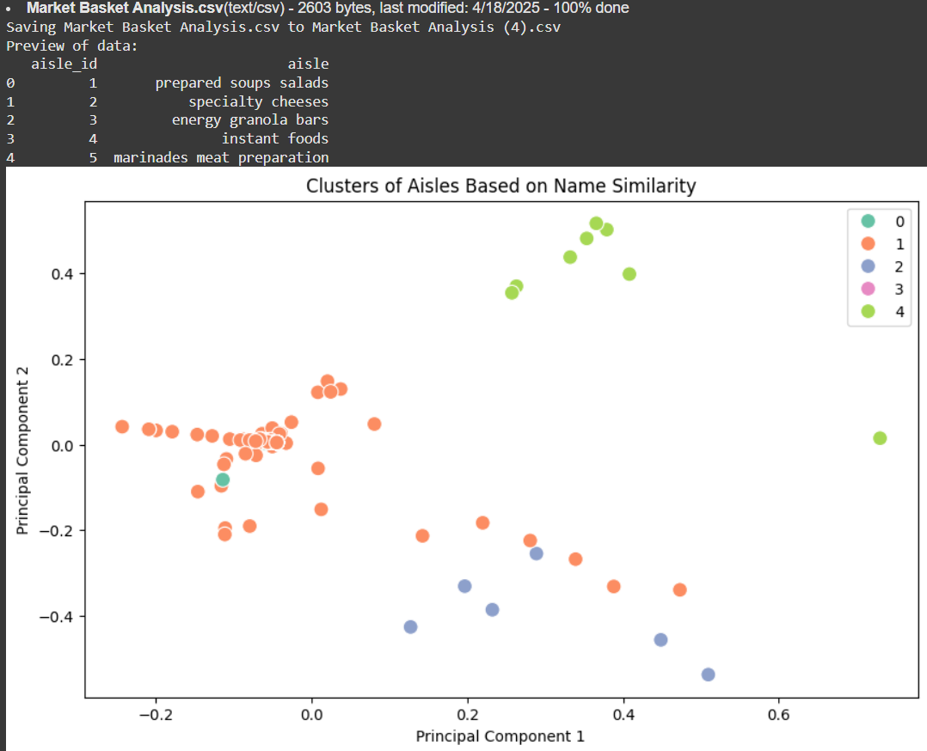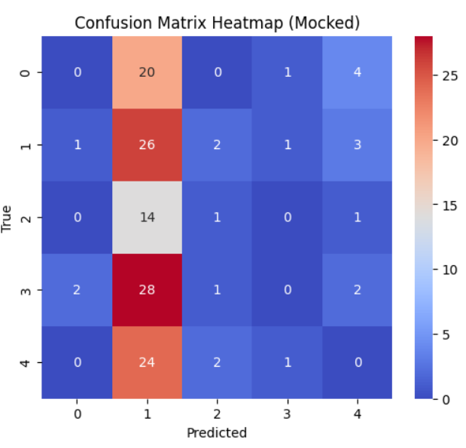

**References/Credits:**

* Dataset: [Provide the source of your dataset, if applicable]
* **Libraries Used:**
* **Images**: The images used for visualizing the data (scatter plot and heatmap) were generated through the code provided.