**Number to Word Converter**

As per requirement, Please find the solution, which will have the following artefacts

* Web Api
* Web Page to call the web service
* Web Api Test Projects

**Following are the brief description about the solution:**

* The solution is ASP.Net Web Application, using web.api template of asp.net 4.6.1.
* Adding folder and core reference of MVC and Web API
* Unit Tests are included
* NumberToWordController is the Web Api controller
* Web Page is designed using MVC Asp.net
* Jquery is used to communicate with Web and Web API

**Running the Solution:**

* Open the solution
* Build and it will restore all the nuget packages
* Run the solution (Google Chrome, IE)
* When run, it will be open with localhost address at your end and following page will come

Example : <http://localhost:6221/>

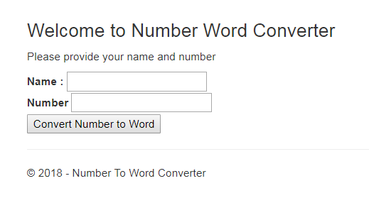

* Whatever local host port you are getting
  + Web Api Address - Web Api – Address (please change the port)

[http://localhost:**6221**/api/NumberToWord/ConvertNumberToWord/100/](http://localhost:6221/api/NumberToWord/ConvertNumberToWord/100/)

* + **Note** : change the port

Go to Views -> Home -> Index.cshtml and change the local host address to the following line

$.getJSON("http://localhost:**6221**/api/NumberToWord/ConvertNumberToWord/" + number + "/",

You are all set to run the application.

**Application Run:**

* 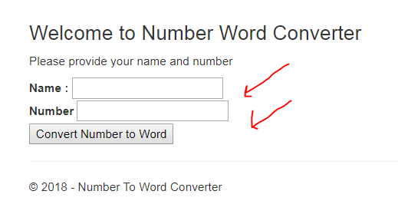
* Enter Name and Number
* Click on Convert Number to Word button. Number will get the converted to word.

**Example**

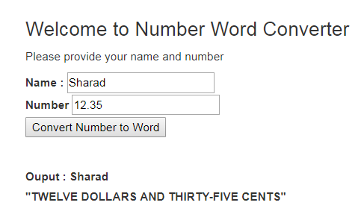

Client side validations:

* + If Name is Empty – alert message – “Please enter your name”
  + If Number is Empty or Not a number (alphanumeric or special characters) – Alert message – “Please enter valid number”

**Unit Testing –** *I am using Microsoft unit testing framework*

* + To test the service, there are unit tests are for NumberToWordControllerTest to get the 100% as follows:

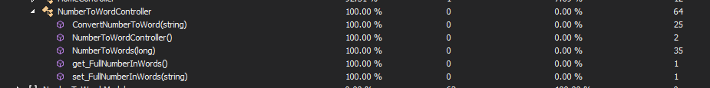

**Good Coding Practice**:

* Readability – code is readable and understandable.
* Validations – Capture good amount of validations. Example is if number is entered as 0.25 or .25
* Keep it simple – Solution is simple and easy to understand. Avoid unnecessary complication. Less populated code.
* Task oriented – Code is written to cater the requirement given. It is catering requirements to great extend
* Remove all the unused namespaces
* Always use StringComparison instead of directly comparing strings
* Comments in the code