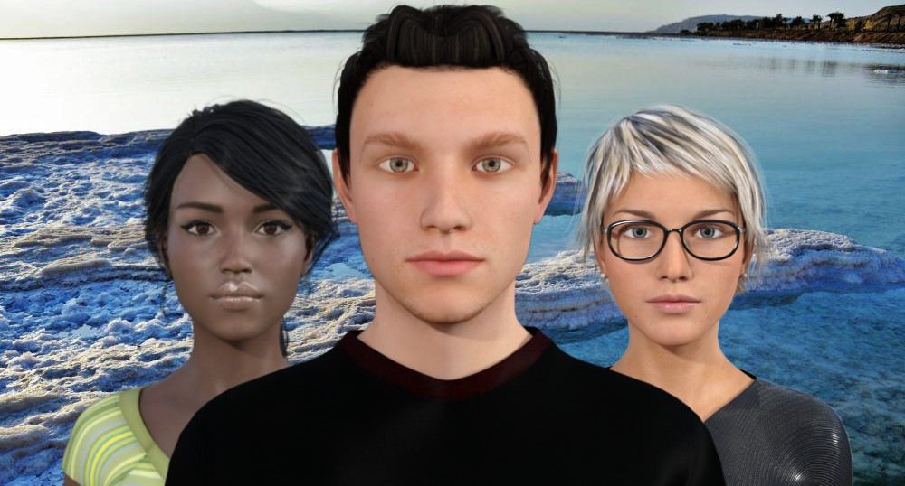

SOLVE IT !

**GIS COURSE**

**(Topography of Jericho and Dead**

**Sea)**

**Noor Kmail**

**Ruba Kmail**

**Sharaf Khalil**

**Dr.rami Hodrob**

**Contents :**

1. **Preface**
2. **Introduction**
3. **Stakeholders**
4. **scenarios**
5. **Requirements**

**5.1 .Functional Requirements**

**5.1.1. User Requirements**

**5.1.2. System Requirements**

**5.2 .Non-Functional Requirements**

**5.3 .advantages**

**6.Use Cases Description**

**7.Models**

**7.1 .Context diagram**

**7.2 .Use Case diagram**

**7.3 .State diagram**

**7.4 .Activity diagram**

**7.5 .Sequence diagram**

**7.6 .Class diagram**

**8. Practical work (open simulator)**

1. **Preface:**

We create a new project we call it a GIS Course this is the first version ever, we want to make the learning more interesting beside get solution for the Dead Sea problem and this game is an way to study this course as the student will get mark in the end of the semester by giving a new solution or give some one that have already exist. And in this Document we will describe everything in details.

**2.Introduction:**

These days there is an problem in the dead which call receding water in the Dead Sea . In this game we will learn by playing , to make the learning more interesting and more fun ,so we will describe an brief history about Jericho and the Dead sea , and what distinguishes this place ? discussing the problem and when was it appear ? and give some solution for the problem by giving an videos and some of studies on the problem and why it’s important to solve this one ? and who’s care about the dead sea .  
This game is an virtual reality , the place will be in Jericho and the Dead sea , Notice that the information will be 100% correctly in history and in the other side , if there is and wrong places or ambiguity in the geographic of the place it will be for an easy and to make the game and  make the game more sense and interesting .  
The game will start in Jericho going to Dead Sea by describing some information and historical stories in Jericho and talking about the benefits of the tourist in Jericho and making money by selling an some of heritage issues , so we have to learn about the problem to avoid the causes and using some solution to minimize the risk of this .  
First of all, the user will be represent as an avatar. The avatar will be start in Jericho and discussing the four basics issue the water , the weather , the rocks (the holes created by receding water) and the soil .  
The game will contain an xp (like an point) and this xp will make the avatar going to the next level, by collecting point in the right answer .  
The system will show to the avatar an question as needed ,if the avatar get the right answer he will get an xp if the answer will be wrong he will lose point and continue until get the right answer , and there will be an option name help to get more information about the question.  
The avatar goes level  by level until get to the dead sea and see some of sample places that the problem appear on it. So he can analysis problem and he will have an enough information to decide that it is from the problem or something else and give some solution by testing him and giving him points .

we have to consider that there is an timer begin with the start of the game and pause when its out of the game and then start from the previous one, this timer is determine which is the best one if there is an 2 solution or more than one  the same .

In the end the user will have an acknowledgment about historical of Jericho and dead sea , about the geographic of that place, and about the problem and solution , he will get an good result in test and give him an subject certificate ,all of that by playing and learning in different way because these days the student get boring in studying from books and teacher .

This game is an section of course GIS , in every course the student learn about the problem and discussing the solution and if any new solution or idea will discussed by the student add that solution to the main solution if it’s an effective and better than the exists solution.

**3.Stakeholders:**

|  |  |  |  |
| --- | --- | --- | --- |
| Name | Role | Organization/  Position | Contact Information |
| Best one company | sponsor | Company | ****** |
| Rami Hodrob | project manager | Engineer | RamiHodrob@gmail.com |
| Sharaf Khalil | Team Member | VP.  Marketing | Sharafbkhalil97@gmail.com |
| Noor Kmail | Team Member | VP.  Designing | Noor.kmail97@gmail.com |
| Ruba kmail | Team Member | VP.  programming | Rubaikmail9@gmail.com |
| ****** | Customer | Universities or institutes | ****** |
| ****** | User | Gis Students | ****** |

**4.STORIES :**

In the beginning, the screen appears for the player to enter, if he is not registered, he must register and then enter, but if he is already registered, enter the game, when entered successfully, show him a screen, either start, or learn the instructions of the game, if pressed "Start", start the game, start the timer, and move to the first stage of the game, if pressed "guidelines", show instructions in an easy and understandable way, after being recognized, press "Start", and moves to the first stage.

First stage ,The student will be on "Maqam al- Nabi  Musa" with zero XP ,on this level he will discovering all things about soil ,he going to start with a small trip around the place looking to soil trying to recognize the type of soil , touch it to know even it rough or soft  and take a small sample of soil then he entered the "Maqam" Now the system will display a screen provides information about this soil together with some videos and pictures .Now, the test in this stage is going to be on some question about soil .Then , there's a change  will be on xp depend on his behavior at the test

Second  stage , on this stage we are going to cover all things about stones , The student can choose the place from these choices ("Wadi al-Qilt","Tal al-Sultan"," Deir Qruntul") ,Based on his choice  he going to make a trip on the place , through the trip he must to pick one of each type of stones he funded ,then the system will give him information about the stones ,but these information have some keys  these keys are a Question about the place itself , the amount of information depends on how much question he can answer , if he can't answer any one of them , then no information he can get .Testing here will happen through an experiment and a few of question

note: the timer still on and the xp as what we said on the previous stage

‏The third stage is the study of climate in the Dead Sea area. This time, it will be practical, show him a video about the water cycle in the region and move to the laboratory, using the information he knows about the soil and climate, to do something similar to the problem of the Dead Sea. When he finishes, the system asks him a set of questions. If he answers, he moves to the fourth and final stage, and if he does not complete it, he will give him two other att

‏The final phase will be after finishing the previous three stages, and acquiring new information. This is the stage of exploring the problem. At the Dead Sea, the student will learn about the Dead Sea and study the nature of the water to gather information that will help him understand the problem more and provide solutions to solve the problem of the Dead Sea. , There is a tour guide at the beginning to guide him , then the student enters to explore it himself, the avatar dive into the water, see if they will float on the surface of the water or not, use some methods to try to enter to reveal the existence of living organisms, the existence of jewels ,and then go out to meet another tour guide asks him what he discovered, and provides a solution that the student sees will solve the problem, the student finishes the game, gives the solution, The company will see all solutions they have received from students, to decide the most appropriate solution and work on it, the awards will be presented .

**5. Requirements :**

**5.1 User and System Requirements:**

1. The user turn on the Internet, opens the game easily and shall  registered previously , after entering it, he can start playing, or show game instructions.

         1.1 .sign up : The user shall register in game with his email , username and                                               password, there is a rules to accept the username and password, after registering, the user information saves on the database, then, any time he can enter the game if      he enters the password and username that stored in the database correctly .

           * Prevent two users to have same username.

1.2  log in : The user enters to the game using his  username and password, if enters them correctly can enters, if not entered correctly as stored in the database . so he is not allows to login, if user  forgets the password or user name, there is an option in this case to restore his/her information, the system sends his/her information to his/her registered email.

1.3 choose between two options beginning: When the user enters the game correctly, the user has two options , either entering the game directly, moving to the first stage, or choosing "View guidelines ", so that the game's instructions are presented in an easy, understandable and beautiful way. Then he can start the game.

2. at first stage The student wants to recognize the nature of  the soil ,at second        stage student need to differentiate between type of stones and known them ,at third stage he wants to learn about climate ,on  final stage the user want to recognize the problem with Dead sea water and trying to find a solution for this problem

2.1 the system shall allow the user making a trip on each stage in different places , in first stage the place going on "Maqam al-Nabi Musa", at the second the system allow the student to choose between these three options ("Wadi al-Qilt" ,"Tal al-Sultan" ,"Deir Qruntul "),and  each of third and final stage will be on the Dead sea .

2.2 the system will give the student on first three stages an information and the type of these information depend on the  thing he will learn on each stage means at first stage the information going to be about the soil ,at the second about the stones and  at the third one the information will related to the climate and these information will provide via videos and pictures.

2.3 at third stage the system  shall provides an a laboratory to allow the student doing some experiments about the soil and climate .

2.4 the system will test the student on first three stages  through questions and on each stage these questions will be about what he learned on it and allow for him an three attempts on each test , passing the test allow him to go next stage

2.5 the xp of the student increases on first three one  but this increase depend on his behavior on the test like if he pass form  first attempt the xp will increases by 5 point , if the pass occurred on the second attempt the points are 3 , last attempt just give him 2 points .

2.6  on these three stages the system will keep the timer on and if the student filled of the test the system shall to freezes the game for 30 second and this time will added to his timer and  then take him back again to take information.

2.7 at final stage the system shall provides the student with a   tour guide give him information related to the water and depend in how much the student learned in a previous stages ,he shall to find a solution for the problem that he observed with water, then the guide will test him in little  questions

3. After four levels ends ,timer is stops and  student can submit a solution for receding water in dead sea problem .

        3.1 calculate Time : when game ends , timer stop, system shall show the time to      student

    3.2 Submit solution : system allows the student to submit a solution for receding water in dead sea problem through “Suggest a Solution “ button , student can wrote his suggestion , and this suggestion and the  time taken in game stores in database with his username .

3.3 show state and solutions :teachers can show the state or solutions for his students ,and  experts work with “best one “ company can show all solutions , and state of any student .

3.4 pick up one solution : experts work with “best one “ company show all solutions and pick up the most optimal solution

**5.2 Non Functional Requirements:**

The Non Functional Requirements is the Constraints on the services or functions offered by the system such as timing constraints, constraints on the development process, standards, and we will discussed how does this system deal with this Requirements.

**1.constraints**: This game is for an specific student which they registered  in GIS course .we will get that by make a restriction by using portal user name and id.

**2.speed :** The system can have over 1000 student in the same time , so the probability    of failure is very small and that make the processes fast . We have a huge database a good and fast processor and fast internet.

**3.Size :** This application is connected with the DB of the university which its huge and good and that make an easy to connect which other system and that make high speed.

**4.Ease of use :** This application contains guidelines to help the user and tell him what to do ,however it’s like any game you play .

**5.Robustness:** As the system has a huge size and can have over 1000 student in the same time that make the failure very small.However the system will take just a moment to make refresh for the game if there is any failure.

**5.3: The advantages:**

1.Get a good acknowledgement with playing games and make it in different way

2. The class can share data and speak with each other by playing at the same time that make fun.

3. We can solve real problem .

4. The win will achieve money from the advertise company which its deal with university.

**6. Use Cases :**

|  |  |
| --- | --- |
| **Use case :** | Register |
| **Actors :** | Student |
| **Type:** | Primary and essential |
| **Description :** | For first time the user login to the game , he should make an account , by user name , email and password , provide other information . |

|  |  |
| --- | --- |
| **Use case :** | Log in |
| **Actors :** | Student |
| **Type:** | Primary and essential |
| **Description :** | When user want to learn with playing , login to the game easily . |

|  |  |
| --- | --- |
| **Use case :** | Turn on internet |
| **Actors :** | User |
| **Type:** | Primary and essential |
| **Description :** | The user should turn on the internet , so he connected with the system |

|  |  |
| --- | --- |
| **Use case :** | Forget the password or username |
| **Actors :** | student |
| **Type:** | secondary and essential |
| **Description :** | if the user  Forget or want to change the password   , the system will send to the user verification code so he can change and get new one. |

|  |  |
| --- | --- |
| **Use case :** | Show instructions |
| **Actors :** | student |
| **Type:** | Secondary and non essential |
| **Description :** | The user can show the instruction of game the start to play , or he can start directly . |

|  |  |
| --- | --- |
| **Use case :** | Get knowledge |
| **Actors :** | Student |
| **Type:** | Primary  and essential |
| **Description :** | After student starts game  , he will explores the area and get knowledge about geographical information during the four stages . |
| **Use-Cases** | Get quiz |

|  |  |
| --- | --- |
| **Use case :** | Get quiz |
| **Actors :** | Student |
| **Type:** | Primary  and essential |
| **Description :** | In the end of each level of the game , the system will show some questions to the  student , if he answers these questions , he moves to the next level . |

|  |  |
| --- | --- |
| **Use case :** | Update information |
| **Actors :** | Geographical expert |
| **Type:** | Primary  and essential |
| **Description :** | If there is any change on the geographical information , the expert update the information , so the game stays synchronized with the changes  . |

|  |  |
| --- | --- |
| **Use case :** | Show suggestions |
| **Actors :** | Geographical expert |
| **Type:** | Primary  and essential |
| **Description :** | If there is a suggestions from instructors , the experts show it , and decide to work with it or not . |

|  |  |
| --- | --- |
| **Use case :** | Suggest an update |
| **Actors :** | Instructors |
| **Type:** | Primary  and essential |
| **Description :** | The instructors can suggest an update on the information of the system . |

|  |  |
| --- | --- |
| **Use case :** | Start game |
| **Actors :** | student |
| **Type:** | Primary and essential |
| **Description :** | User enters the game . |
| **Use-cases** | get knowledge |

|  |  |
| --- | --- |
| **Use case :** | Submit solution |
| **Actors :** | Student |
| **Type:** | Secondary  and essential |
| **Description :** | Student can submit a solution he think that will solve the main problem |

|  |  |
| --- | --- |
| **Use case :** | Show solutions |
| **Actors :** | Geographical experts |
| **Type:** | Primary and essential |
| **Description :** | Main goal for the game is to provide learning for GIS students and take a solutions from the students to solve main problem which is receding water in dead sea . so the experts at the company show solutions that’s the students submitted . |
| **Use-Cases** | pick up solution |

|  |  |
| --- | --- |
| **Use case :** | Pick up solution |
| **Actors :** | Best one company |
| **Type:** | Primary and essential |
| **Description :** | after the experts show the solutions , they choose the best solution to work with. |

|  |  |
| --- | --- |
| **Use case :** | Show student’s state |
| **Actors :** | Geographical experts , instructors |
| **Type:** | Secondary  and non essential |
| **Description :** | Actors can show the state of students . |

|  |  |
| --- | --- |
| **Use case :** | Calculate time |
| **Actors :** | Timer |
| **Type:** | primary and essential |
| **Description :** | the time that student takes to end game must be known |

**7. Models :**

**7.1 context diagram:**

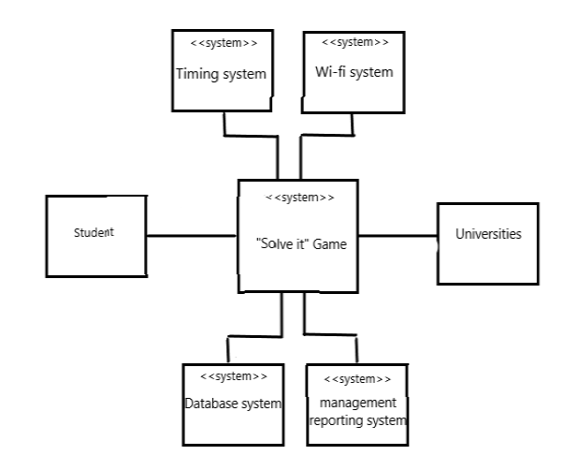

**7.2 Use Case diagram :**

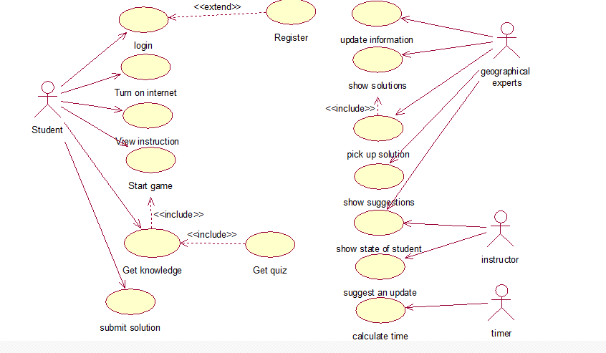

**7.3 State diagram:**

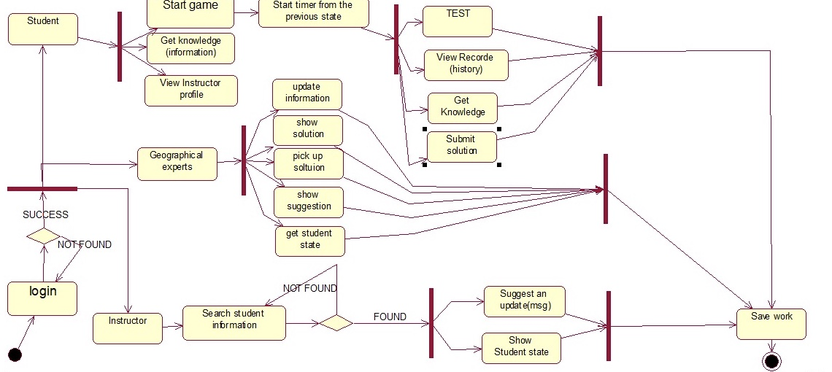

**7.4 Activity diagram:**

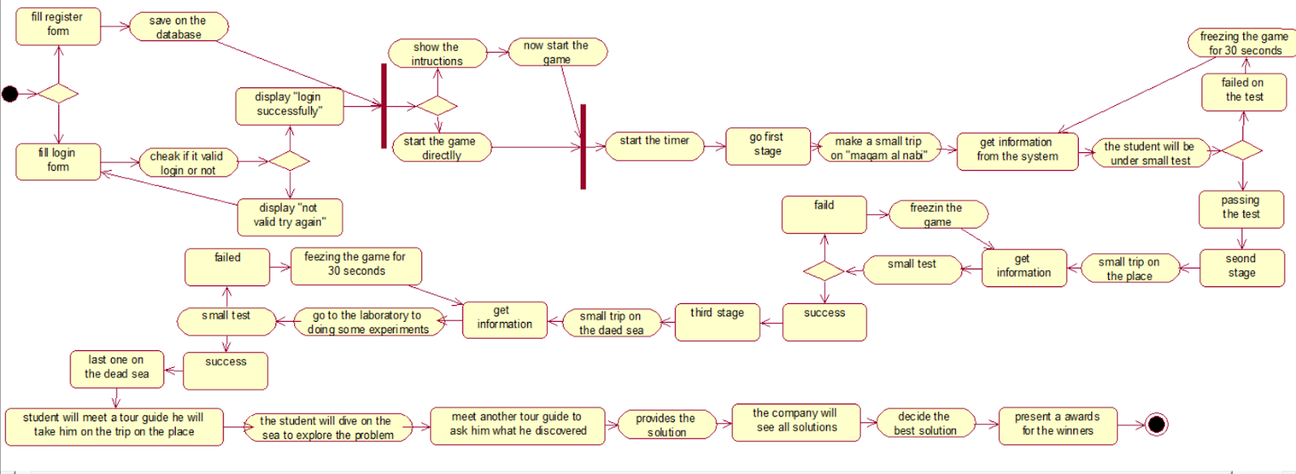

**7.5 Sequence diagram:**

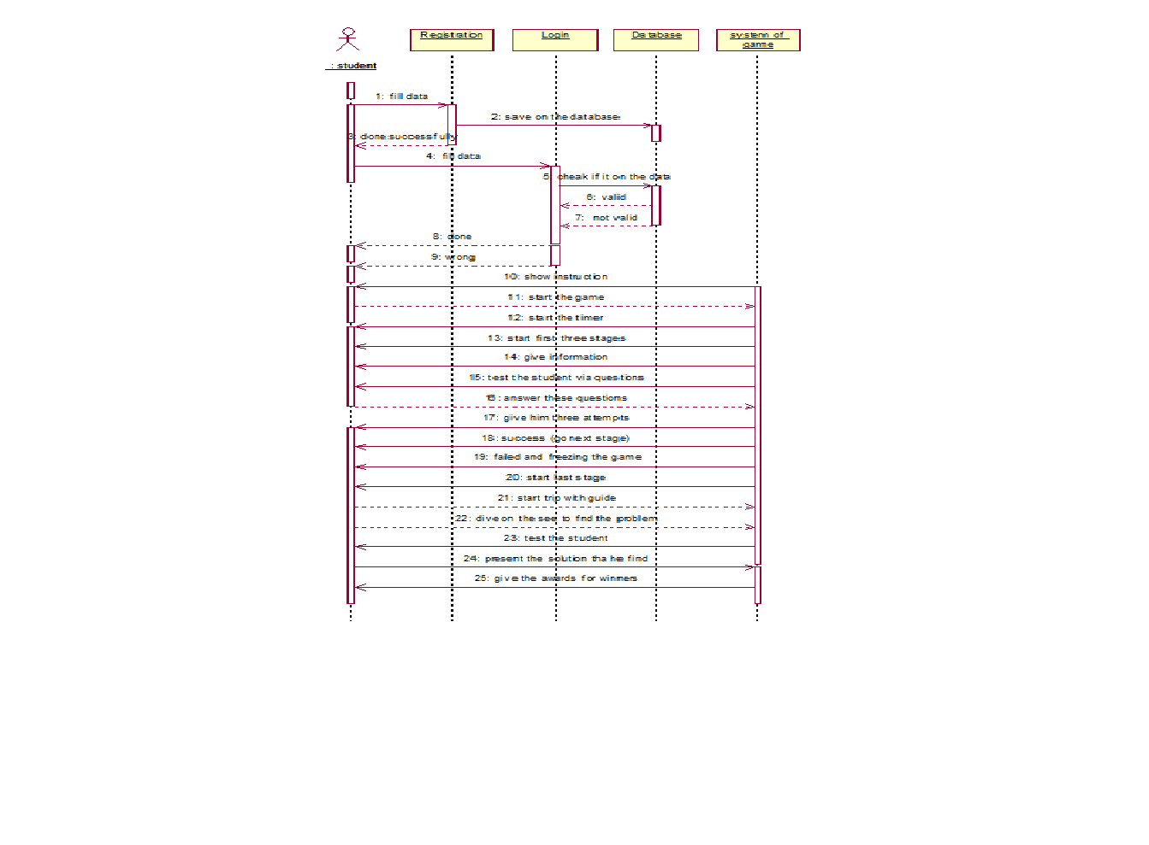

**7.6 classes diagram:**

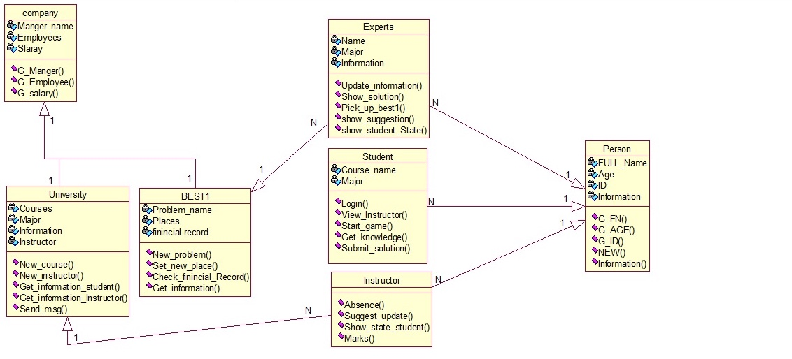

THANK U !!