PERSONAL INFORMATION | Sharaf Basman Khalil Ibraheem.
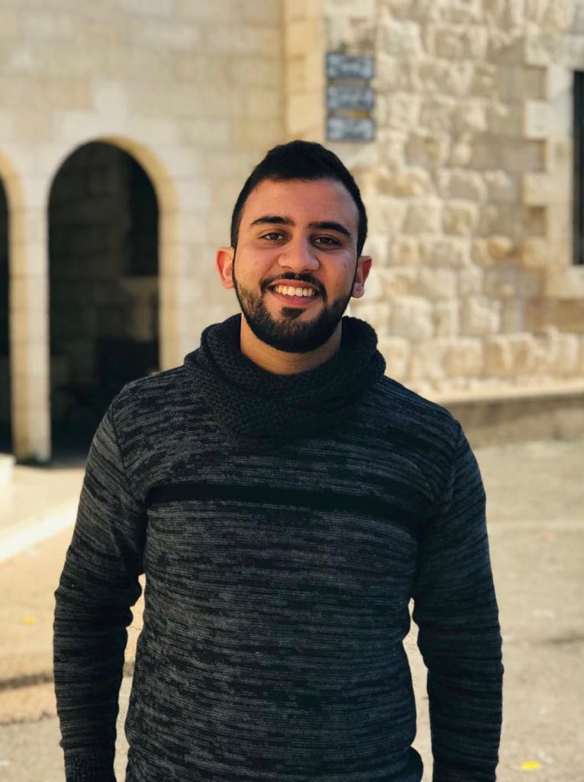 |   Jenin - Palestine.

00970569963232

sharafbkhalil97@gmail.com
Sex male | Date of birth 10/9/1997 | Nationality Palestinian.
Marital Status single.
Memberships:
- JEC [Jeunesse Etudiante Chretienne]
As leader for the Youth .

OBJECTIVE:
- Complete my Bachelor then specialize in data mining, data science, big data and AI.
-To be up to date with the Technology and learning all the Time.
- Be at least professional in python and AI.

QUALIFICATION:

- Good social communication with other people.
- A fourth year student, Computer System Engineering at AAUP.
- Cumulative GPA 3.12 of 4.
- Creativity at software engineering and python.
- Working under pressure and adapting to teamwork quickly.
- Ambitious and guidance or leadership as I have been a leader in many groups.
- An active person who participates in most events.

COMPETITIONS:

- I participated in ACM (PCPC 2018), Certificate ().
- I participated in hash code 2019.
- I was a judge in First LEGO league competition 2019 at AAUJ.

COMPUTER SKILIS:

- Languages: Java, C++, python ,Assembly .
- Data structure.
- Algorithms.
- Data science: python.
- Database: oracle.
- Basic Of Network.
LANGUAGES:

- Arabic: excellent in writing and speaking.
- English: Good in writing and speaking.
- Hebrew: Poor.
- French : Poor.
- Italian : Poor.

Hobbies:

- Swimming.
- Playing piano.
- Reading [Books, Novels, Poetry]
- Writing in Arabic [Short story and some of poetry]
- Sports.

Driving License:
Don't have.

REFERENCES:
Available Upon Request.

