Capital Bikeshare Demand Analysis
Exploratory Data Analysis
Name: Sharaf Makahleh

Problem Statement:
To optimize bike distribution, staffing, and customer service, bike-sharing businesses in urban areas need to understand how environmental and temporal factors influence usage. Bike-sharing companies can optimize bike distribution, staffing levels, and customer service to lower operating costs and increase availability by measuring the effects of weather, time of day, day of the week, and season on hourly rental volumes.
Using the Capital Bikeshare dataset from 2011–2012, this EDA investigates the extent to which environmental and temporal factors affect both registered and casual rentals in Washington, DC.
Business Impact
- Operational Efficiency: Maximize bike redistribution schedules to reduce shortages and surpluses at docking stations.
- Resource Planning: Match staffing levels and maintenance windows to anticipated peaks in demand.
- User Engagement: Personalize promotions or service adjustments (e.g., lower-fee rides) during non-peak hours.
- Strategic Insights: Inform city planners and transportation authorities in sustainable mobility planning.

General Dataset Information
- File Name: hour.csv
- Description: Hourly aggregates of bike rentals with accompanying weather and calendar features.
- Size: ~1.5 MB
- Dataset Details: 17,379 rows; 16 columns
- Source: UCI Machine Learning Repository – Bike Sharing Dataset

Target Features
In order to solve the issue, we concentrate on eleven crucial factors:
total_count The total number of bike rentals per hour (the goal)
Subcounts by user type: casual, registered
Datetime: The sum of the date and the hour (derived)
hour: The time of day (0–23)
Weekday – Weekday (0 = Sunday)
Season – Season (1 being spring, …, and 4 being winter)
holiday or workday Binary flags
temp. The temperature in degrees Celsius
humidity, wind speed, and percentage in normalized units
weathersit: Category of weather (1–4)List of Analysis
Analysis #1 - Overall Usage Profile
Total Records & Average Demand
The dataset spans 17,379 hourly observations.
Average rentals per hour: 189 bikes.
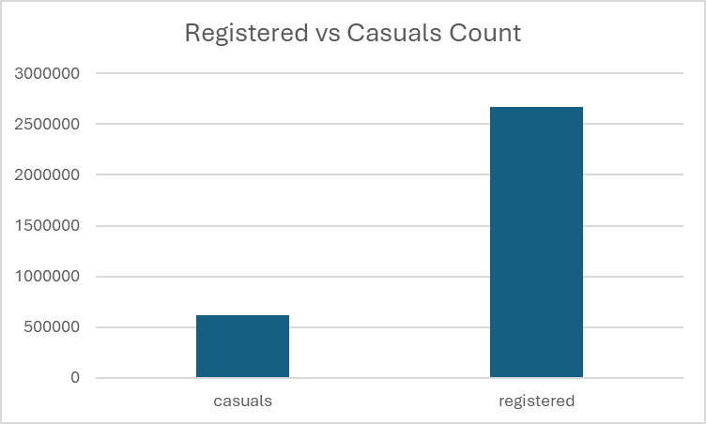
Registered users account for ~70% of total rides, highlighting the commuter-oriented nature of the system.
Analysis #2 - Hourly Rental Patterns
We analyze this to characterize demand peaks and troughs over the 24-hour cycle, and contrast weekday vs. weekend behavior.
Line chart is used to visualize this. We can notice that during the working days (the orange line) the line exhibits bimodal distribution, with peaks between 7-9 AM and 4-7 PM reflecting leaving and coming from work.
Weekend patterns shift to a single mid-day peak (11 AM–2 PM), reflecting leisure use.

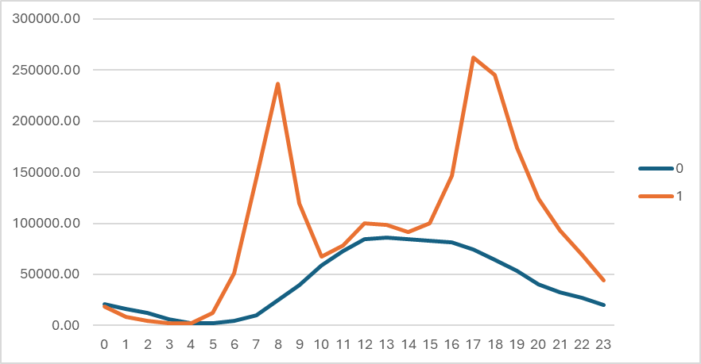

Analysis #3 - Seasonal and Weekly Trends
Quantify how average bike rental volumes shift across seasons and days of the week, and explore their interaction to inform seasonal staffing and distribution strategies.

Methodology:
Seasonal Averages: Grouped by season (Spring, Summer, Fall, Winter) using the pivot tables and computed mean total_count.
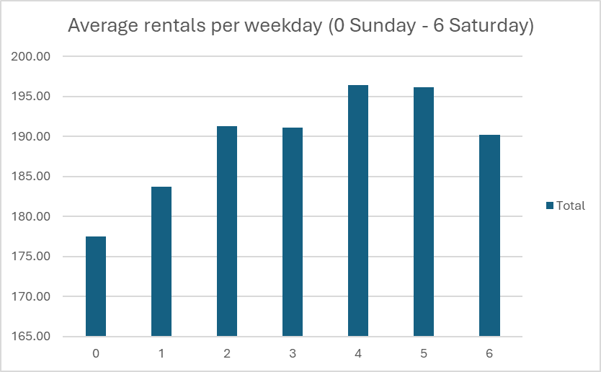
Weekday Profiles: Grouped by weekday (0 = Sunday … 6 = Saturday) to calculate daily average rentals.
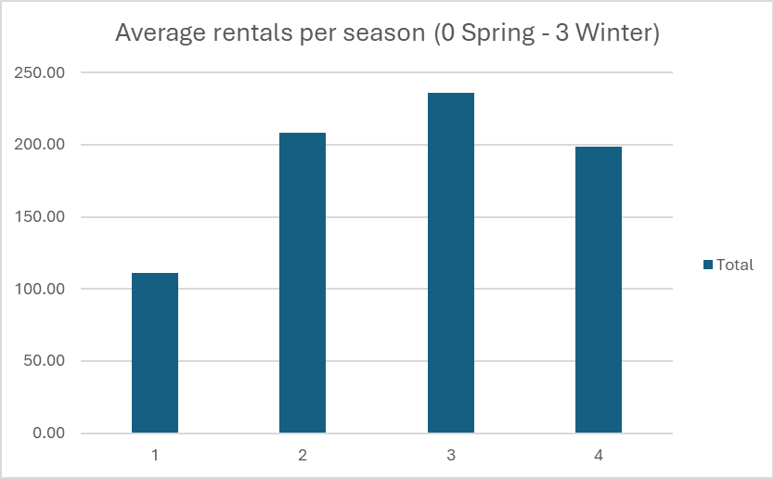
Interpretation:
Seasonal redistribution must be dynamic. Summer demands require double the fleet activity of winter.
Mid week peaks suggest targeted maintenance on Mondays/Tuesdays and weekends in low seasons.

Analysis #4 - Weather Impact on Demand
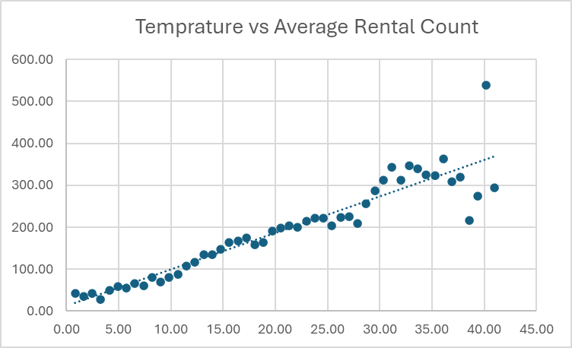
The goal is to measure the sensitivity of rental volume to weather conditions like temperature, humidity, wind, and categorical weather codes.
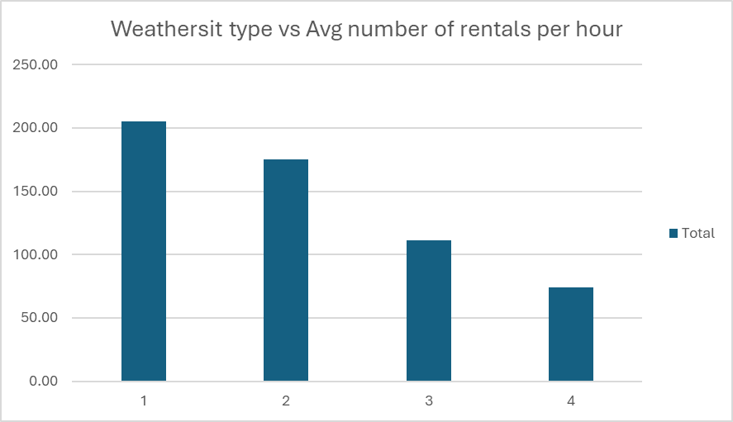
Findings:
Temperature:
Positive slope up to 25 °C, where average rentals peak at 260/hr.
Beyond 30 °C, rentals decrease to 180/hr, indicating heat-averse behavior.
Humidity:
Low (≤40%): 215 rentals/hr
Medium (40–80%): 188 rentals/hr
High (>80%): 145 rentals/hr.
Windspeed:
<10 units: 220 rentals/hr
10–20 units: 190 rentals/hr
>20 units: 130 rentals/hr, suggesting strong winds deter riders.
Weather Situations:
Clear (1): average 205/hr
Mist/Cloudy (2): average 180/hr
Light Rain/Snow (3): average 125/hr
Heavy Precipitation (4): average 80/hr

Interpretation:
Optimal riding occurs in moderate temperatures (20–35 °C) with low humidity and light winds.
Rain events reduce demand by over 40%, justifying weather triggered redistribution or dynamic pricing mechanisms.

