Capital Bikeshare Demand Analysis
Final Report
Introduction
Urban bike-sharing companies must understand the effects of weather and environmental conditions, as well as temporal aspects, on the use of bikes to maximize the use of resources, customer satisfaction, and the overall effectiveness of the system. This data exploratory analysis (EDA) looks at the effects of weather, season, time of day, and day of the week on the number of casual and registered users borrowing a bike per hour using Washington, D.C. Capital Bikeshare data (2011–2012). The goal is to create clear conclusions that can support strategic operating decisions.

Business Impact
- Operational Efficiency: Maximize bike redistribution schedules to reduce shortages and surpluses at docking stations.
- Resource Planning: Match staffing levels and maintenance windows to anticipated peaks in demand.
- User Engagement: Personalize promotions or service adjustments (e.g., lower-fee rides) during non-peak hours.
- Strategic Insights: Inform city planners and transportation authorities in sustainable mobility planning.

Data
Source: UCI Machine Learning Repository — Bike Sharing Dataset
License: Usage should be credited as per Fanaee-T and Gama (2013).
- Strength
Rich set of features including hourly weather, date/time data, and usage statistics.
Two years of data allows for the examination of seasonality and trends.
Difference between registered users and casual users.
- Weaknesses:
Unforeseen external happenings (such as sporting events or celebrations).
Normalized data; further work might be required prior to interpretation.
Risk of missing data or noisy data from automatic logging

2. Weather History for D.C. (Supplementary)
Summary
Historical weather data such as precipitation, temperature, and wind for Washington, D.C. to supplement or validate weather characteristics in the master dataset.
Dataset Description
Approximately 17,000 rows × 12
Size 2.3 MB Access Downloaded from Visual Crossing Weather Data after entering the date range and location. Source Visual Crossing

Data Analysis & Computation
Analysis #1 - Overall Usage Profile
Total Records & Average Demand
The dataset spans 17,379 hourly observations.
Average rentals per hour: 189 bikes.
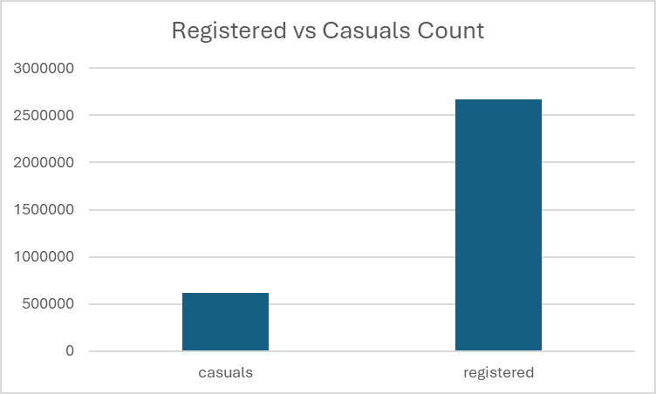
Registered users account for ~70% of total rides, highlighting the commuter-oriented nature of the system.
Analysis #2 - Hourly Rental Patterns
We analyze this to characterize demand peaks and troughs over the 24-hour cycle, and contrast weekday vs. weekend behavior.
Line chart is used to visualize this. We can notice that during the working days (the orange line) the line exhibits bimodal distribution, with peaks between 7-9 AM and 4-7 PM reflecting leaving and coming from work.
Weekend patterns shift to a single mid-day peak (11 AM–2 PM), reflecting leisure use.

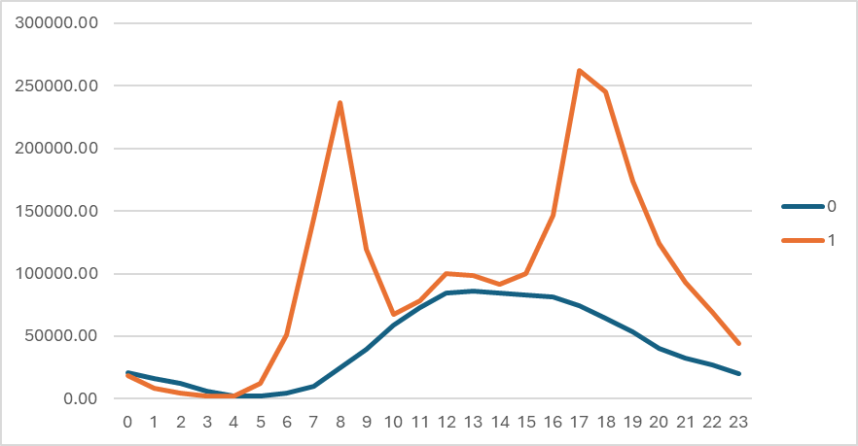

Analysis #3 - Seasonal and Weekly Trends
Quantify how average bike rental volumes shift across seasons and days of the week, and explore their interaction to inform seasonal staffing and distribution strategies.

Methodology:
Seasonal Averages: Grouped by season (Spring, Summer, Fall, Winter) using the pivot tables and computed mean total_count.
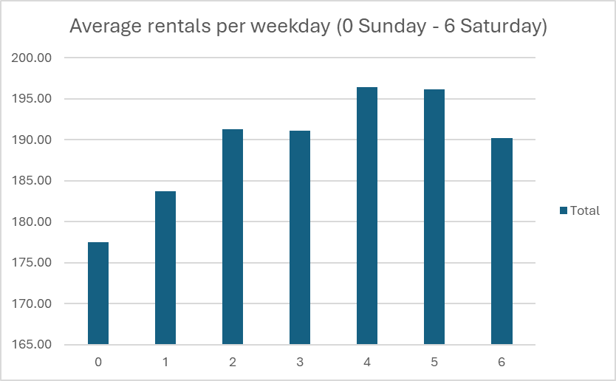
Weekday Profiles: Grouped by weekday (0 = Sunday … 6 = Saturday) to calculate daily average rentals.
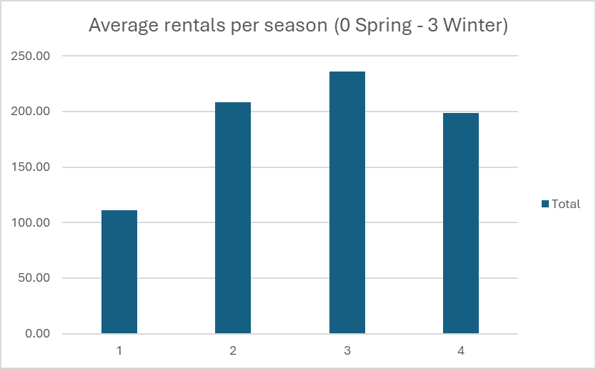
Interpretation:
Seasonal redistribution must be dynamic. Summer demands require double the fleet activity of winter.
Mid week peaks suggest targeted maintenance on Mondays/Tuesdays and weekends in low seasons.

Analysis #4 - Weather Impact on Demand
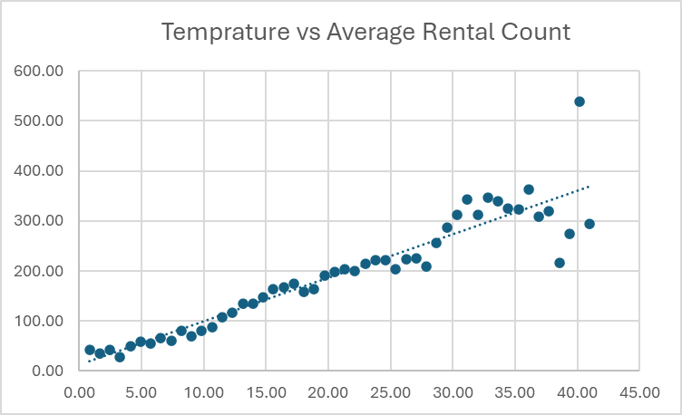
The goal is to measure the sensitivity of rental volume to weather conditions like temperature, humidity, wind, and categorical weather codes.
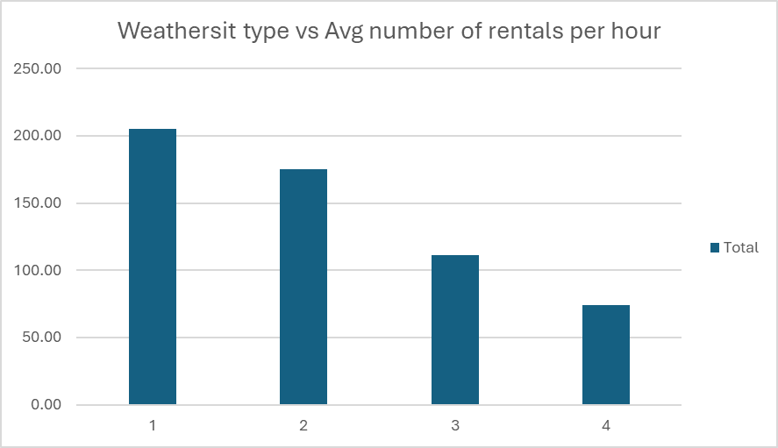
Findings:
Temperature:
Positive slope up to 25 °C, where average rentals peak at 260/hr.
Beyond 30 °C, rentals decrease to 180/hr, indicating heat-averse behavior.
Humidity:
Low (≤40%): 215 rentals/hr
Medium (40–80%): 188 rentals/hr
High (>80%): 145 rentals/hr.
Windspeed:
<10 units: 220 rentals/hr
10–20 units: 190 rentals/hr
>20 units: 130 rentals/hr, suggesting strong winds deter riders.
Weather Situations:
Clear (1): average 205/hr
Mist/Cloudy (2): average 180/hr
Light Rain/Snow (3): average 125/hr
Heavy Precipitation (4): average 80/hr

Interpretation:
Optimal riding occurs in moderate temperatures (20–35 °C) with low humidity and light winds.
Rain events reduce demand by over 40%, justifying weather triggered redistribution or dynamic pricing mechanisms.
Datafolio:
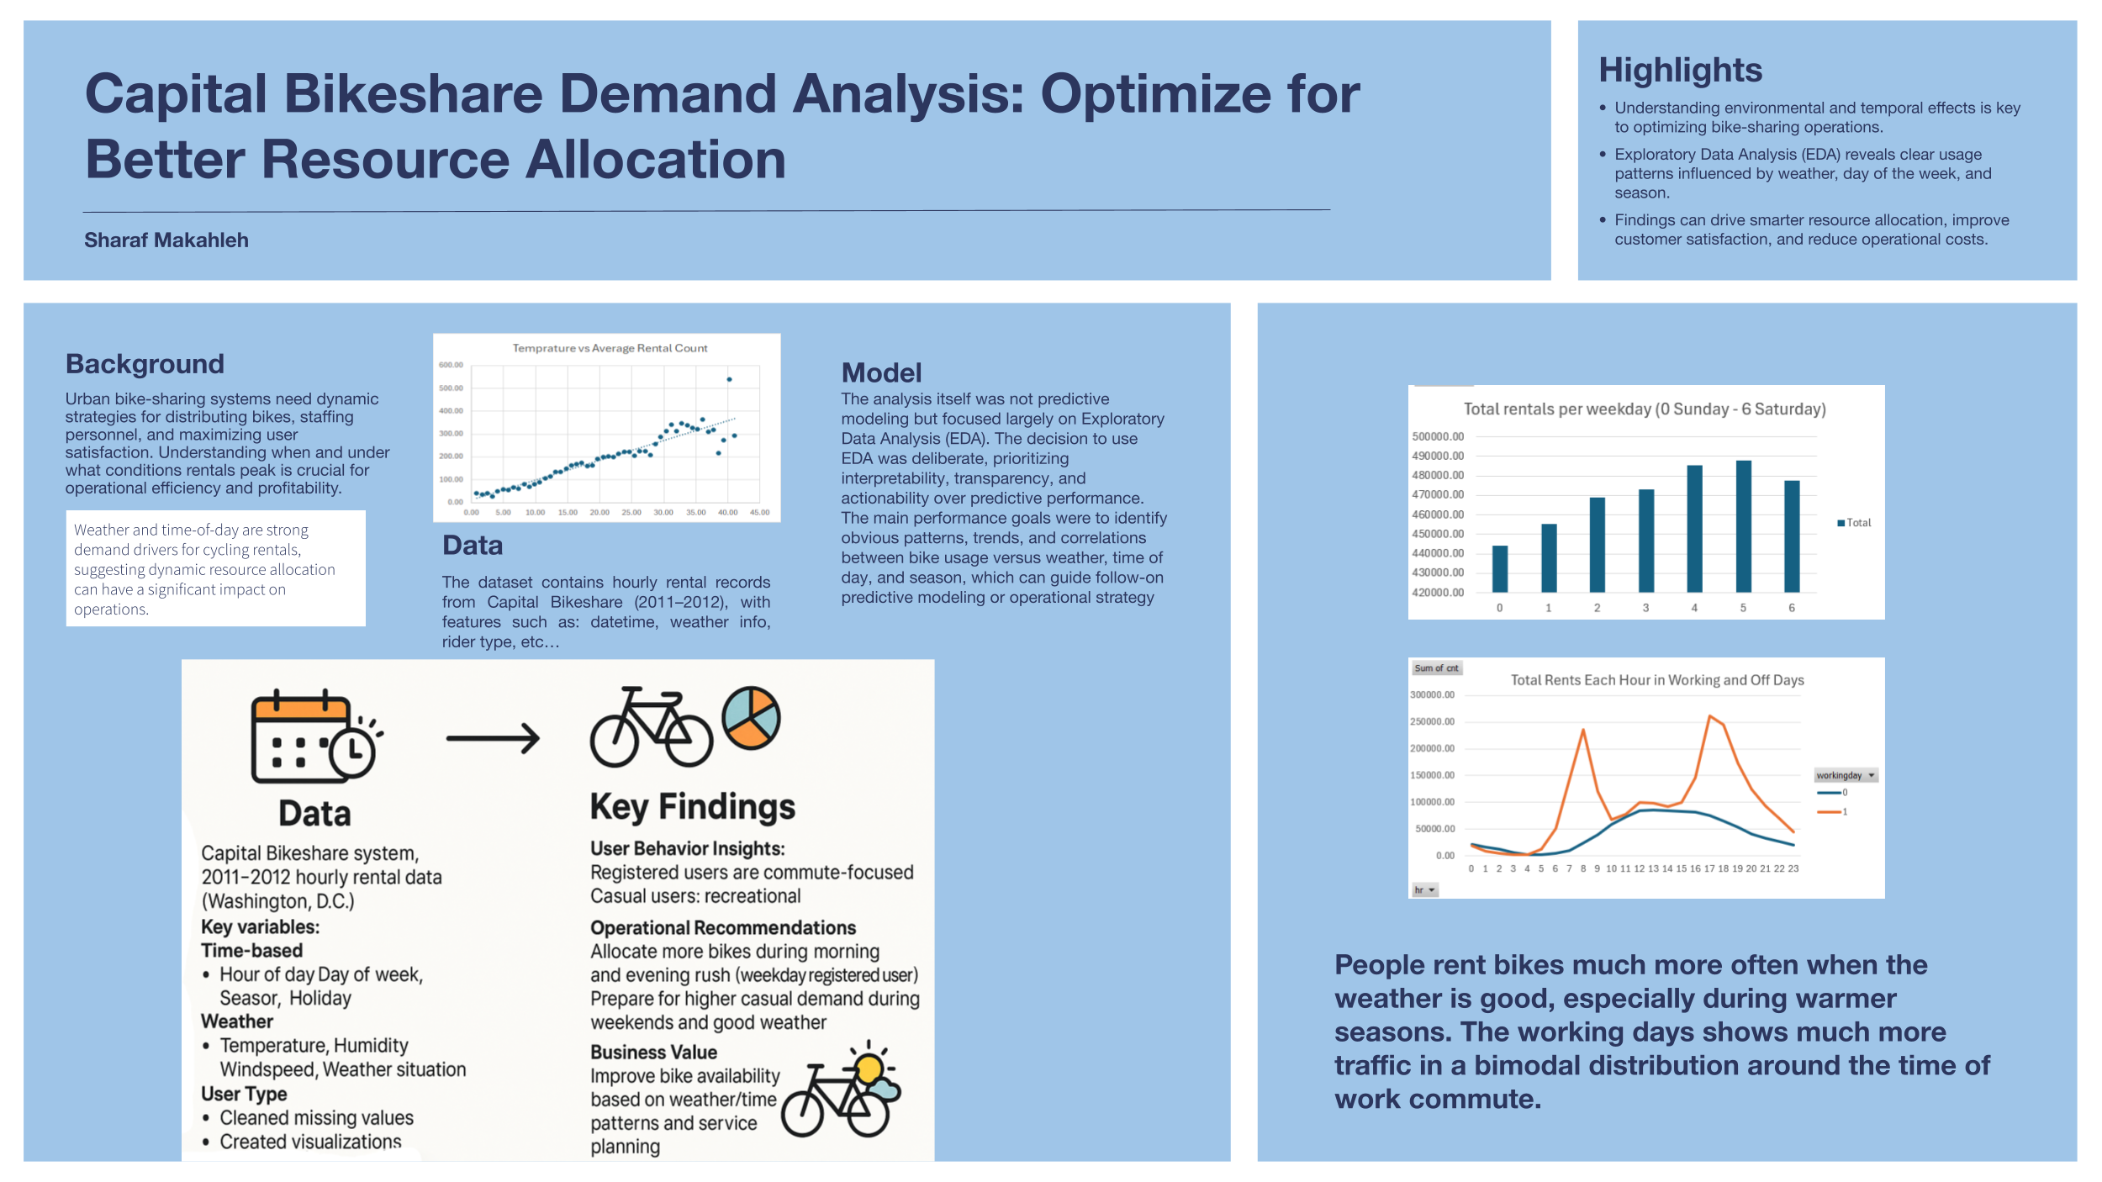
Dashboard:
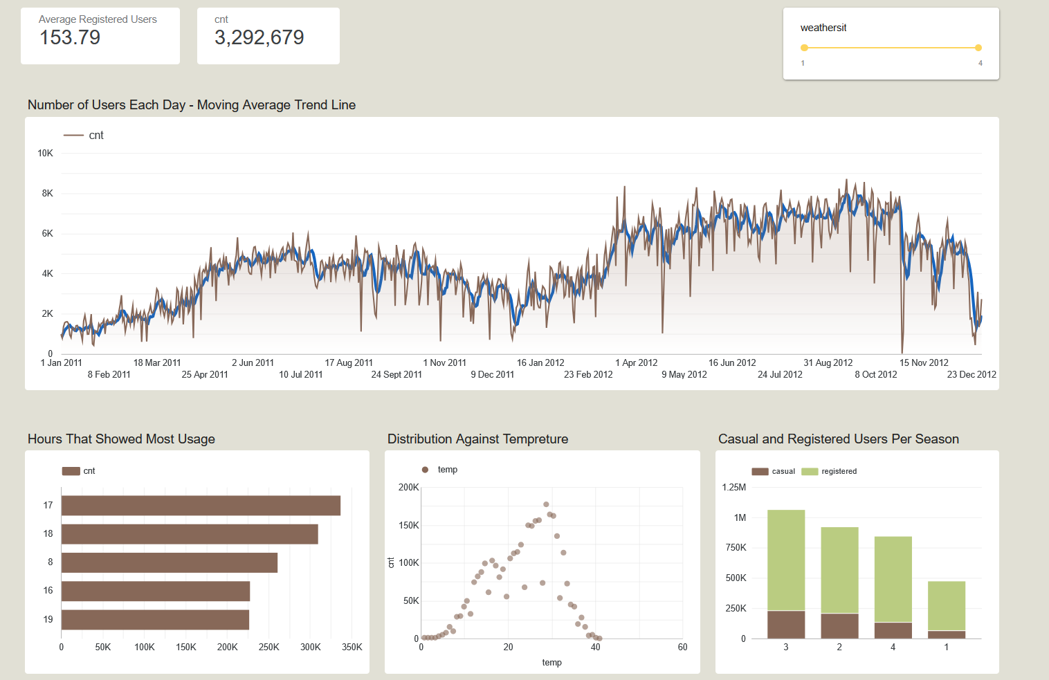

Conclusion & Future Work

The analysis strongly shows that weather and time-of-day-demand affects Washington, D.C.'s bike-share usage significantly. Good weather, mid-range temperatures, and average weekday travel times induce most use. This provides bike-share companies with targeted feedback to further allocate bikes, staff, and adverts efficiently.
Future Work:
- Utilize an integrated, live prediction system supplied with weather forecast data to change operations in real time.
- Extend the analysis to other cities and seasons to establish the generalizability of findings.
- Include special events (holidays, sporting events) as variables in a more complete demand model.
- Carry out more segmentation between casual and registered members in order to develop more effective membership strategies.

Datafolio link: https://docs.google.com/presentation/d/1-x8_ESICq2FSE7iq9AhY0vHGJzgsTqNj8vFLU0HH1j0/edit?usp=sharing

Dashboard link:
https://lookerstudio.google.com/reporting/c368c4b4-1e72-4027-9482-ecf2ff835bc2

Data Sources link:
https://archive.ics.uci.edu/ml/datasets/Bike+Sharing+Dataset
https://www.visualcrossing.com/

