GRADUATE PLACEMENT, SKILL GAP & IT JOB- MARKET ANALYSIS — 2026

Data Analytics Portfolio Project Report
B.E. Computer Science Engineering (Data Science)

Sharan V
Prepared by
A synthetic-data case study in placement analytics and industry skill-gap reporting

Tools
Excel • MySQL • SQL • Power BI • DAX • Python / Pandas (where used)

Prepared as a personal portfolio project — Data Analyst track
All student records are synthetically generated; see Section 8 for full disclosure.

1. Executive Summary
This project demonstrates a complete, end-to-end analytics workflow that combines a simulated engineering-student placement dataset with a prepared IT job-market dataset. It explores placement patterns across departments and academic profiles, and compares student skill availability with skill mentions drawn from job-market records. MySQL and SQL provide storage, cleaning and analysis, while Power BI presents the findings across two linked report pages designed for executive and analytical audiences.
The report is written to be read on its own by a reviewer with no prior context: every figure, chart and recommendation carries the scope and caveats needed to interpret it correctly, so that the project reads as a rigorous, responsibly-documented analytics exercise rather than a simple spreadsheet of numbers.
Important: the student placement records used throughout this report are synthetic and do not represent verified outcomes from any real college. Job-market conclusions are similarly limited by the coverage, recency and provenance of the underlying job dataset. Both limitations are restated at the point of use throughout this document, and in full in Section 8, so that no figure is read out of context.

2. Business Problem and Objectives
Placement and training teams within an engineering college need a practical, repeatable way to explore placement outcomes, understand which student attributes are associated with better results, and identify where the skills students hold diverge from the skills the job market is actively seeking. Today this kind of analysis is often done manually, inconsistently, or not at all, which makes it difficult to target training, internships and career-readiness interventions where they matter most.
This project sets out to meet that need through four concrete objectives:
- Summarize placement outcomes by department, so that relative performance across branches is visible at a glance.
- Explore recorded CGPA, internship, project and certification attributes, to see how they relate to placement status and package.
- Compare job-record skill demand with student skill availability, surfacing the skills most worth prioritizing.
- Communicate every result through a Power BI dashboard with transparent, visible caveats, so no number is mistaken for a verified outcome.

3. Data and Scope

Student Dataset
The student dataset contains 500 synthetic records, each describing one simulated graduating student. The fields captured are: Student_ID, Department, CGPA, Internship, Projects_Count, Certifications_Count, Skills, Placement_Eligible, Placement_Status, Company, Job_Role and Package_LPA. Together these fields support analysis of academic performance, practical experience and placement outcome at the individual student level, while rolling up cleanly to department- and batch-level summaries.

Job-Market Dataset
The job-market dataset consists of prepared IT and technology job records filtered to the 2025–2026 window, with skill labels standardized for comparability, and a separate job-skill bridge table that records which skills appear in which job postings. Before any public release of this project, the original source, collection method, license and date coverage of this dataset must be documented in full — this is treated as a hard prerequisite, not a nice-to-have, and is repeated in Section 9.

Database Design
All data is stored in a MySQL database named placement_analysis, structured around three tables: students, job_market and job_skills. The job_skills table links to job_market via a shared Job_ID key, giving a clean many-to-many relationship between jobs and the skills they mention. This relational structure keeps the two source populations cleanly separated at the storage layer, which supports the next point directly.

Student records and job records describe two different populations collected for different purposes, and must be analyzed separately rather than joined as though they represented the same people or the same hiring events. Any comparison between the two datasets in this report is made at the aggregate, skill level only — never by matching individual students to individual job postings.

4. Tools and Workflow
The project follows a conventional analytics pipeline, chosen to mirror the tools a working data analyst is expected to use day to day:
Stage | Tool | Purpose
Inspection & prep | Excel / CSV | Inspect raw files; sanity-check structure before loading
Data preparation | Python / Pandas | Filter the job dataset to scope, standardize skill labels, build one row per job-skill association
Storage | MySQL | Host the three-table relational schema (students, job_market, job_skills)
Analysis | SQL | Calculate placement summaries and skill-demand comparisons
Reporting | Power BI / DAX | Connect via the configured ODBC data source, define measures, build report pages
Interpretation | Report (this document) | Interpret results and document assumptions and limitations
Table 1. End-to-end workflow from raw files to published report.

5. Dashboard Page 1 — Placement Overview
The first dashboard page gives a single-screen executive view of placement performance across the synthetic batch. It includes the placement-status distribution, total students, placed students, not-placed students, placement rate, average CGPA, average package, placement status by department, student count by department, placement rate by department, and the top 10 companies by simulated student placements.
Metric | Value
Total students | 500
Placed | 317
Not placed | 183
Placement rate | 63.40%
Average CGPA | 7.59
Average package | ₹3.67 LPA
Table 2. Headline figures shown on Dashboard Page 1. These values describe the synthetic dataset only and should not be read as representing any real institution or batch.
These headline figures anchor the rest of the page's department-level breakdowns and give a reviewer an immediate sense of scale before drilling into department, CGPA or company detail.
Figure 1. Power BI dashboard — Placement Overview (synthetic student data).
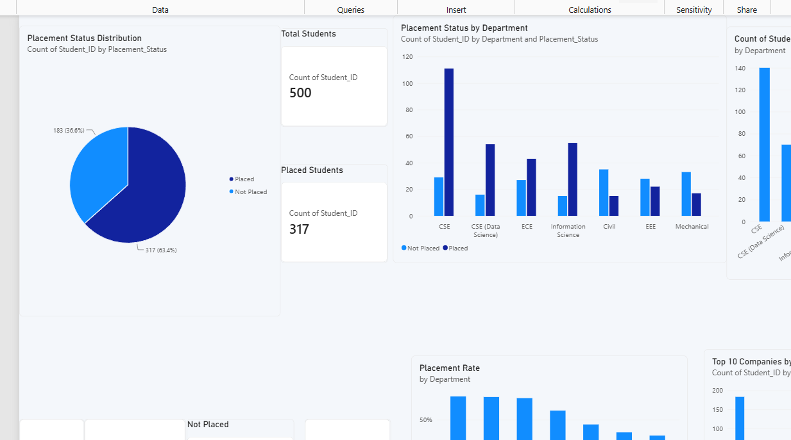

6. Dashboard Page 2 — Skill Gap Analysis
The second dashboard page is the analytical centrepiece of the project. It compares Job Skill Demand % against Student Skill Availability % for each standardized skill, and presents the result in a skill-level table alongside a visual comparison. The intended calculation is:
Skill Gap % = Job Skill Demand % − Student Skill Availability %
Job Skill Demand % is defined as the percentage of job records that mention a given skill, not the percentage of all employers who require it — the distinction matters because a single employer may post several job records, and the dataset captures postings, not employers. Student Skill Availability % is defined as the percentage of distinct synthetic students recorded as having that skill.
Figure 2. Power BI dashboard — Skill Gap Analysis (current build).
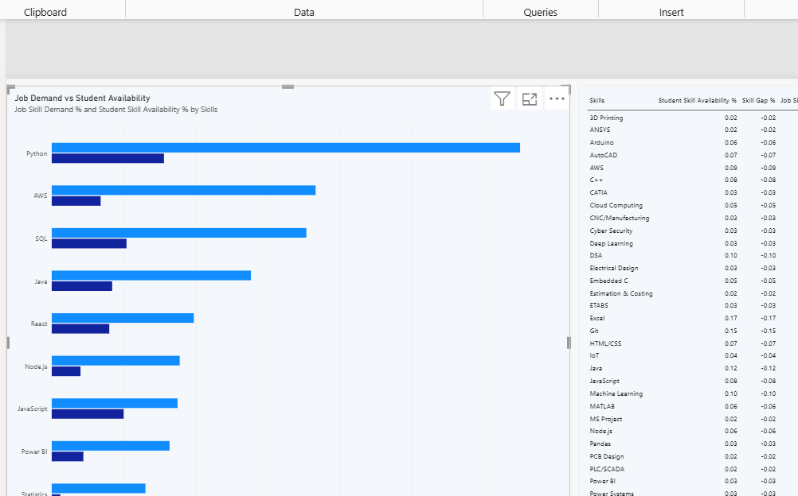
Interpretation note: this screenshot documents the current dashboard build. Reconcile the final SQL and DAX skill-gap values against the source tables before publishing specific skill rankings or percentages.
A positive gap means job-record demand exceeds recorded student availability, flagging a skill that may be under-represented in the student population relative to what the job market is asking for. A negative gap means the reverse: the skill is more common among students than it is mentioned in job records. Both directions are informative, and neither should be read as a causal claim about employability.

7. Interpretation and Recommendations
Validated results can be used to identify departments with comparatively higher or lower simulated placement rates, and to shortlist the skills with the largest positive gaps as candidates for attention. Throughout, these should be treated as exploratory findings that describe patterns in this dataset, not as proof that any one factor causes a particular placement outcome.
With that framing in mind, three potential actions follow from the analysis:
- Consider targeted workshops for skills with the largest verified positive gaps, once the underlying job data has been validated.
- Review internship and project patterns descriptively, rather than as confirmed drivers of placement.
- Repeat the analysis with verified institutional placement records and a documented, representative job-listing sample before any of its conclusions are used to inform real decisions.

8. Limitations and Responsible Use
This project is a demonstration of analytical method, and its findings should be read strictly within that frame:
- Student data is synthetic; the placement rates, packages and department comparisons it produces are illustrative, not evidentiary.
- Job-market records may not represent the entire IT labor market, and should not be treated as a complete or unbiased sample of it.
- Skill normalization choices and the coverage of the original source material both affect the resulting counts.
- The two datasets describe different populations collected for different purposes, so any comparison between them is descriptive, not a matched or causal analysis.
- Differences in outcomes across departments or attributes do not prove that CGPA, internships, projects or certifications cause placement — only that they are associated with it in this synthetic dataset.

9. Recommended Repository Contents
To present this project professionally in a portfolio or public repository, the following contents are recommended:
File / Folder | Contents
README.md | Project overview, setup instructions, and synthetic-data disclosure
SQL_Analysis_Queries.sql | Core SQL used for placement and department summaries
Step5_Skill_Gap_Analysis.sql | SQL used to compute the skill-gap comparison
Power BI PBIX + screenshots | The working dashboard file and exported page images
Data dictionary | Field-by-field definitions for every table and column
Dataset files | Only files that may legally be redistributed
Table 3. Recommended repository structure. Every component should carry clear source notes and a synthetic-data disclosure consistent with Section 8.

10. Conclusion
This project demonstrates a practical, end-to-end workflow that runs from data preparation and relational storage through SQL analysis to Power BI reporting. Its portfolio value lies in the integration of a placement analysis with a job-skill comparison — a pairing that goes beyond a single-table dashboard and shows the ability to design a small relational schema, write analytical SQL across it, and communicate the result responsibly.
The results throughout this report should be presented as exploratory. Student data must be clearly disclosed as synthetic, and job-data provenance and limitations must be stated transparently wherever the findings are shared.

