**Output Screenshots:**

* Week1_Gold.xml

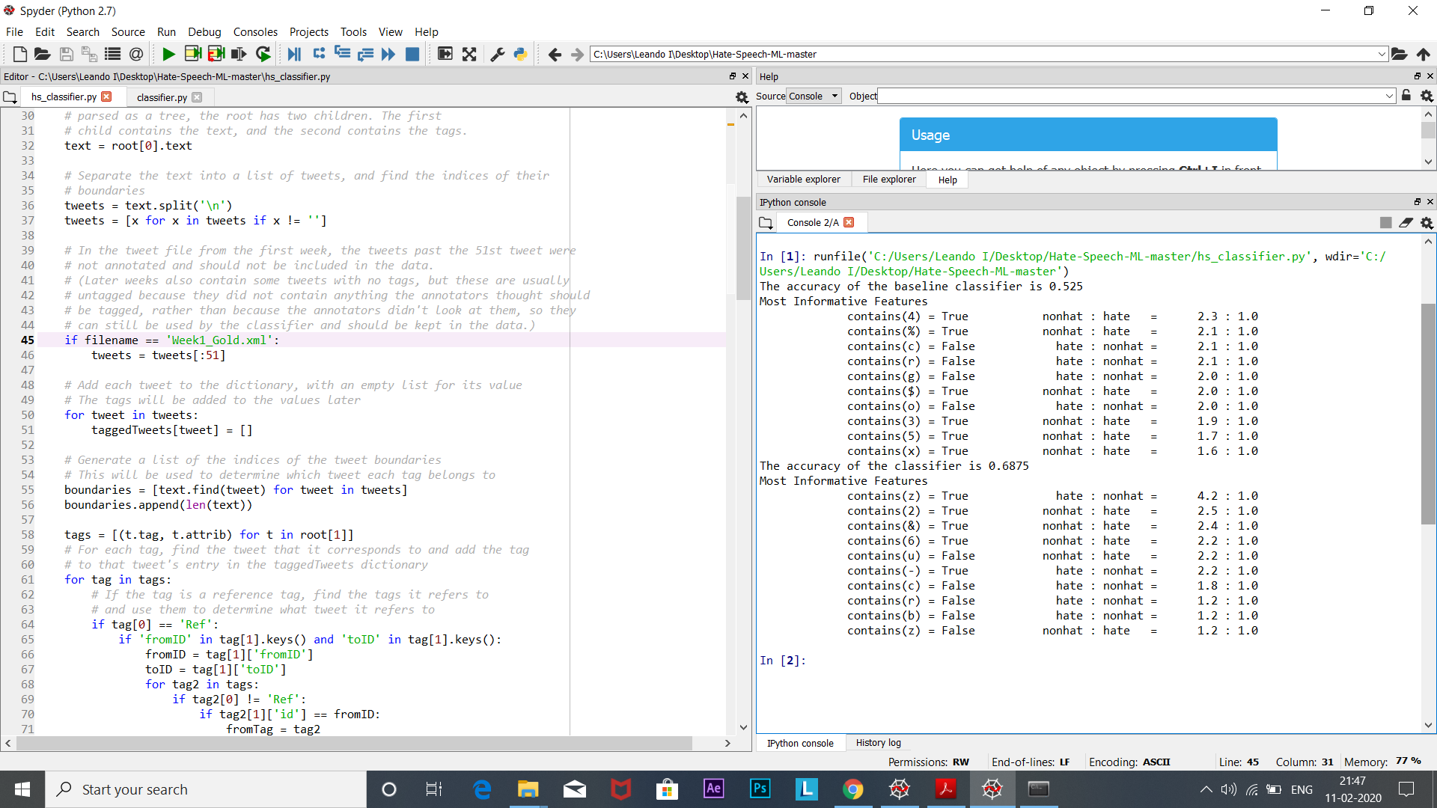

Accuracy of baseline classifier=0.525

Accuracy of advanced classifier=0.6875

* Week1_Gold2.xml 🡺Range[0-20]

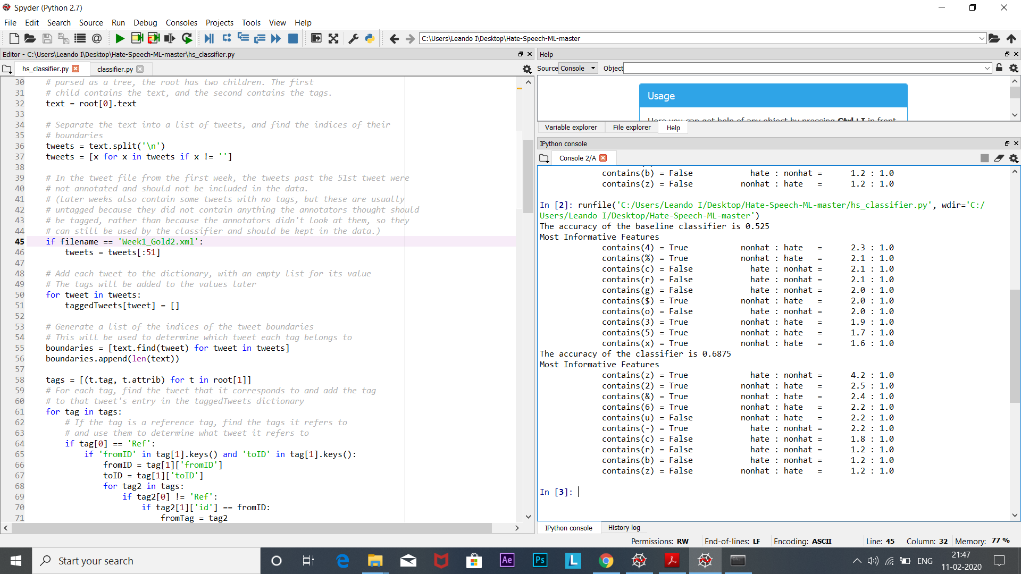

Accuracy of baseline classifier=0.525

Accuracy of advanced classifier=0.6875

* Week1_Gold3.xml 🡺Range[0-100]

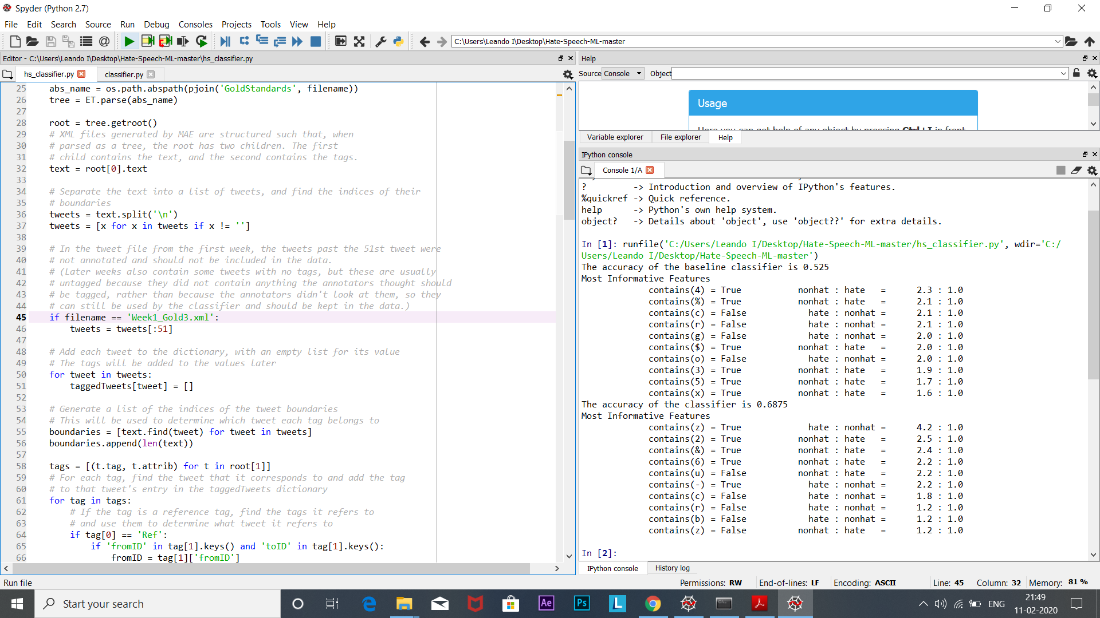

Accuracy of baseline classifier=0.525

Accuracy of advanced classifier=0.6875

* Week1_Gold5.xml 🡺Range[0-27]

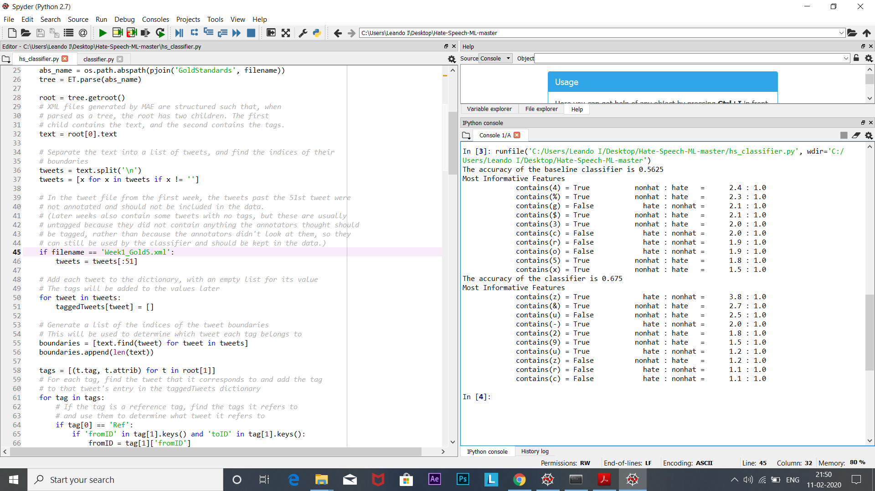

Accuracy of baseline classifier=0.5625

Accuracy of advanced classifier=0.675

**N-FOLD:**

Accuracy of baseline classifier = ((0.525+0.525+0.525+0.5675)/4)

Accuracy=0.535

Accuracy of advanced classifier = ((0.6875+0.6875+0.6875+0.675)/4)

Accuracy=0.684