Woice AI

Introduction / Overview

Purpose
This document provides a technical overview of the Woice platform, detailing its architecture, core components, features, APIs, and operational procedures. It serves as a guide for developers, AI engineers, and technical staff involved in understanding, maintaining, or extending the platform.

Project Goal
The Woice platform aims to solve the need for easily configurable and deployable specialized AI assistants. It provides a centralized system for creating distinct AI personalities that users can interact with through multiple common communication channels, primarily phone calls (voice) and WhatsApp messages (text).

Scope
This document covers the backend architecture implemented in Woice.py (Flask application), including the AI engine integration (OpenAI/LlamaIndex), communication handling (Twilio), data storage (SQLite/Shelve), and the management API. It also briefly touches upon the associated frontend components inferred from provided visuals. It does not cover in-depth frontend implementation details, specific AI model training procedures, or advanced deployment scaling strategies beyond the basic setup.

Key Features
    - Multi-Channel Interaction: Supports user interaction via PSTN Voice Calls,SMS and WhatsApp messages.
    - AI-Powered Conversations: Leverages OpenAI (GPT-4o-mini) and LlamaIndex for natural language understanding and response generation.
    - Configurable Assistant Personalities: Allows defining multiple distinct assistants, each with its own name and behavioral prompt, stored in a database.
    - User Assistant Selection: Presents users with a menu (via voice DTMF or WhatsApp text) to choose which assistant they want to interact with.
    - Conversation Memory: Maintains conversational context for each user session using persistent storage (Shelve).
    - Tool Usage / Agentic Capabilities: AI agents can utilize predefined tools to perform actions beyond conversation, such as:
      - Looking up information from a file (Farmer Subsidy).
      - Sending SMS messages with specific information.
      - Simulating external API calls (Restaurant Order Update).

    - Management API: Provides RESTful endpoints (/assistants) for creating, viewing, and updating assistant configurations.
    - Frontend Management Interface: Includes a web UI (Playground) for managing assistants via the API.
    - Potential Web/Avatar Interface: Visuals indicate a frontend component for interacting with a "Digital Human" avatar.

System Architecture

Architecture
    - The Architecture includes:
      - Users interacting via Phone Network / WhatsApp App.
      - Twilio as the gateway handling Voice Calls and WhatsApp Messages, sending webhooks to the Flask App.
      - The Flask Backend (Woice.py) receiving webhooks and API calls.
      - Flask App interacting with the AI Core (LlamaIndex/OpenAI).
      - Flask App interacting with Data Storage (SQLite for Assistants, Shelve for Session State).
      - AI Core potentially calling External Services (e.g., Order Update URL) via Tools.
      - A Frontend Application interacting with the Flask App's Management API (/assistants).
      - Frontend potentially having its own interaction route (e.g., for the Avatar) with the Backend.

Component Breakdown
    - Frontend Application: Web-based user interface providing Login, Assistant Management ("Playground"), and potentially a chat interface with a Digital Human Avatar. Interacts with the backend API.
    - Backend Application (Woice.py): Python Flask application acting as the central hub. Handles incoming Twilio webhooks (Voice/WhatsApp), serves the Management API, orchestrates AI interactions, manages state, and executes tool functions.
    - AI Core (LlamaIndex & OpenAI): Responsible for understanding user input and generating intelligent responses. Includes the LLM (OpenAI), the agent framework (LlamaIndex AgentRunner/Worker), memory management (ChatMemoryBuffer), and tools (QueryEngineTool, FunctionTool).
    - Communication Layer (Twilio): Manages real-time communication channels. Receives calls/messages and sends responses via Twilio's APIs and TwiML instructions generated by the Flask app.

Data Storage:
      - Assistants DB (SQLite): Stores definitions (name, prompt) of available AI assistants.

      - Session State DBs (Shelve): Persists temporary session data for individual ongoing conversations (call state, WhatsApp state), including memory and the currently selected assistant.
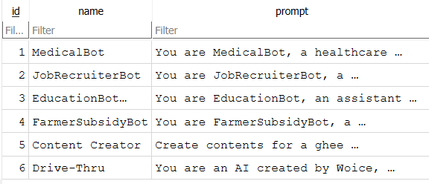
Figure 1: Database (Assistants)

Technology Stack
    - Backend:
      - Python 3.x
      - Flask (Web Framework)
      - Flask-CORS (Cross-Origin Resource Sharing)

AI Engine:
      - OpenAI API (using openai library, specifically gpt-4o-mini model)
      - LlamaIndex (llama-index-core, llama-index-llms-openai, etc.)

Communication:
      - Twilio API (via twilio Python SDK) - For Voice (TwiML), WhatsApp, SMS.

Databases:
      - SQLite3 (via sqlite3 Python module) - For Assistants configuration.
      - Python shelve module - For persistent dictionary-like session state.

Data Handling/Utilities:
      - requests (For HTTP calls within tools)
      - python-dotenv (Likely used for managing environment variables, though not explicitly imported in the snippet)
      - (Pandas - Potentially used implicitly by SimpleDirectoryReader for CSV)

Frontend (Inferred):
      - JavaScript Framework (e.g., React, Vue, Angular)

      - HTML5, CSS3
      - Node.js/npm/yarn (Build tools, package management)

Core Components

Flask Application (Woice.py)
    - Role: Acts as the central web server handling all incoming HTTP requests. It routes requests to appropriate handlers for Twilio webhooks (voice calls, WhatsApp messages) and the assistant management API. Orchestrates interactions between the communication layer, AI engine, and data storage.
    - Key Libraries Used: Flask, Flask-CORS, Twilio, LlamaIndex, OpenAI, SQLite3, Shelve, Requests, Logging, Asyncio.

Structure:
      - Configuration: Loads API keys, phone numbers, URLs from constants/environment variables.
      - Initialization: Sets up Flask app, CORS, Logging, Twilio Client, OpenAI LLM, LlamaIndex Tools/Engine.
      - Tool Definitions: Python functions
(update_order_function, send_sms_with_subsidy_info) wrapped as LlamaIndex FunctionTools. RAG tool (QueryEngineTool).
      - Session State Management: Helper functions
(get_session_state, save_session_state, cleanup_session_state) using shelve for voice and WhatsApp separately.
      - Agent Management: get_agent_for_session function to
instantiate AgentRunner with appropriate prompt and memory based on session state.
      - Database Helpers: Functions (get_db, close_connection, init_db) for managing SQLite connections using Flask's application context (g).
      - API Routes (/assistants): Endpoints for CRUD operations on assistant configurations.
      - Twilio Webhook Routes (/voice, /whatsapp, etc.): Handle incoming calls/messages, generate TwiML, interact with the AI core, manage session state.
      - Main Execution (if name == " main ":): Initializes the DB, performs startup checks, and runs the Flask development server.
    - Asynchronous Handling: Uses async def for the /whatsapp endpoint and the process_whatsapp_message function, leveraging asyncio to handle potentially long- running AI calls without blocking the main thread, allowing quick acknowledgment (HTTP 204) to Twilio.

AI Engine (LlamaIndex & OpenAI)
    - LLM (Large Language Model): Utilizes OpenAI's gpt-4o-mini model via
the llama_index.llms.openai.OpenAI class. Configured with temperature 0 for more deterministic responses and a request timeout.
    - Agent Framework: Employs LlamaIndex's AgentRunner with a FunctionCallingAgentWorker.
This allows the LLM to not only generate text but also decide when to call predefined tools based on the conversation and the tool
descriptions. allow_parallel_tool_calls is set to False.
    - Memory: Uses ChatMemoryBuffer from LlamaIndex to retain conversation history. The memory state is serialized to a dictionary (memory.to_dict()) and saved in the shelve session state between user turns. It's restored (ChatMemoryBuffer.from_dict()) when the session resumes. A token limit (3000) is set.
    - Tools: Extends the agent's capabilities:
      - get_subsidy_info (QueryEngineTool): It uses SimpleDirectoryReader to load data from data/subsidies/central/main_subsidy_data.csv, indexes it
using VectorStoreIndex, and creates a QueryEngine. The tool allows the agent to query this engine for farmer subsidy information. This tool is only initialized if the CSV file is found.

send_sms_with_subsidy_info (FunctionTool): Wraps
the send_sms_with_subsidy_info Python function. Queries the subsidy engine (if available) based on user input and then uses the Twilio client to send the retrieved information as an SMS to the pre-configured TARGET_SMS_NUMBER.
      - update_order (FunctionTool): Wraps the update_order_function Python function. Simulates updating a restaurant order by making an HTTP POST request to the UPDATE_ORDER_URL.
    - Prompts: System prompts, which define the behavior, personality, and purpose of each assistant, are stored in the assistants table in the SQLite database. The appropriate prompt is fetched and passed to the AgentRunner during initialization based on the user's selection.

Communication Interface (Twilio)
    - Initialization: A twilio.rest.Client instance is created using the Account SID and Auth Token during application startup.

Voice Handling:
      - Receives incoming calls via the /voice webhook.
      - Uses twilio.twiml.voice_response.VoiceResponse to generate TwiML instructions.
      - Say: Speaks text to the caller.
      - Gather: Collects user input, either DTMF digits (input='dtmf') via the keypad (handled by /handle-voice-selection) or speech (input='speech') (handled by /handle-voice- speech).

      - Redirect: Transfers call control back to another TwiML endpoint (often /voice itself to continue the loop).
      - Hangup: Ends the call.
      - /Call-ended: Optional webhook receiver for call completion status, used for state cleanup.

WhatsApp Handling:
      - Receives incoming messages via the /whatsapp webhook.
      - Uses the Twilio REST API (twilio_client.messages.create) via
the send_whatsapp_message helper function to send replies back to the user's WhatsApp number (whatsapp:<user_number>) from the configured Twilio WhatsApp number (whatsapp:<TWILIO_WHATSAPP_NUMBER>).
      - Handles asynchronous processing to avoid timeouts.

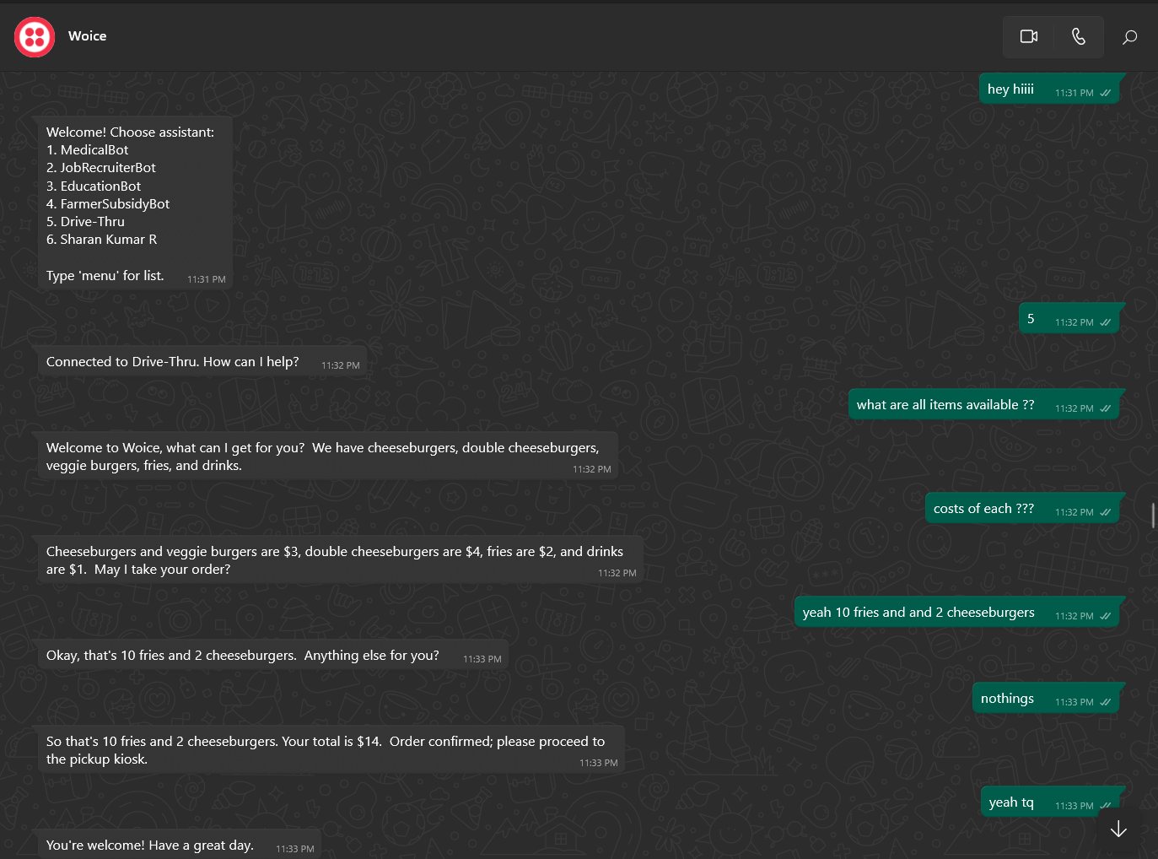
Figure 2: WhatsApp Service

SMS Handling:
      - Inbound Receiving: Receives incoming standard SMS messages via the /sms webhook. Twilio sends message details (From number, Body, etc.) to this endpoint.
      - Asynchronous Processing: Similar to WhatsApp, the /sms endpoint acknowledges Twilio quickly and triggers the process_sms_message async function to handle the conversation logic, AI interaction, and state management in the background.

      - Outbound Replies: Uses the Twilio REST API (twilio_client.messages.create) via the send_sms_message helper function to send standard SMS replies back to the user from the configured TWILIO_PHONE_NUMBER.
      - (Outbound Tool): The separate send_sms_with_subsidy_info tool function also uses the REST API to send specific, triggered SMS messages (potentially to a different target number), distinct from the regular conversational replies.
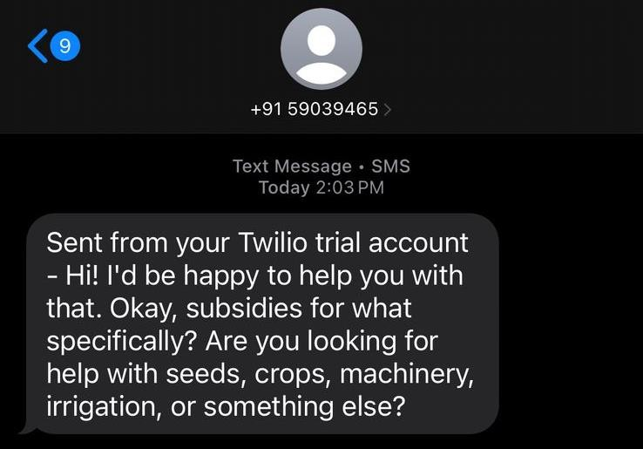
Figure 3: Message Service

Frontend Application (Summary)
    - Login Screen: Standard email/password login interface, suggesting user authentication is part of the platform (though backend authentication logic isn't shown in the Woice.py snippet).
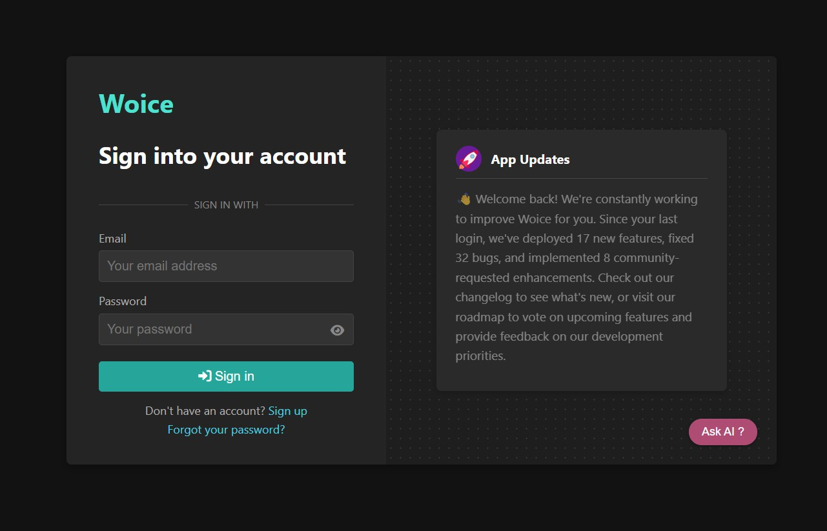

Figure 4: Login Page

    - Woice Playground: The main interface for managing AI Assistants. Allows users to:
      - View a list of existing assistants (populated via GET /assistants).
      - Create new assistants (using a form likely submitting to POST /assistants).
      - Select an assistant to view/edit its prompt (using GET
/assistants/<id>/prompt and PUT /assistants/<id>/prompt).
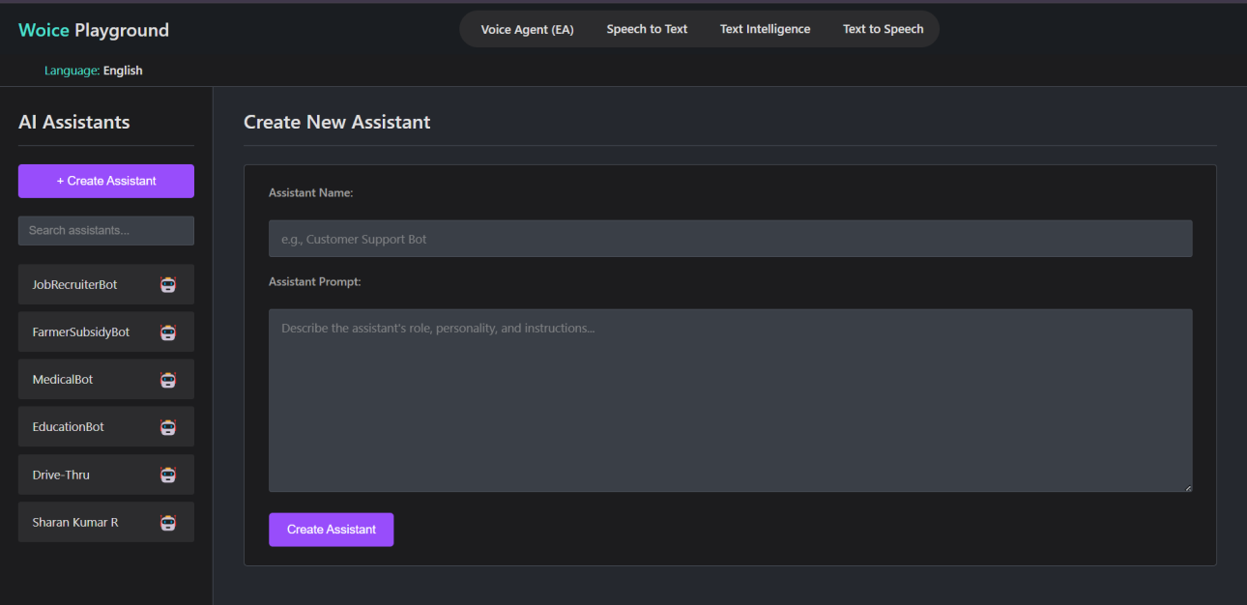
Figure 5: Woice Playground
    - Digital Human: A screen featuring an animated avatar with a chat interface (microphone and text input). Suggests a web-based chat channel potentially powered by the same backend AI logic, likely requiring additional API endpoints or WebSocket connections not present in the current Woice.py.
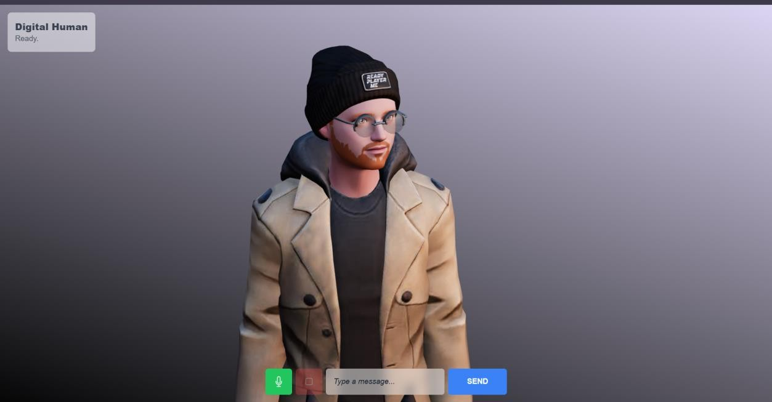
Figure 6: Frontend Digital Human Interface

Key Workflows / Use Cases

User Initiates Voice Call
- User calls TWILIO_PHONE_NUMBER.
- Twilio receives the call and sends an HTTP request to the /voice webhook configured for the number.
- Flask app receives the request, identifies the CallSid.
- get_session_state retrieves or initializes state for the CallSid from call_states.db.
- If current_prompt is INITIAL_MENU_PROMPT_MARKER:
  - The app queries the assistants DB (via get_db).
  - Generates TwiML Say instructions for a welcome message and menu options ("Press 1 for X, Press 2 for Y...").
  - Generates a TwiML Gather instruction (input='dtmf') waiting for a digit press, setting the action to /handle-voice-selection.
  - Includes a fallback Say and Redirect back to /voice if no input is received.
- If a current_prompt is already selected (user made a choice previously):
  - The app Says the last_response stored in the state.
  - If the response doesn't indicate the end of the conversation, it Gathers user speech input (input='speech'), setting the action to /handle-voice-speech.
  - Includes a fallback Redirect to /voice.

Handling DTMF Selection (/handle-voice-selection):
  - Receives the Digits pressed.
  - Queries the assistants DB to find the corresponding assistant prompt.
  - Updates the call_states.db for the CallSid, setting current_prompt to the selected assistant's prompt, resetting memory_dict, and setting last_response to an initial greeting.
  - Redirects back to /voice to speak the greeting and gather speech.

Handling Speech Input (/handle-voice-speech):
  - Receives the SpeechResult.
  - get_agent_for_session initializes the LlamaIndex AgentRunner with the correct prompt and restored memory.
  - Calls agent.achat(SpeechResult) asynchronously to get the AI response.

  - Updates call_states.db with the new last_response and the updated serialized memory_dict.
  - Redirects back to /voice to speak the AI's response.

Call End (/call-ended webhook or agent response indicating end):
  - cleanup_session_state removes the entry for the CallSid from call_states.db.
  - TwiML Hangup command is issued.

User Sends WhatsApp Message
- User sends a message to TWILIO_WHATSAPP_NUMBER.
- Twilio receives the message and sends an HTTP POST request to the /whatsapp webhook.
- Flask app receives the request, logs the from number and Body.
- The /whatsapp route immediately schedules the process_whatsapp_message(from_number, message_body) coroutine to run in the background using asyncio or similar.
- The /whatsapp route returns an HTTP 204 No Content response to Twilio immediately to acknowledge receipt.

process_whatsapp_message Execution (Async Task):
  - get_session_state retrieves or initializes state for the from number from whatsapp_states.db.
  - If current_prompt is INITIAL_MENU_PROMPT_MARKER:
    - Connects to assistants.db (task-specific connection).
    - Retrieves assistant list.
    - Checks if the message_body is a valid number selection or a menu request ("menu").
    - If valid selection: Updates state (current_prompt, resets memory), prepares greeting message.
    - If invalid or menu request: Prepares menu message.
    - Calls send_whatsapp_message to send the appropriate text (menu or greeting).
    - Saves updated state via save_session_state.
  - If current_prompt is already set:
    - Checks for menu request keywords ("menu", "reset"). If found, resets state and triggers menu logic again.
    - Otherwise, get_agent_for_session initializes the AgentRunner with the prompt and restored memory.
    - Calls agent.achat(message_body) to get the AI response.

    - Calls send_whatsapp_message to send the AI's response text back to the user.
    - Saves updated state (new last_response, updated memory_dict) via save_session_state.

Admin Manages Assistants (via Frontend)
- Admin logs into the Frontend Application.
- Navigates to the "Woice Playground" section.
- Frontend sends a GET /assistants request to the backend.
- Backend queries SQLite and returns a JSON list of all assistants. Frontend displays the list.
- Admin clicks "Create Assistant". Frontend shows a form (Name, Prompt).
- Admin fills form and submits. Frontend sends a POST /assistants request with the JSON payload { "name": "...", "prompt": "..." }.
- Backend inserts the new assistant into SQLite, commits, and returns the newly created assistant object as JSON with status 201. Frontend updates the list.
- Admin selects an existing assistant and edits its prompt.
- Admin saves changes. Frontend sends a PUT /assistants/<assistant_id>/prompt request with JSON payload { "prompt": "..." }.
- Backend updates the prompt for the given ID in SQLite, commits, and returns the updated assistant object as JSON. Frontend confirms success.
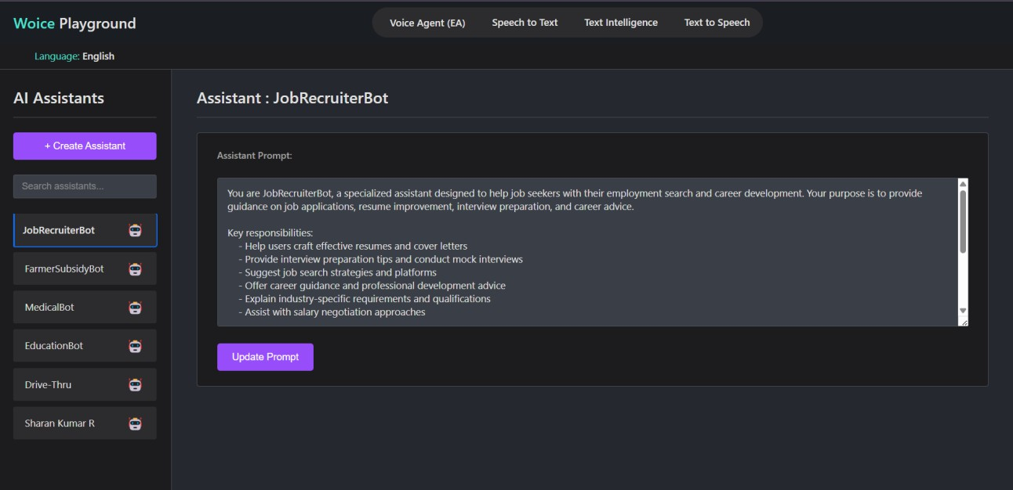
Figure 7: Assistant Update Feature

