Informal Peer Discussion
Name: Sharan Ravula
Subsection: Rotational Base
Section number: 3
Team Number: 1

Coming into the discussion:

Place below an image of your subsection going into the discussion. If your subsection is software based, a screenshot showing what you feel to be a representation of how much is done. For example if you have the vision system, an image showing found areas or an output showing measured dimensions.

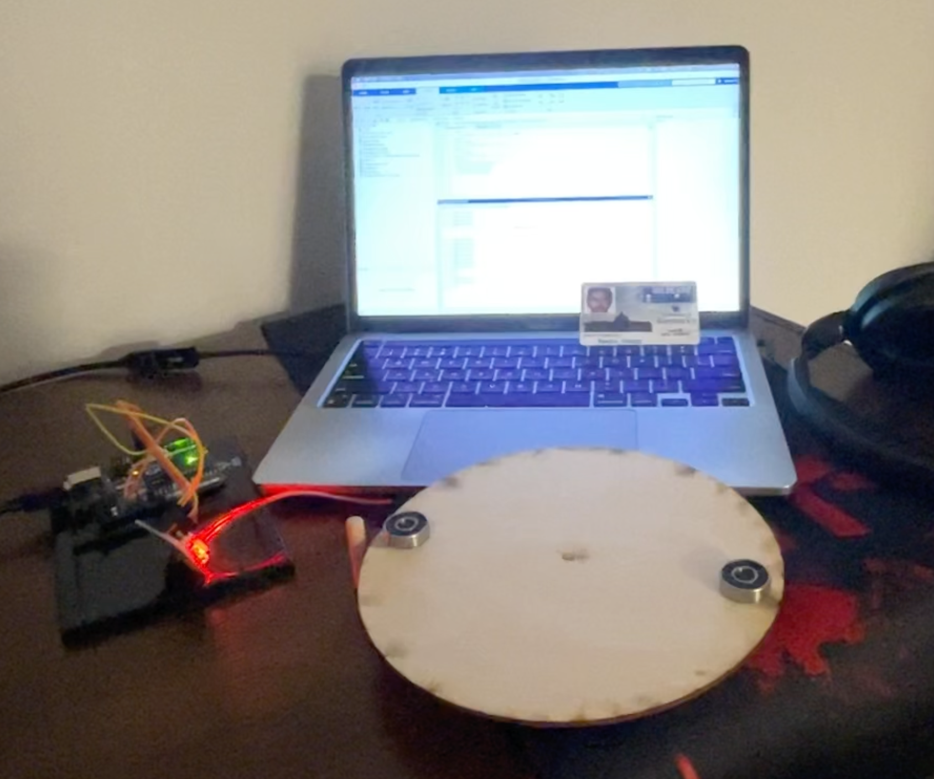

Give a few-sentence description of where you were at in your design, specifically with respect to meeting the demonstration requirements for your subsystem:

In the design process, I have made significant progress in understanding the key constraints and factors related to the rotational base subsystem. Through calculations and analysis, I now have a clear understanding of the role of radius, friction, and torque in the design. This knowledge will be instrumental in shaping the design to meet the demonstration requirements, ensuring that the rotational base can operate smoothly and reliably. The next steps will involve translating this understanding into a detailed design, considering materials, motor selection, and operational efficiency to create a functional prototype.

The discussion itself:

Describe how your design compares to others in the discussion.
- Are you ahead or behind your peers in getting to a working subsection?
- Are other people having similar problems to the ones you are encountering?

In addition to the challenges related to friction, torque, and material selection, it's worth noting that weight-related issues have also emerged as a common concern in our discussion. Weight considerations encompass selecting appropriate materials to support loads, ensuring the structural integrity of components, and addressing weight distribution. These challenges underscore the complexity of designing and optimizing mechanical systems. While my design approach differs from some peers who use gear-based mechanisms, it's evident that collectively, we are all navigating these fundamental principles and shared challenges. This collaborative setting provides an opportunity for us to share insights and work together to find effective solutions to these multifaceted design issues.

Identify at least 2 ideas that you got from this discussion that you might implement on your device OR
Identify at least 2 ideas that you gave others to address problems that they were having:

Here are two ideas that I got from this discussion that I might implement in my device design:
- Use of Low-Friction Materials: From the discussion, I learned about the significance of friction in the rotational base design. To address this, I might explore the use of low-friction materials for the base and the surface it interacts with. Additionally, surface treatments or coatings that further reduce friction can be considered. This could enhance the overall efficiency and smoothness of the rotation.
- Consideration of Load Distribution: Weight-related challenges have been highlighted in the discussion. To address this, I will pay careful attention to load distribution within my device. This includes selecting materials that can bear the load effectively and ensuring that the design distributes the weight evenly across key components. This will contribute to the stability and longevity of the device.
These ideas from the discussion will help optimize the performance and reliability of my rotational base design.

Take away:

What are specific steps that you can take to use what you have learned to improve or fix your design?

To improve my design, I'll:
- Select low-friction materials.
- Ensure even load distribution.
- Choose an appropriate motor/mechanism.
- Build and test a prototype.
- Iterate based on test results.
- Document the design process.
- Collaborate with peers for insights.

