CO3-AT2
1.DURING AC SWEEP ANALYSIS OF THE GIVEN COMMON EMITTER AMPLIFIER, THE LOWER CUTOFF FREQUENCY IS MEASURED AS 320Hz, WHERE AS THE EXPECTED VALUE IS 150 Hz. ANALYSE THE CIRCUIT AND IDENTIFY WHICH CAPACITOR IS MOST LIKELY RESPONSIBLE FOR THE INCREASE IN LOWER CUTOFF FREQUENCY.
ANSWER:

CIRCUIT:

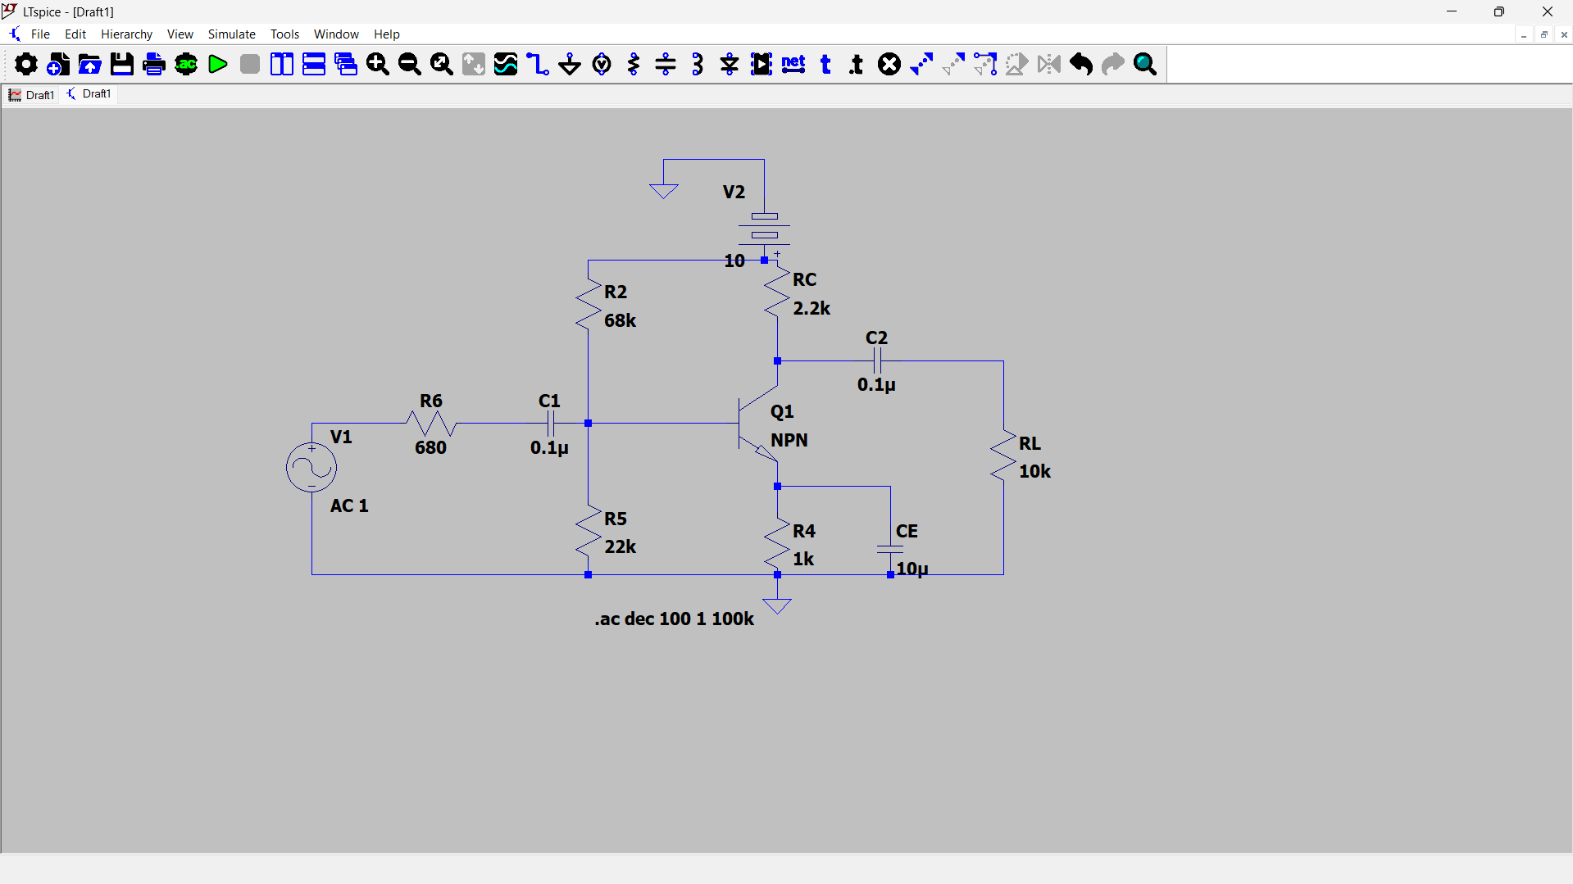
OUTPUT: