 

## A Minor Project Report on

**TEMPERATURE CONTROLLED FAN**

## Submitted by

**POORVASANDHYA P (927622BEE081)**

## SHARANYA P (927622BEE105)

## SRINITHI K (927622BEE115)

## PRAVEEN M (927622BEE307)



**DEPARTMENT OF ELECTRICAL AND ELECTRONICS ENGINEERING M.KUMARASAMY COLLEGE OF ENGINEERING**

(An Autonomous Institution Affiliated to Anna University, Chennai) THALAVAPALAYAM, KARUR-639113.

## NOVEMBER 2024

M.KUMARASAMY COLLEGE Of ENGINEERING

(Autonomous Institution, Affiliated to Anna University, Chennai)

# BONAFIDE CERTIFICATE

Certified that this Report titled **“Temperature Controlled Fan”** is the bonafide workof **POORVASANDHYA P (927622BEE081), SHARANYA P (927622BEE105), SRINITHI K (927622BEE115), PRAVEEN M (927622BEE307)** who carried out the work during the academic year (2024-2025) under my supervision. Certified further that to the best of my knowledge the work reported herein does not form part of any other project report.

**SIGNATURE SIGNATURE**

**SUPERVISOR HEAD OF THE DEPARTMENT**

Mr.S.DineshKumar M.E., Dr.J.Uma M.E., Ph.D.,

Assistant Professor, Professor & Head,

Department of Electrical and Electronics Engineering,

M.Kumarasamy College of

Engineering, Karur.

Department of Electrical and Electronics Engineering,

M.Kumarasamy College of

Engineering, Karur.

Submitted for Minor Project III (18EEP301L) viva-voce Examination held at M Kumarasamy College of Engineering, Karur-639113 on ………………...

## DECLARATION

We affirm that the Minor Project III report titled “**TEMPERATURE CONTROLLED FAN”** being submitted in partial fulfillment for the award of **Bachelor of Engineering in Electrical and Electronics Engineering** is the original work carried out by us.

|  |  |  |
| --- | --- | --- |
| **REG.NO** | **STUDENT NAME** | **SIGNATURE** |
| **927622BEE081** | **POORVASANDHYA P** | **-----------------------** |
| **927622BEE105** | **SHARANYA P** | **-----------------------** |
| **927622BEE115** | **SRINITHI K** | **-----------------------** |
| **927622BEE307** | **PRAVEEN M** | ----------------------- |

|  |
| --- |
|  |

### 

### VISION AND MISSION OF THE INSTITUTION

**VISION**

* To emerge as a leader among the top institutions in the field of technical education

### MISSION

* Produce smart technocrats with empirical knowledge who can surmount the global Challenges.
* Create a diverse, fully engaged, learner - centric campus environment to provide Quality education to the students.
* Maintain mutually beneficial partnerships with our alumni, industry and Professional associations.

### DEPARTMENT OF ELECTRICAL AND ELECTRONICS ENGINEERING VISION

To produce smart and dynamic professionals with profound theoretical and practical knowledge comparable with the best in the field.

### MISSION

* Produce hi-tech professionals in the field of Electrical and Electronics Engineering by inculcating core knowledge.
* Produce highly competent professionals with thrust on research.
* Provide personalized training to the students for enriching their skills.

### PROGRAMME EDUCATIONAL OBJECTIVES(PEOs)

* **PEO1:** Graduates will have flourishing career in the core areas of Electrical Engineering and allied disciplines.
* **PEO2:** Graduates will pursue higher studies and succeed in academic/research careers.
* **PEO3:** Graduates will be a successful entrepreneur in creating jobs related to Electrical and Electronics Engineering /allied disciplines.
* **PEO4:** Graduates will practice ethics and have habit of continuous learning for their success in the chosen career.

**PROGRAMME OUTCOMES(POs)**

After the successful completion of the B.E. Electrical and Electronics Engineering degree program, the students will be able to:

**PO1: Engineering Knowledge:** Apply the knowledge of mathematics, science, engineering fundamentals, and an engineering specialization to the solution of complex engineering problems.

**PO2: Problem Analysis:** Identify, formulate, review research literature, and analyze complex engineering problems reaching substantiated conclusions using first principles of mathematics, natural sciences, and engineering sciences.

**PO3: Design/Development of solutions:**

Design solutions for Complex engineering problems and design system components or processes that meet the specified needs with appropriate consideration for the public health and safety, and the cultural, societal, and environmental considerations.

**PO4: Conduct Investigations of complex problems:** Use research-based knowledge and research methods including design of experiments, analysis and interpretation of data, and synthesis of the information to provide valid conclusions.

**PO5: Modern Tool Usage:** Create, select, and apply appropriate techniques, resources, and modern engineering and IT tools including prediction and modeling to complex engineering activities with an understanding of the limitations.

**PO6: The Engineer and Society:** Apply reasoning in formed by the contextual knowledge to assess societal, health, safety, legal and cultural issues and the consequent responsibilities relevant to professional engineering practice.

**PO7: Environment and Sustainability:** Understand the impact of the professional engineering solutions in societal and environmental contexts, and demonstrate the knowledge of, and need for sustainable development.

**PO8: Ethics:** Apply ethical principles and commit to professional ethics and responsibilities and norms of the engineering practice.

**PO9: Individual and Teamwork:** Function effectively as an individual, and as a member or leader in diverse teams, and in multi-disciplinary settings.

**PO10: Communication:** Communicate effectively on complex engineering activities with the engineering community and with society at large, such as, being able to comprehend and write effective reports and design documentation, make effective presentations, and give and receive clear instructions.

**PO11: Project Management and Finance:** Demonstrate knowledge and understanding of the engineering and management principles and apply these to one’s own work, as a member and leader in a team, to manage projects and in multi-disciplinary environments.

**PO12: Life-long learning:** Recognize the need for and have the preparation and ability to engage in independent and life-long learning in the broadest context of technological change.

### PROGRAM SPECIFIC OUTCOMES(PSOs)

The following are the Program Specific Outcomes of Engineering Students:

* **PSO1:** Apply the basic concepts of mathematics and science to analyses and design circuits, controls, Electrical machines and drives to solve complex problems.
* **PSO2:** Apply relevant models, resources and emerging tools and techniques to provide solutions to power and energy related issues & challenges.
* **PSO3:** Design, Develop and implement methods and concepts to facilitate solutions for electrical and electronics engineering related real-world problems.

|  |  |
| --- | --- |
| **Abstract (Key Words)** | **Mapping of POs and PSOs** |
| Arduino, PWM, Temperature sensor, 2N2222 Transistor | PO1, PO2, PO3, PO4, PO5, PO6, PO7, PO8, PO9, PO11, PO12, PSO1, PSO2, PSO3. |

## [ACKNOWLEDGEMENT](https://www.google.com/search?rlz=1C1CHBD_enIN820IN820&q=ACKNOWLEDGEMENT&spell=1&sa=X&ved=0ahUKEwj99az1_ZXhAhVN63MBHRVODE4QkeECCCkoAA&cshid=1553265789884876)

Our sincere thanks to **Thiru.M.Kumarasamy Founder, and Dr.K.Ramakrishnan B.E., Chairman** of **M.Kumarasamy College of Engineering** for providing extra ordinary infrastructure, which helped us to complete the Minor project in time.

It is a great privilege for us to express our gratitude to our esteemed **Principal Dr.B.S.Murugan., M.Tech., Ph.D.,** for providing us right ambiance for carrying out the project work.

We would like to thank our **Head of the Department Dr.J.Uma.,M.E., Ph.D., Department of Electrical and Electronics Engineering,** for her unwavering moral support throughout the evolution of the project.

We would like to express my deep gratitude to our Minor Project Guide **Mr.S.DineshKumar**.,**M.E., Assistant Professor, Department of Electrical and Electronics Engineering,** for his constant encouragement, kind co-operation, valuable suggestions and support rendered in making our project a success.

We offer our wholehearted thanks to our Minor project coordinator **Mrs.R. Indhumathi M.E**.**,**  **Assistant Professor, Department of Electrical and Electronics Engineering,** for her constant encouragement, kind co-operation and valuable suggestions for making our project a success.

We are glad to thank all the **Faculty Members** of **Department of Electrical and Electronics Engineering** for extending a warm helping hand and valuable suggestions throughout the project.

Words are boundless to thank **Our Parents and Friends** for their constant encouragement to complete this Minor project successfully.

|  |  |  |
| --- | --- | --- |
| CHAPTER NO | CONTENTS | PAGE NO |
| 1 | **ABSTRACT** |  |
| 2 | **LITERATURE REVIEW**  2.1Basics of Temperature-Controlled Fan systems  2.2.Applicationin Electronics Cooling  2.3.HVAC and Building Automation  2.4.Automotive Industry and EVs  2.5 Energy Efficiency and Sustainability | 1 |
| 3 | **PROPOSED METHODOLOGY**  3.1 Block Diagram  3.2 Circuit Diagram  3.3 Description  3.4 Cost Estimation | 2  3  7  8 |
| 4  5 | **FUTURE SCOPES**  **CONCLUSION** | 9  10 |
| 6 | **REFERENCES** | 11 |
|  |  |  |

|  |  |  |
| --- | --- | --- |
| **FIGURE NO** | **TITLE** | **PAGE NO** |
| 2.1 | Block diagram of Temperature Controlled Fan | 2 |
| 2.2 | Circuit Diagram of Temperature Controlled Fan | 3 |
| 2.3 | Arduino Uno | 3 |
| 2.4 | DTH11 Temperature Sensor | 4 |
| 2.5 | 5 Volt DC Controlled  Fan | 4 |
| 2.6 | 2N222 Transistor | 5 |
| 2.7 | Bread Board | 5 |
| 2.8 | LCD Display 16x2 | 6 |

**LIST OF FIGURES**

**LIST OF TABLE**

|  |  |  |
| --- | --- | --- |
| **TABLE NO** | **TITLE** | **PAGE NO** |
| **2.1** | Cost estimation | 8 |

**LIST OF ABBREVIATION**

|  |  |  |  |
| --- | --- | --- | --- |
| **S.NO** | **ABBREVIATION** |  | **EXPANSION** |
| **1** | BJT |  | Bipolar Junction Transistor |
| **2** | LCD |  | Liquid Crystal Display |
| **3** | ADC |  | Analog to Digital |
| **4** | PID |  | Proportional-Integral-Derivative |
| **5** | PWM |  | Pulse Width Modulation |
| **6** | LED |  | Light Emitting Diode |

**ABSTRACT**

The goal of this project is to design and implement an temperature controlled fan system provides efficient automated cooling, integrating advanced temperature sensors and intelligent control algorithms to adjust fan speed in real-time and maintain optimal temperatures. Key features include precise temperature monitoring, automated speed control, user customization and energy efficiency. Suitable for personal, industrial, electronic device and automotive applications, this innovative system enhances comfort, productivity and durability while minimizing energy consumption. Benefits include consistent temperature maintenance, reduced power usage, extended lifespan and versatile design. By optimizing fan operation and thermal comfort, this temperature-controlled fan system offers an ideal solution for managing temperature and energy usage. This innovative temperature-controlled fan system provides efficient and automated cooling solutions. Integrating advanced temperature sensors and intelligent control algorithms, the fan adjusts its speed in real-time to maintain a user-defined optimal temperature range.

**CHAPTER 1**

**LITERATURE REVIEW**

**PAPER 1.1:Basics of Temperature-Controlled Fan Systems**

Temperature-controlled fans use sensors to adjust speed based on temperature, aiming to maintain safe operating ranges efficiently. Control methods range from basic on/off mechanisms to advanced PID controllers, PWM, and AI models, allowing for precise, responsive adjustments without overusing the fan. This enhances stability, energy efficiency, and equipment lifespan.

**PAPER 1.2:Applications in Electronics Cooling**

Temperature-controlled fans prevent overheating in electronics, protecting components like CPUs and GPUs. In data centers, they enhance energy efficiency by dynamically adjusting speeds based on workload and temperature.

**PAPER 1.3:HVAC and Building Automation**

In HVAC systems, temperature-controlled fans adjust for comfort and efficiency. Smart building technology uses IoT sensors and machine learning to adapt fan speeds based on occupancy and climate, optimizing energy use.

**PAPER 1.4:** **Automotive Industry and EVs**

In automotive and electric vehicles, temperature-controlled fans manage battery and motor temperatures to enhance safety and efficiency. Hybrid cooling systems that combine fans with liquid cooling, along with optimization techniques like fuzzy logic controllers, improve responsiveness to temperature fluctuations.

**PAPER1.5:Energy Efficiency and Sustainability**

Temperature-controlled fans enhance energy efficiency by reducing power consumption at lower speeds. They also prevent overheating in renewable energy systems, such as wind turbines and solar panels, increasing system longevity and reducing maintenance costs**.**

**CHAPTER 2**

**PROPOSED METHODOLOGY**

**2.1 BLOCK DIAGRAM**

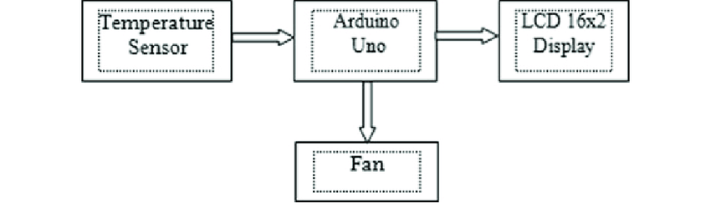

**Fig2.1** **Block diagram of Temperature Controlled Fan**

**Explanation:**

This block diagram illustrates a simple temperature control system using anArduino Uno board .The temperature sensor continuously measures the temperature and sends the data to the Arduino Uno.The Arduino processes the received data and compares it with a predefined setpoint (desired temperature).

If the temperature is higher than the setpoint, the Arduino activates the fan to cool down the environment.If the temperature is lower than the setpoint, the Arduino turns off the fan.The Arduino sends the measured temperature and other relevant information to the LCD display for user monitoring.

**2.2Circuit Diagram**

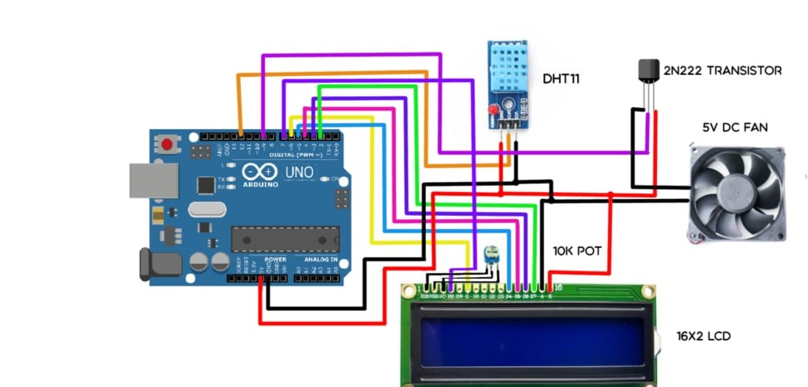

**Fig2.2 Circuit Diagram of Temperature Controlled Fan**

**2.3 Arduino Uno**

Arduino uno board has 6 ADC input ports. Among those any one or all of them can be used as inputs for Analog voltage. The **Arduino Uno ADC** is of 10-bit resolution (so the integer values from (0-(2^10) 1023)). This means that it will map input voltages between 0 and 5 volts into integer values between 0 and 1023. So, for every (5/1024= 4.9mV) per unit. The UNO ADC channels have a default reference value of 5V. This means we can give a maximum input voltage of 5V for ADC conversion at any input channel. Since some sensors provide voltages from 0-2.5V, with a 5V reference we get lesser accuracy, so we have a instruction that enables us to change this reference value.

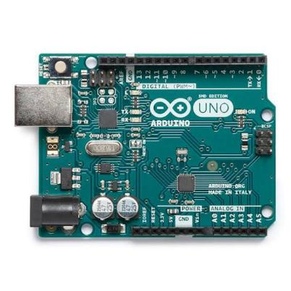

**Fig2.3 Arduino Uno**

**2.4 DTH11 Temperature Sensor**

The DHT11 is a digital temperature and humidity sensor that measures temperature in the range of 0 to 50 °C with an accuracy of ±2 °C and humidity from 20% to 80% RH with an accuracy of ±5%. It provides output through a single-wire digital interface and is commonly used in various electronics applications, including weather stations and home automation systems.**.**

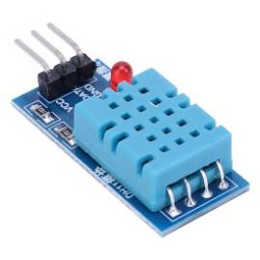

**Fig2.4**

**DTH11 Temperature Sensor**

**2.5 5 VOLT DC CONTROLLED FAN**

A **5 Volt DC fan** is an electric fan that operates on a 5-volt direct current (DC) power supply. It is commonly used for cooling and ventilation in small electronic devices, computer systems, and battery-powered applications, known for its compact size .

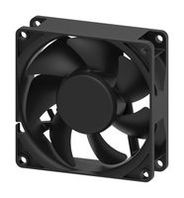

**Fig2.5 .** **5 VOLT DC CONTROLLED FAN**

**2.6 2N222 Transistor**

The 2N222 is a type of NPN bipolar junction transistor (BJT) that is commonly

used in electronic circuits for general-purpose switching and amplification. It is characterized by its ability to handle collector currents up to 800 mA and collector-emitter voltages up to 40 V. This transistor is widely employed in various applications, including audio and radio frequency amplification, as well as in digital circuits. Max Collector Current Can handle up to 800 mA, allowing it to drive loads like small motors or LEDs. Max Collector-Emitter Voltage (VCE) Rated for 40 V, making it suitable for low to moderate voltage applications. Common applications include switching circuits for devices like motors and lights, signal amplification in audio and RF systems, and use in basic digital logic circuits.

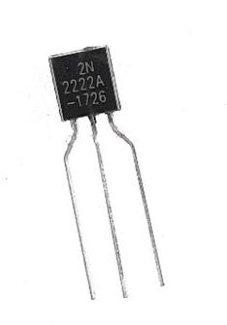

**Fig2.6 2N222 Transistor**

**2.7 Bread Board**

A breadboard is a rectangular board used for prototyping and testing electronic circuits, allowing for easy connection and disconnection of components without soldering. It consists of a grid of rows and columns, with holes that accept wire and component leads, and is typically made of plastic or fiberglass. The breadboard's rows are often connected horizontally, while the columns are connected vertically, making it simple to build and modify circuits. Jumper wires and components can be inserted and rearranged as needed, allowing for quick experimentation and troubleshooting.

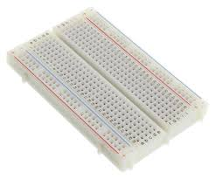

**Fig2.7 Bread Board**

**2.8 LCD Display 16x2**

A **16x2 LCD display** is a type of liquid crystal display that consists of 16 columns and 2 rows, allowing it to display up to 32 characters at a time. It is commonly used in electronic devices and projects to provide a visual interface for text-based information. The display typically operates with a microcontroller and can show alphanumeric characters, making it ideal for simple user interfaces, data visualization, and status updates.

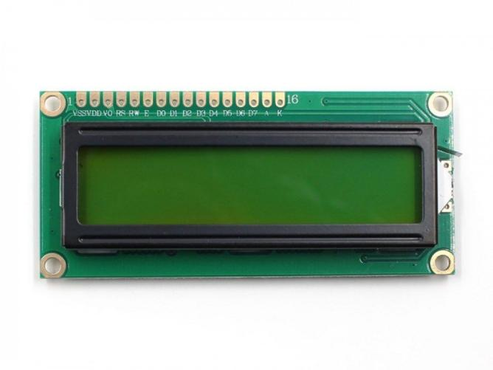

**Fig2.8 LCD Display 16x2**

**2.3 Description**

This innovative temperature-controlled fan seamlessly blends functionality and comfort, providing optimal cooling or heating depending on the room's temperature. With its sleek design and advanced thermostat, it automatically adjusts airflow to maintain a preset temperature range. When the room temperature rises, the fan accelerates for enhanced cooling. Conversely, when temperatures drop, the fan slows or reverses for gentle warmth circulation. Its whisper-quiet operation and energy-efficient design make it perfect for bedrooms, offices or living spaces. The fan's smart temperature control ensures consistent comfort, reducing the need for manual adjustments. Featuring adjustable thermostat settings, remote control and LED display, this fan offers customizable convenience for personalized climate control. The concept of "less is more" emphasizes simplicity, quality and intention over quantity. This philosophy promotes eliminating unnecessary elements to focus on what truly adds value.

In design, "less is more" means clean lines, minimal ornamentation and functional simplicity. It encourages creativity within constraints. In life, it inspires clarity, reducing clutter to reveal what's truly important. A temperature-controlled fan is an innovative cooling solution designed to enhance comfort and energy efficiency. Equipped with advanced sensors, this fan automatically adjusts its speed and airflow based on the surrounding temperature. When the room heats up, the fan speeds up to provide a refreshing breeze, while it slows down or turns off as the temperature drops, helping to maintain a pleasant environment. This feature not only optimizes energy usage, reducing electricity bills, but also promotes a more consistent and comfortable indoor climate. With sleek designs and whisper-quiet operation, temperature-controlled fans are perfect for any home or office setting, making them an essential addition to modern living.

**2.4 COST ESTIMATION**

**Table 2.1 COST ESTIMATION**

|  |  |  |  |
| --- | --- | --- | --- |
| **S.NO** | **COMPONENT** | **QUANTITY** | **COST** |
| 01 | DHT11Temperature sensor | 1 | 65 |
| 02 | Arduino uno | 1 | 150 |
| 03 | Bread board | 1 | 54 |
| 04 | Transistor 2N2222 | 1 | 20 |
| 05 | LCD display | 1 | 155 |
| 06 | Transformer | 1 | 200 |
|  |  | **Total** | 2000 |

**CHAPTER 3**

**Future Scope**

The future of temperature-controlled fans is poised for significant evolution, aligning with broader trends in smart home technology, energy efficiency, and sustainability. As homeowners increasingly seek integrated solutions, these fans will likely become key components of smart home ecosystems, allowing seamless control through apps, voice commands, and automation. Enhanced energy-efficient designs will not only lower electricity bills but also contribute to environmental conservation by optimizing airflow based on real-time data from occupancy and temperature sensors.

Moreover, advancements in sensor technology will provide more precise measurements of temperature and humidity, enabling fans to respond dynamically to changing conditions. This responsiveness could be further enhanced through IoT connectivity, allowing fans to interact with other smart devices to create tailored climate control systems throughout a home. Future designs may also incorporate health-oriented features, such as air quality monitoring and filtration capabilities, to improve indoor air quality and address concerns about allergens and pollutants.

Sustainability will continue to be a focal point, with manufacturers exploring eco-friendly materials and production methods, as well as the potential for fans to operate on renewable energy sources like solar power. Additionally, as design aesthetics evolve, fans will likely blend functionality with modern aesthetics, appealing to consumers who value both style and performance. As global temperatures rise and climate patterns shift, the demand for efficient cooling solutions will only increase, making temperature-controlled fans a vital part of the future home landscape. Overall, the convergence of technology, health, and sustainability positions temperature-controlled fans as an essential tool for enhancing comfort and well-being in everyday life.

**CONCLUSION**

A temperature-controlled fan offers a remarkable blend of comfort, convenience, and energy efficiency, making it an essential addition to any modern living space. By intelligently adjusting its speed based on ambient temperature, this innovative device not only ensures a consistently pleasant environment but , also significantly reduces energy consumption, which translates into lower utility bills. Its sleek design and quiet operation further enhance its appeal, seamlessly fitting into various home and office settings. Whether it’s during the sweltering heat of summer or the mild temperatures of spring and fall, a temperature-controlled fan provides personalized cooling tailored to individual needs. By investing in this advanced technology, users can enjoy enhanced comfort while contributing to sustainable living practices. Overall, the temperature-controlled fan stands out as a smart, effective solution for achieving optimal indoor climates year-round.

**CHAPTER 4**

**REFERENCES**

1. *Dr. A. K. Gupta* - Focuses on energy-efficient building designs and HVAC systems.

2. *Prof. John W. Mitchell* - Known for his research on smart home technologies and energy management systems.

3. *Dr. M. S. P. Reddy* - Studies indoor air quality and ventilation systems, including the role of fans in enhancing comfort.

4. *Dr. Alok Sharma* - Works on sustainable design and energy-efficient appliances, including innovative fan technologies.

5. *Dr. Rajendra P. Singh* - Researches IoT applications in household systems, which includes smart temperature-controlled devices.

6.Refer the video link:

https://myclassbook.org/temperature-controlled-dc-fan-using-thermistor/