**NAME: V. NAGASAKETH**

**REGNO: 20MIS0140**

**CAMPUS: VELLORE**

# -------------------------------------------------------------------

**Assignment - 2**

# Question:

1. Create, update, delete commands in mysql
2. Create tables, and perform joins in mysql
3. Create, update, delete commands in mongo

**MYSQL COMMANDS:**

**1.Create, Update, Delete commands in MYSQL.**

CREATE DATABASE example1;

use example1;

CREATE TABLE `courses` (

`CourseID` int NOT NULL AUTO_INCREMENT,

`Name` varchar(45) NOT NULL,

`Price` int NOT NULL,

`Duration` varchar(45) NOT NULL,

`Mode` varchar(45) NOT NULL DEFAULT 'Offline',

PRIMARY KEY (`CourseID`)

**INSERTION:**

INSERT INTO courses values(1001,"PYTHON",5000,"45DAYS","Offline");

INSERT INTO courses(name,price,duration) values("JavaScript",4000,"45DAYS");

INSERT INTO courses(name,price,duration) values("Web Development",7000,"45DAYS");

INSERT INTO courses(name,price,duration) values("JAVA",4500,"45DAYS");

INSERT INTO courses(name,price,duration) values("C-LAN",3500,"45DAYS");

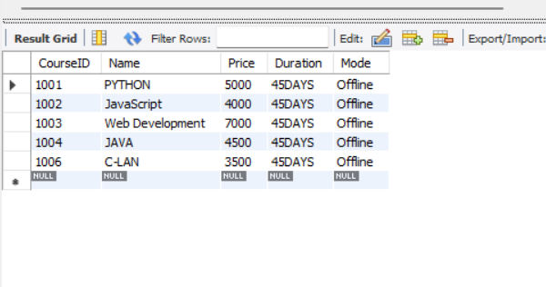

**UPDATE QUERY:**

update courses set mode = "Online" where CourseID = 1004;

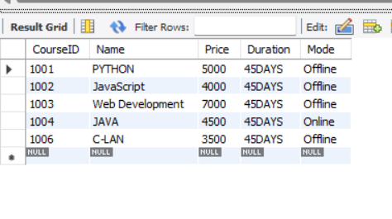

**DELETE QUERY:**

delete from courses where COURSEID = “1006”

## 2.Create tables, and perform join operations in MySQL

create database mydb; use mydb;

create table customers(id int primary key, cust_name varchar(45) not null, occupation varchar(45) not null,

income int not null,

qualification varchar(45) not null

);

insert into customers

(id, cust_name, occupation, income, qualification) values (1, 'Sudharshan', 'Developer', 20000, 'Btech'),

(2, 'Kusuma', 'Engineer', 40000, 'Btech'),

(3, 'Mukesh', 'Scientists', 60000, 'MSc'),

(4, 'Navya', 'Businessman', 100000, 'MBA'),

(5, 'Chandu', 'Manager', 50000, 'MBA');

create table orders(order_id int primary key, date date not null,

customer_id int not null, price int not null

);

insert into orders

(order_id, date, customer_id, price) values (1001, '2020-03-20', 2, 300),

(1002, '2020-02-15',4, 2500),

(1003, '2020-01-31', 5, 5000),

(1004, '2020-09-23', 2, 1500),

(1005, '2020-09-30', 1, 4500);

select customers.id, customers.cust_name, customers.income, orders.price

from customers

inner join orders

on customers.id = orders.customer_id;

select customers.id, customers.cust_name, customers.income, orders.price

from customers left join orders

on customers.id = orders.customer_id;

select customers.id, customers.cust_name, customers.income, orders.price

from customers right join orders

on customers.id = orders.customer_id;

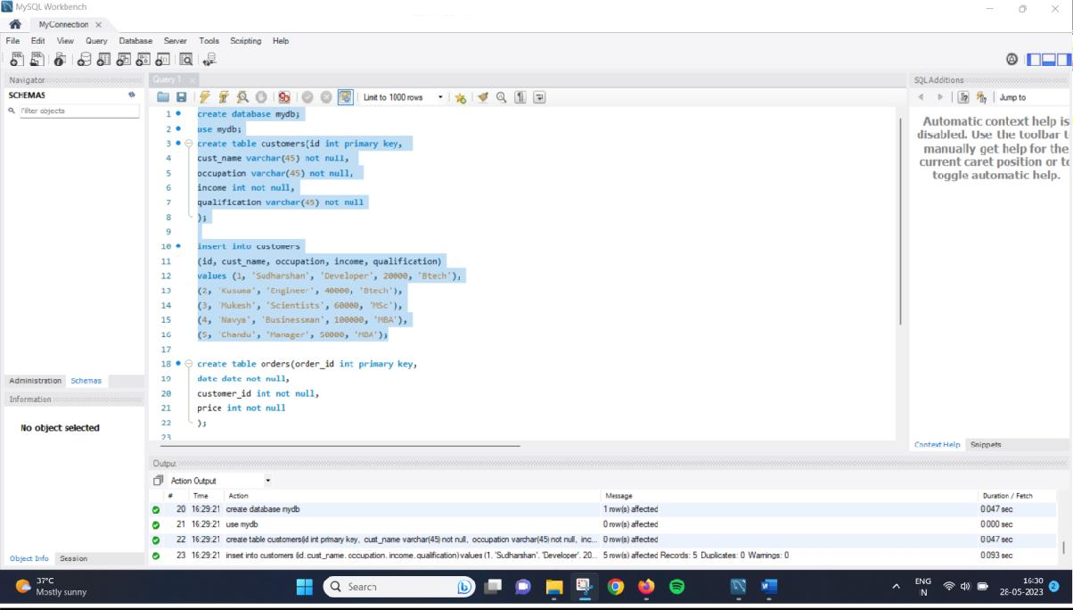

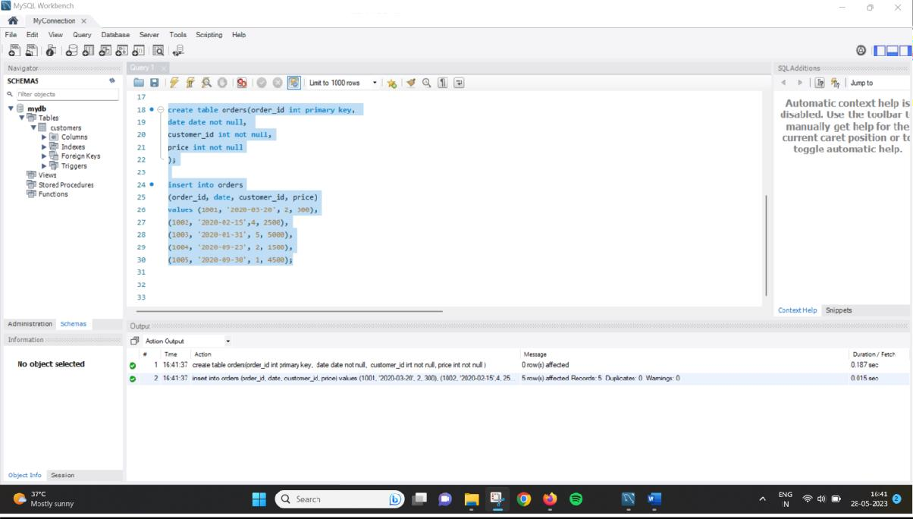

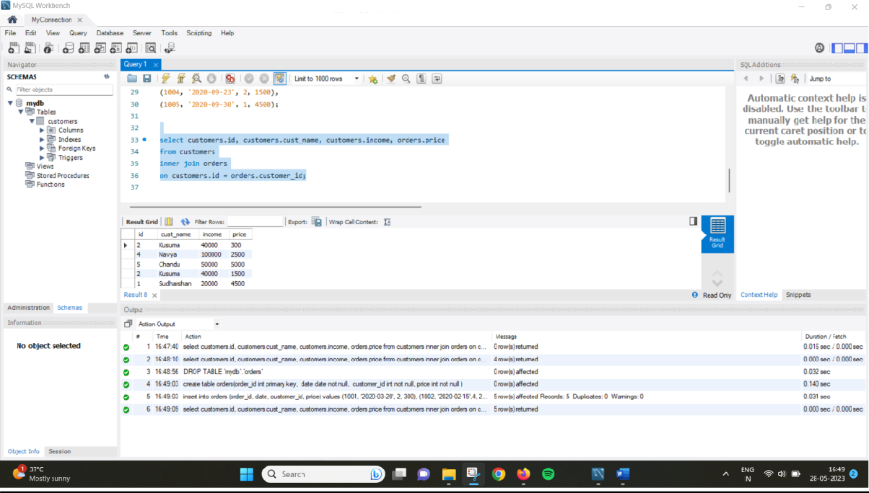

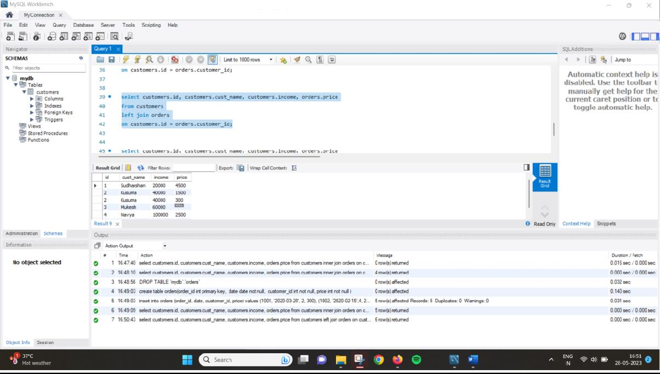

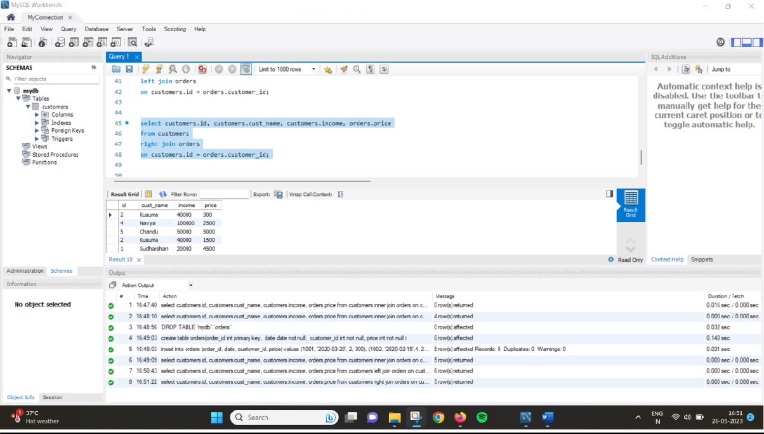

## 3.Create, update, delete commands in MongoDB. Create:

**Update:**

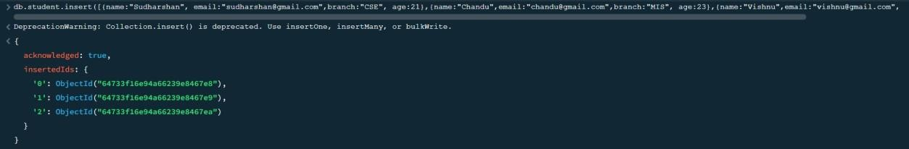

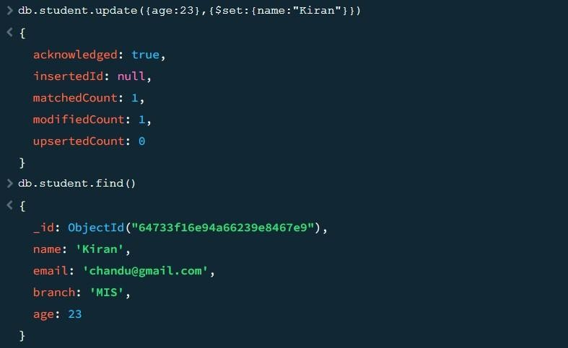

## Delete:

