1.Write a program to store your age, height, and name in appropriate variables and print them in a proper format.
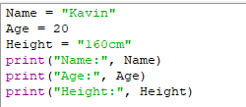
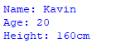
3.Write a program to declare variables of different datatypes (integer, float, character, and double) and display their values.
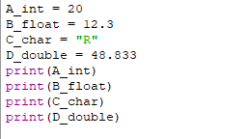
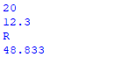
5.Write a program that uses variables, datatypes, operators, and expressions to calculate the area and perimeter of a rectangle.
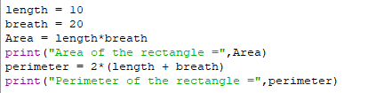
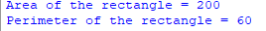
6.Write a program to perform addition, subtraction, multiplication, division, and modulus operations on two numbers.
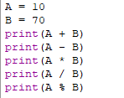
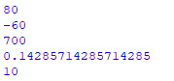
7.Write a program to compare two numbers using relational operators and logical operators, and display the results.
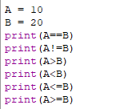
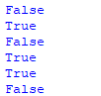
8.Write a program to swap two numbers without using a third variable, using arithmetic operators.
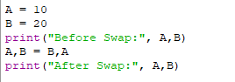
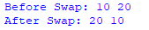
9.Write a program to check whether a given number is positive, negative, or zero using relational operators.
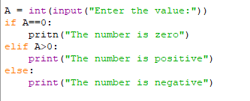
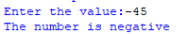

10.Write a program to check whether a given number is even or odd using arithmetic and relational operators.
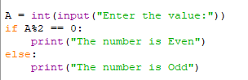
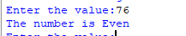
11.Write a program to find the largest of three numbers using relational and logical operators.
