PowerPoint Presentation Content

# Slide 1: Title Slide

Title: Model Performance Analysis

Subtitle: A comparison of SVR, Random Forest, and XGBoost

Presented by: [Your Name]

Date: [Presentation Date]

# Slide 2: Agenda

1. Overview of models

2. Methodology

3. Error Metrics Comparison

4. Model Fit Metrics Comparison

5. Visualizations

6. Overall Analysis

7. Conclusion

8. Q&A

# Slide 3: Overview of Models

Brief descriptions of Support Vector Regression, Random Forest, and XGBoost models.

# Slide 4: Methodology

Explanation of the dataset and the process used for training the models.

# Slide 5: Error Metrics Comparison

Discuss the importance of MSE, RMSE, and MAE for model performance.

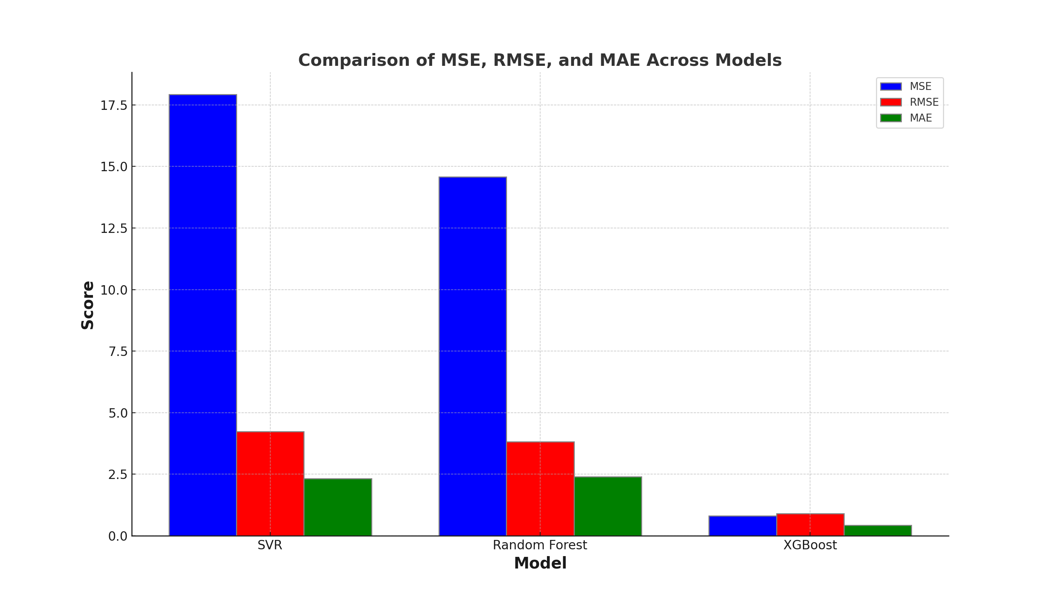

# Slide 6: Model Fit Metrics Comparison

Explain R-squared, Adjusted R-squared, and other fit metrics.

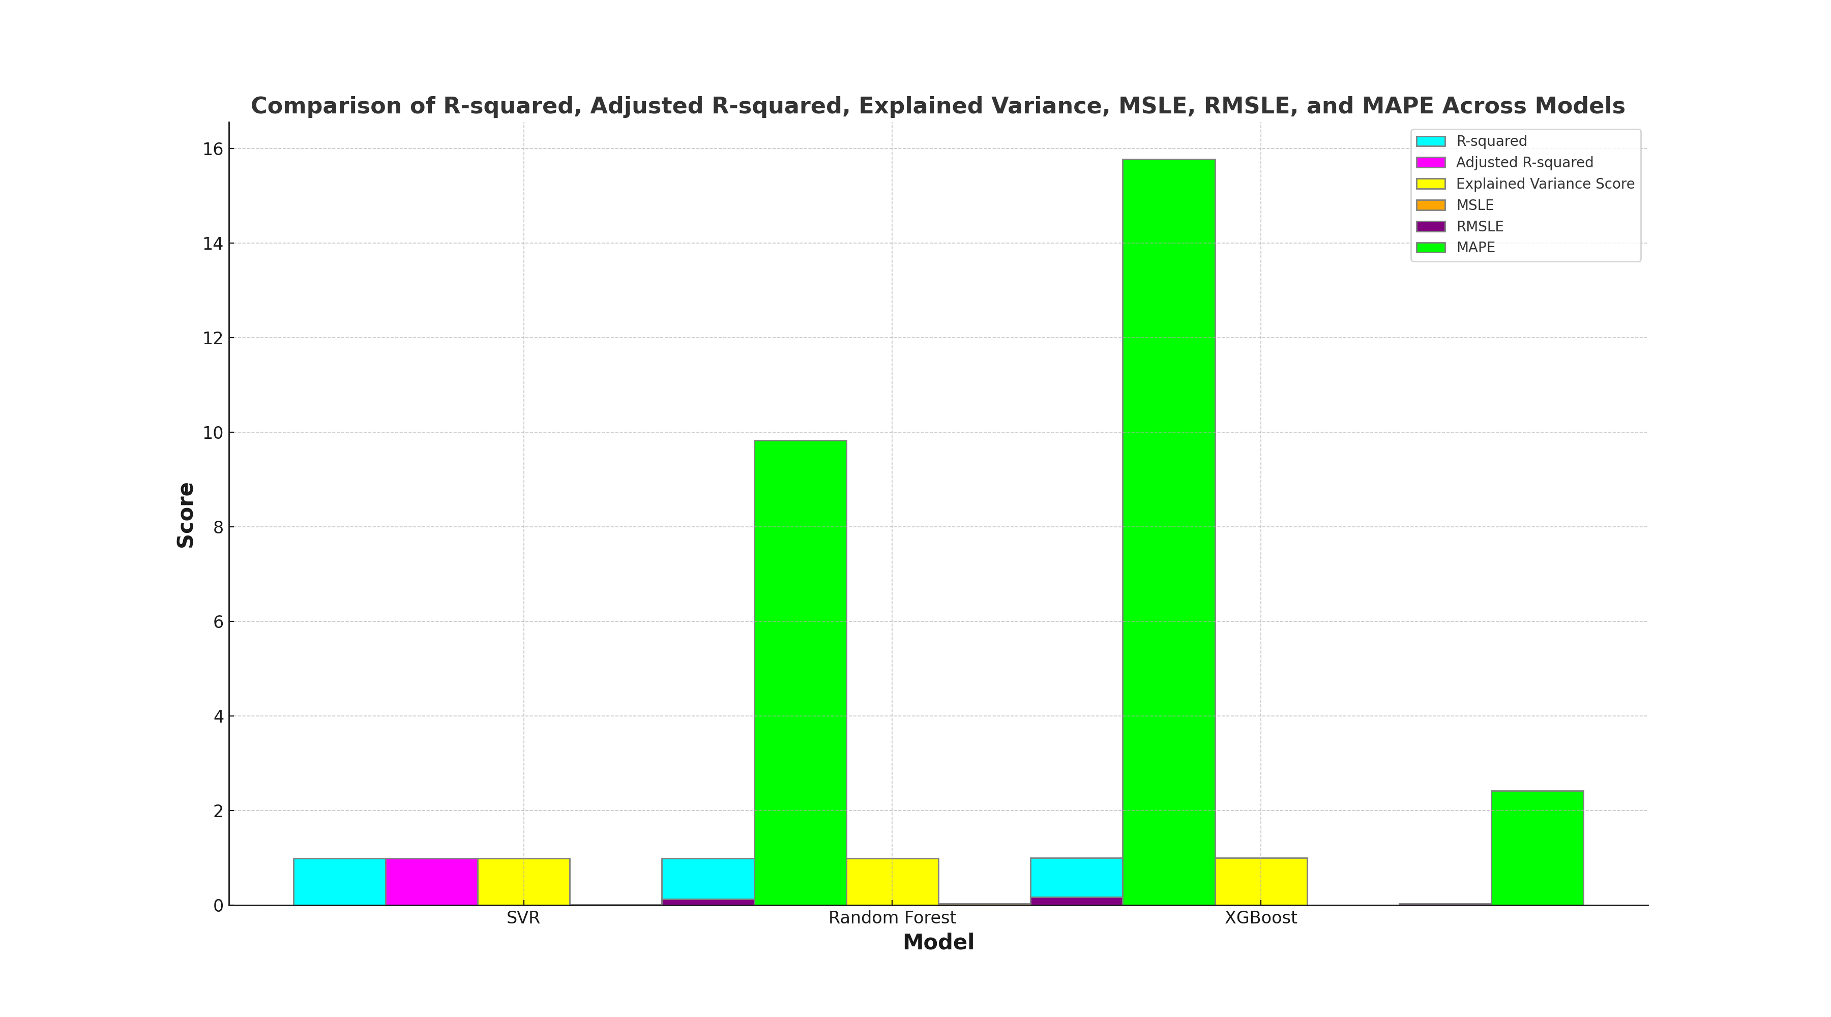

# Slide 7: Visualizations

Discuss the cumulative metrics line chart and the radar chart.

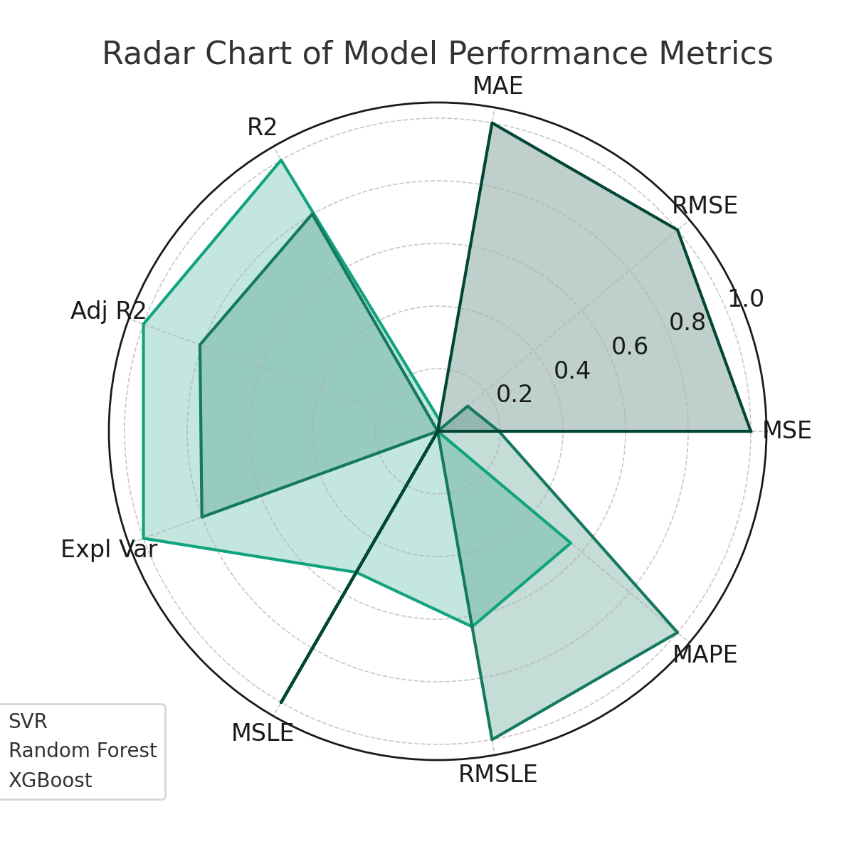

# Slide 8: Overall Analysis

XGBoost is the superior model across all metrics, indicating it is more capable of capturing the underlying patterns in the dataset.

XGBoost has the lowest error rates, suggesting its predictions are the closest to the actual values.

The low MSE, RMSE, and MSLE for XGBoost indicate that its predictions are consistent across different scales.

The R-squared and Adjusted R-squared values are nearly 1 for XGBoost, showing an excellent fit to the data.

XGBoost seems to be robust to outliers and various scales of data, as evidenced by its low median absolute error and MSLE.

The low MAPE for XGBoost indicates its predictions are, on average, closer to the actual values in percentage terms.

While not directly provided in the metrics, we can infer that Random Forest and especially XGBoost are likely to be more complex models compared to SVR.

If computational resources and prediction time are not limiting factors, XGBoost would be the clear choice for this dataset. However, if there are constraints, one might consider SVR or Random Forest, accepting a trade-off in prediction accuracy.

# Slide 9: Conclusion

Recap of the findings and recommendations for model usage.

# Slide 10: Q&A

Open the floor for questions.

**Slide 1: Title Slide**

* **Title**: Model Performance Analysis
* **Subtitle**: A comparison of SVR, Random Forest, and XGBoost
* **Presented by**: [Your Name]
* **Date**: [Presentation Date]

**Slide 2: Agenda**

* **Briefing**: Outline the session's flow and what to expect in the coming slides.

**Slide 3: Overview of Models**

* **Support Vector Regression (SVR)**: A machine learning model that uses support vector machines (SVMs) to predict quantitative data, minimizing error margins.
* **Random Forest**: An ensemble learning method for regression (and classification) that works by constructing a multitude of decision trees at training time and outputting the mean prediction of the individual trees.
* **XGBoost**: Short for “Extreme Gradient Boosting”, it is an efficient and scalable implementation of gradient boosting framework by enhancing the performance and speed of a model.

**Slide 4: Methodology**

* **Dataset Description**: Cover the sources of the data, the size, the features included, and the nature of the target variable being predicted.
* **Training Process**: Discuss the process for training, including data pre-processing, splitting into training and test sets, and any parameter tuning steps.

**Slide 5: Error Metrics Comparison**

* **Mean Squared Error (MSE)**: This reflects the average squared difference between the estimated values and the actual value.
* **Root Mean Squared Error (RMSE)**: The square root of MSE, indicating the standard deviation of the residuals.
* **Mean Absolute Error (MAE)**: The average of the absolute differences between predictions and actual observations.
* **Graphical Representation**: Showcase the bar chart comparing these metrics across the three models.

**Slide 6: Model Fit Metrics Comparison**

* **R-squared (R2)**: The proportion of the variance in the dependent variable that is predictable from the independent variables.
* **Adjusted R-squared**: A modified version of R2 that has been adjusted for the number of predictors in the model.
* **Explained Variance Score**: An indicator of how well our model is coping with the variance in the dataset.
* **Mean Squared Logarithmic Error (MSLE)**: Measures the ratio between the true and predicted values.
* **Root Mean Squared Logarithmic Error (RMSLE)**: The root of MSLE, mitigating the effect of large errors.
* **Mean Absolute Percentage Error (MAPE)**: The mean or average of the absolute percentage differences between predicted and actual values.
* **Graphical Representation**: Display the bar chart comparing these metrics across the three models.

**Slide 7: Visualizations**

* **Cumulative Metrics Line Chart**: Present the chart that illustrates the cumulative normalized metric scores across all models, highlighting the overall performance.
* **Radar Chart**: Display the radar chart to visually compare the performance of each model across all metrics.

**Slide 8: Overall Analysis**

* **XGBoost's Superiority**: Elaborate on how XGBoost outperforms the other models on every metric.
* **Prediction Consistency**: Discuss how XGBoost provides consistent predictions across various metrics.
* **Robustness**: Highlight XGBoost's strength in dealing with different scales of data and outliers.
* **Explanatory Power**: Mention the high R-squared and Adjusted R-squared values, which show that XGBoost can explain most of the variability in the data.

**Slide 9: Conclusion**

* **Model Recommendation**: Recap the findings and suggest XGBoost as the best model for the dataset due to its superior performance.
* **Use Cases for Other Models**: Discuss where SVR or Random Forest might still be preferred, such as in situations where model interpretability is more important.
* **Next Steps**: Suggest potential next steps for implementing the model in a production environment or for further research.