TOIT-Asset Discovery tool

The TOIT tool is a special integration of different technology such as python and Zeek scripting language to extract various network related details such as: device details, protocols in use, the type of communication between assets. The tool also includes a dashboard, list of assets in the network etc.

A TOIT rule engine is developed to parse through the uploaded PCAP file and extract and map relevant information. This rule engine is customizable and can be used to gather any kind of data based on requirement.

The TOIT platform consists of various components performing different tasks. The components present are Packet Analysis which includes Network Mapper, Dashboard which includes Asset Discovery.

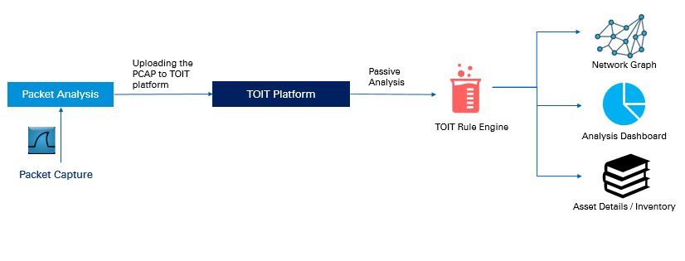

**Packet Analysis**

* The PCAP file is analyzed by Scapy and Zeek scripting language to get information about the network such as IP addresses, different protocols that are in use.
* The extracted information is sent to the Django application for visualization (generating network map, dashboard etc.)

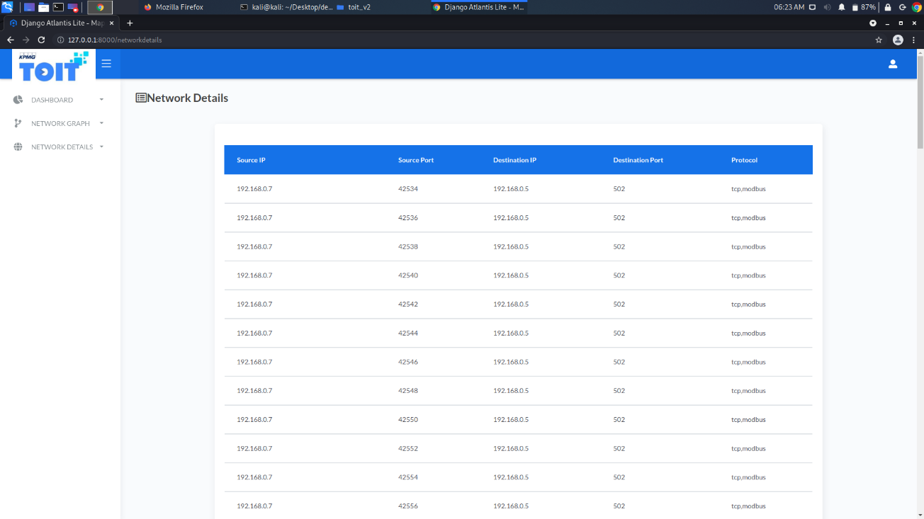

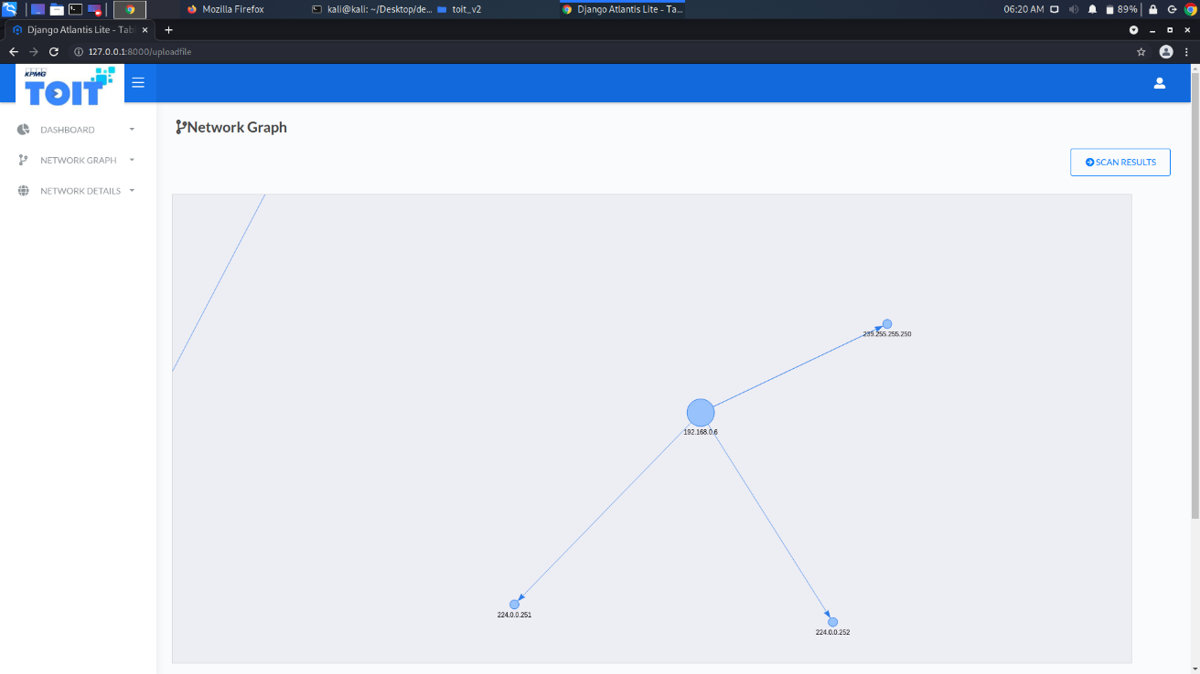

**Dashboard**

* A python library is used to create a network map obtained from Packet Analysis.
* TOIT dashboard shows the running statistics of operations of the packaging unit, and an overview of the network details

