PROJECT REPORT

On

SECURE AND CHEAP AIRLINES ANALYSIS

By

SHETTY PRAJWAL SHUBHAKAR
(4NY19MCA68)
SUMEDA KUMARA B SHETTY
(4NY19MCA76)

Department of Master of Computer Applications
NMAM INSTITUTE OF TECHNOLOGY, NITTE-574 110

2019-2020



(An Autonomous Institution affiliated to VTU, Belagavi)

Nitte Mahalinga Adyanthaya Memorial Institute of Technology

Nitte – 574110, Karkala, Udupi District

Department of Master of Computer Applications

BONAFIDE CERTIFICATE

Certified that this project report “SECURE AND CHEAP AIRLINES ANALYSIS” is the bonafide work of Mr. SHETTY PRAJWAL SHUBHAKAR(4NY19MCA68) & Mr. SUMEDA KUMARA B SHETTY(4NY19MCA76) who presented the project under my supervision.

SIGNATURE SIGNATURE
Head of the Department Project in charge
Dr. Surendra Shetty Ms.Mangala .A.G.
Department of MCA Assistant Professor
NMAMIT, Nitte Department of MCA
NMAMIT,Nitte
Chapter No | Title | Page No
1. | Introduction | 4
2. | Modules | 4/5
3. | Software and Hardware Specifications | 6/8
4. | Screen shots and  Results | 8/11
5. | Conclusion | 12
6. | Reference | 12
 | Total Pages | 12

- INTRODUCTION
R is open source software environment for statistical computing and graphics and is widely used by both academic and Industry. R software works on Windows, Linux and MAC-OS. It was ranked no 1 in a KDnuggests poll on top languages for analytics, Data Mining and Data Science. RStudio is a user friendly environment for R that has become popular.
Flight timing and cost is a very vast topic . So we do not go over each and every detail but the idea here is to get started with it is how to carryout analysis in R. We used here is decomposition of the data.
Data is used here is available within R called ‘airline.csv’ which includes prices, satisfaction rate and incidents and fatalities of various airlines. We are going to analyse price of various flights and see which are the best airlines for the passengers that is both secure as well as cheap.

- MODULES

  - o Reading data obtained from built in data i.e of ‘airline.csv’
  - o Find out the attributes of the data
  - o Log transformation of the data
o Decomposition of this additive timeseries into 3 componets
Trend
Seasonality
Random

MODULES
Reading data obtained from built in data i.e of airline Reading data obtained from built in data i.e of AirPassengers Reading data obtained from built in data i.e of AirPassengers Reading data obtained from built in data i.e of AirPassengers built in data i.e of AirPassengers

Find out the attributes of data

Log transformation of data

DATA ANALYSIS
Decomposition of data

Create line chart of trend,seasonality and random component by decomposing of observed data

- SOFTWARE & HARDWARE SPECIFICATION
  - Language - R Language
  - Software tool – RStudio
  - Hardware
    - Minimum of 2 GB RAM
    - Minimum of 50GB Disk
    - Dual core Processor or above processor
    - RStudio and R Language is to be installed in System.
R is open source software environment for statistical computing and graphics and is widely used by both academic and Industry. R software works on Windows, Linux and MAC-OS. It was ranked no 1 in a KDnuggests poll on top languages for analytics, Data Mining and Data Science. RStudio is a user friendly environment for R that has become popular.
With the increasing importance of computational text analysis in research, many researcher face the challenge of learning how to use advanced software that enables this text analysis. Currently, one of the most popular environments for computational methods and the emerging field of “data science” is the R statistical software. However, for researchers that are not well-versed in programming, learning how to use R can be challenge, and performing text analysis in particular can seem daunting. In this Step guide one can learn that performing text analysis in R is not as hard as some might fear. This is an introduction into the use of common techniques, with computational text analysis in general, as well as getting a start at performing advanced text analysis studies in R.
R was specially designed for statistical analysis, which makes it highly suitable for data science highly suitable for data science applications Although the learning curve for programming with R can be step, especially for people without prior programming experience, the tools now available for carrying out text analysis in R make it easy to perform powerful, cutting-edge text analytics using only a few simple commands. One of the keys to R’s explosive growth has been its densely populated collection of extension software libraries, known in R terminology as packages, supplied and maintained by R’s extensive user community. Each package extends the functionality of the base R language and core packages, and in addition to functions and data must include documentation and examples, often in the form of vignettes demonstrating the use of the package repository, the Comprehensive R Archive Network (CRAN), currently has 10,000 packages that are published.

- SCREEN SHOTS & RESULTS
Observed Data:
By observing the data structure, we see that price varies from 3000 to 5000 from various airlines. So we only needed was the data are cheap that is close to nearly 3000. So what we did is sort of the given data in increasing order using order function and taking the top 15 data of airlines using head function. We also see variation rating by customer.

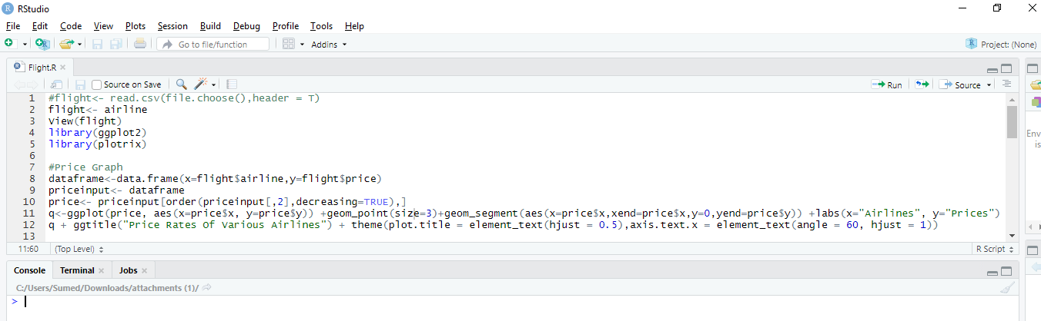
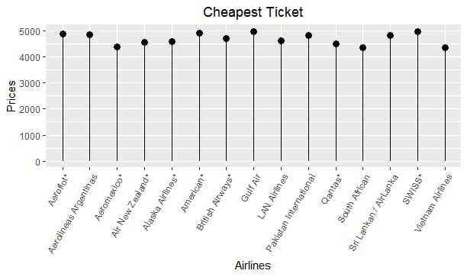
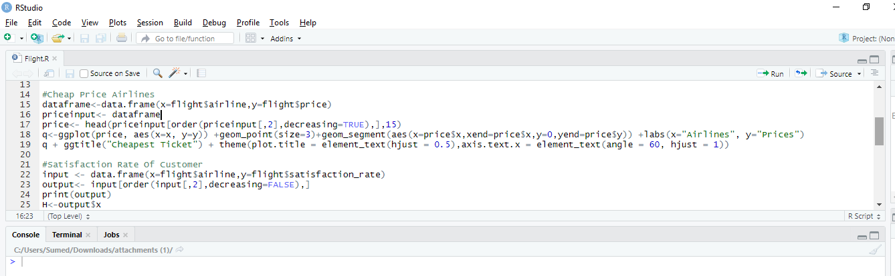
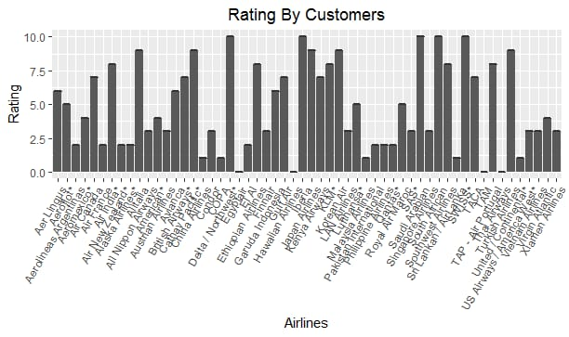

Finally we are comparing the price of tickets with satisfying rates of customers which would eventually suggest the which airline is most safe and cheap by using point graph as follows.

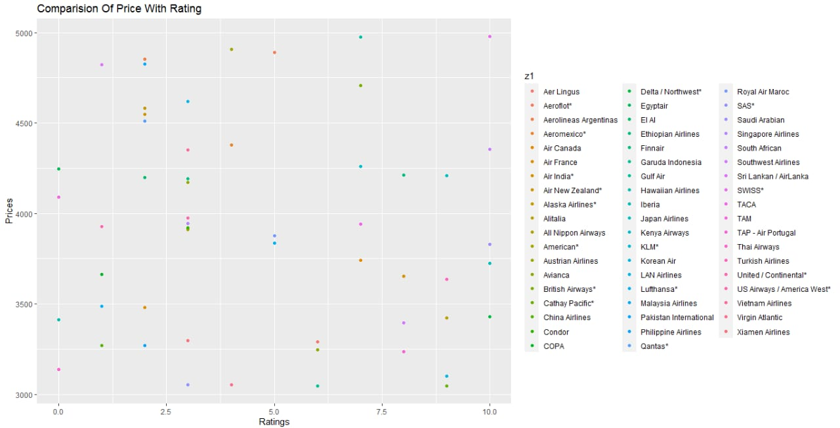
So in order to look for secure airlines, we are observing the number of incidents with number of fatalities happening in airlines. The point which are near to (5000,10) are most insecure while point near (0,0) are the most secure. So look for the point is near x-axis is 0 as well as y-axis is 0 that represents there were no incidents as well as fatalities.

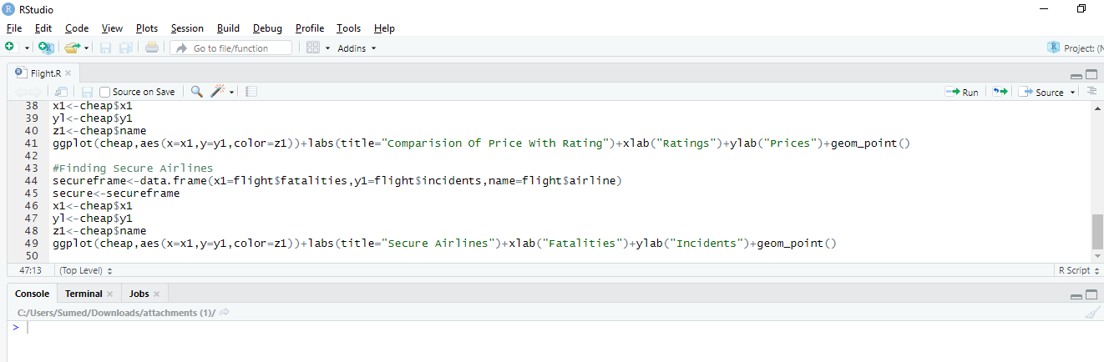

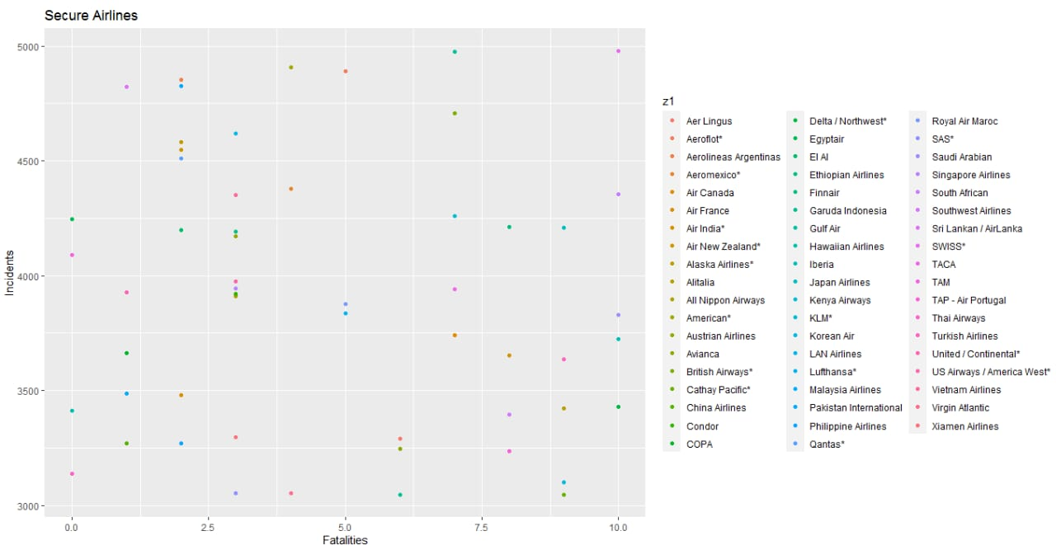

- CONCLUSION
This analysis of the data helps us to decompose of the observed data , By that we can clearly come to know about the most safest airlines as well as most cheapest satisfying airlines. We can also know about the price variation and cheapest price for ticket. This will help customers to buy a ticket which provide good service to customer as well as most secure airlines.

- REFERENCE
  - www.github.com
  - www.tutorialspoint.com
  - www.youtube.com/edureka

