AI Assisted Coding

Assignment - 6.5

Name: L. Sharan Sai Varshith
Ht.no:2303A51450
Bt.no:21

Task Description #1
(AI-Based Code Completion for Conditional Eligibility Check) Task: Use an AI tool to generate eligibility logic.
Prompt: “Generate Python code to check voting eligibility based on age and citizenship.” Code:

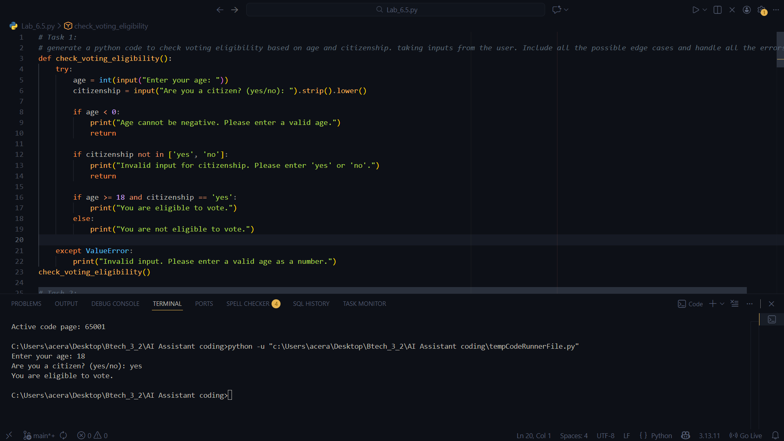

Task Description #2
(AI-Based Code Completion for Loop-Based String Processing)
Task: Use an AI tool to process strings using loops. Prompt:
“Generate Python code to count vowels and consonants in a string using a loop.”
Code:
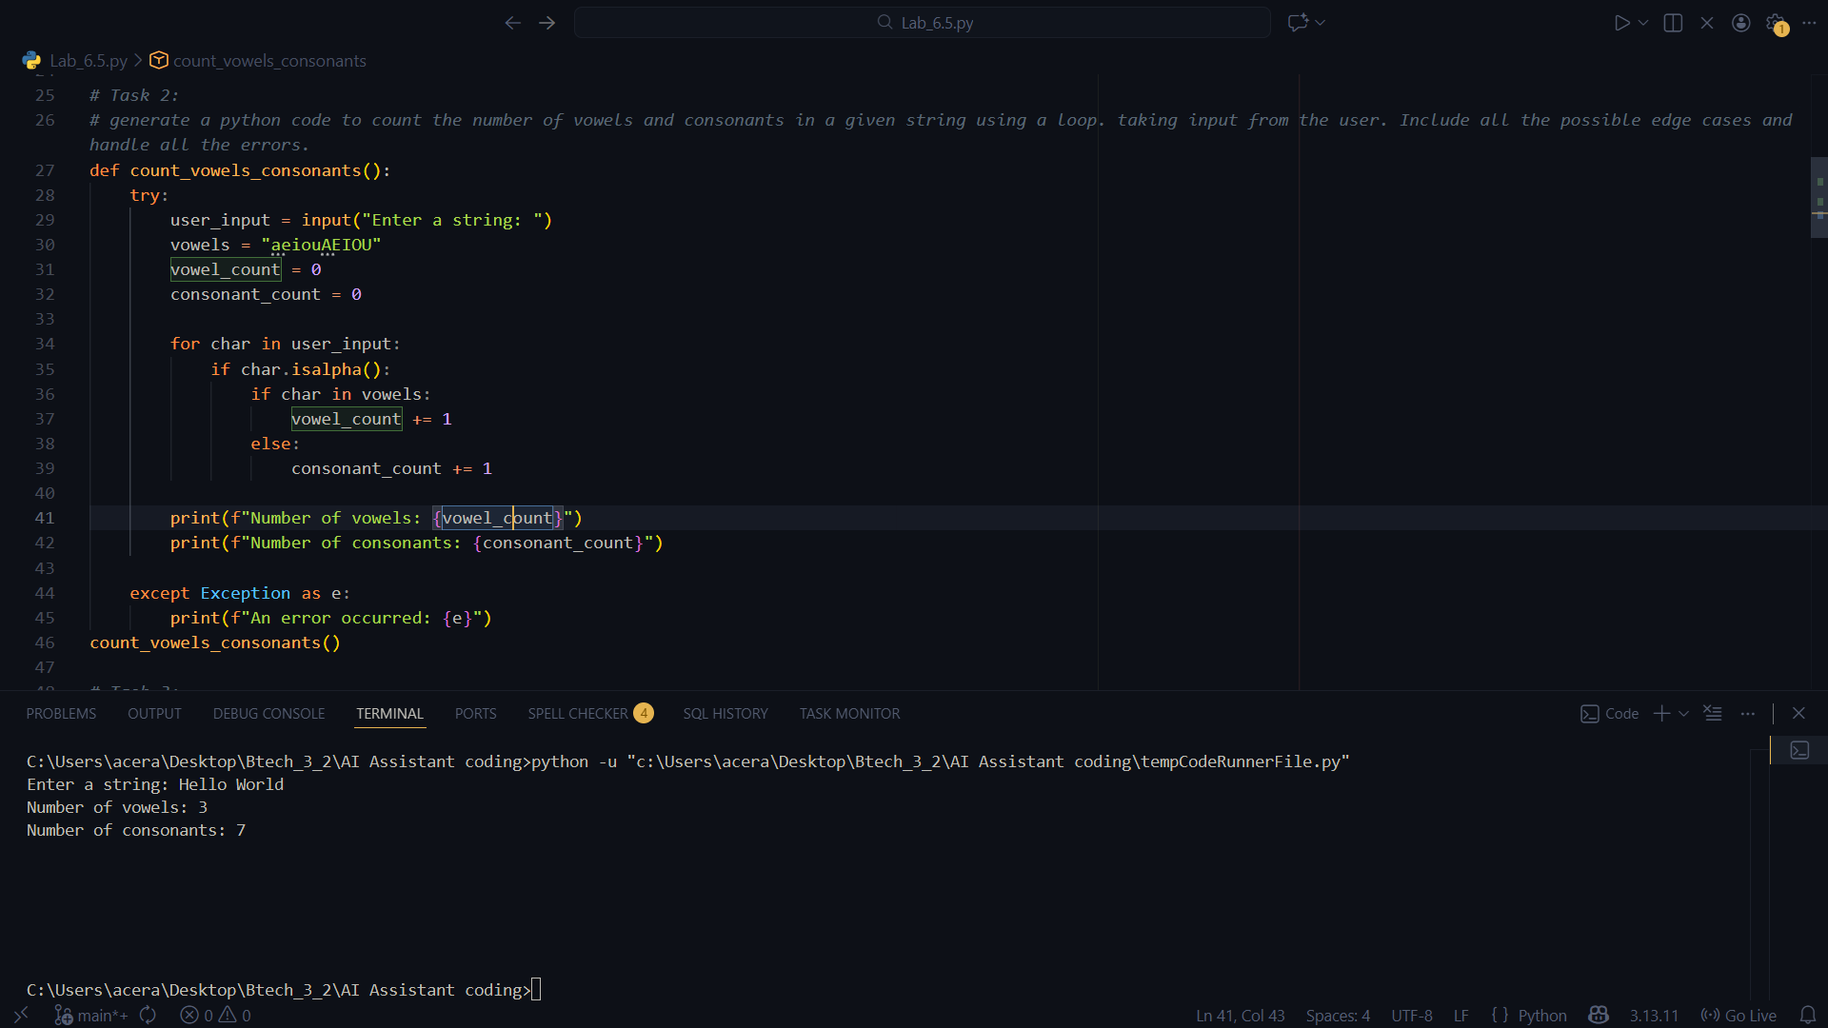

Output:

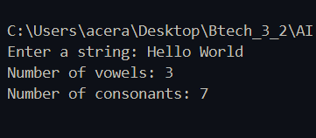

Task Description #3
(AI-Assisted Code Completion Reflection Task)
Task: Use an AI tool to generate a complete program using classes, loops, and conditionals. Prompt:
“Generate a Python program for a library management system using classes, loops, and conditional statements.”

Expected Output:
- Complete AI-generated program.
- Review of AI suggestions quality.
- Short reflection on AI-assisted coding experience.
Code:
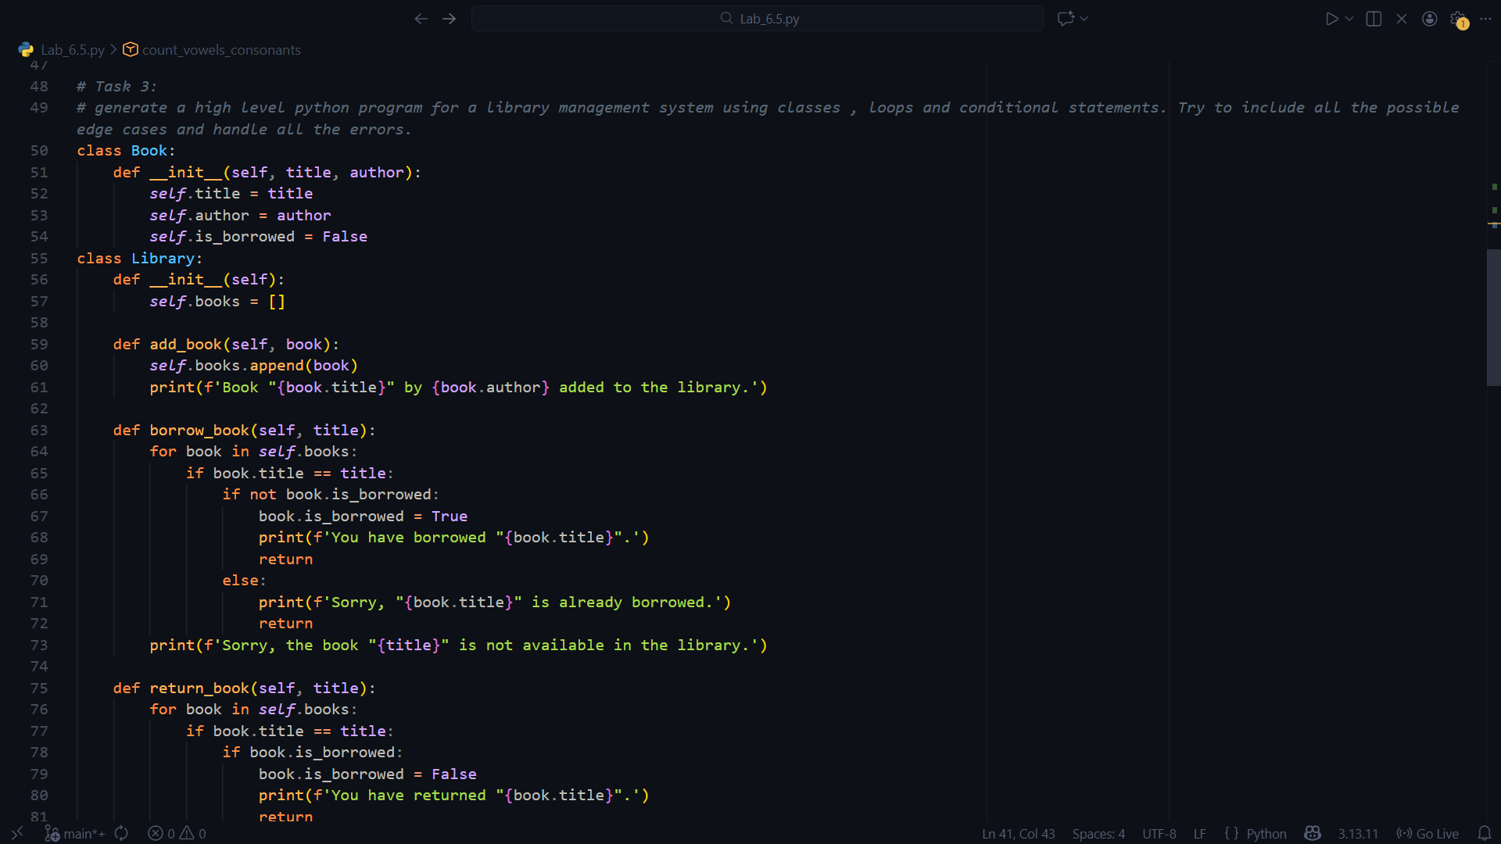

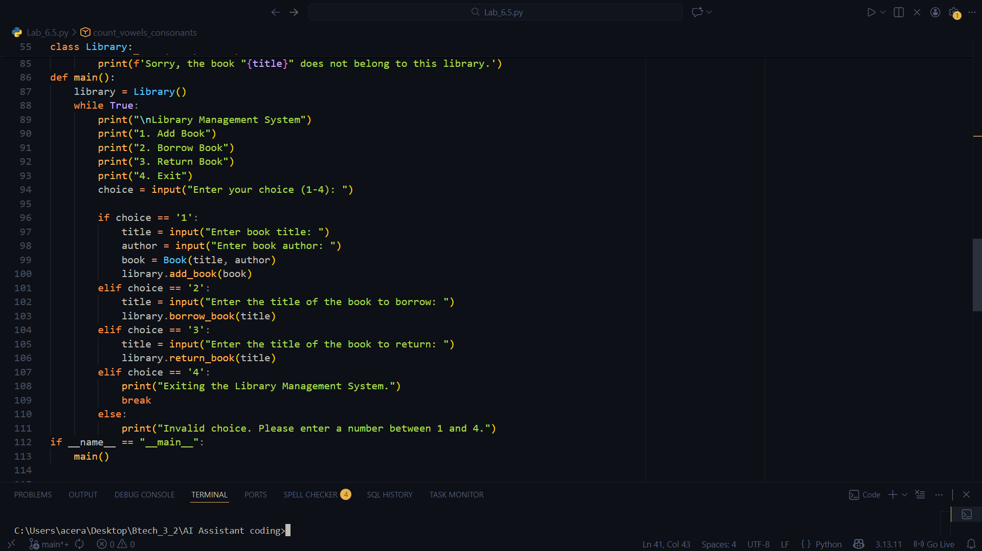Output:
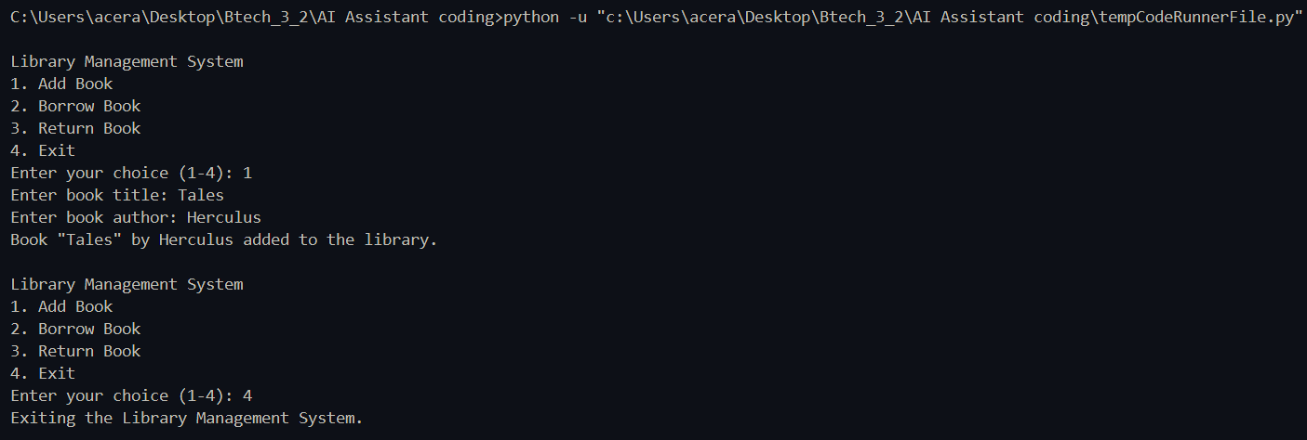

Task Description #4
(AI-Assisted Code Completion for Class-Based Attendance System) Task: Use an AI tool to generate an attendance management class.
Prompt: “Generate a Python class to mark and display student attendance using loops.”
Expected Output:
- AI-generated attendance logic.
- Correct display of attendance.
- Test cases.

Code:
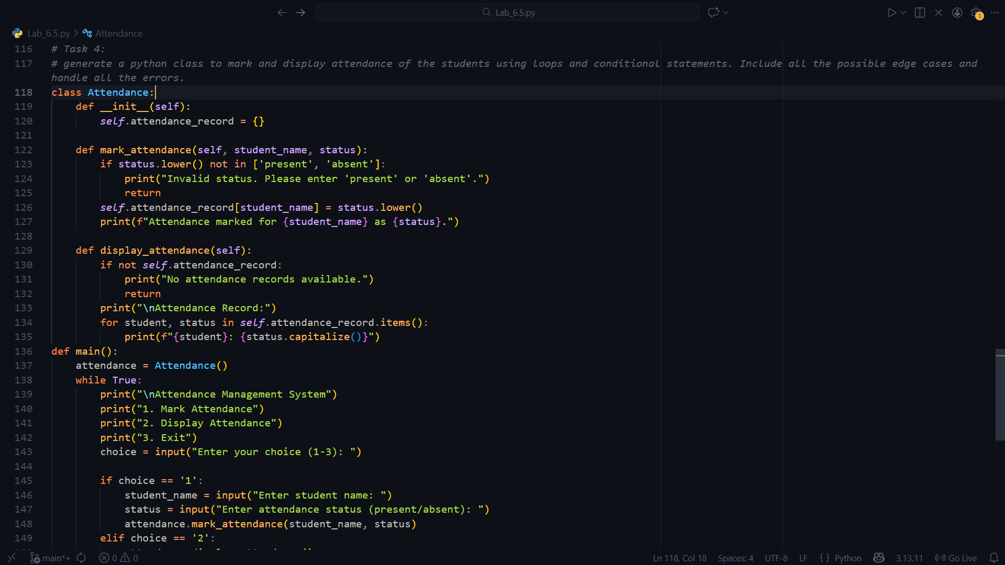

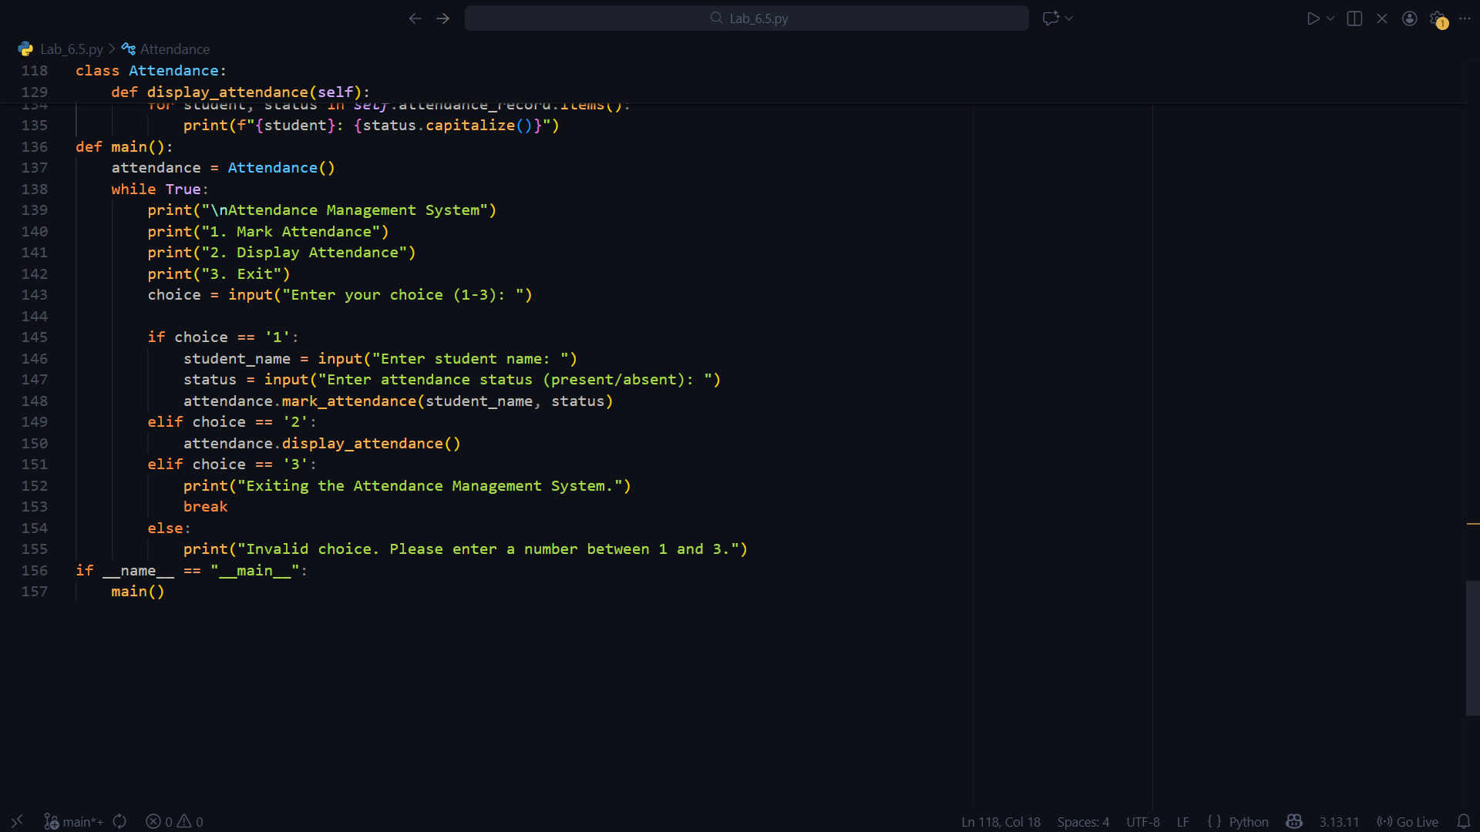

Output:
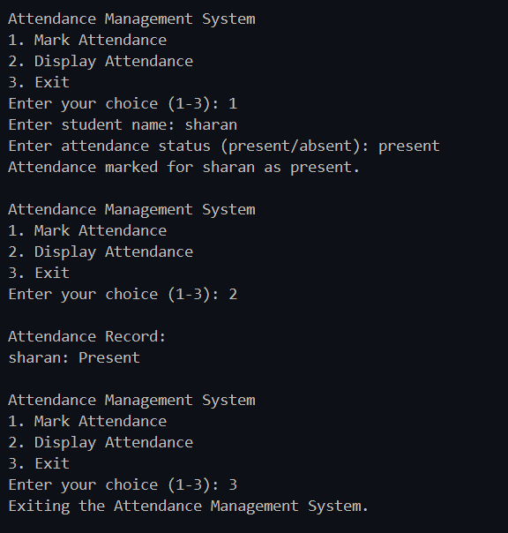

Task Description #5
(AI-Based Code Completion for Conditional Menu Navigation) Task: Use an AI tool to complete a navigation menu.
Prompt: “Generate a Python program using loops and conditionals to simulate an ATM menu.” Expected Output:
- AI-generated menu logic.
- Correct option handling.

- Output verification
Code:
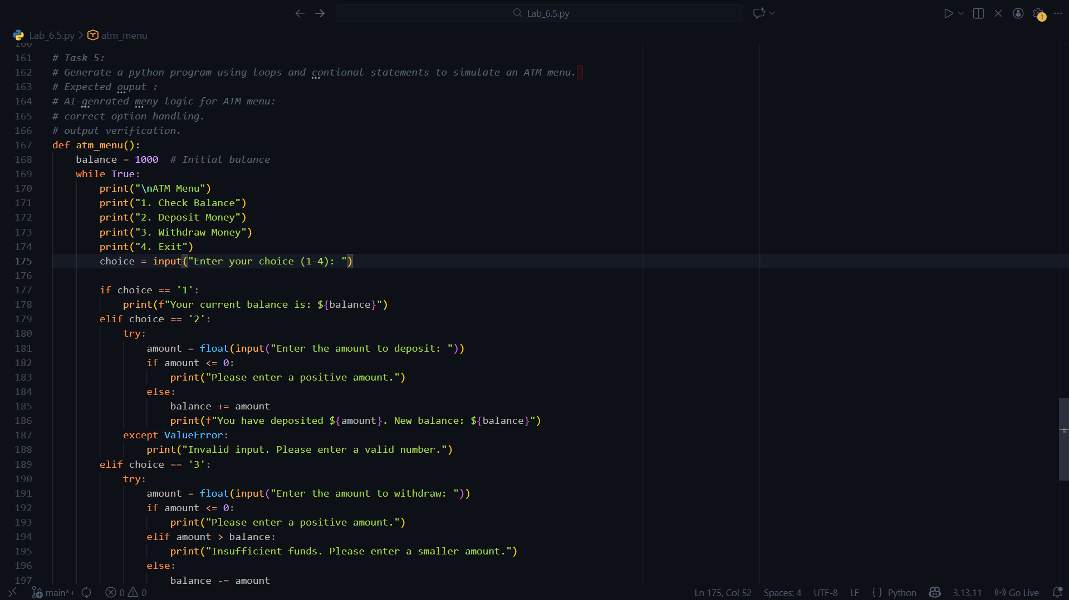

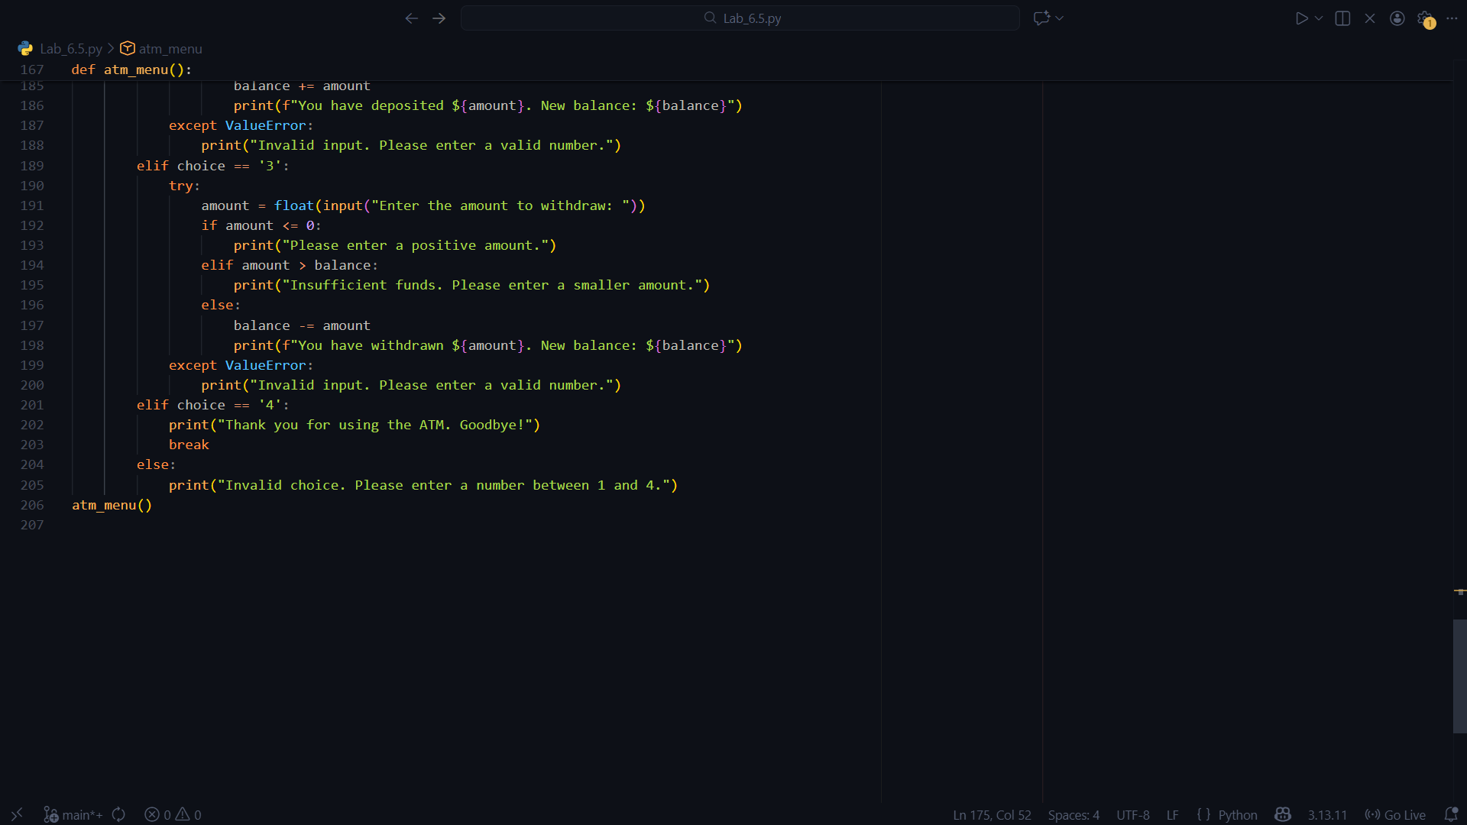

Output:

