

COVER LETTER

**Date: November 25, 2024**

**The Consulate General Embassy of Netherlands, India.**

**Subject:** Application for the issuance of Netherlands work permit and a national long stay visa (Type D).

**Dear Sir/madam,**

**Greetings from AquaVita Group,**

We are currently working for our ongoing projects in Netherlands, for which we are hiring manpower from India (A vacancy report demonstrating that the company searched for qualified Dutch nationals to fill the position) but we were unable to find suitable employees as per our requirements. So we selected the candidates from India which successfully matched our requirements.

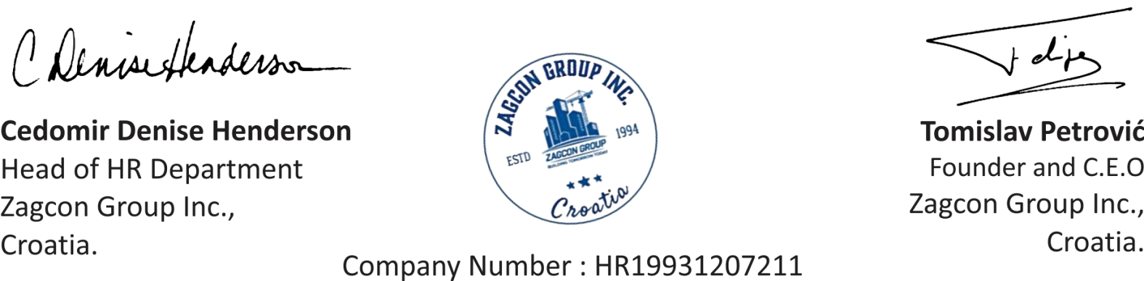

We hereby request you for the issuance of a Netherlands work permit / national long stay visa (Type D) for the below mentioned employee. We have completed our hiring process by selecting the employee and conducting the required background checks. The employee was issued a letter of appointment mentioning all the benefits and remuneration of the offered position which he has accepted with his will and he is ready to work on our project.

We hereby assure that the safety of this expected employee will be our responsibility and we will provide him food, accommodation, transportation, group medical insurance and other benefits as per the labour laws of Netherlands for a foreign national employee.

**Name:** Benedict Valaskan Simon, **Passport No.**: M9768298, **Nationality:** Indian

Enclosed please find application for the issue of a work permit in the name of **Benedict Valaskan Simon**, On behalf of AquaVita Group

* He will be working with us for the position of **Heavy Vehicle Driver.**
* He will be receiving a remuneration of € 24000 per year from the Company.
* He will be working on our **ongoing site in** Rotterdam**.**

Please find enclosed personal C/V, job description and photos along with the accepted letter of appointment. Should you need any additional information, please do not hesitate to contact the undersigned.

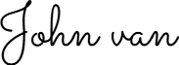

**HR Director**

**AquaVita Group, Netherlands.**

John Van