1. Missing features
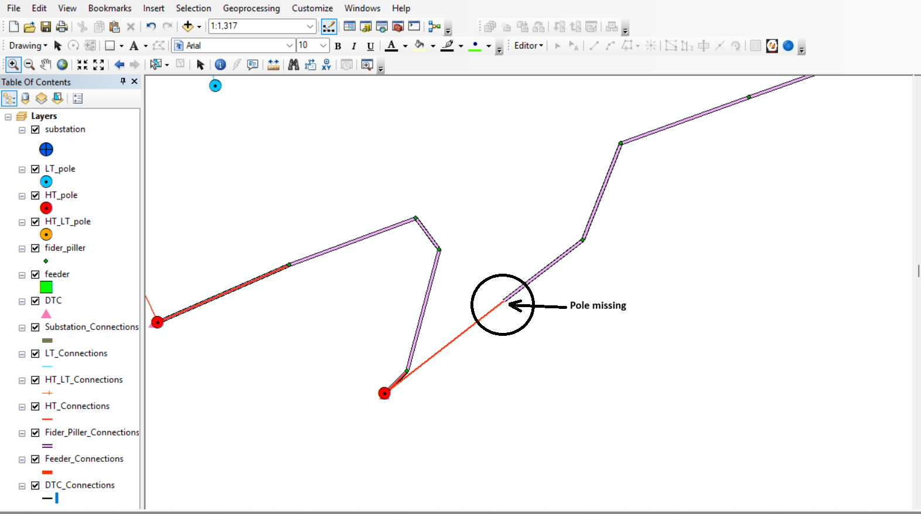

2. Field names are not as per Data model
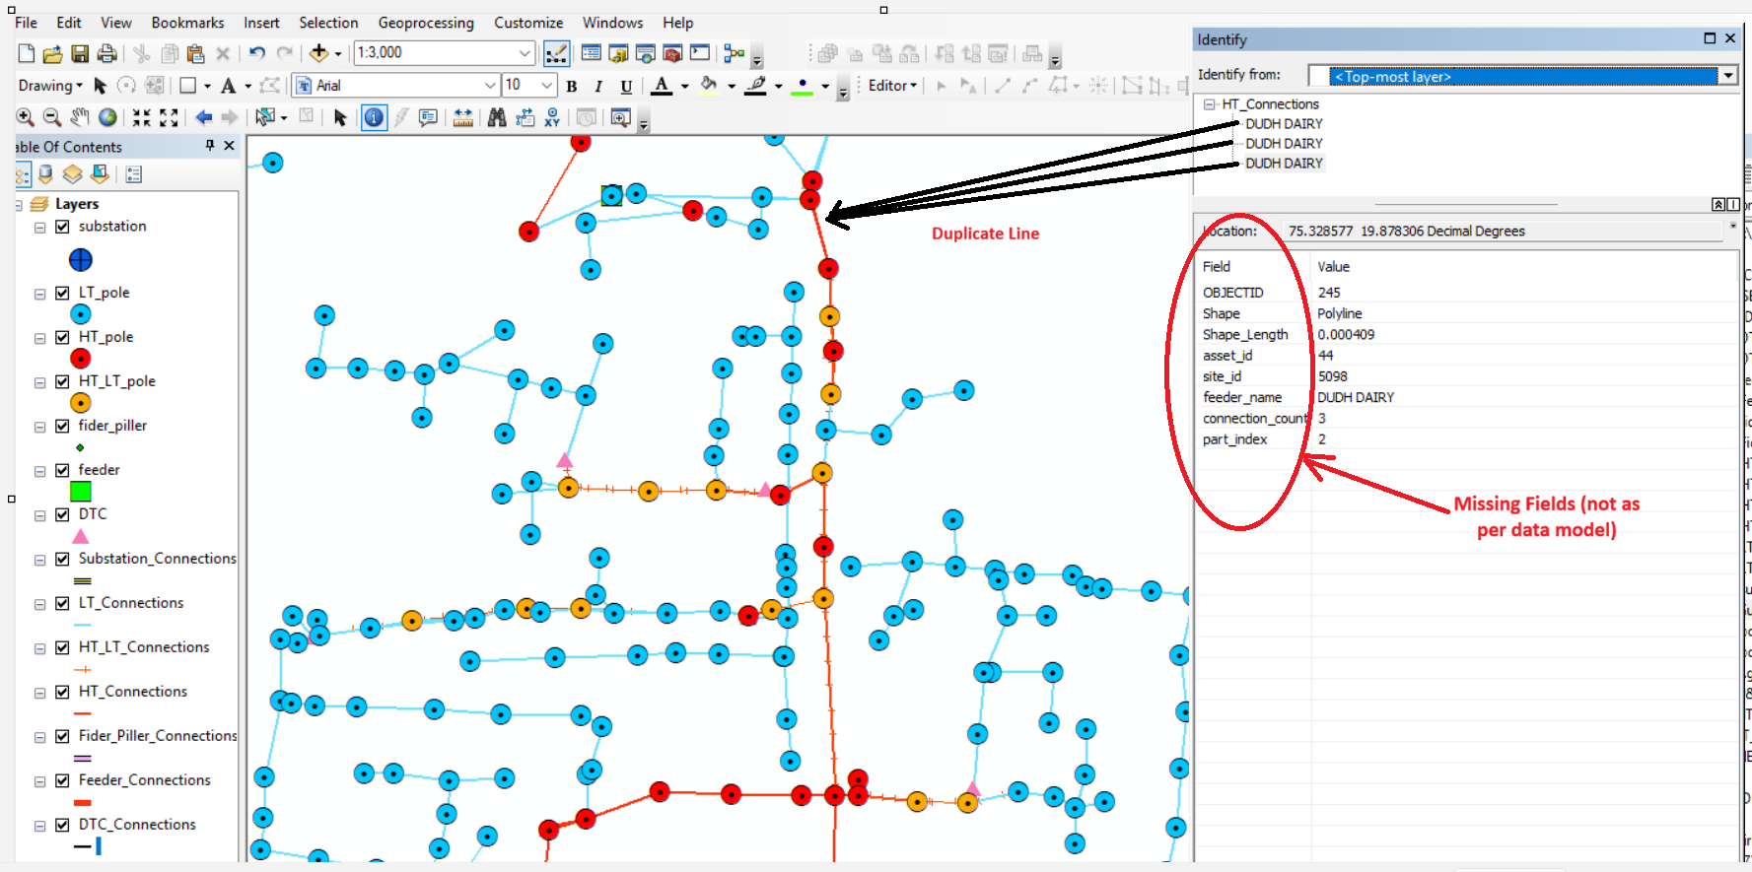

3. Hanging Pole features
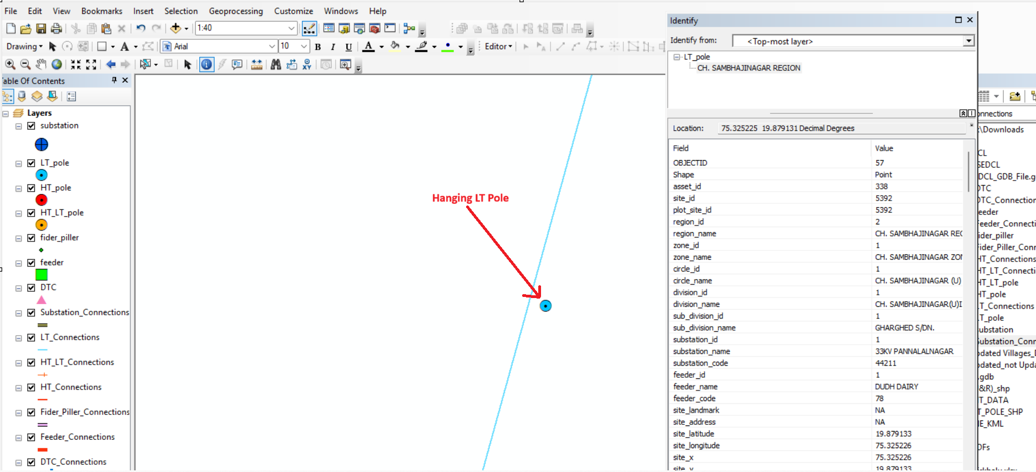

4. Hanging Line feature

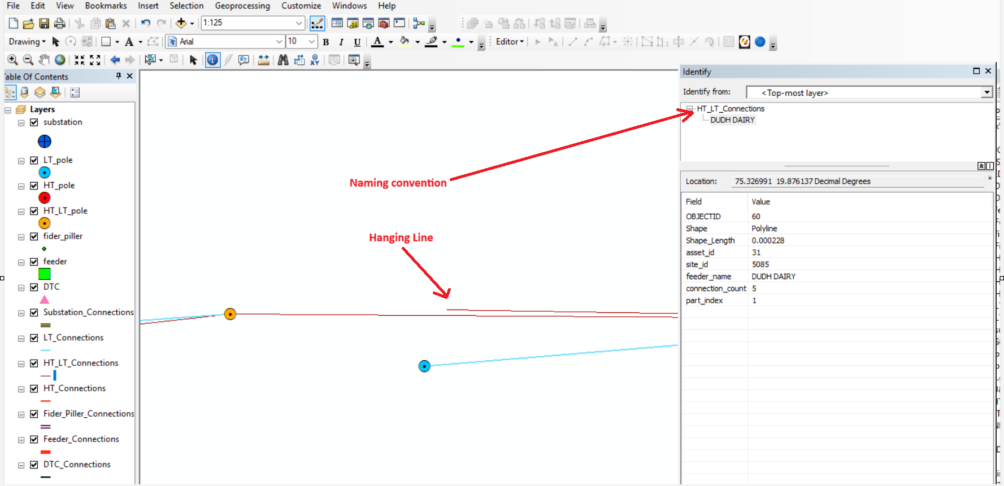

5. HT line present in between LT network
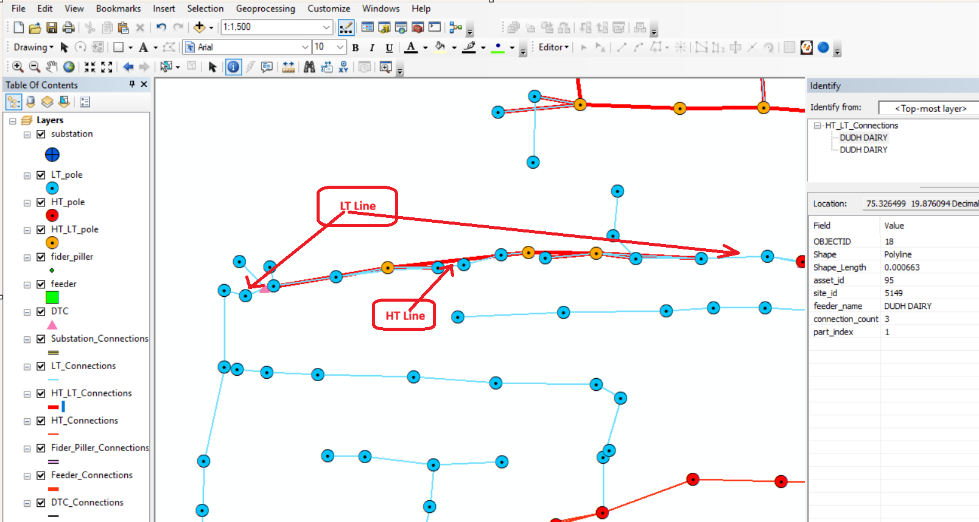

6. Field Names issues
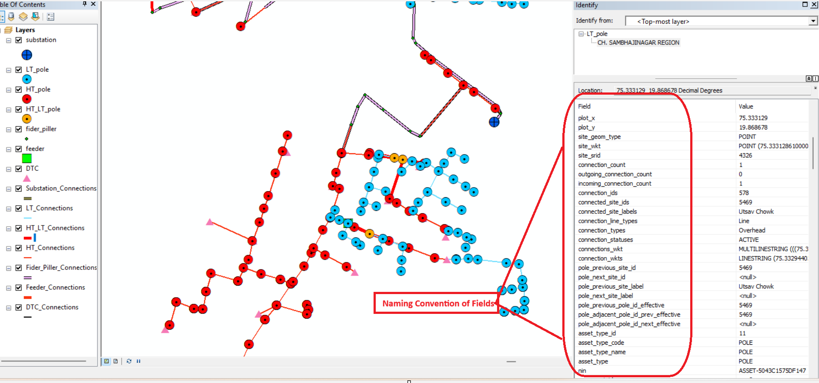

7. The electricity features are not network features, they are simply placed as per the location only.
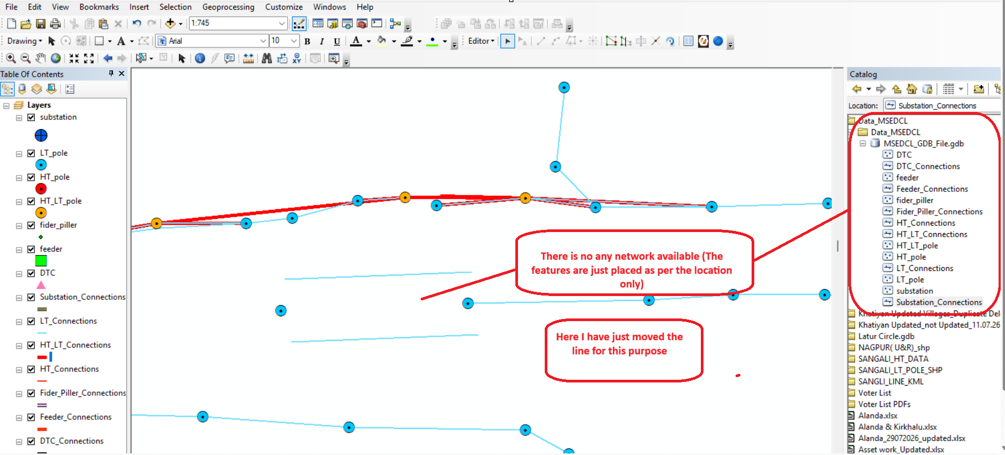

Note: As per my above observation, lots of activities need to be done and then only it will be ready for NA

