**Batch -** T5

**Practical No. -** 1

**Title -** Study of Web and its Basics

**Student Name -** Sharaneshwar Bharat Punjal

**Student PRN -** 23520011

**Problem Statement 1 -** Study and describe the following concepts in your words

**1. Evolution of Web including Web 3.0**

* Web 1.0: The earliest stage of the web, characterized by static web pages that were primarily text-based and hand-coded in HTML. Users could only read content and had limited interactivity.
* Web 2.0: Marked by the shift to dynamic content and user-generated content. Key features included social media, blogs, wikis, and interactive web applications using technologies like AJAX. It emphasized collaboration and sharing.
* Web 3.0: Also known as the Semantic Web, it focuses on creating a more intelligent and interconnected web. It uses technologies like AI, machine learning, and blockchain to enable decentralized data structures, personalized content, and more efficient data management.

**2. Which ports and protocols are used by web? Describe those in detail**

* HTTP (Port 80): Standard port for unencrypted web traffic using the HyperText Transfer Protocol.
* HTTPS (Port 443): Standard port for encrypted web traffic using HTTP Secure, which employs SSL/TLS for security.
* FTP (Port 21): Used for the control connection in the File Transfer Protocol, which is used for transferring files between a client and server.
* SMTP (Port 25): Used by the Simple Mail Transfer Protocol for sending emails.
* DNS (Port 53): Used by the Domain Name System to translate domain names into IP addresses, enabling users to access websites using human-readable names.

**3. Difference Between HTTP & HTTPS**

* HTTP (HyperText Transfer Protocol):
  + Transfers data in plaintext, making it vulnerable to interception and attacks.
  + Uses port 80.
  + Suitable for non-sensitive data and internal networks.
* HTTPS (HyperText Transfer Protocol Secure):
  + Uses SSL/TLS to encrypt data, ensuring secure communication between client and server.
  + Uses port 443.
  + Essential for sensitive data, e-commerce, and user login areas to protect against eavesdropping and tampering.

**4. What is web developer tools and why it is needed?**

Web Developer Tools are a set of built-in tools in web browsers that help developers inspect, debug, and optimize their web applications.

**Importance**:

* + View and edit the DOM and CSS styles live in the browser.
  + Debug JavaScript: Set breakpoints, step through code, and analyze call stacks.
  + Analyze network requests to ensure efficient data loading and identify bottlenecks.
  + Measure performance metrics like page load time and rendering speed.
  + Test how websites look and function on different devices and screen sizes.

**5. Elaborate with diagram client server architecture and MVC architecture. When to use which architecture?**

**Client-Server Architecture**:

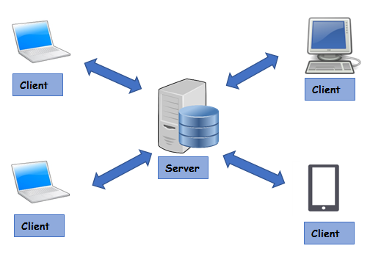

* + Clients (e.g., web browsers) send requests to the server, which processes the requests and returns the appropriate resources (e.g., HTML pages, data).
  + Suitable for applications requiring centralized data storage and processing, such as web portals, online banking, and content management systems.

**MVC (Model-View-Controller) Architecture**:

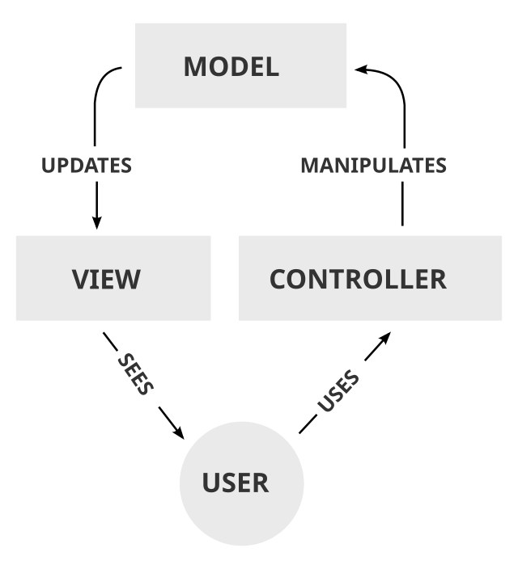

Separates an application into three components:

* + - Model: Manages data and business logic.
    - View: Displays data and sends user inputs to the controller.
    - Controller: Handles user input and updates the model and view accordingly.
  + Ideal for complex applications requiring a clear separation of concerns, such as web applications with multiple user interfaces and data sources.

**6. What is HTML and HTML5?**

* HTML (HyperText Markup Language): The standard language for creating web pages and web applications. It structures content using elements and tags.
* HTML5: The latest version of HTML, introducing new elements (e.g., <header>, <footer>, <article>), attributes, and behaviors, as well as APIs for complex web applications. HTML5 also improves support for multimedia and graphical content.

**7. Which are the currently used versions of HTML and CSS for web development?**

* HTML5: The current version of HTML, offering advanced features for multimedia, form controls, and APIs for offline storage, geolocation, and more.
* CSS3: The latest version of CSS, providing advanced styling capabilities, animations, transitions, and responsive design features.

**8. Which tools are available for frontend development and backend development?**

**Front End Development Tools:**

* + Frameworks/Libraries: React, Angular, Vue.js
  + Code Editors: Visual Studio Code, Sublime Text
  + Design Tools: Figma, Adobe XD

**Back End Development Tools:**

* + Frameworks: Express.js, Django, Flask, Ruby on Rails
  + Databases: MongoDB, MySQL, PostgreSQL
  + Code Editors: Visual Studio Code, Atom
  + Server Tools: Nginx, Apache

**9. What MERN stack includes? Why and when it is preferred for web development?**

MERN Stack Components:

* + MongoDB: NoSQL database for storing data.
  + Express.js: Web application framework for Node.js.
  + React: Front-end library for building user interfaces.
  + Node.js: JavaScript runtime environment for server-side programming.

MERN Stack is preferred for building dynamic, single-page applications with a seamless integration of front-end and back-end, enabling full-stack development with a single language (JavaScript).

**10. List out newly introduced input types, APIs, form elements, and elements that support media content in HTML5.**

* New Input Types: email, date, time, url, number, range, color
* APIs: Geolocation API, Web Storage API, Canvas API, Web Workers API
* Form Elements: <datalist>, <output>, <progress>, <meter>
* Media Elements: <audio>, <video>

**11. Explain HTML5 Web storage.**

HTML5 Web Storage allows web applications to store data locally within the user's browser. It is useful for saving user preferences, session data, and enabling offline functionality in web applications.

Types of Storing Data:

* localStorage: Stores data with no expiration date, persisting even after the browser is closed.
* sessionStorage: Stores data for the duration of the page session, cleared when the page session ends.

**Problem Statement 2 -** Study of Different HTML and CSS tags

**1. Study different tags of HTML and CSS.**

**HTML Tags**

* <!DOCTYPE html>: Declares the document type and version of HTML.
* <html>: The root element of an HTML document.
* <head>: Contains meta-information about the document, such as title, links to stylesheets, and scripts.
* <title>: Sets the title of the document, shown in the browser’s title bar or tab.
* <meta>: Provides metadata such as character set, viewport settings, and SEO keywords.
* <link>: Links to external resources like stylesheets.
* <style>: Embeds CSS styles within the HTML document.
* <script>: Embeds or links to JavaScript files.
* <body>: Contains the content of the HTML document.
* <header>: Represents introductory content, typically contains navigation links or logos.
* <nav>: Defines a navigation section containing links to other pages or sections.
* <main>: Represents the main content of the document.
* <section>: Defines a section of the document, often with a heading.
* <article>: Represents a self-contained composition that can be independently distributed or reused.
* <aside>: Contains content indirectly related to the main content, such as sidebars.
* <footer>: Represents the footer of a section or document.
* <h1> to <h6>: Define headings, <h1> being the highest level and <h6> the lowest.
* <p>: Defines a paragraph.
* <a>: Defines a hyperlink.
* <ul>: Defines an unordered list.
* <ol>: Defines an ordered list.
* <li>: Defines a list item.
* <div>: Defines a division or section, used for grouping content.
* <span>: Defines a section within a line, used for styling parts of text.
* <img>: Embeds an image.
* <form>: Defines a form for user input.
* <input>: Defines an input field.
* <button>: Defines a clickable button.
* <table>: Defines a table.
* <tr>: Defines a row in a table.
* <td>: Defines a cell in a table.
* <th>: Defines a header cell in a table.
* <br>: Inserts a line break.
* <hr>: Inserts a thematic break (horizontal rule).

**CSS Tags (Properties)**

* color: Sets the text color.
* background-color: Sets the background color.
* font-family: Specifies the font of the text.
* font-size: Sets the size of the font.
* font-weight: Sets the weight (boldness) of the font.
* text-align: Sets the horizontal alignment of text.
* text-decoration: Adds decoration to text (underline, overline, line-through).
* margin: Sets the margin area around an element.
* padding: Sets the padding area inside an element.
* border: Sets the border around an element.
* width: Sets the width of an element.
* height: Sets the height of an element.
* display: Specifies the display behavior of an element (block, inline, flex, etc.).
* position: Specifies the type of positioning for an element (static, relative, absolute, fixed).
* top, right, bottom, left: Specify the position of an element.
* flex: Specifies the ability of a flex item to grow or shrink.
* grid: Defines a grid layout.
* align-items: Aligns flex items along the cross axis.
* justify-content: Aligns flex items along the main axis.
* z-index: Specifies the stack order of an element.
* overflow: Specifies what happens if content overflows an element’s box.
* cursor: Specifies the type of cursor to be displayed.
* visibility: Specifies whether an element is visible or not.
* opacity: Sets the opacity level of an element.
* box-shadow: Adds shadow to an element’s box.
* text-shadow: Adds shadow to text.
* border-radius: Rounds the corners of an element’s border.
* transition: Specifies the transition effect for changing CSS properties.
* animation: Defines keyframes and properties for CSS animations.
* background-image: Sets a background image for an element.

**2. Create a static web page for “Portfolio” of your own. Which will include photo, name, class, College name, Achievements/Certificates, Extracurricular Activities, Courses Completed, hobbies, technical expertise, etc.**

Technologies Used - Basic HTML and CSS

Screenshots -

