**Batch -** T5

**Practical No. -** 10

**Title –** Projects using MySQL, NodeJS and ExpressJS, React.js

**Student Name -** Sharaneshwar Bharat Punjal

**Student PRN -** 23520011

**Perform following problem statements using Node.Js**

**Problem Statement 1: Personal Task Manager**

* Develop a simple task manager where users can add, edit, and delete their personal tasks. The tasks should have fields like title, description, dueDate, and status (pending/completed).
* User authentication (JWT-based login/signup).
* CRUD operations for tasks (Create, Read, Update, Delete).
* Filtering tasks by status (pending/completed).
* Allow users to categorize tasks and set priorities (high, medium, low).

**Screenshots –**

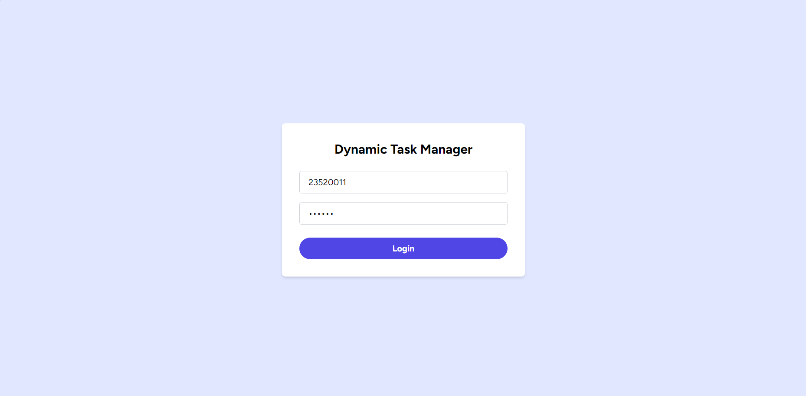

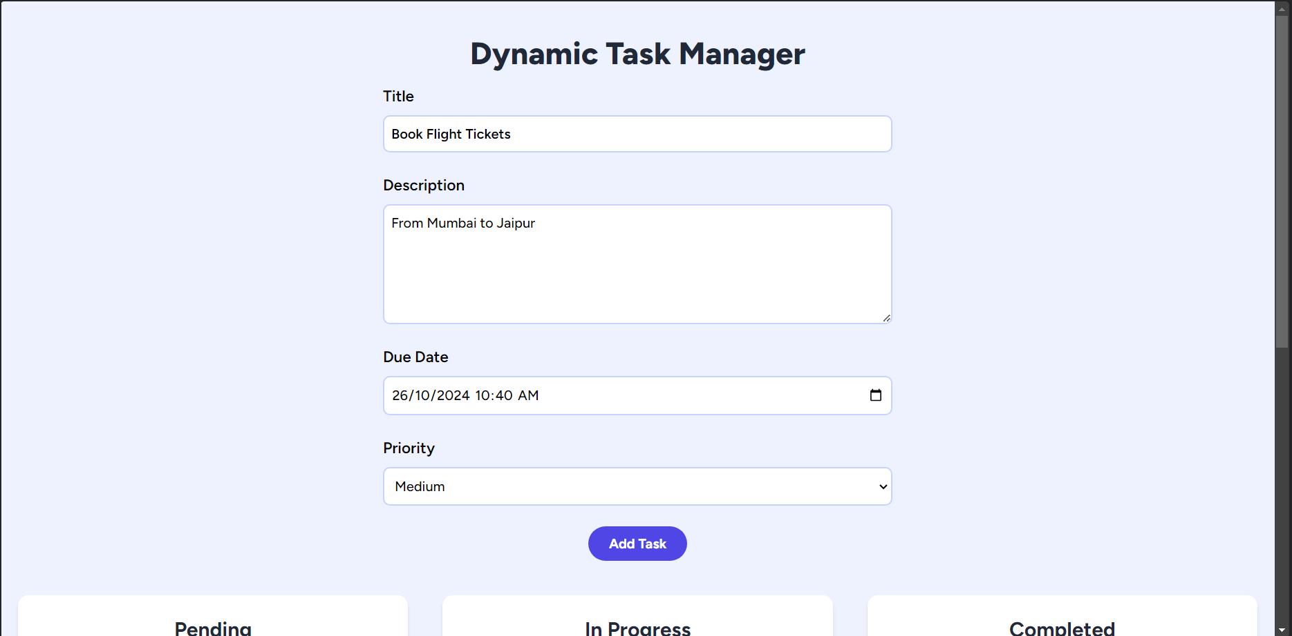

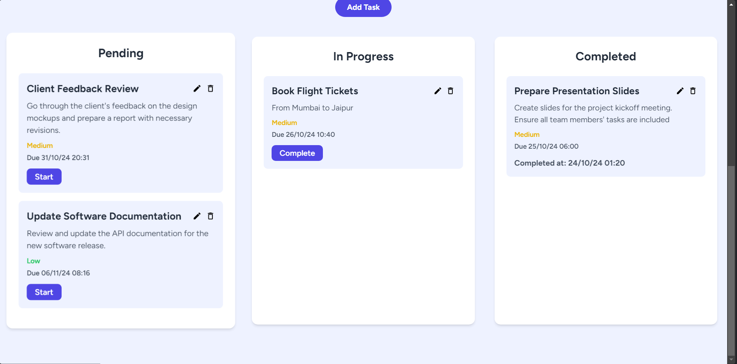

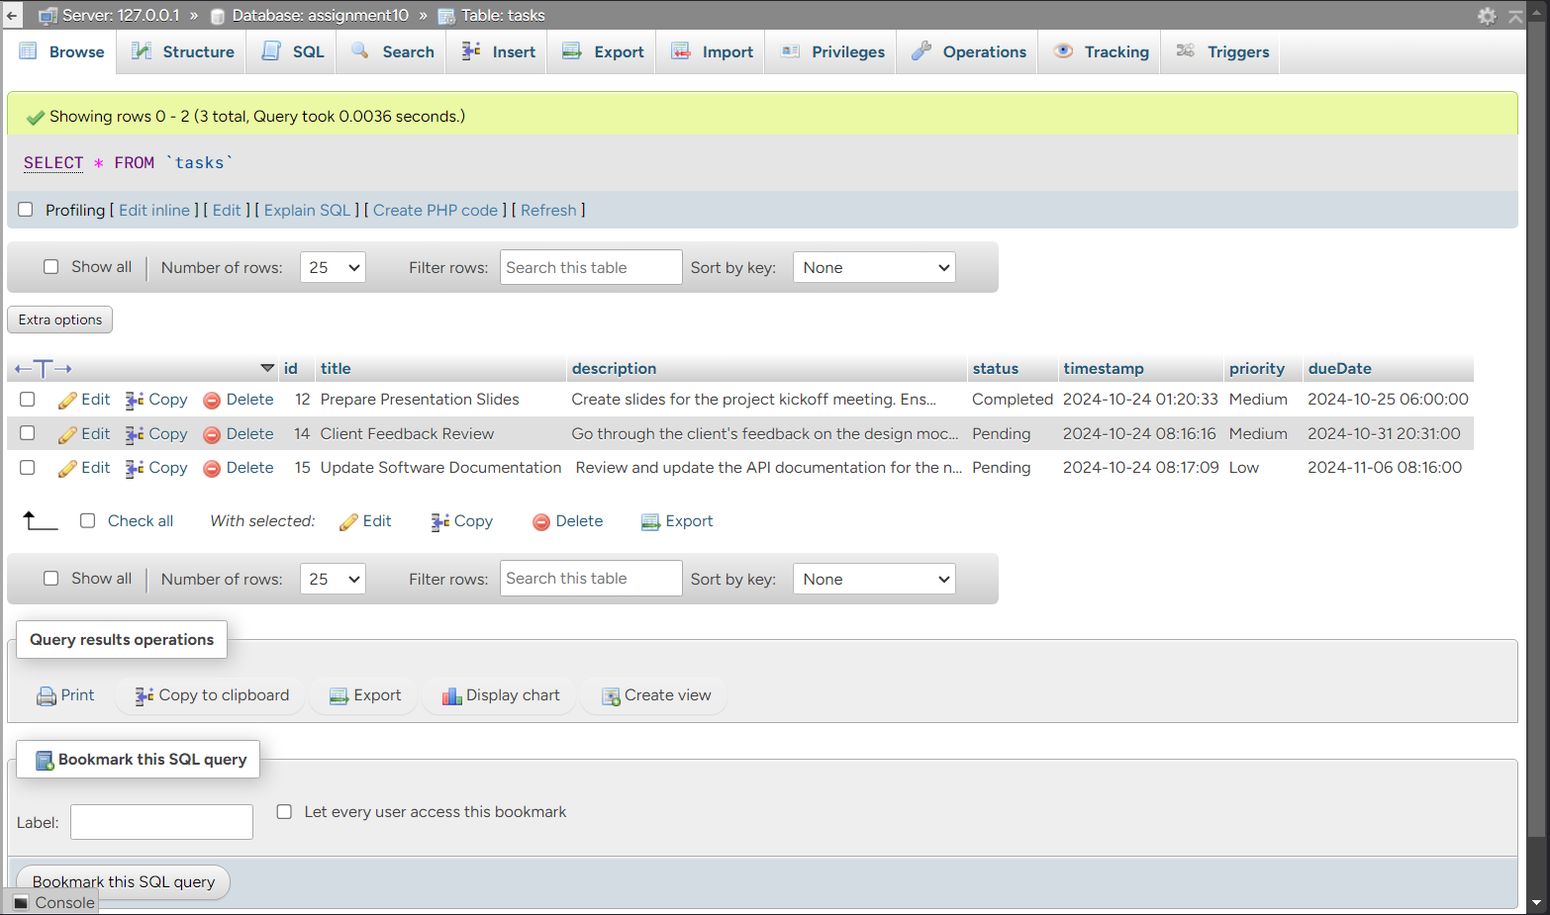

**Problem Statement 2: Simple Blog Application**

* Create a simple blog platform where users can sign up, log in, and write, edit, or delete their blog posts. Other users can view the blog posts but not edit or delete them.
* User authentication (JWT).
* Blog post CRUD operations.
* Display all blog posts on the homepage, with individual post details accessible through a unique URL.
* Add comment functionality where users can comment on blog posts

**Screenshots –**



