**Batch -** T5

**Practical No. -** 3

**Title –** Study of JavaScript

**Student Name -** Sharaneshwar Bharat Punjal

**Student PRN -** 23520011

**Problem Statement 1: Basics of Java Script**

Write a JavaScript function that takes an array of numbers as input and returns the sum of all numbers divisible by 10 in the array. Additionally, create a simple HTML interface with an input field where the user can enter comma-separated numbers and a button to trigger the calculation. Display the result below the button.

**Screenshot:**

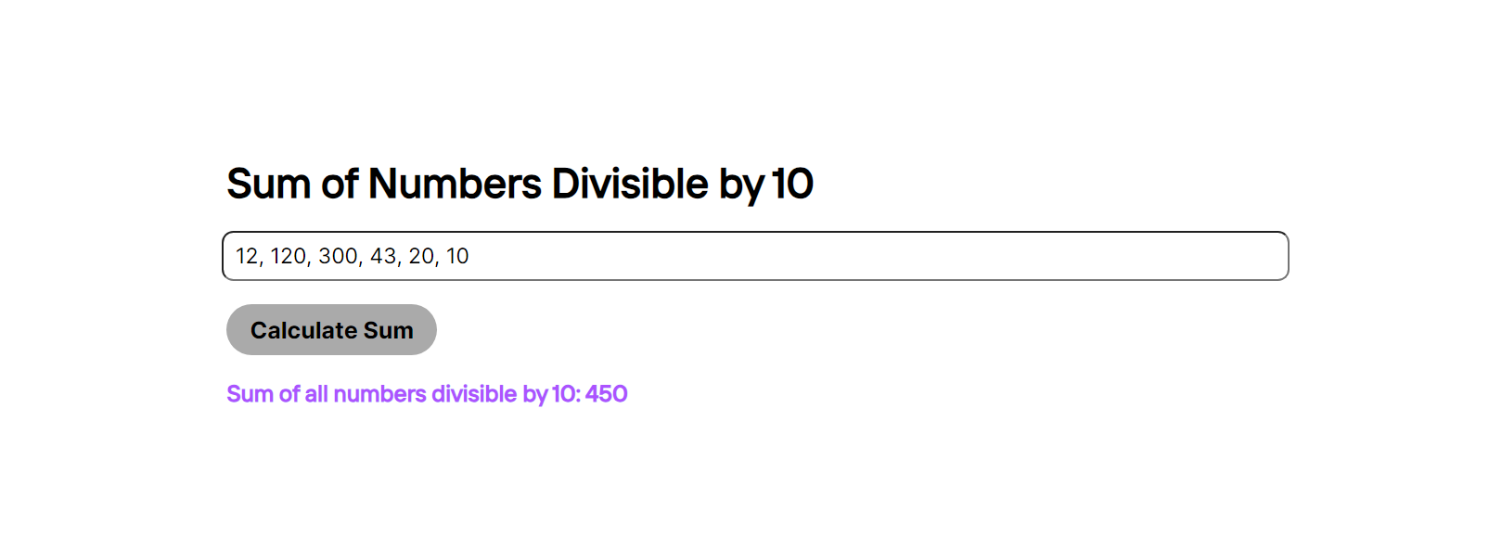

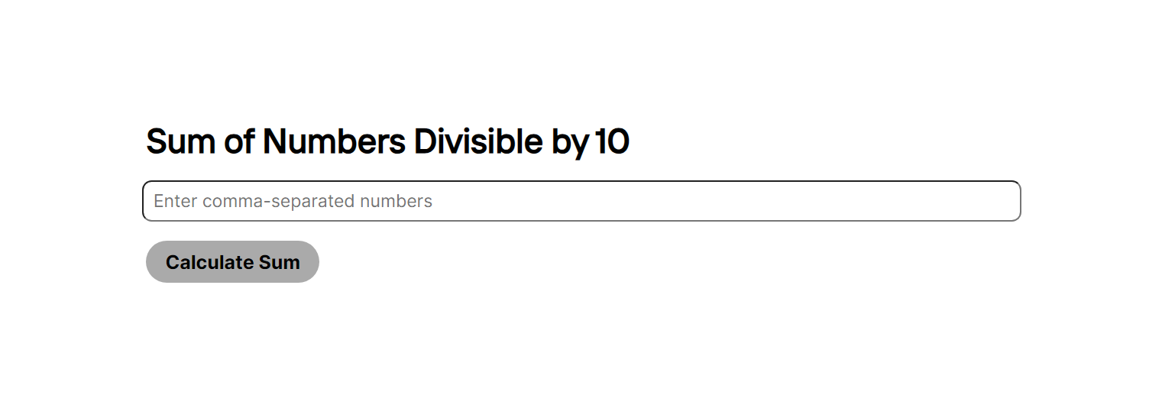

**Problem Statement 2**: **Implement a function that validates a password based on the following criteria:**

At least 8 characters long.

Contains at least one uppercase letter, one lowercase letter, one digit, and one special character.

Create an HTML form with an input field for the password and a "Check Password" button. Display a message indicating whether the password is valid or not.

**Screenshot:**

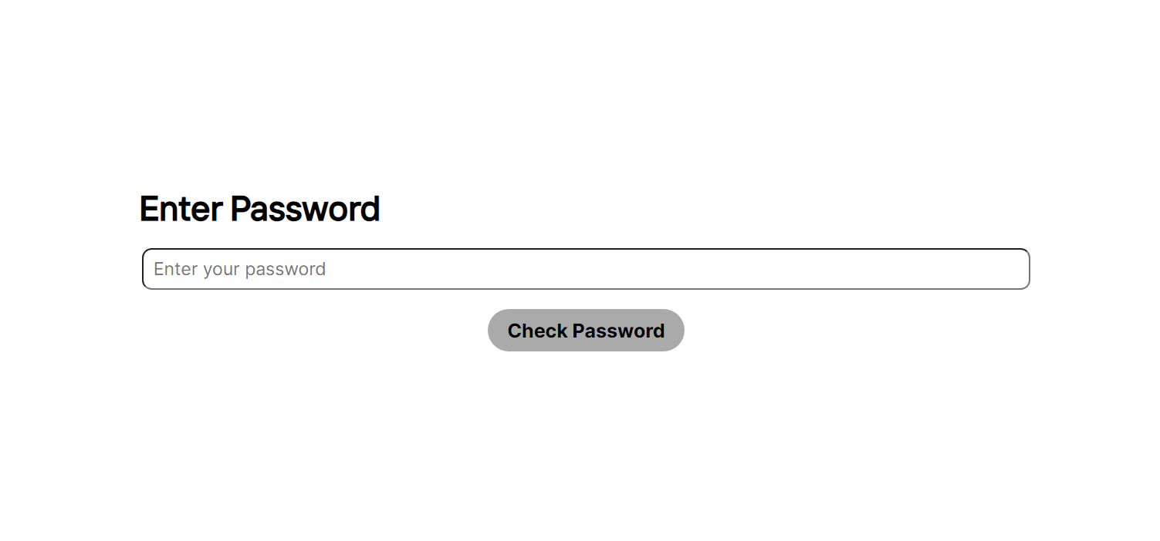

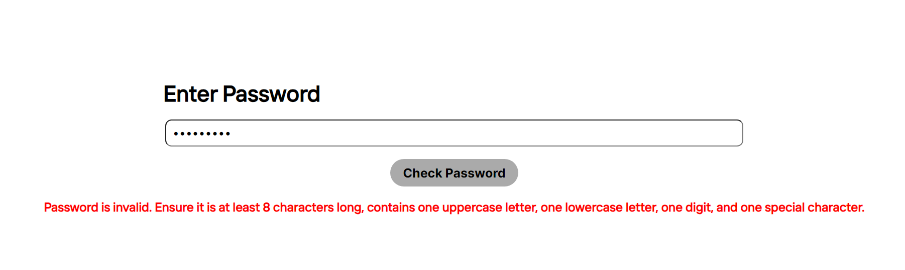

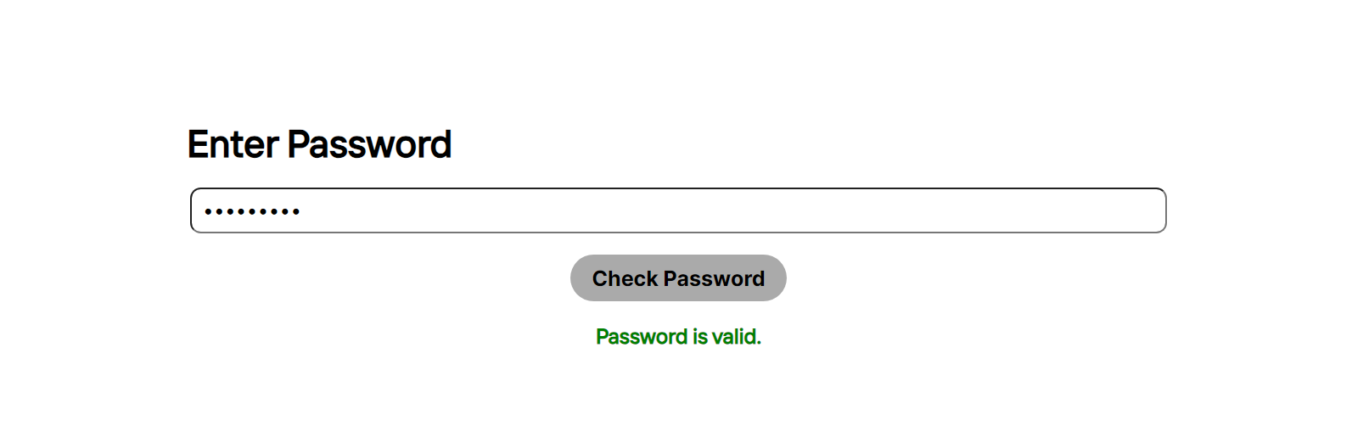

**Problem Statement 3: Web Development**

Create a basic web page for a fictional online bookstore using HTML, CSS, and JavaScript. The web page should have the following features:

* A header with the bookstore name and a navigation menu (Home, Books, Contact).
* An area to showcase featured books with their titles, authors, and cover images.
* A section where all available books are displayed in a grid format. Each book should have an image, title, author, and a button to "Add to Cart".
* Implement a simple shopping cart functionality using JavaScript. Allow users to add books to their cart and display the total number of items in the cart on the navigation menu.

**Screenshot:**

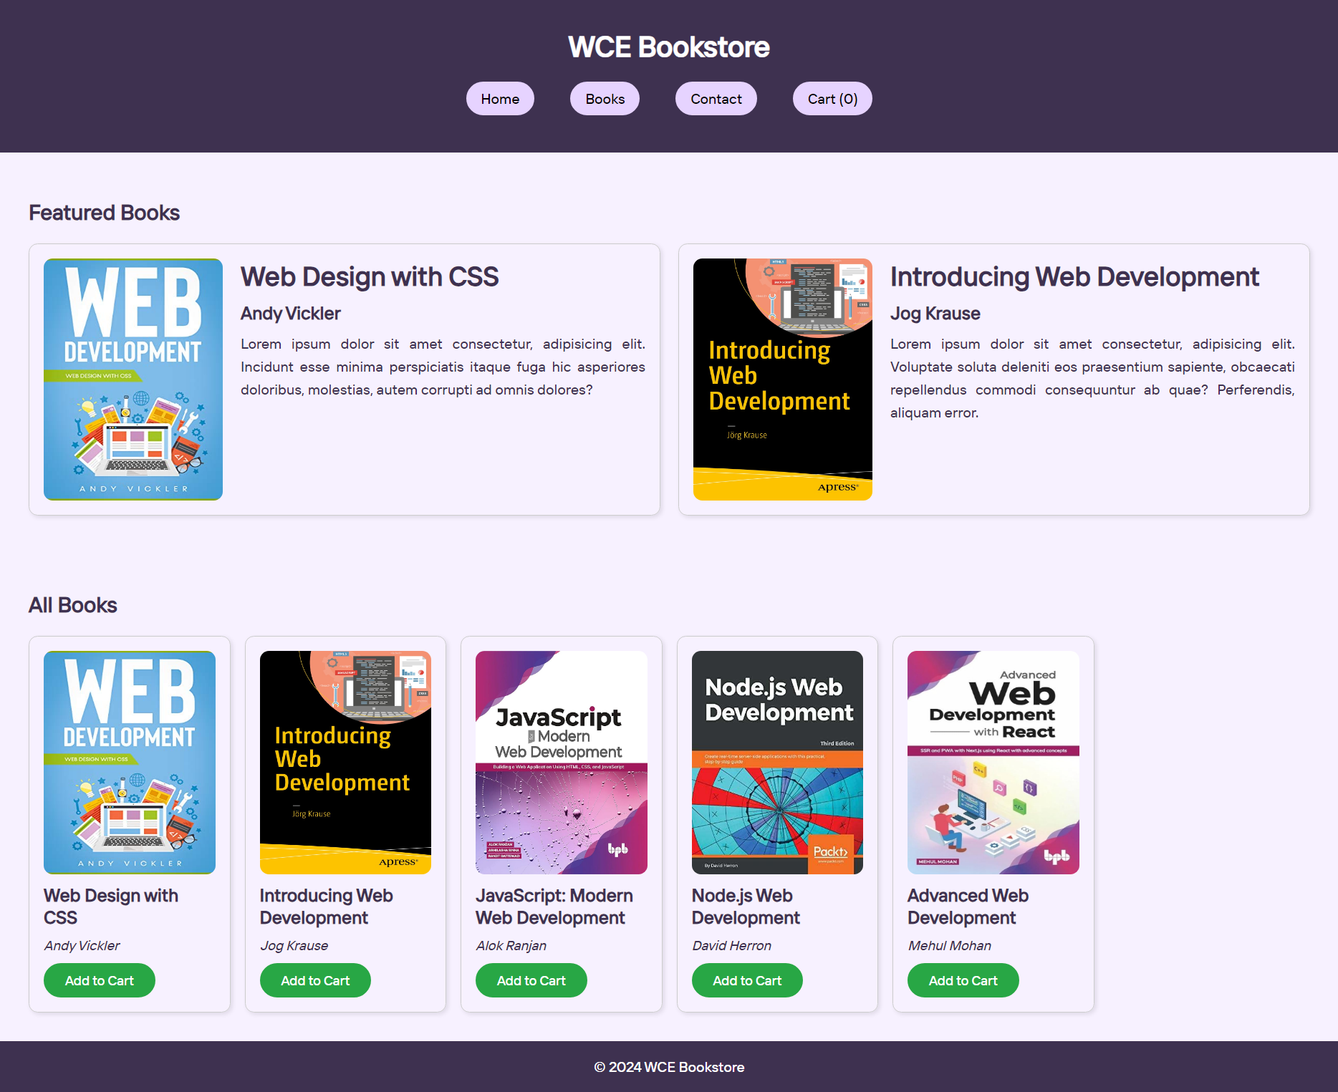

**Problem Statement 4**: **Responsive Design**

* Implement responsive design techniques to make the website mobile-friendly.
* Ensure that the navigation menu collapses into a hamburger menu on smaller screens.
* Adjust the layout and font sizes for optimal viewing on various devices.

**Screenshots:**

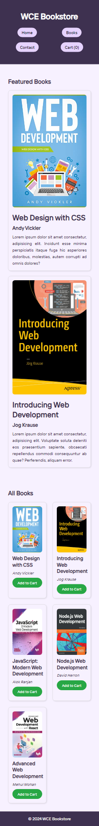

**Screenshots:**

