**Batch -** T7

**Assignment No. -** 1

**Title –** Installation, configuration & testing of MySQL

**Student Name -** Sharaneshwar Bharat Punjal

**Student PRN -** 23520011

**Tasks:**

1. Download / get setup CD of Server & Client (Win/Linux).

2. Read and follow the prerequisite for installation and accordingly set the system.

3. If server already installed, uninstall it.

4. Install MySQL Server on one machine.

5. Install Client (MySQL Workbench) on another machine.

6. Check the connectivity from Web client and SQL command line. (Note use the demo/example schema)

7. Create new user by your PRN e.g. 22511234.

8. Create sample database, create sample tables in newly created database

9. Repeat the step 6 for this new database.

10. Demonstrate the DML on new tables.

11. Create simple form in Angular which will connect to the database created in step 7. Allows to choose available tables. Provision in Angular Form to perform the CRUD operations on selected table.

**Solutions:**

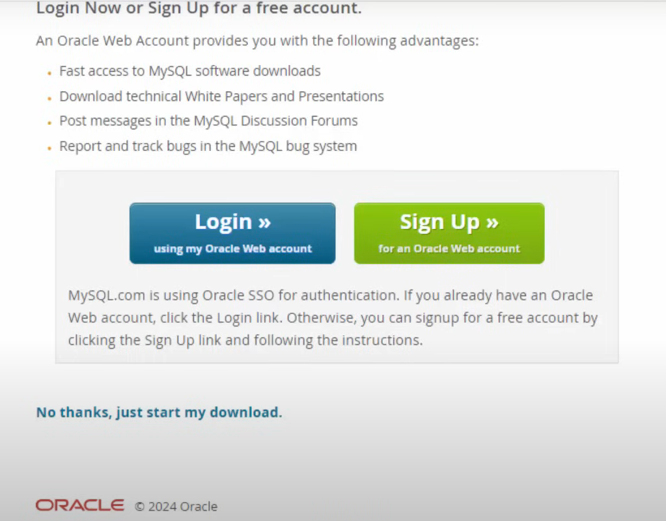

1. Change the bind-address to 0.0.0.0 so that anyone can access the server.

2. Ping to check the server client network.

3. Creation of database and checking the availability.

4. Also, connect new user with the IP address of the server to be given to client for connection over the same network if required.

As u can see the connection is successful.

**Angular Project**

Backend – Node JS, Express JS

Frontend – Angular

Functionalities – CRUD Operations on Remote Database Server

**Screenshots:**

