**ADSL Assignment 10**

Name: Sharaneshwar Punjal

PRN: 23520011

Batch: T7

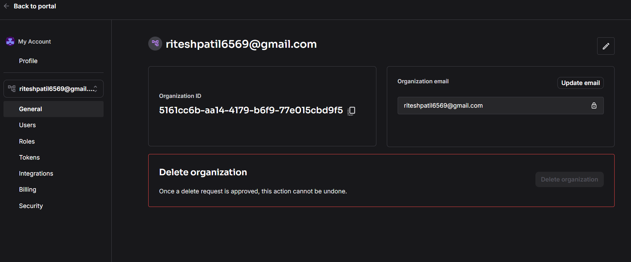

**punjalsharaneshwar@gmail.com**

**punjalsharaneshwar@gmail.com**

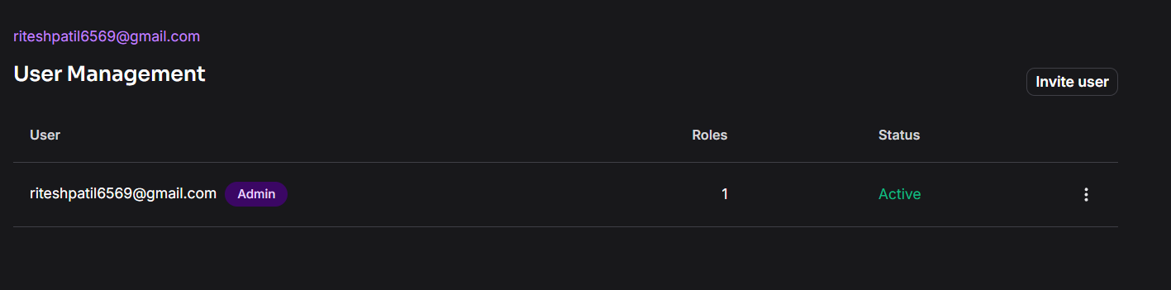

**punjalsharaneshwar@gmail.com**

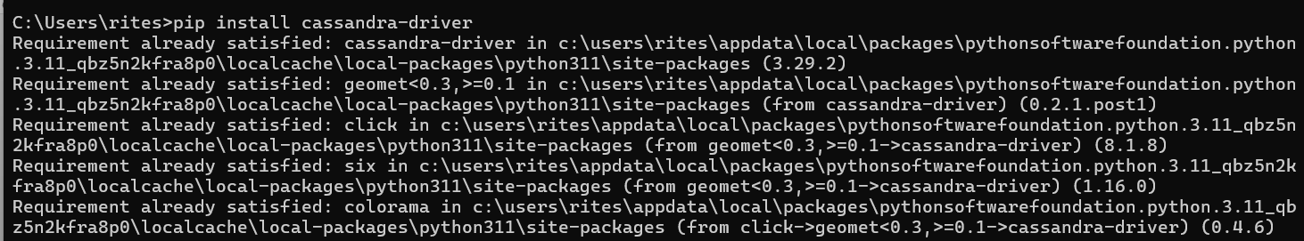

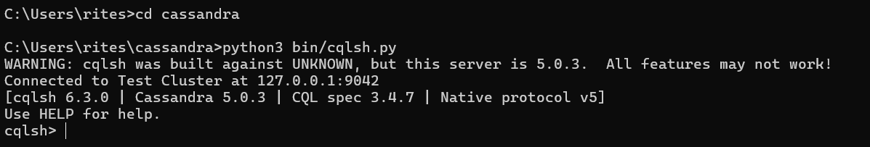

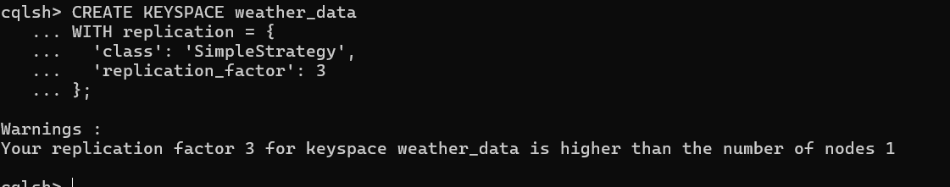

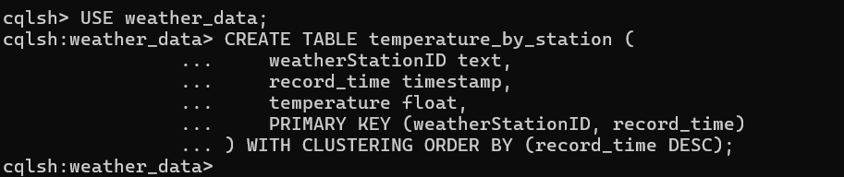



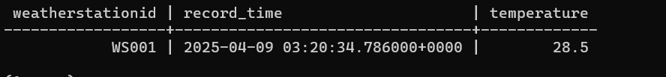

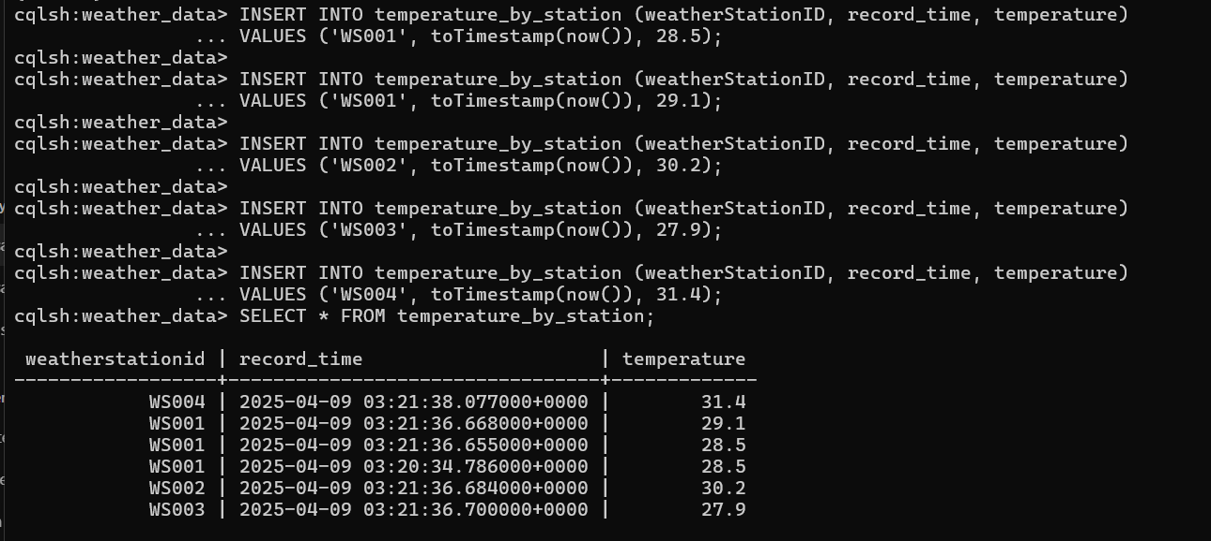

**Configure Node1 (127.0.0.2)**

cluster_name: '2025GRP44'

listen_address: 127.0.0.2

rpc_address: 127.0.0.2

seed_provider:

- class_name: org.apache.cassandra.locator.SimpleSeedProvider

parameters:

- seeds: "127.0.0.2"

data_file_directories:

- C:/Cassandra/Node1/data

commitlog_directory: C:/Cassandra/Node1/commitlog

saved_caches_directory: C:/Cassandra/Node1/saved_caches

**Configure Node2 (127.0.0.3)**

cluster_name: '2025GRP44'

listen_address: 127.0.0.3

rpc_address: 127.0.0.3

seed_provider:

- class_name: org.apache.cassandra.locator.SimpleSeedProvider

parameters:

- seeds: "127.0.0.2"

data_file_directories:

- C:/Cassandra/Node2/data

commitlog_directory: C:/Cassandra/Node2/commitlog

saved_caches_directory: C:/Cassandra/Node2/saved_caches

**Configure Node3 (127.0.0.4)**

cluster_name: '2025GRP44'

listen_address: 127.0.0.4

rpc_address: 127.0.0.4

seed_provider:

- class_name: org.apache.cassandra.locator.SimpleSeedProvider

parameters:

- seeds: "127.0.0.2"

data_file_directories:

- C:/Cassandra/Node3/data

commitlog_directory: C:/Cassandra/Node3/commitlog

saved_caches_directory: C:/Cassandra/Node3/saved_caches

