Batch - T5
Assignment No. - 1
Title - Sorting Algorithm
Student Name - Sharaneshwar Bharat Punjal
Student PRN - 23520011

1) You are given two sorted array, A and B, where A has a large enough buffer at the end to hold B. Write a method to merge B into A in sorted order.
import java.util.Scanner;

public class Q1 {
public static void merge(int[] A, int[] B, int n, int m) {
int i = n - 1;
int j = m - 1;
int k = n + m - 1;

while (i >= 0 && j >= 0) {
if (A[i] > B[j]) {
A[k] = A[i];
i--;
} else {
A[k] = B[j];
j--;
}
k--;
}

while (j >= 0) {
A[k] = B[j];
j--;
k--;
}
}

public static void main(String[] args) {
Scanner sc = new Scanner(System.in);
int n = sc.nextInt();
int m = sc.nextInt();

int[] A = new int[n + m];
int[] B = new int[m];

for (int i = 0; i < n; i++)
A[i] = sc.nextInt();

for (int i = 0; i < m; i++)
B[i] = sc.nextInt();

merge(A, B, n, m);

for (int i = 0; i < n + m; i++)
System.out.print(A[i] + " ");

System.out.println();
sc.close();
}
}
Test Case 1:
5 5
1 3 5 7 9
2 4 6 8 10
Output:
1 2 3 4 5 6 7 8 9

Test Case 2:
5 3
1 3 5 7 9
2 4 6
Output:
1 2 3 4 5 6 7 9

Test Case 3:
6 5
2 4 6 8 10 12
1 3 5 7 9
Output:
1 2 3 4 5 6 7 8 9 10 12

Test Case 4:
3 3
10 20 30
15 25 35
Output:
10 15 20 25 30 35

2) Write a method to sort an array of string so that all the anagrams are next to each other.
import java.util.Arrays;
import java.util.Scanner;

public class Q2 {
public static void sortAnagrams(String[] arr) {
int n = arr.length;

for (int i = 0; i < n - 1; i++) {
for (int j = 0; j < n - i - 1; j++) {
if (canonicalForm(arr[j]).compareTo(canonicalForm(arr[j + 1])) > 0) {
String temp = arr[j];
arr[j] = arr[j + 1];
arr[j + 1] = temp;
}
}
}
}

private static String canonicalForm(String s) {
char[] chars = s.toCharArray();
for (int i = 0; i < chars.length - 1; i++) {
for (int j = 0; j < chars.length - i - 1; j++) {
if (chars[j] > chars[j + 1]) {
char temp = chars[j];
chars[j] = chars[j + 1];
chars[j + 1] = temp;
}
}
}
return new String(chars);
}

public static void main(String[] args) {
Scanner sc = new Scanner(System.in);
int n = sc.nextInt();
String[] arr = new String[n];
for (int i = 0; i < n; i++)
arr[i] = sc.next();
sc.close();
sortAnagrams(arr);
System.out.println(Arrays.toString(arr));
}
}
Test Case 1:
6
cat dog tac god act odg
Output:
[act, cat, tac, dog, god, odg]

Test Case 2:
4
listen silent enlist inlets
Output:
[enlist, inlets, listen, silent]

Test Case 3:
5
abc bca cab xyz zyx
Output:
[abc, bca, cab, xyz, zyx]

Test Case 4:
7
bat tab cat act tca rat tar
Output:
[bat, tab, act, cat, tca, rat, tar]

Q) Given a sorted array of n integers that has been rotated an unknown number of times, write code to find an element in the array. You may assume that the array was originally sorted in increasing order.
EXAMPLE
Input: find 5 in {15, 16, 19, 20, 25, 1, 3, 4, 5, 7, 10, 14}
Output: 8 (the index of 5 in the array)
import java.util.Scanner;

public class Q3 {
public static void main(String[] args) {
Scanner sc = new Scanner(System.in);
int n = sc.nextInt();
int[] arr = new int[n];
for (int i = 0; i < n; i++)
arr[i] = sc.nextInt();
int target = sc.nextInt();
sc.close();

System.out.println(findElement(arr, target));
}

public static int findElement(int[] arr, int target) {
int left = 0;
int right = arr.length - 1;

while (left <= right) {
int mid = left + (right - left) / 2;

if (arr[mid] == target) {
return mid;
}

if (arr[left] <= arr[mid]) {
if (target >= arr[left] && target < arr[mid]) {
right = mid - 1;
} else {
left = mid + 1;
}
} else {
if (target > arr[mid] && target <= arr[right]) {
left = mid + 1;
} else {
right = mid - 1;
}
}
}

return -1;
}
}
Test Case 1:
12
15 16 19 20 25 1 3 4 5 7 10 14
5
Output:
8

Test Case 2:
10
4 5 6 7 8 9 1 2 3
3
Output:
9

Test Case 3:
7
10 20 30 40 50 5 7
50
Output:
4

Test Case 4:
8
50 60 70 80 90 100 10 20
70
Output:
2

Q) Imagine you have a 20GB file with one string per line. Explain how you would sort the file.
The idea is to use the external sort algorithm. We can't bring all the data into memory, so we need to use a divide and conquer approach. We can divide the file into chunks which are x megabytes each, where x is the amount of memory we have available. Each chunk is sorted separately and then saved back to the file system. Once all the chunks are sorted, we merge the chunks one by one. We can use a min heap to keep track of the next element to write to the file. We read the first element of each chunk into the heap and then write the smallest one to the file. We then read the next element from the chunk we took the smallest element from and add it to the heap. We continue this process until all elements have been written to the file. This is the external sort algorithm.

Q) Given a sorted array of string which is interspersed with empty string, write a method to find the location of a given string.
EXAMPLE
Input: find “ball” in {“at”, “”, “”, “ball”, “”, “”, “car”, “”, “”, “dad”, “”,””}
Output: 4
import java.util.Scanner;

public class Q5 {
public static void main(String[] args) {
Scanner sc = new Scanner(System.in);
int n = sc.nextInt();
String[] arr = new String[n];
sc.nextLine();
for (int i = 0; i < n; i++)
arr[i] = sc.nextLine();
String target = sc.nextLine();

sc.close();
System.out.println(findString(arr, target));
}

public static int findString(String[] arr, String target) {
if (arr == null || target == null || target.isEmpty()) {
return -1;
}
return search(arr, target, 0, arr.length - 1);
}

private static int search(String[] arr, String target, int left, int right) {
if (left > right) {
return -1;
}

int mid = left + (right - left) / 2;

if (arr[mid].isEmpty()) {
int leftMid = mid - 1;
int rightMid = mid + 1;

while (true) {
if (leftMid < left && rightMid > right) {
return -1;
} else if (rightMid <= right && !arr[rightMid].isEmpty()) {
mid = rightMid;
break;
} else if (leftMid >= left && !arr[leftMid].isEmpty()) {
mid = leftMid;
break;
}
rightMid++;
leftMid--;
}
}

if (arr[mid].equals(target)) {
return mid;
} else if (arr[mid].compareTo(target) < 0) {
return search(arr, target, mid + 1, right);
} else {
return search(arr, target, left, mid - 1);
}
}
}
Test Case 1:
12
at
""
""
ball
""
""
car
""
""
dad
""
""
ball
Output:
3

Test Case 2:
8
apple
""
banana
""
""
cat
""
dog
banana
Output:
2

Test Case 3:
10
at
""
ball
""
""
""
car
""
""
cat
car
Output:
6

Test Case 4:
10
at
""
ball
""
""
""
car
""
""
cat
car
Output:
4

Q) Given an M*N matrix in which each row and each column is sorted in ascending order, write a method to find an element.
import java.util.Arrays;
import java.util.Scanner;

public class Q6 {
public static void main(String[] args) {
Scanner sc = new Scanner(System.in);
int m = sc.nextInt();
int n = sc.nextInt();
int[][] matrix = new int[m][n];
for (int i = 0; i < m; i++)
for (int j = 0; j < n; j++)
matrix[i][j] = sc.nextInt();
int target = sc.nextInt();
sc.close();

System.out.println(Arrays.toString(findElement(matrix, target)));
}

public static int[] findElement(int[][] matrix, int target) {
if (matrix == null || matrix.length == 0 || matrix[0].length == 0) {
return new int[]{-1, -1};
}

int row = 0;
int col = matrix[0].length - 1;

while (row < matrix.length && col >= 0) {
if (matrix[row][col] == target) {
return new int[]{row, col};
} else if (matrix[row][col] < target) {
row++;
} else {
col--;
}
}

return new int[]{-1, -1};
}
}
Test Case 1:
3 4
1 4 7 11
2 5 8 12
3 6 9 16
8
Output:
[1, 2]

Test Case 2:
3 4
1 4 7 11
2 5 8 12
3 6 9 16
10
Output:
[-1, -1]

Test Case 3:
1 1
5
5
Output:
[0, 0]

Test Case 4:
0 0
5
Output:
[-1, -1]

Q) A circus is designing a tower routine consisting of people standing atop one another’s shoulders. For practical and aesthetic reasons, each person must be both shorter and lighter than the person below him or her. Given the heights and weight of each circus, write a method to compute the largest possible number of people in such tower.
EXAMPLE:
Input(ht,wt): (65, 100) (70, 150) (56, 90) (75,190) (60, 95) (68, 110).
Output: The longest tower is length 6 and includes from top to bottom:
(56, 90) (60, 95) (65, 100) (68, 110) (70, 150) (75, 190)
import java.util.Arrays;
import java.util.Scanner;

public class Q7 {
public static void main(String[] args) {
Scanner sc = new Scanner(System.in);

int n = sc.nextInt();
int[][] people = new int[n][2];

for (int i = 0; i < n; i++) {
people[i][0] = sc.nextInt();
people[i][1] = sc.nextInt();
}

sc.close();

System.out.println(findLongestTower(people));
}

public static int findLongestTower(int[][] people) {
if (people == null || people.length == 0) {
return 0;
}

Arrays.sort(people, (p1, p2) -> {
if (p1[0] != p2[0]) {
return Integer.compare(p1[0], p2[0]);
} else {
return Integer.compare(p1[1], p2[1]);
}
});

int[] dp = new int[people.length];
Arrays.fill(dp, 1);

for (int i = 1; i < people.length; i++) {
for (int j = 0; j < i; j++) {
if (people[i][0] > people[j][0] && people[i][1] > people[j][1]) {
dp[i] = Math.max(dp[i], dp[j] + 1);
}
}
}

return Arrays.stream(dp).max().getAsInt();
}
}
Test Case 1:
6
65 100
70 150
56 90
75 190
60 95
68 110
Output:
6

Test Case 2:
4
80 200
75 210
85 180
90 170
Output:
1

Test Case 3:
5
65 100
70 150
56 105
75 130
60 90
Output:
3

Test Case 4:
8
56 90
60 110
65 100
70 150
75 130
80 190
68 120
66 80
Output:
5

Q) Imagine you are reading in stream of integers. Periodically, you wish to be able to look up the rank of number x (the number of values less than or equal to x). Implement the data structures and algorithms to support these operations. That is, Implement the method track (int x), which is called when each number is generated, and the method getRankOfNumber (int x), which return the number of values less than or equal to x (not including x itself).
EXAMPLE
Stream (in order of appearance) : 5, 1, 4, 4, 5, 9, 7, 13, 3
getRankOfNumber(1) = 0
getRankOfNumber(3) = 1
getRankOfNumber(4) =3
import java.util.Arrays;
import java.util.Scanner;

public class Q8 {
public static void main(String[] args) {
Scanner sc = new Scanner(System.in);
int n = sc.nextInt();

int stream[] = new int[n];
for (int i = 0; i < n; i++) {
stream[i] = sc.nextInt();
}
sc.close();

Arrays.sort(stream);

System.out.println(getRankOfNumber(stream, 1));
System.out.println(getRankOfNumber(stream, 3));
System.out.println(getRankOfNumber(stream, 4));
System.out.println(getRankOfNumber(stream, 9));
}

private static int getRankOfNumber(int stream[], int x) {
int left = 0;
int right = stream.length - 1;

while (left <= right) {
int mid = left + (right - left) / 2;
if (stream[mid] <= x) {
left = mid + 1;
} else {
right = mid - 1;
}
}
return left - 1;
}
}
Test Case 1:
9
5 1 4 4 5 9 7 13 3
Output:
0
1
3
6

Test Case 2:
7
2 2 2 2 2 2 2
Output:
6
6
6
6

Test Case 3:
6
-3 -1 0 2 4 6
Output:
0
1
2
5

Test Case 4:
1
10
Output:
-1
-1
-1
0

Batch – T5
Assignment No. - 2
Title - Searching Algorithm
Student Name - Sharaneshwar Bharat Punjal
Student PRN - 23520011

1) You are an IT company's manager. Based on their performance over the last N working days, you must rate your employee. You are given an array of N integers called workload, where workload[i] represents the number of hours an employee worked on an ith day. The employee must be evaluated using the following criteria:
Rating = the maximum number of consecutive working days when the employee has worked more than 6 hours.
You are given an integer N where N represents the number of working days. You are given an integer array workload where workload[i] represents the number of hours an employee worked on an ith day.
Task: Determine the employee rating
import java.util.Scanner;

public class Q1 {
public static void main(String[] args) {
Scanner sc = new Scanner(System.in);
int n = sc.nextInt();
int[] workload = new int[n];
for (int i = 0; i < workload.length; i++)
workload[i] = sc.nextInt();
sc.close();

System.out.println(getRating(workload, n));
}

private static int getRating(int[] workload, int N) {
int rating = Integer.MIN_VALUE;
int cnt = 0;

for (int i : workload) {
if (i > 6)
cnt++;
else {
rating = Math.max(rating, cnt);
cnt = 0;
}
}
rating = Math.max(rating, cnt);
return rating;
}
}

Test Case 1:
7
8 7 5 6 10 9 2
Output:
2

Test Case 2:
5
7 8 9 10 11
Output:
5

Test Case 3:
4
3 4 5 6
Output:
0

Test Case 4:
20
5 6 7 8 2 3 4 5 9 10 11 12 1 2 3 6 7 8 1 2
Output:
4

2) You have N boxes numbered 1 through N and K candies numbered 1 through K. You put the candies in the boxes in the following order:
first candy in the first box,
second candy in the second box,
.......
.......
so up to N-th candy in the Nth box,
the next candy in (N - 1)-th box,
the next candy in (N - 2)-th box
.......
.......
and so on up to the first box,
then the next candy in the second box
...... and so on until there is no candy left.
So you put the candies in the boxes in the following order:
Find the index of the box where you put the K-th candy.
import java.util.Scanner;

public class Q2 {
public static void main(String[] args) {
Scanner sc = new Scanner(System.in);
int T = sc.nextInt();

while (T-- > 0) {
int N = sc.nextInt();
int K = sc.nextInt();
System.out.println(findBoxIndex(N, K));
}

sc.close();
}

private static int findBoxIndex(int N, int K) {
int cycleLength = 2 * (N - 1);

int pos = (K - 1) % cycleLength;

if (pos < N)
return pos + 1;
else
return N - (pos - N + 1);
}
}
Test Case 1:
4
5 7
4 10
6 20
10 25
Output:
3
2
6
6

Test Case 2:
3
2 5
3 8
7 14
Output:
2
2
7

Test Case 3:
4
3 7
5 13
6 18
8 24
Output:
1
3
6
8

Test Case 4:
3
4 100
7 150
10 200
Output:
4
6
10

3) Implement and Explain Tower of Hanoi algorithm.
import java.util.Scanner;

public class Q3 {
public static void main(String[] args) {
Scanner sc = new Scanner(System.in);
int n = sc.nextInt();
sc.close();
towerOfHanoi(n, 'A', 'C', 'B');
}

private static void towerOfHanoi(int n, char from, char to, char aux) {
if (n == 1) {
System.out.println("Move disk 1 from rod " + from + " to rod " + to);
return;
}

towerOfHanoi(n - 1, from, aux, to);
System.out.println("Move disk " + n + " from rod " + from + " to rod " + to);
towerOfHanoi(n - 1, aux, to, from);
}
}
Test Case 1:
3
Output:
Move disk 1 from rod A to rod C
Move disk 2 from rod A to rod B
Move disk 1 from rod C to rod B
Move disk 3 from rod A to rod C
Move disk 1 from rod B to rod A
Move disk 2 from rod B to rod C
Move disk 1 from rod A to rod C

Test Case 2:
2
Output:
Move disk 1 from rod A to rod B
Move disk 2 from rod A to rod C
Move disk 1 from rod B to rod C

Test Case 3:
4
Output:
Move disk 1 from rod A to rod B
Move disk 2 from rod A to rod C
Move disk 1 from rod B to rod C
Move disk 3 from rod A to rod B
Move disk 1 from rod C to rod A
Move disk 2 from rod C to rod B
Move disk 1 from rod A to rod B
Move disk 4 from rod A to rod C
Move disk 1 from rod B to rod C
Move disk 2 from rod B to rod A
Move disk 1 from rod C to rod A
Move disk 3 from rod B to rod C
Move disk 1 from rod A to rod B
Move disk 2 from rod A to rod C
Move disk 1 from rod B to rod C

Test Case 4:
5
Output:
Move disk 1 from rod A to rod C
Move disk 2 from rod A to rod B
Move disk 1 from rod C to rod B
Move disk 3 from rod A to rod C
Move disk 1 from rod B to rod A
Move disk 2 from rod B to rod C
Move disk 1 from rod A to rod C
Move disk 4 from rod A to rod B
Move disk 1 from rod C to rod B
Move disk 2 from rod C to rod A
Move disk 1 from rod B to rod A
Move disk 3 from rod C to rod B
Move disk 1 from rod A to rod C
Move disk 2 from rod A to rod B
Move disk 1 from rod C to rod B
Move disk 5 from rod A to rod C
Move disk 1 from rod B to rod A
Move disk 2 from rod B to rod C
Move disk 1 from rod A to rod C
Move disk 3 from rod B to rod A
Move disk 1 from rod C to rod B
Move disk 2 from rod C to rod A
Move disk 1 from rod B to rod A
Move disk 4 from rod B to rod C
Move disk 1 from rod A to rod C
Move disk 2 from rod A to rod B
Move disk 1 from rod C to rod B
Move disk 3 from rod A to rod C
Move disk 1 from rod B to rod A
Move disk 2 from rod B to rod C
Move disk 1 from rod A to rod C

4) There is a frog initially placed at the origin of the coordinate plane. In exactly 1 second, the frog can either move up 1 unit, move right 1 unit, or stay still. In other words, from position (x, y), the frog can spend 1 second to move to:
(X + 1, Y)
(X, Y + 1)
(X, Y)
After T seconds, a villager who sees the frog reports that the frog lies on or inside a square of side-length s with coordinates (X, Y), (X + S, Y), (X, Y + S), (X + S, Y + S). Calculate how many points with integer coordinates on or inside this square could be the frog's position after exactly T seconds
Input Format:
The first and only line of input contains four space-separated integers: X, Y, S, and T.
Output Format:
Print the number of points with integer coordinates that could be the frog's position after T seconds.
import java.util.Scanner;

public class Q4 {
public static void main(String args[] ) throws Exception {
Scanner sc = new Scanner(System.in);
int X = sc.nextInt();
int Y = sc.nextInt();
int s = sc.nextInt();
int T = sc.nextInt();

int count = 0;
for (int i = X; i <= X + s; i++)
for (int j = Y ; j <= Y + s; j++)
if (i + j <= T)
count++;

System.out.println(count);

sc.close();
}
}
Test Case 1:
1 1 2 5
Output:
8

Test Case 2:
0 0 1 2
Output:
4

Test Case 3:
2 2 3 6
Output:
6

Test Case 4:
2 60 95 116
Output:
1540

5) Implement linear Search Algorithm.
import java.util.Scanner;

public class Q5 {
public static void main(String[] args) {
Scanner sc = new Scanner(System.in);
int n = sc.nextInt();
int arr[] = new int[n];
for (int i = 0; i < n; i++)
arr[i] = sc.nextInt();

int key = sc.nextInt();
sc.close();

int index = linearSearch(arr, key);
if (index == -1) {
System.out.println("Element not found");
} else {
System.out.println("Element found at index: " + index);
}
}

public static int linearSearch(int[] arr, int key) {
for (int i = 0; i < arr.length; i++) {
if (arr[i] == key) {
return i;
}
}
return -1;
}
}
Test Case 1:
25
10 22 35 47 50 65 78 89 90 102 113 124 135 146 157 168 179 190 201 212 223 234 245 256 267
124
Output:
Element found at index: 11

Test Case 2:
30
5 17 29 41 53 65 77 89 101 113 125 137 149 161 173 185 197 209 221 233 245 257 269 281 293 305 317 329 341 353
305
Output:
Element found at index: 25

Test Case 3:
22
8 16 24 32 40 48 56 64 72 80 88 96 104 112 120 128 136 144 152 160 168 176
474
Output:
Element not found

Test Case 4:
24
7 14 21 28 35 42 49 56 63 70 77 84 91 98 105 112 119 126 133 140 147 154 161 168
140
Output:
Element found at index: 20

6) Implement Binary Search algorithm.
import java.util.Scanner;

public class Q6 {
public static void main(String[] args) {
Scanner sc = new Scanner(System.in);
int n = sc.nextInt();
int arr[] = new int[n];
for (int i = 0; i < n; i++)
arr[i] = sc.nextInt();

int key = sc.nextInt();
sc.close();

int index = binarySearch(arr, key);

if (index == -1) {
System.out.println("Element not found");
} else {
System.out.println("Element found at index: " + index);
}
}

public static int binarySearch(int[] arr, int key) {
int low = 0;
int high = arr.length - 1;

while (low <= high) {
int mid = low + (high - low) / 2;

if (arr[mid] == key) {
return mid;
}

if (arr[mid] < key) {
low = mid + 1;
} else {
high = mid - 1;
}
}

return -1;
}
}
Test Case 1:
15
3 7 11 16 20 25 30 35 40 45 50 55 60 65 70
55
Output:
Element found at index: 11

Test Case 2:
20
-10 -5 0 5 10 15 20 25 30 35 40 45 50 55 60 65 70 75 80 85
5
Output:
Element found at index: 3

Test Case 3:
25
100 200 300 400 500 600 700 800 900 1000 1100 1200 1300 1400 1500 1600 1700 1800 1900 2000 2100 2200 2300 2400 2500
1950
Output:
Element not found

Test Case 4:
18
2 4 6 8 10 12 14 16 18 20 22 24 26 28 30 32 34 36
28
Output:
Element found at index: 13

Batch - T5
Assignment No. - 3
Title - Divide and Conquer Strategy – Part 1
Student Name - Sharaneshwar Bharat Punjal
Student PRN – 23520011

1) Implement algorithm to find the maximum element in an array which is first increasing and then decreasing, with time complexity O (log n).
Algorithm:
1. Initialize two pointers: low at the start of the array and high at the end.
2. While low is less than or equal to high:
Calculate the middle index mid.
Check if mid is the peak element
3. If the element at mid is greater than both its neighbours, then arr[mid] is the
maximum element.
4. If the array is increasing at mid, then move the low pointer to mid + 1.
5. Otherwise, move the high pointer to mid - 1.
6. The loop will eventually converge on the maximum element.

Code:
import java.util.Scanner;

public class Q1 {
public static void main(String[] args) {
Scanner sc = new Scanner(System.in);
int n = sc.nextInt();
int[] arr = new int[n];
for (int i = 0; i < n; i++)
arr[i] = sc.nextInt();
sc.close();

System.out.println(findMaximum(arr, n));
}

public static int findMaximum(int[] arr, int n) {
int left = 0;
int right = n - 1;

while (left <= right) {
int mid = left + (right - left) / 2;

if (left == right)
return arr[left];

if (right == left + 1)
return Math.max(arr[left], arr[right]);

if (arr[mid] > arr[mid - 1] && arr[mid] > arr[mid + 1])
return arr[mid];

if (arr[mid] > arr[mid - 1] && arr[mid] < arr[mid + 1])
left = mid + 1;
else
right = mid - 1;
}

return -1;
}
}

Test Case 1:
10
1 3 5 7 9 12 15 10 6 2
Output:
15

Test Case 2:
15
5 10 15 20 25 30 35 30 25 20 15 10 5 3 1
Output:
35

Test Case 3:
20
2 5 10 15 20 30 40 50 45 35 25 15 10 5 2 1 0 -1 -2 -3
Output:
50

Test Case 4:
25
3 6 12 18 27 35 40 38 30 20 15 10 5 2 1 0 -2 -5 -10 -15 -20 -25 -30 -35 -40
Output:
40

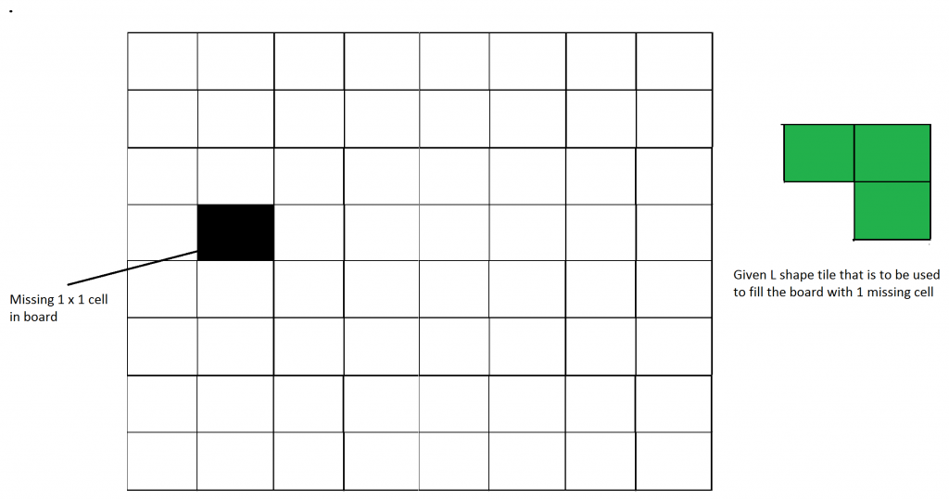
2) Implement algorithm for Tiling problem: Given an n by n board where n is of form 2k where k >= 1 (Basically n is a power of 2 with minimum value as 2). The board has one missing cell (of size 1 x 1). Fill the board using L shaped tiles. An L shaped tile is a 2 x 2 square with one cell of size 1×1 missing.
Algorithm:
1. Start with an empty board of size n x n initialized with all zeros.
2. Mark the pre-filled cell (given as input) with -1.
3. Define a recursive function tile(size, r, c, board) to fill the board.
4. If the current sub-board size is 2 x 2, fill it with a unique tile number, ensuring that the missing tile is respected.
5. Find the coordinates of the pre-filled cell within the current sub-board.
6. Based on the location of this pre-filled cell, place an L-shaped tromino in the other three quadrants.
7. Recursively apply the tile function to the four quadrants.
8. The base case is when the size of the sub-board is 2 x 2. In this case, fill the empty cells with the current tile number.
9. After the board is fully tiled, output the board.

Code:
import java.util.Scanner;

public class Q2 {

static int tileNum = 0;
static char[][] board;

private static void place(int x1, int y1, int x2, int y2, int x3, int y3) {
tileNum++;
board[x1][y1] = '*';
board[x2][y2] = '*';
board[x3][y3] = '*';
}

private static void tile(int size, int r, int c) {
if (size == 2) {
tileNum++;
for (int i = 0; i < size; i++) {
for (int j = 0; j < size; j++) {
if (board[r + i][c + j] == ' ') {
board[r + i][c + j] = '*';
}
}
}
return;
}

int mr = -1, mc = -1;
for (int i = r; i < r + size; i++) {
for (int j = c; j < c + size; j++) {
if (board[i][j] != ' ') {
mr = i;
mc = j;
break;
}
}
if (mr != -1) break;
}

if (mr < r + size / 2 && mc < c + size / 2) {
place(r + size / 2, c + size / 2 - 1, r + size / 2, c + size / 2, r + size / 2 - 1, c + size / 2);
} else if (mr >= r + size / 2 && mc < c + size / 2) {
place(r + size / 2 - 1, c + size / 2, r + size / 2, c + size / 2, r + size / 2 - 1, c + size / 2 - 1);
} else if (mr < r + size / 2 && mc >= c + size / 2) {
place(r + size / 2, c + size / 2 - 1, r + size / 2, c + size / 2, r + size / 2 - 1, c + size / 2 - 1);
} else if (mr >= r + size / 2 && mc >= c + size / 2) {
place(r + size / 2 - 1, c + size / 2, r + size / 2, c + size / 2 - 1, r + size / 2 - 1, c + size / 2 - 1);
}

tile(size / 2, r, c + size / 2);
tile(size / 2, r, c);
tile(size / 2, r + size / 2, c);
tile(size / 2, r + size / 2, c + size / 2);
}

public static void main(String[] args) {
Scanner sc = new Scanner(System.in);
int n = sc.nextInt();
int mr = sc.nextInt();
int mc = sc.nextInt();
sc.close();

board = new char[n][n];
for (int i = 0; i < n; i++) {
for (int j = 0; j < n; j++) {
board[i][j] = ' ';
}
}

board[mr][mc] = '+';

tile(n, 0, 0);

for (int i = 0; i < n; i++) {
for (int j = 0; j < n; j++) {
System.out.print(board[i][j] + " ");
}
System.out.println();
}
}
}
Test Case 1:
4
1 2
Output:
* * * *
* * + *
* * * *
* * * *

Test Case 2:
8
2 2
Output:
* * * * * * * *
* * * * * * * *
* * + * * * * *
* * * * * * * *
* * * * * * * *
* * * * * * * *
* * * * * * * *
* * * * * * * *

Test Case 3:
16
4 3
Output:
* * * * * * * * * * * * * * * *
* * * * * * * * * * * * * * * *
* * * * * * * * * * * * * * * *
* * * * * * * * * * * * * * * *
* * * + * * * * * * * * * * * *
* * * * * * * * * * * * * * * *
* * * * * * * * * * * * * * * *
* * * * * * * * * * * * * * * *
* * * * * * * * * * * * * * * *
* * * * * * * * * * * * * * * *
* * * * * * * * * * * * * * * *
* * * * * * * * * * * * * * * *
* * * * * * * * * * * * * * * *
* * * * * * * * * * * * * * * *
* * * * * * * * * * * * * * * *
* * * * * * * * * * * * * * * *

Test Case 4:
2
1 1
Output:
* *
* +

3) Implement algorithm for The Skyline Problem: Given n rectangular buildings in a 2-dimensional city, computes the skyline of these buildings, eliminating hidden lines. The main task is to view buildings from a side and remove all sections that are not visible.
All buildings share common bottom and every building is represented by triplet (left, ht, right)
‘left’: is x coordinated of left side (or wall).
‘right': is x coordinate of right side
‘ht': is height of building.
For example, the building on right side is represented as (1, 11, 5)
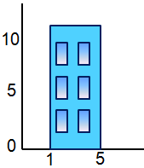
A skyline is a collection of rectangular strips. A rectangular strip is represented as a pair (left, ht) where left is x coordinate of left side of strip and ht is height of strip.
Required Time Complexity - O (n log n)
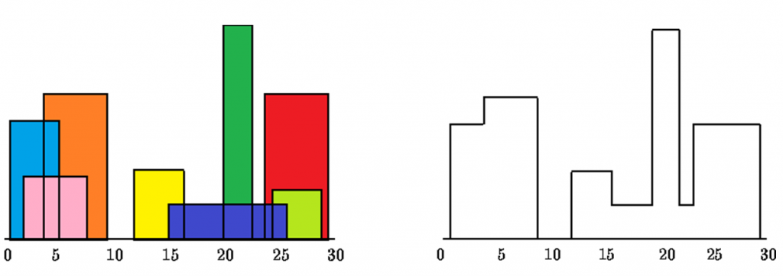
Algorithm:
1. The input is a list of buildings, where each building is represented by a triplet [Li, Ri, Hi], where Li is the left coordinate, Ri is the right coordinate, and Hi is the height.
2. For each building, generate two points:
- A start point (Li, -Hi) which represents the beginning of the building with negative height to distinguish start from end.
- An end point (Ri, Hi) which represents the end of the building with positive height.
3. Sort the points. If two points have the same x-coordinate, the point with the
smaller height comes first. If two points have the same height, the start point
(negative height) comes before the end point (positive height).
4. Use a max-heap to keep track of the current heights of the buildings as you iterate through the points. For each point:
- If it’s a start point, add its height to the heap.
- If it’s an end point, remove its height from the heap.
- Compare the current maximum height (top of the heap) with the previous maximum height. If they differ, this means the skyline changes at this point, so record this point in the result.

Code:
import java.util.*;

public class Q3 {

static class Point {
int x, height;

Point(int x, int height) {
this.x = x;
this.height = height;
}
}

public static List<List<Integer>> getSkyline(int[][] buildings) {
List<List<Integer>> result = new ArrayList<>();
TreeSet<Integer> heights = new TreeSet<>(Collections.reverseOrder());
List<Point> points = new ArrayList<>();

for (int[] building : buildings) {
points.add(new Point(building[0], -building[2]));
points.add(new Point(building[1], building[2]));
}

points.sort((a, b) -> {
if (a.x != b.x)
return Integer.compare(a.x, b.x);
return Integer.compare(b.height, a.height);
});

int ongoingHeight = 0;

for (Point point : points) {
int currentPoint = point.x;
int heightAtCurrentPoint = point.height;

if (heightAtCurrentPoint < 0) {
heights.add(-heightAtCurrentPoint);
} else {
heights.remove(heightAtCurrentPoint);
}

int currentHeight = heights.isEmpty() ? 0 : heights.first();

if (ongoingHeight != currentHeight) {
ongoingHeight = currentHeight;
result.add(Arrays.asList(currentPoint, ongoingHeight));
}
}

return result;
}

public static void main(String[] args) {
Scanner sc = new Scanner(System.in);
int n = sc.nextInt();
int[][] buildings = new int[n][3];

for (int i = 0; i < n; i++) {
buildings[i][0] = sc.nextInt();
buildings[i][1] = sc.nextInt();
buildings[i][2] = sc.nextInt();
}

List<List<Integer>> result = getSkyline(buildings);
for (List<Integer> r : result) {
System.out.println(r.get(0) + " " + r.get(1));
}

sc.close();
}
}
Test Case 1:
3
2 9 10
3 7 15
5 12 12
Output:
2 10
3 15
7 12
12 0

Test Case 2:
2
1 2 2
3 4 3
Output:
1 2
2 0
3 3
4 0

Test Case 3:
4
1 4 4
2 5 6
4 6 2
5 7 3
Output:
1 4
2 6
5 2
5 3
7 0

Test Case 4:
5
1 3 4
2 5 6
4 7 3
6 8 5
9 10 2
Output:
1 4
2 6
5 3
6 5
8 0
9 2
10 0

Batch – T5
Assignment No. - 4
Title - Divide and Conquer Strategy – Part 2
Student Name - Sharaneshwar Bharat Punjal
Student PRN - 23520011

Strassen’s Matrix Multiplication
1) Implement Naive method multiply two matrices and Justify complexity is O(n³)
Algorithm:
Given two matrices:
AAA of size n × m
BBB of size m × p
The resulting matrix C will be of size n × p.
For each element in the resulting matrix C[i][j]:
1. Initialize C[i][j] to 0.
2. For each k from 0 to m − 1:
Multiply A[i][k] by B[k][j] and add the result to C[i][j].

Pseudocode:
Input:
A, a matrix of size n x m
B, a matrix of size m x p
Output:
C, a matrix of size n x p
Initialize matrix C of size n x p with all elements as 0
for i from 0 to n-1:
for j from 0 to p-1:
C[i][j] = 0
for k from 0 to m-1:
C[i][j] = C[i][j] + (A[i][k] * B[k][j])
return C

Code:
import java.util.Scanner;

public class Q1 {
public static int[][] multiplyMatrices(int[][] A, int[][] B, int n, int m, int p) {
int[][] C = new int[n][p];

for (int i = 0; i < n; i++) {
for (int j = 0; j < p; j++) {
C[i][j] = 0;
for (int k = 0; k < m; k++) {
C[i][j] += A[i][k] * B[k][j];
}
}
}

return C;
}

public static void displayMatrix(int[][] matrix, int rows, int cols) {
for (int i = 0; i < rows; i++) {
for (int j = 0; j < cols; j++) {
System.out.print(matrix[i][j] + " ");
}
System.out.println();
}
}

public static void main(String[] args) {
Scanner sc = new Scanner(System.in);

int n = sc.nextInt();
int m = sc.nextInt();
int p = sc.nextInt();
int[][] A = new int[n][m];
for (int i = 0; i < n; i++) {
for (int j = 0; j < m; j++) {
A[i][j] = sc.nextInt();
}
}
int[][] B = new int[m][p];
for (int i = 0; i < m; i++) {
for (int j = 0; j < p; j++) {
B[i][j] = sc.nextInt();
}
}
sc.close();
int[][] C = multiplyMatrices(A, B, n, m, p);
displayMatrix(C, n, p);
}
}
Test Case 1:
2 2 2
1 2
3 4
5 6
7 8
Output:
19 22
43 50

Test Case 2:
2 3 2
1 2 3
4 5 6
7 8
9 10
11 12
Output:
58 64
139 154

Test Case 3:
3 3 3
1 0 2
-1 3 1
2 2 2
3 1 2
2 1 1
1 0 1
Output:
5 1 4
7 2 4
12 4 8

Test Case 4:
4 2 3
1 2
3 4
5 6
7 8
9 8 7
6 5 4
Output:
21 18 15
51 42 33
81 66 51
111 90 69

2) Implement Strassen’s matrix multiplication for 3x3 matrix. Do analysis of algorithm with respect to time complexity.
Strassen's algorithm is an efficient matrix multiplication method that improves the time complexity from O(n³) (in the naive method) to approximately O(n^{2.81}). This is achieved by reducing the number of multiplications.

Algorithm:
1) Divide matrix A and matrix B into submatrices of equal size.
A = A11 A12
A21 A22
B = B11 B12
B21 B22
2) Compute 7 products using the Strassen formula:
P1 = (A11 + A22) * (B11 + B22)
P2 = (A21 + A22) * B11
P3 = A11 * (B12 - B22)
P4 = A22 * (B21 - B11)
P5 = (A11 + A12) * B22
P6 = (A21 - A11) * (B11 + B12)
P7 = (A12 - A22) * (B21 + B22)
3) Combine the results to compute the four submatrices of the result:
C11 = P1 + P4 - P5 + P7
C12 = P3 + P5
C21 = P2 + P4
C22 = P1 - P2 + P3 + P6
4) Combine the submatrices C11, C12, C21, C22 into the final result matrix.
5) Since Strassen's algorithm is designed for square matrices with sizes that are powers of 2, we will modify our approach to handle 3×3 matrices by padding them with zeros to convert them to 4×4.

Code:
import java.util.Scanner;

public class Q2 {
public static int[][] add(int[][] A, int[][] B) {
int n = A.length;
int[][] result = new int[n][n];
for (int i = 0; i < n; i++) {
for (int j = 0; j < n; j++) {
result[i][j] = A[i][j] + B[i][j];
}
}
return result;
}

public static int[][] subtract(int[][] A, int[][] B) {
int n = A.length;
int[][] result = new int[n][n];
for (int i = 0; i < n; i++) {
for (int j = 0; j < n; j++) {
result[i][j] = A[i][j] - B[i][j];
}
}
return result;
}

public static int[][] strassenMultiply(int[][] A, int[][] B) {
int n = A.length;

if (n == 1) {
int[][] result = new int[1][1];
result[0][0] = A[0][0] * B[0][0];
return result;
}

// Divide the matrices into 4 submatrices
int newSize = n / 2;
int[][] A11 = new int[newSize][newSize];
int[][] A12 = new int[newSize][newSize];
int[][] A21 = new int[newSize][newSize];
int[][] A22 = new int[newSize][newSize];

int[][] B11 = new int[newSize][newSize];
int[][] B12 = new int[newSize][newSize];
int[][] B21 = new int[newSize][newSize];
int[][] B22 = new int[newSize][newSize];

// Partition the matrix
for (int i = 0; i < newSize; i++) {
for (int j = 0; j < newSize; j++) {
A11[i][j] = A[i][j];
A12[i][j] = A[i][j + newSize];
A21[i][j] = A[i + newSize][j];
A22[i][j] = A[i + newSize][j + newSize];

B11[i][j] = B[i][j];
B12[i][j] = B[i][j + newSize];
B21[i][j] = B[i + newSize][j];
B22[i][j] = B[i + newSize][j + newSize];
}
}

// Apply Strassen’s formula
int[][] P1 = strassenMultiply(add(A11, A22), add(B11, B22));
int[][] P2 = strassenMultiply(add(A21, A22), B11);
int[][] P3 = strassenMultiply(A11, subtract(B12, B22));
int[][] P4 = strassenMultiply(A22, subtract(B21, B11));
int[][] P5 = strassenMultiply(add(A11, A12), B22);
int[][] P6 = strassenMultiply(subtract(A21, A11), add(B11, B12));
int[][] P7 = strassenMultiply(subtract(A12, A22), add(B21, B22));

// Combine the results
int[][] C11 = add(subtract(add(P1, P4), P5), P7);
int[][] C12 = add(P3, P5);
int[][] C21 = add(P2, P4);
int[][] C22 = add(subtract(add(P1, P3), P2), P6);

// Combine C11, C12, C21, C22 into final result matrix
int[][] result = new int[n][n];
for (int i = 0; i < newSize; i++) {
for (int j = 0; j < newSize; j++) {
result[i][j] = C11[i][j];
result[i][j + newSize] = C12[i][j];
result[i + newSize][j] = C21[i][j];
result[i + newSize][j + newSize] = C22[i][j];
}
}

return result;
}

public static void main(String[] args) {
Scanner sc = new Scanner(System.in);

int n = 3;
int[][] A = new int[4][4];
int[][] B = new int[4][4];
for (int i = 0; i < n; i++) {
for (int j = 0; j < n; j++) {
A[i][j] = sc.nextInt();
}
}
for (int i = 0; i < n; i++) {
for (int j = 0; j < n; j++) {
B[i][j] = sc.nextInt();
}
}

int[][] result = strassenMultiply(A, B);
for (int i = 0; i < n; i++) {
for (int j = 0; j < n; j++) {
System.out.print(result[i][j] + " ");
}
System.out.println();
}

sc.close();
}
}
Test Case 1:
1 2 3
4 5 6
7 8 9
9 8 7
6 5 4
3 2 1
Output:
30 24 18
84 69 54
138 114 90

Test Case 2:
2 4 6
8 10 12
14 16 18
1 2 3
4 5 6
7 8 9
Output:
60 72 84
144 177 210
228 282 336

Test Case 3:
1 0 0
0 1 0
0 0 1
9 8 7
6 5 4
3 2 1
Output:
9 8 7
6 5 4
3 2 1

Test Case 4:
1 1 1
1 1 1
1 1 1
1 1 1
1 1 1
1 1 1
Output:
3 3 3
3 3 3
3 3 3

Batch – T5
Assignment No. - 5
Student Name - Sharaneshwar Bharat Punjal
Student PRN - 23520011

1) You are working on the city construction project. You have A houses in the city. You have to divide these houses into B localities such that every locality has at least one house. Also, every house in a locality should have a telephone connection wire with each of the other houses in the locality. You are given integers A and B.
Task - Print the minimum and the maximum number of telephone connections possible if you design the city accordingly.
Algorithm:
- Compute the maximum possible locality size, and calculate the maximum number of connections using combinatorics.
- Calculate the quotient and remainder when dividing the houses among localities.
- Use the quotient and remainder to determine the minimum number of connections.
- Return the calculated minimum and maximum connections.

Code:
import java.util.Scanner;

public class Q1 {
public static void main(String[] args) {
Scanner sc = new Scanner(System.in);

// Input values for n and m
long n = sc.nextLong();
long m = sc.nextLong();

long kmin, kmax;
long x;

x = n / m + 1;
kmin = ((x * (x - 1)) / 2) * (n % m);
x -= 1;
kmin += ((x * (x - 1)) / 2) * (m - (n % m));

// Calculating kmax
x = n - m + 1;
kmax = (x * (x - 1)) / 2;

// Output the results
System.out.println(kmin + " " + kmax);

sc.close();
}
}

Test Case 1:
6 2
Output:
6 10

Test Case 2:
5 1
Output:
10 10

Test Case 3:
247 85
Output:
239 13203

Test Case 4:
522 112
Output:
968 84255

2) You are working in the Data Consistency team of your company. You are allocated a task as follows:
You have a data stream consisting of an equal number of odd and even numbers. You
can make separations in the data stream but the number of odd elements should be equal to the number of even elements in both partitions after separation. Also, if you make a separation between a number x and number y, then the cost of this operation will be |x-y| coins.
You are given the following:
An integer N
An array arr
An integer K
Task - Determine the maximum number of separations that can be made in the array by spending no more than K coins.
Algorithm:
- Traverse the array and count odd and even numbers up to each index.
- Whenever the number of odd and even numbers are equal, calculate the separation cost between the current and next element.
- Sort the separation costs in ascending order to minimize the total cost.
- Keep adding the costs to the total until the sum exceeds the allowed budget, K.
- Return the maximum number of separations you can make within the given budget

Code:
import java.util.*;

public class Q2 {
public static void main(String[] args) {
Scanner sc = new Scanner(System.in);
int N = sc.nextInt();
int K = sc.nextInt();
int[] arr = new int[N];
for (int i = 0; i < N; i++) {
arr[i] = sc.nextInt();
}

int result = Max(N, K, arr);
System.out.println(result);

sc.close();
}

static int Max(int N, int K, int[] arr) {
int result = 0;
int even = 0, odd = 0;

// Create a list to store the differences when even and odd counts match
List<Integer> list = new ArrayList<>();

// Loop through the array to find even and odd counts
for (int i = 0; i < N - 1; i++) {
if (arr[i] % 2 == 0) even++;
else odd++;

// When even and odd counts are equal, add the absolute difference to the list
if (even == odd) {
list.add(Math.abs(arr[i + 1] - arr[i]));
}
}

Collections.sort(list);

// Calculate the total cost and increment result based on the budget (K)
int total = 0;
for (int diff : list) {
total += diff;
if (total <= K) result++;
else break;
}

return result;
}
}
Test Case 1:
4
10
1 3 2 4
Output:
0

Test Case 2:
6
3
1 2 3 4 5 6
Output:
2

Test Case 3:
10
15
5 7 9 8 6 4 2 1 3 5
Output:
2

Test Case 4:
25
50
1 2 3 4 5 6 7 8 9 10 11 12 13 14 15 16 17 18 19 20 21 22 23 24 25
Output:
12

3) Bob has an array A of size N, and he is very fond of two integers X and Y. Find the length of the longest subarray, such that it contains exactly X distinct integers and Y exist at least once in the subarray.
Input Format -
The first line contains an integer T, which denotes the number of test cases.
The first line of each test case contains three space separated integers N, X, Y denoting the size of array A, the value of X and Y, respectively.
The second line of each test case contains N space-separated integers, denoting the elements of array A.
Output Format -
For each test case, print the length of the largest subarray, such that it contains exactly X distinct integers and Y exist at least once in the subarray in a new line.
Algorithm:
- Use a sliding window approach, expanding the window by moving the right pointer and adding the current element to a frequency map.
- Maintain the count of distinct elements within the window.
- If the number of distinct elements exceeds X, shrink the window from the left by moving the left pointer until the distinct element count is valid.
- Track whether the element Y is present within the window.
- Whenever the window has exactly X distinct elements and contains Y, calculate the length of the current subarray and update the maximum length.

Code:
import java.util.*;

public class Q3 {
public static void main(String args[]) {
Scanner sc = new Scanner(System.in);

long t = sc.nextLong();

while (t-- > 0) {
long n = sc.nextLong();
long x = sc.nextLong();
long y = sc.nextLong();

long[] a = new long[(int) n];
for (int i = 0; i < n; i++) {
a[i] = sc.nextLong();
}

long l = 0, r = 0;
HashMap<Long, Long> mp = new HashMap<>();
long cnt = 0, maxi = 0;
boolean flag = false;

while (r < n) {
mp.put(a[(int) r], mp.getOrDefault(a[(int) r], 0L) + 1);

if (mp.get(a[(int) r]) == 1) {
cnt++;
}

while (cnt > x) {
mp.put(a[(int) l], mp.get(a[(int) l]) - 1);
if (mp.get(a[(int) l]) == 0) {
cnt--;
}
if (a[(int) l] == y && mp.get(a[(int) l]) == 0) {
flag = false;
}
l++;
}

if (a[(int) r] == y) {
flag = true;
}

if (cnt == x && flag) {
maxi = Math.max(maxi, r - l + 1);
}

r++;
}

System.out.println(maxi);
}

sc.close();
}
}
Test Case 1:
2
3 2 1
2 3 1
1 1 2
1
Output:
2
0

Test Case 2:
1
5 2 5
5 1 5 1 5
Output:
5

Test Case 3:
3
7 2 4
4 4 1 2 3 4 4
10 4 1
1 2 3 4 5 1 2 3 1 1
6 3 3
3 1 3 2 4 3
Output:
3
6
4

Test Case 4:
2
6 2 1
1 1 2 3 4 1
5 3 7
7 7 7 7 1
Output:
3
0
4) The country of Byteland consists of n cities. Between any 2 cities it is possible to have a railway track and a road. Railway tracks are bidirectional, meaning if there exists a railway track between u and v then you can take a train from u to v as well as from v to u. Similarly, roads are bidirectional, meaning if there exists a route between u and v then you can drive from u to v as well as from v to u.
2 cities, u and v are called railway-connected if it is possible to travel between u and v using railway tracks.
2 cities, u and v are called road-connected if it is possible to travel between u and v using roads.The transportation network is called balanced if for all pairs of cities u, v:
u, v are railway-connected if and only if u,v are road-connected.
Initially, there are n cities and no roads or railways in Byteland. You will be given q instructions asking you to build either a railway track or a road between some 2 cities. After each instruction, you must report whether the transportation network is balanced.
Input format
The first line of input will contain 2 integers, n and q. q lines will follow. Each line will contain 3 space-separated integers in one of the following formats:
1 u v : build a railway track between u and v
2 u v : build a road between u and v
Output format
You must print q lines. The ith line contains an answer to the question whether the transport network is balanced after the ith instruction. If it is balanced print "YES" (without quotes) otherwise print "NO" (without quotes)
Algorithm:
- Create two disjoint-set data structures (Union-Find) to manage railway and road connections separately.
- For each query, either connect two cities with a railway or a road based on the instruction.
- After each connection, check if the transportation network is balanced, meaning railway-connected cities should also be road-connected.
- If the network is balanced, return "YES"; otherwise, return "NO".
- Continue processing until all queries are handled

Code:
import java.util.*;

class UnionFind {
private int[] parent, rank;

public UnionFind(int n) {
parent = new int[n];
rank = new int[n];
for (int i = 0; i < n; i++) {
parent[i] = i;
rank[i] = 0;
}
}

// Find function with path compression
public int find(int x) {
if (parent[x] != x) {
parent[x] = find(parent[x]);
}
return parent[x];
}

public void unionSets(int x, int y) {
int rootX = find(x);
int rootY = find(y);

if (rootX != rootY) {
if (rank[rootX] > rank[rootY]) {
parent[rootY] = rootX;
} else if (rank[rootX] < rank[rootY]) {
parent[rootX] = rootY;
} else {
parent[rootY] = rootX;
rank[rootX]++;
}
}
}

public boolean connected(int x, int y) {
return find(x) == find(y);
}
}

public class Q4 {

public static String checkBalance(int n, UnionFind railwayUnion, UnionFind roadUnion) {
for (int i = 0; i < n; i++) {
for (int j = i + 1; j < n; j++) {
if (railwayUnion.connected(i, j) != roadUnion.connected(i, j)) {
return "NO";
}
}
}
return "YES";
}

public static void main(String[] args) {
Scanner sc = new Scanner(System.in);

int n = sc.nextInt();
int q = sc.nextInt();

UnionFind railwayUnion = new UnionFind(n);
UnionFind roadUnion = new UnionFind(n);

List<String> results = new ArrayList<>();

for (int i = 0; i < q; i++) {
int t = sc.nextInt();
int u = sc.nextInt() - 1;
int v = sc.nextInt() - 1;

if (t == 1) {
railwayUnion.unionSets(u, v); // Railway union
} else if (t == 2) {
roadUnion.unionSets(u, v); // Road union
}

results.add(checkBalance(n, railwayUnion, roadUnion));
}

for (String result : results) {
System.out.println(result);
}

sc.close();
}
}
Input:
5 8
1 1 2
1 2 3
2 1 3
2 1 2
1 3 4
2 2 5
1 4 5
2 1 4
Output:
NO
NO
NO
YES
NO
NO
NO
YES

Batch – T5
Assignment No. – 6
Title – Greedy Method
Student Name - Sharaneshwar Bharat Punjal
Student PRN - 23520011

To apply Greedy method to solve problems of
1) Job sequencing with Deadlines
A) Generate table of feasible,proceesing sequencing, profit .
B) What is the solution generated by the function JS when n = 7, (p1, p2, ..., p7) = (3, 5, 20, 18, 1, 6, 30), and (d1, d2, d3, ..., d7) = (1,3,4,3,2,1,2)?
C) Input: Five Jobs with following deadlines and profits

JobID | Deadline | Profit
a | 2 | 90
b | 1 | 19
c | 2 | 27
d | 1 | 25
e | 3 | 15

Output: Following is maximum profit sequence of jobs: c, a, e
D) Study and implement Disjoint set algorithm to reduce time complexity of JS from O($n^{2}$) to nearly O(n)
Algorithm:
- Sort The jobs by decreasing order of profit
- For each job find the largest day which can be allotted before its deadline. If found do the job and update the deadline otherwise continue. [ For updating deadline we merge the Day and Day-1 together in DSU ]
- Maintain the answer during operations.

Code:
import java.util.*;

class Job {
int id, deadline, profit;
public Job(int id, int deadline, int profit) {
this.id = id;
this.deadline = deadline;
this.profit = profit;
}
}

public class Q1 {

static boolean compareJobs(Job j1, Job j2) {
return j1.profit > j2.profit;
}

static List<Integer> jobSequencing(List<Job> jobs, int n) {
jobs.sort((j1, j2) -> j2.profit - j1.profit);

int maxDeadline = 0;
for (int i = 0; i < n; i++) {
maxDeadline = Math.max(maxDeadline, jobs.get(i).deadline);
}

int[] slots = new int[maxDeadline];
Arrays.fill(slots, -1);

List<Integer> sequence = new ArrayList<>();

for (int i = 0; i < n; i++) {
for (int j = jobs.get(i).deadline - 1; j >= 0; j--) {
if (slots[j] == -1) { // Slot available
slots[j] = jobs.get(i).id;
sequence.add(jobs.get(i).id); // Add job to sequence
break;
}
}
}

return sequence;
}

public static void main(String[] args) {
Scanner sc = new Scanner(System.in);
System.out.print("Enter the number of jobs: ");
int n = sc.nextInt();
List<Job> jobs = new ArrayList<>();
System.out.println("Enter job details (id, deadline, profit):");
for (int i = 0; i < n; i++) {
int id = sc.nextInt();
int deadline = sc.nextInt();
int profit = sc.nextInt();
jobs.add(new Job(id, deadline, profit));
}
List<Integer> sequence = jobSequencing(jobs, n);
System.out.println("Maximum profit job sequence: " + sequence);
sc.close();
}
}
Output:
Enter the number of jobs: 4
Enter job details (id, deadline, profit):
1 4 20
2 1 10
3 1 40
4 1 30
Maximum profit job sequence: [3, 1]

Time Complexity - O(N)
Space Complexity - O(N)

2) To implement Fractional Knapsack problem 3 objects (n=3).
(w1,w2,w3) = (19,15,10)
(p1,p2,p3) = (25,24,15)
M = 20
With strategy
a) Largest-profit strategy
Algorithm:
Step 1: Sort items by profit:
p1 = 25, p2 = 24, p3 = 15.
Sorted order: Item 1, Item 2, Item 3.

Step 2: Add items to the knapsack -
Item 1: Weight = 19, Profit = 25. It fits in the knapsack.
Remaining capacity = 1, Total profit = 25.
Item 2: Weight = 15, Profit = 24. Take a fraction (1/15) since only 1 unit of space is left.
Fractional profit = 1.6.
Total profit = 25 + 1.6 = 26.6.

Result:
Chosen: Entire Item 1, fraction of Item 2.
Total Profit = 26.6.

b) Smallest-weight strategy
Algorithm:
Step 1: Sort items by weight:
w1 = 19, w2 = 15, w3 = 10.
Sorted order: Item 3, Item 2, Item 1.

Step 2: Add items to the knapsack:
Item 3: Weight = 10, Profit = 15. It fits in the knapsack.
Remaining capacity = 10, Total profit = 15.
Item 2: Weight = 15, Profit = 24. Take a fraction (10/15) since only 10 units of space are left.
Fractional profit = 24 × (10/15) = 16.
Total profit = 15 + 16 = 31.

Result:
Chosen: Entire Item 3, fraction of Item 2.
Total Profit = 31.

c) Largest profit-weight ratio strategy
Algorithm:
Step 1: Sort items by profit/weight ratio:
p1/w1 = 1.32, p2/w2 = 1.6, p3/w3 = 1.5.
Sorted order: Item 2, Item 3, Item 1.

Step 2: Add items to the knapsack:
Item 2: Weight = 15, Profit = 24. It fits in the knapsack.
Remaining capacity = 5, Total profit = 24.
Item 3: Weight = 10, Profit = 15. Take a fraction (5/10) since only 5 units of space are left.
Fractional profit = 15 × (5/10) = 7.5.
Total profit = 24 + 7.5 = 31.5.

Result:
Chosen: Entire Item 2, fraction of Item 3.
Total Profit = 31.5.

Code:
import java.util.Arrays;
import java.util.Scanner;

public class Q2 {
static boolean largestProfitStrategy(int a, int b, double[] profit) {
return profit[a] > profit[b];
}

static boolean smallestWeightStrategy(int a, int b, double[] weight) {
return weight[a] < weight[b];
}

static boolean largestProfitWeightRatioStrategy(int a, int b, double[] profit, double[] weight) {
return (profit[a] / weight[a]) > (profit[b] / weight[b]);
}

static double fractionalKnapsack(int n, double[] profit, double[] weight, int capacity, int strategy) {
Integer[] index = new Integer[n];
for (int i = 0; i < n; i++) {
index[i] = i;
}

if (strategy == 1) {
Arrays.sort(index, (a, b) -> largestProfitStrategy(a, b, profit) ? -1 : 1);
} else if (strategy == 2) {
Arrays.sort(index, (a, b) -> smallestWeightStrategy(a, b, weight) ? -1 : 1);
} else if (strategy == 3) {
Arrays.sort(index, (a, b) -> largestProfitWeightRatioStrategy(a, b, profit, weight) ? -1 : 1);
}

double totalProfit = 0.0;
double currentWeight = 0.0;

for (int i = 0; i < n; i++) {
int idx = index[i];
if (currentWeight + weight[idx] <= capacity) {
totalProfit += profit[idx];
currentWeight += weight[idx];
} else {
double remainingCapacity = capacity - currentWeight;
totalProfit += (profit[idx] / weight[idx]) * remainingCapacity;
break;
}
}
return totalProfit;
}

public static void main(String[] args) {
Scanner scanner = new Scanner(System.in);

System.out.print("Enter the number of items: ");
int n = scanner.nextInt();

double[] profit = new double[n];
double[] weight = new double[n];

System.out.println("Enter profits and weights for each item:");
for (int i = 0; i < n; i++) {
System.out.print("Profit for item " + (i + 1) + ": ");
profit[i] = scanner.nextDouble();
System.out.print("Weight for item " + (i + 1) + ": ");
weight[i] = scanner.nextDouble();
}

System.out.print("Enter the capacity of the knapsack: ");
int capacity = scanner.nextInt();

double largestProfit = fractionalKnapsack(n, profit, weight, capacity, 1);
System.out.println("Largest Profit Strategy: Total Profit = " + largestProfit);

double smallestWeight = fractionalKnapsack(n, profit, weight, capacity, 2);
System.out.println("Smallest Weight Strategy: Total Profit = " + smallestWeight);

double largestProfitWeightRatio = fractionalKnapsack(n, profit, weight, capacity, 3);
System.out.println("Largest Profit Weight Ratio Strategy: Total Profit = " + largestProfitWeightRatio);

scanner.close();
}
}

Output:
Enter the number of items: 3
Enter profits and weights for each item:
Profit for item 1: 25
Weight for item 1: 19
Profit for item 2: 24
Weight for item 2: 15
Profit for item 3: 15
Weight for item 3: 10
Enter the capacity of the knapsack: 20
Largest Profit Strategy: Total Profit = 26.6
Smallest Weight Strategy: Total Profit = 31.0
Largest Profit Weight Ratio Strategy: Total Profit = 31.5

Time Complexity - O(N)
Space Complexity - O(N)

Batch – T5
Assignment No. – 7
Title – Greedy Algorithms
Student Name - Sharaneshwar Bharat Punjal
Student PRN - 23520011

Implement Kruskal’s & Prim's algorithm to find Minimum Spanning Tree (MST) of the given an undirected, connected and weighted graph.
Kruskal’s Algorithm:
- Sort the Edges: Sort all edges in non-decreasing order based on their weights.
- Initialize Union-Find Structures: Create a parent array where parent[i] points to the parent of node i. Initially, every node is its own parent. Create a rank array to keep track of the tree's height to optimize the union operation.
- Process Edges: Iterate over the sorted edges. For each edge, use the findParent function to determine the root of the source and destination vertices. If the roots are different (i.e., they are not connected), add the edge to the result list (MST). Use the unionSets function to connect the two trees.
- Stop Condition: Stop when the number of edges in the MST is equal to V − 1 (where V is the number of vertices).
- Output the Result: Print the edges included in the MST and their weights.

Code:
import java.util.ArrayList;
import java.util.Collections;
import java.util.Comparator;
import java.util.List;

class Edge {
char src, dest;
int weight;

Edge(char src, char dest, int weight) {
this.src = src;
this.dest = dest;
this.weight = weight;
}
}

public class KruskalMST {
static int findParent(int[] parent, int i) {
if (parent[i] == i)
return i;
return parent[i] = findParent(parent, parent[i]);
}

static void unionSets(int[] parent, int[] rank, int x, int y) {
int xroot = findParent(parent, x);
int yroot = findParent(parent, y);

if (rank[xroot] < rank[yroot])
parent[xroot] = yroot;
else if (rank[xroot] > rank[yroot])
parent[yroot] = xroot;
else {
parent[yroot] = xroot;
rank[xroot]++;
}
}

static void kruskalMST(List<Edge> edges, int V) {
List<Edge> result = new ArrayList<>();
int[] parent = new int[V];
int[] rank = new int[V];

for (int v = 0; v < V; ++v) {
parent[v] = v;
rank[v] = 0;
}

Collections.sort(edges, Comparator.comparingInt(edge -> edge.weight));

for (Edge edge : edges) {
int x = findParent(parent, edge.src - 'A');
int y = findParent(parent, edge.dest - 'A');

if (x != y) {
result.add(edge);
unionSets(parent, rank, x, y);
}

if (result.size() == V - 1) break;
}

System.out.println("Kruskal's MST:");
for (Edge edge : result) {
System.out.println(edge.src + " -- " + edge.dest + " == " + edge.weight);
}
}

public static void main(String[] args) {
List<Edge> edges = new ArrayList<>();
edges.add(new Edge('A', 'B', 15));
edges.add(new Edge('A', 'C', 10));
edges.add(new Edge('B', 'D', 7));
edges.add(new Edge('B', 'E', 17));
edges.add(new Edge('C', 'D', 19));
edges.add(new Edge('C', 'F', 16));
edges.add(new Edge('D', 'E', 12));
edges.add(new Edge('D', 'F', 6));
edges.add(new Edge('E', 'G', 20));
edges.add(new Edge('F', 'G', 9));
edges.add(new Edge('G', 'H', 4));
edges.add(new Edge('G', 'I', 1));
edges.add(new Edge('G', 'J', 11));
edges.add(new Edge('H', 'J', 2));
edges.add(new Edge('I', 'J', 18));
edges.add(new Edge('F', 'I', 5));

int V = 10;

kruskalMST(edges, V);
}
}
Output:
Kruskal's MST:
G -- I == 1
H -- J == 2
G -- H == 4
F -- I == 5
D -- F == 6
B -- D == 7
A -- C == 10
D -- E == 12
A -- B == 15

Time Complexity – O(V+E)
Space Complexity – O(V+E)

Prim’s Algorithm Code:
- Initialize Structures: Create a key array to store the minimum weight edge for each vertex, initialized to infinity (or a large value). Create a parent array to keep track of the selected edges for the MST. Create a boolean array to track which vertices are included in the MST.
- Set the Starting Vertex: Set the key value of the starting vertex to 0, indicating that it will be included in the MST first. Push the starting vertex into a priority queue (or min-heap) based on its key value.
- Process Vertices: While the priority queue is not empty, extract the vertex with the minimum key value. Mark this vertex as included in the MST.
- Update Key Values: For each adjacent vertex of the extracted vertex, if the vertex is not already included in the MST and the weight of the edge connecting them is less than the current key value of the adjacent vertex, update the key value. Set the parent of the adjacent vertex to the extracted vertex. Push the updated adjacent vertex into the priority queue.
- Repeat Until All Vertices Are Processed: Continue processing until all vertices have been included in the MST.
- Output the Result: Print the edges included in the MST along with their weights by traversing the parent array.

Code:
import java.util.*;

class Edge2 {
int weight;
char dest;

Edge2(int weight, char dest) {
this.weight = weight;
this.dest = dest;
}
}

public class PrimMST {

public static void primMST(List<List<Edge2>> graph, int V, char start) {
int[] key = new int[V];
char[] parent = new char[V];
boolean[] inMST = new boolean[V];

Arrays.fill(key, Integer.MAX_VALUE);
Arrays.fill(parent, '-');
Arrays.fill(inMST, false);

PriorityQueue<Edge2> pq = new PriorityQueue<>(Comparator.comparingInt(e -> e.weight));

int startIdx = start - 'A';
pq.add(new Edge2(0, start));
key[startIdx] = 0;

while (!pq.isEmpty()) {
char u = pq.poll().dest;
int uIdx = u - 'A';
inMST[uIdx] = true;

for (Edge2 edge2 : graph.get(uIdx)) {
char v = edge2.dest;
int weight = edge2.weight;
int vIdx = v - 'A';

if (!inMST[vIdx] && key[vIdx] > weight) {
key[vIdx] = weight;
pq.add(new Edge2(key[vIdx], v));
parent[vIdx] = u;
}
}
}

System.out.println("Prim's MST:");
for (int i = 1; i < V; ++i) {
System.out.println(parent[i] + " -- " + (char) ('A' + i) + " == " + key[i]);
}
}

public static void main(String[] args) {
int V = 10;

List<List<Edge2>> graph = new ArrayList<>(V);
for (int i = 0; i < V; i++) {
graph.add(new ArrayList<>());
}

graph.get(0).add(new Edge2(15, 'B'));
graph.get(0).add(new Edge2(10, 'C'));
graph.get(1).add(new Edge2(15, 'A'));
graph.get(1).add(new Edge2(7, 'D'));
graph.get(1).add(new Edge2(17, 'E'));
graph.get(2).add(new Edge2(10, 'A'));
graph.get(2).add(new Edge2(19, 'D'));
graph.get(2).add(new Edge2(16, 'F'));
graph.get(3).add(new Edge2(7, 'B'));
graph.get(3).add(new Edge2(19, 'C'));
graph.get(3).add(new Edge2(12, 'E'));
graph.get(3).add(new Edge2(6, 'F'));
graph.get(4).add(new Edge2(17, 'B'));
graph.get(4).add(new Edge2(12, 'D'));
graph.get(4).add(new Edge2(20, 'G'));
graph.get(5).add(new Edge2(16, 'C'));
graph.get(5).add(new Edge2(6, 'D'));
graph.get(5).add(new Edge2(9, 'G'));
graph.get(5).add(new Edge2(5, 'I'));
graph.get(6).add(new Edge2(20, 'E'));
graph.get(6).add(new Edge2(9, 'F'));
graph.get(6).add(new Edge2(4, 'H'));
graph.get(6).add(new Edge2(1, 'I'));
graph.get(6).add(new Edge2(11, 'J'));
graph.get(7).add(new Edge2(4, 'G'));
graph.get(7).add(new Edge2(2, 'J'));
graph.get(8).add(new Edge2(1, 'G'));
graph.get(8).add(new Edge2(5, 'F'));
graph.get(8).add(new Edge2(18, 'J'));
graph.get(9).add(new Edge2(11, 'G'));
graph.get(9).add(new Edge2(2, 'H'));
graph.get(9).add(new Edge2(18, 'I'));

primMST(graph, V, 'A');
}
}
Output:
Prim's MST:
A -- B == 15
A -- C == 10
B -- D == 7
D -- E == 12
D -- F == 6
I -- G == 1
G -- H == 4
F -- I == 5
H -- J == 2

Time Complexity – O(V+E)
Space Complexity – O(V+E)

Q) How many edges does a minimum spanning tree for above example?
A minimum spanning tree (MST) for a graph with V vertices always has V−1 edges. In this case, the graph has 10 vertices, so the MST will have 9 edges.

Q) In a graph G. let the edge u v have the least weight. is it true that u v is always part of any minimum spanning tree of G?. Justify your answers.
No, it is not always true. While an edge with the least weight might be included in an MST, it is not guaranteed unless it does not form a cycle with other edges. In some cases, other edges can provide a lower overall cost for a spanning tree if they lead to less expensive paths.

Q) Let G be a graph and T be a minimum spanning tree of G. Suppose that the weight of an edge e is decreased. How can you find the minimum spanning tree of the modified graph? What is the runtime of your solution?
If the weight of an edge e is decreased, and if e is part of the MST, then the MST remains the same. However, if e was not part of the MST, you should check whether adding this edge to the MST will replace any other edge, which can be done in O(E) time by rerunning either Prim's or Kruskal's algorithm for this modified graph. The runtime complexity of finding the MST again is O(E log V) using Kruskal's algorithm or Prim's algorithm, where E is the number of edges and V is the number of vertices.

Q) Find order of edges for Kruskal's and Prim's?
Kruskal's Algorithm Order:
(6,8), (5,6), (6,7), (4,5), (0,2), (3,5), (0,1), (7,8), (8,9), (6,8), (5,6), (6,7), (4,5), (0,2), (3,5), (0,1), (7,8), (8,9), (6,8), (5,6), (6,7), (4,5), (0,2), (3,5), (0,1), (7,8), (8,9)

Prim's Algorithm Order:
(0,2), (2,5), (5,6), (6,7), (6,8), (0,1), (1,3), (3,4), (8,9), (0,2), (2,5), (5,6), (6,7), (6,8), (0,1), (1,3), (3,4), (8,9), (0,2), (2,5), (5,6), (6,7), (6,8), (0,1), (1,3), (3,4), (8,9)

2) From a given vertex in a weighted connected graph, implement shortest path finding Dijkstra's algorithm.

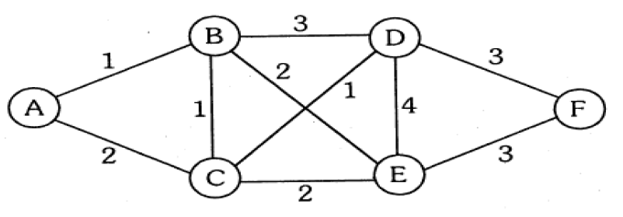

Algorithm:
- Initialize Distances: Create an array dist to store the shortest distance from the start vertex to each vertex. Initialize all distances as infinity (or a large number) except for the start vertex, which should be initialized to 0.
- Use a Priority Queue: Use a priority queue (min-heap) to efficiently get the next vertex with the smallest distance. Push the start vertex with a distance of 0 into the priority queue.
- Process the Queue: While the priority queue is not empty, repeat the following steps:
- Extract the vertex u from the priority queue that has the smallest distance.
- For each neighbor v of vertex u, check if the distance to v through u is smaller than the known distance to v.
- If it is, update the distance to v in the dist array and push v into the priority queue with the updated distance.
- Stop Condition: The algorithm continues until all vertices have been processed and the priority queue is empty.
- Output the Result: After processing all vertices, print the shortest distances from the start vertex to all other vertices.

Code:
import java.util.*;

public class Dijkstra {
static class Edge {
int weight;
int vertex;

Edge(int weight, int vertex) {
this.weight = weight;
this.vertex = vertex;
}
}

public static void dijkstra(List<List<Edge>> graph, int V, int start) {
PriorityQueue<Edge> pq = new PriorityQueue<>(Comparator.comparingInt(e -> e.weight));
int[] dist = new int[V];
Arrays.fill(dist, Integer.MAX_VALUE);
pq.offer(new Edge(0, start));
dist[start] = 0;

while (!pq.isEmpty()) {
int u = pq.poll().vertex;

for (Edge edge : graph.get(u)) {
int v = edge.vertex;
int weight = edge.weight;

if (dist[u] + weight < dist[v]) {
dist[v] = dist[u] + weight;
pq.offer(new Edge(dist[v], v));
}
}
}

System.out.printf("%-10s%-20s%n", "Vertex", "Distance from Start Vertex");
for (int i = 0; i < V; i++) {
System.out.printf("%-10c%-20d%n", (char) ('A' + i), dist[i]);
}
}

public static void main(String[] args) {
int V = 6;

List<List<Edge>> graph = new ArrayList<>(V);
for (int i = 0; i < V; i++) {
graph.add(new ArrayList<>());
}

graph.get(0).add(new Edge(1, 1)); // A -> B (weight 1)
graph.get(0).add(new Edge(2, 2)); // A -> C (weight 2)
graph.get(1).add(new Edge(1, 0)); // B -> A (weight 1)
graph.get(1).add(new Edge(3, 3)); // B -> D (weight 3)
graph.get(1).add(new Edge(2, 2)); // B -> C (weight 2)
graph.get(2).add(new Edge(2, 0)); // C -> A (weight 2)
graph.get(2).add(new Edge(4, 4)); // C -> E (weight 4)
graph.get(2).add(new Edge(1, 1)); // C -> B (weight 1)
graph.get(3).add(new Edge(1, 4)); // D -> E (weight 1)
graph.get(3).add(new Edge(5, 5)); // D -> F (weight 5)
graph.get(4).add(new Edge(2, 2)); // E -> C (weight 2)
graph.get(4).add(new Edge(3, 3)); // E -> B (weight 3)
graph.get(4).add(new Edge(5, 5)); // E -> F (weight 5)
graph.get(5).add(new Edge(4, 3)); // F -> E (weight 4)
graph.get(5).add(new Edge(5, 4)); // F -> D (weight 5)

Scanner scanner = new Scanner(System.in);
System.out.print("Enter the starting vertex (A-F): ");
char startVertex = scanner.next().charAt(0);
dijkstra(graph, V, startVertex - 'A');
scanner.close();
}
}
Output:
Enter the starting vertex (A-F): A
Vertex Distance from Start Vertex
A 0
B 1
C 2
D 4
E 5
F 9

Time Complexity - O((V+E)logV)
Space Complexity - O(V+E)

Q) Show that Dijkstra’s algorithm doesn’t work for graphs with negative weight edges.
Dijkstra's algorithm assumes that once a node’s shortest distance is found, it doesn't need to be updated again. This assumption breaks down in the case of negative weight edges.

Q) Modify the Dijkstra’s algorithm to find shortest path.
To modify Dijkstra's algorithm to not only find the shortest distance from the source vertex to all other vertices but also to reconstruct the shortest path, we need to maintain a parent array that keeps track of the previous vertex for each vertex in the shortest path tree. This way, once we have computed the shortest distances, we can trace back the path from the destination vertex to the source.

Step-by-Step Algorithm
- Initialize Distances and Parent Array: Create an array dist to store the shortest distance from the source vertex to each vertex. Initialize all distances as infinity (or a large number) except for the source vertex, which should be initialized to 0. Also, create a parent array to store the previous vertex for each vertex in the shortest path.
- Priority Queue: Use a priority queue (min-heap) to always expand the vertex with the smallest known distance.
- Relax Edges: While the priority queue is not empty, pop the vertex with the smallest distance. For each of its adjacent vertices, check if the distance can be relaxed (i.e., if the distance to the current vertex plus the edge weight is less than the known distance to the adjacent vertex). If it can be relaxed, update the distance and set the parent of the adjacent vertex to the current vertex. Push the updated adjacent vertex into the priority queue.
- Reconstruct the Path: After the algorithm completes, you can reconstruct the shortest path from the source to any vertex by following the parent pointers from the destination back to the source.
- Output the Result: Print the shortest distance and the path from the source to each vertex.

Batch – T5
Assignment No. – 8
Title – Dynamic Programming Algorithms
Student Name - Sharaneshwar Bharat Punjal
Student PRN - 23520011

1) You are given an array containing n integers. Your task is to determine the longest increasing subsequence in the array, i.e., the longest subsequence where every element is larger than the previous one.
A subsequence is a sequence that can be derived from the array by deleting some elements without changing the order of the remaining elements.
Input:
The first line contains an integer n: the size of the array.
After this there are n integers x1,x2,....,xn: the contents of the array.
Output:
Print the length of the longest increasing subsequence.
Constraints:
1 ≤ n ≤ 2 * 105
1 ≤ xi ≤109
Example
Input:
8
7 3 5 3 6 2 9 8
Output:
4
Brute Force Approach:
- Generate all possible subsequences of the given array.
- For each subsequence, check if it is strictly increasing.
- Keep track of the length of the longest increasing subsequence found.
- Return the length of the longest subsequence.
Time Complexity: O(2^n), where n is the number of elements in the array, due to generating all possible subsequences.

Dynamic Programming (DP) Approach (Memoization):
- Create a recursive function that takes the current index and the previous index as parameters.
- For each index, decide to either include or exclude the current element in the subsequence.
- Use memoization to store results for already computed states to avoid redundant calculations.
- Return the length of the longest increasing subsequence found.
Time Complexity: O(n^2), where n is the number of elements in the array.

Dynamic Programming (DP) Approach (Tabulation):
- Create a DP array where dp[i] represents the length of the longest increasing subsequence ending at index i.
- Initialize all elements of the DP array to 1, as the minimum length of the LIS ending at each element is 1 (the element itself).
- Iterate through the array, and for each element, check all previous elements to see if they can extend the LIS.
- Update the DP array accordingly.
- Return the maximum value in the DP array.
Time Complexity: O(n^2), where n is the number of elements in the array.

Binary Search Approach:
- Create a DP array to store the smallest tail for increasing subsequences of different lengths.
- Iterate through the input array. For each element, use binary search to find its position in the DP array.
- If the element is greater than the largest element in the DP array, append it. Otherwise, replace the element at the found position.
- The length of the DP array will give the length of the longest increasing subsequence.
Time Complexity: O(n log n), where n is the number of elements in the array, due to the binary search operation.

Code:
import java.util.ArrayList;
import java.util.Arrays;
import java.util.List;
import java.util.Scanner;

public class Q1 {
public static void main(String[] args) {
Scanner scanner = new Scanner(System.in);
int n = scanner.nextInt();
int[] arr = new int[n];
for (int i = 0; i < n; i++) {
arr[i] = scanner.nextInt();
}

List<Integer> lis = findLIS(arr, n);
for (int num : lis) {
System.out.print(num + " ");
}
System.out.println();
scanner.close();
}

private static List<Integer> findLIS(int[] arr, int n) {
int[] dp = new int[n];
List<Integer> lis = new ArrayList<>();
int len = 0;

for (int x : arr) {
int i = Arrays.binarySearch(dp, 0, len, x);
if (i < 0) i = -(i + 1);
dp[i] = x;
if (i == len) len++;
if (i < lis.size()) {
lis.set(i, x);
} else {
lis.add(x);
}
}
return lis;
}
}
Test Case 1:
12
3 10 2 1 20 4 6 5 7 8 9 30
Output:
1 4 5 7 8 9 30

Test Case 2:
8
7 3 5 3 6 2 9 8
Output:
2 5 6 8

Test Case 3:
20
10 9 2 5 3 7 101 18 21 22 23 24 25 26 27 28 29 30 31 32
Output:
2 3 7 18 21 22 23 24 25 26 27 28 29 30 31 32

Test Case 4:
10
3 2 6 5 0 3 7 8 1 4
Output:
0 1 4 8

2) There are n people who want to get to the top of a building which has only one elevator. You know the weight of each person and the maximum allowed weight in the elevator. What is the minimum number of elevator rides?
Input:
The first input line has two integers n and x: the number of people and the maximum allowed weight in the elevator.
The second line has n integers w1,w2,...,wn: the weight of each person.
Output:
Print one integer: the minimum number of rides.
Constraints:
1 ≤ n ≤ 20
1 ≤ x ≤ 109
1 ≤ wi ≤ x
Example Input:
4 10
4 8 6 1
Example Output:
2
Brute Force Approach:
- Generate all possible subsets of people.
- For each subset, calculate the total weight.
- If the total weight is less than or equal to the maximum weight the elevator can carry, count this as a valid ride.
- Try all combinations of valid rides to find the minimum number of rides needed to transport all people.
Time Complexity: O(2^n), where n is the number of people.

Better Approach (Backtracking):
- Use backtracking to explore all possible combinations of people that can fit in the elevator.
- Keep track of the number of rides.
- If the current group exceeds the weight limit, backtrack and try the next combination.
Time Complexity: Still O(2^n), but typically performs better than brute force due to pruning of impossible combinations.

Optimal Approach (Bitmask Dynamic Programming):
- Use a bitmask to represent the state of people who have been transported.
- Iterate over all subsets represented by the bitmask.
- For each state, calculate the minimum number of rides needed to transport all people represented in the bitmask.
- Use dynamic programming to save previously computed states to avoid redundant calculations.
Time Complexity: O(n * 2^n), where n is the number of people.

Code:
import java.util.*;

public class Q2 {
public static void main(String[] args) {
Scanner scanner = new Scanner(System.in);
int n = scanner.nextInt();
int x = scanner.nextInt();
int[] weights = new int[n];
for (int i = 0; i < n; i++) {
weights[i] = scanner.nextInt();
}

int minRides = minimumRides(weights, n, x);
System.out.println(minRides);
scanner.close();
}

private static int minimumRides(int[] weights, int n, int x) {
int maxState = 1 << n;
int[] dp = new int[maxState];
Arrays.fill(dp, Integer.MAX_VALUE);
dp[0] = 0;

for (int state = 0; state < maxState; state++) {
for (int i = 0; i < n; i++) {
if ((state & (1 << i)) == 0) {
int nextState = state | (1 << i);
int weightSum = 0;
for (int j = 0; j < n; j++) {
if ((state & (1 << j)) != 0) {
weightSum += weights[j];
}
}
weightSum += weights[i];
if (weightSum <= x) {
dp[nextState] = Math.min(dp[nextState], dp[state]);
} else {
dp[nextState] = Math.min(dp[nextState], dp[state] + 1);
}
}
}
}

return dp[maxState - 1];
}
}
Test Case 1:
4 10
4 8 6 1
Output:
2

Test Case 2:
5 15
5 7 8 6 4
Output:
3

Test Case 3:
8 25
12 10 5 15 20 5 3 8
Output:
5

Test Case 4:
7 30
10 15 20 5 6 9 8
Output:
4

3) In Domino Solitaire, you have a grid with two rows and many columns. Each square in the grid contains an integer. You are given a supply of rectangular 2 × 1 tiles, each of which exactly covers two adjacent squares of the grid. You have to place tiles to cover all the squares in the grid such that each tile covers two squares and no pair of tiles overlap.
The score for a tile is the difference between the bigger and the smaller number that are covered by the tile. The aim of the game is to maximize the sum of the scores of all the tiles.
Here is an example of a grid, along with two different tilings and their scores.
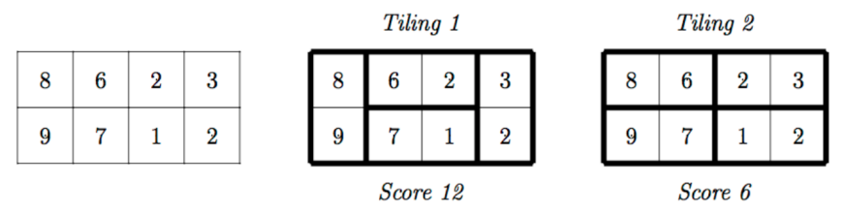
The score for Tiling 1 is 12 = (9−8) + (6−2) + (7−1) + (3−2) while the score for Tiling 2 is 6 = (8−6) + (9−7) + (3−2) + (2−1). There are other tilings possible for this grid, but you can check that Tiling 1 has the maximum score among all tilings.
Your task is to read the grid of numbers and compute the maximum score that can be
achieved by any tiling of the grid.
Solution hint:
Recursively find the best tiling, from left to right. You can start the tiling with one vertical tile or two horizontal tiles. Use dynamic programming to evaluate the recursive expression efficiently.
Input format:
The first line contains one integer N, the number of columns in the grid. This is followed by 2 lines describing the grid. Each of these lines consists of N integers, separated by blanks.
Output format:
A single integer indicating the maximum score that can be achieved by any tiling of the given grid.
Algorithm:
1. Read the number of columns N and the values in the top and bottom rows.
2. Initialize a dynamic programming array dp of size N to store the maximum score achievable for each column.
3. Set dp[0] to the absolute difference between the first elements of the top and bottom arrays.
4. For each subsequent column from 1 to N - 1:
5. Calculate the score if continuing from the previous column: dp[i] = dp[i - 1] + abs(top[i] - bottom[i]).
6. If not the first column, also check the score when skipping the previous column: dp[i] = max(dp[i], dp[i - 2] + abs(top[i - 1] - top[i]) + abs(bottom[i - 1] - bottom[i])).
7. Output the value in dp[N - 1], which contains the maximum score achievable for the entire grid.

Code:
import java.util.Scanner;

public class Q3 {
public static void main(String[] args) {
Scanner scanner = new Scanner(System.in);
int N = scanner.nextInt();

int[] top = new int[N];
int[] bottom = new int[N];

for (int i = 0; i < N; i++) {
top[i] = scanner.nextInt();
}

for (int i = 0; i < N; i++) {
bottom[i] = scanner.nextInt();
}

int[] dp = new int[N];
dp[0] = Math.abs(top[0] - bottom[0]);

for (int i = 1; i < N; i++) {
dp[i] = dp[i - 1] + Math.abs(top[i] - bottom[i]);
if (i > 1) {
dp[i] = Math.max(dp[i], dp[i - 2] + Math.abs(top[i - 1] - top[i]) + Math.abs(bottom[i - 1] - bottom[i]));
}
}

System.out.println(dp[N - 1]);
scanner.close();
}
}
Test Case 1:
4
8 6 2 3
9 7 1 2
Output:
12

Test Case 2:
12 50
2 4 6 8 10 12 14 16 18 20 22 24
24 22 20 18 16 14 12 10 8 6 4 2
Output:
148

Test Case 3:
20 150
1 3 5 7 9 11 13 15 17 19 21 23 25 27 29 31 33 35 37 39
39 37 35 33 31 29 27 25 23 21 19 17 15 13 11 9 7 5 3 1
Output:
473

Test Case 4:
25 500
100 90 80 70 60 50 40 30 20 10 5 15 25 35 45 55 65 75 85 95 100 105 110 115 120
120 110 100 90 80 70 60 50 40 30 20 10 5 15 25 35 45 55 65 75 85 95 87 98
Output:
825

Batch – T5
Assignment No. – 9
Title – Graphs, Dynamic Programming
Student Name - Sharaneshwar Bharat Punjal
Student PRN - 23520011

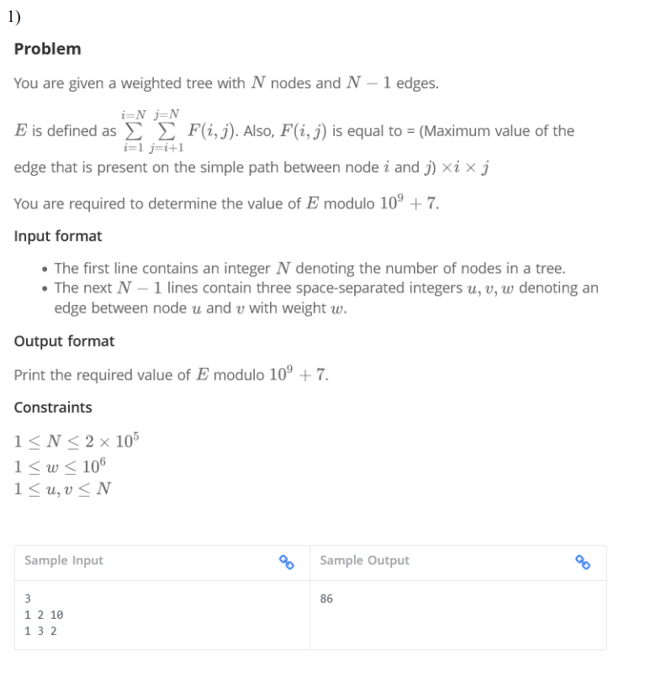
Idea:
We are asked to calculate a value E for a given weighted tree where NNN nodes and N−1 edges are provided. E is defined as:
E=i=1∑N j=i+1∑N F(i,j)
where F(i,j)F(i, j)F(i,j) is:
• The maximum edge weight on the simple path between nodes i and j,
• Multiplied by i,
• Multiplied by j.
We need to compute Emod(10^9+7).
Code:
import java.util.*;

public class Q1 {

static final int MAXN = 200005;
static final int LOG = 20;
static final int MOD = 1000000007;

static class Edge {
int to, weight;

Edge(int to, int weight) {
this.to = to;
this.weight = weight;
}
}

static List<Edge>[] adj = new ArrayList[MAXN];
static int[][] parent = new int[MAXN][LOG];
static int[][] maxEdge = new int[MAXN][LOG];
static int[] depth = new int[MAXN];
static int N;

static void dfs(int node, int par, int w) {
parent[node][0] = par;
maxEdge[node][0] = w;
for (Edge e : adj[node]) {
if (e.to != par) {
depth[e.to] = depth[node] + 1;
dfs(e.to, node, e.weight);
}
}
}

static void preprocess() {
for (int j = 1; j < LOG; j++) {
for (int i = 1; i <= N; i++) {
if (parent[i][j - 1] != -1) {
parent[i][j] = parent[parent[i][j - 1]][j - 1];
maxEdge[i][j] = Math.max(maxEdge[i][j - 1], maxEdge[parent[i][j - 1]][j - 1]);
}
}
}
}

static int getMaxEdge(int u, int v) {
if (depth[u] < depth[v]) {
int temp = u;
u = v;
v = temp;
}
int maxW = 0;
int diff = depth[u] - depth[v];

for (int i = LOG - 1; i >= 0; i--) {
if ((diff & (1 << i)) != 0) {
maxW = Math.max(maxW, maxEdge[u][i]);
u = parent[u][i];
}
}

if (u == v)
return maxW;

for (int i = LOG - 1; i >= 0; i--) {
if (parent[u][i] != parent[v][i]) {
maxW = Math.max(maxW, Math.max(maxEdge[u][i], maxEdge[v][i]));
u = parent[u][i];
v = parent[v][i];
}
}

return Math.max(maxW, Math.max(maxEdge[u][0], maxEdge[v][0]));
}

public static void main(String[] args) {
Scanner sc = new Scanner(System.in);
N = sc.nextInt();

for (int i = 1; i <= N; i++) {
adj[i] = new ArrayList<>();
}

for (int i = 1; i < N; i++) {
int u = sc.nextInt();
int v = sc.nextInt();
int w = sc.nextInt();
adj[u].add(new Edge(v, w));
adj[v].add(new Edge(u, w));
}

dfs(1, -1, 0);
preprocess();

long E = 0;
for (int i = 1; i <= N; i++) {
for (int j = i + 1; j <= N; j++) {
int maxW = getMaxEdge(i, j);
E = (E + 1L * maxW * i * j) % MOD;
}
}

System.out.println(E);
}
}

Test Case 1:
Enter the number of nodes (N): 5
Enter 4 edges in the format (u v w) where:
u = node1, v = node2, w = weight of the edge between u and v
Edge 1: 1 2 5
Edge 2: 2 3 2 3
Edge 3: 3 4 7
Edge 4: 4 5 1
The value of E modulo 10^9 + 7 is: 441

Test Case 2:
Enter the number of nodes (N): 3
Enter 2 edges in the format (u v w) where:
u = node1, v = node2, w = weight of the edge between u and v
Edge 1: 1 2 3 10
Edge 2: 1 3 2
The value of E modulo 10^9 + 7 is: 86

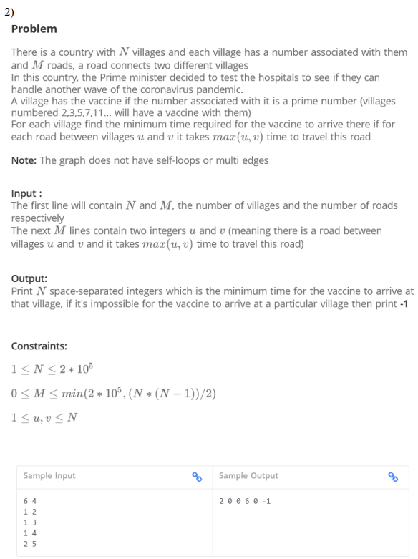

Algorithm:
- Identify Primes for Vaccine Villages:
- Precompute the prime numbers up to NNN using the Sieve of Eratosthenes. Mark these villages as starting points since they have the vaccine.
- Graph Representation:
- Use an adjacency list to represent the graph, where each edge weight is the max(u, v) between connected nodes uuu and vvv.
- Multi-Source Dijkstra’s Algorithm:
- Initialize a priority queue and add all villages with vaccines (prime-numbered villages) with a starting distance of 0.
- For each village, store the minimum distance (time) it takes for the vaccine to reach it.
- Use Dijkstra’s algorithm to propagate the minimum time for the vaccine to reach each village:
  - Pop the village with the minimum time from the queue.
  - For each neighbor, calculate the time it would take to reach the neighbor through the current village.
  - If this new time is less than the previously recorded time for that neighbor, update the time and push the neighbor into the priority queue.
- Handle Unreachable Villages: For any village that wasn’t updated (i.e., it is unreachable from any prime-numbered village), set its time to -1.
- Output the Result: Print the minimum times for each village to receive the vaccine.

Code:
import java.util.*;

public class Q2 {
static final int INF = Integer.MAX_VALUE;

public static void main(String[] args) {
Scanner sc = new Scanner(System.in);
int N = sc.nextInt();
int M = sc.nextInt();

// Graph representation using adjacency list
List<int[]>[] graph = new ArrayList[N + 1];
for (int i = 1; i <= N; i++) {
graph[i] = new ArrayList<>();
}

for (int i = 0; i < M; i++) {
int u = sc.nextInt();
int v = sc.nextInt();
int weight = Math.max(u, v);
graph[u].add(new int[]{v, weight});
graph[v].add(new int[]{u, weight});
}

// Prime detection
boolean[] isPrime = new boolean[N + 1];
Arrays.fill(isPrime, true);
isPrime[0] = isPrime[1] = false;
for (int i = 2; i * i <= N; i++) {
if (isPrime[i]) {
for (int j = i * i; j <= N; j += i) {
isPrime[j] = false;
}
}
}

// Multi-source Dijkstra's algorithm
int[] dist = new int[N + 1];
Arrays.fill(dist, INF);
PriorityQueue<int[]> pq = new PriorityQueue<>(Comparator.comparingInt(a -> a[1]));

for (int i = 1; i <= N; i++) {
if (isPrime[i]) {
dist[i] = 0;
pq.offer(new int[]{i, 0});
}
}

while (!pq.isEmpty()) {
int[] node = pq.poll();
int u = node[0];
int d = node[1];

if (d > dist[u]) continue;

for (int[] edge : graph[u]) {
int v = edge[0];
int weight = edge[1];
int newDist = d + weight;

if (newDist < dist[v]) {
dist[v] = newDist;
pq.offer(new int[]{v, newDist});
}
}
}

// Output results
StringBuilder sb = new StringBuilder();
for (int i = 1; i <= N; i++) {
if (dist[i] == INF) {
sb.append("-1 ");
} else {
sb.append(dist[i]).append(" ");
}
}
System.out.println(sb.toString().trim());

sc.close();
}
}

Test Case 1:
6 4
1 2
1 3
1 4
2 5
Output:
2 0 0 6 0 -1

Test Case 2:
5 5
1 2
1 3
3 4
4 5
2 5
Output:
2 0 0 4 0

Test Case 3:
4 2
1 2
3 4
Output:
2 0 0 4

Test Case 4:
7 6
1 2
2 3
3 4
4 5
5 6
6 7
Output:
2 0 0 4 0 6 0

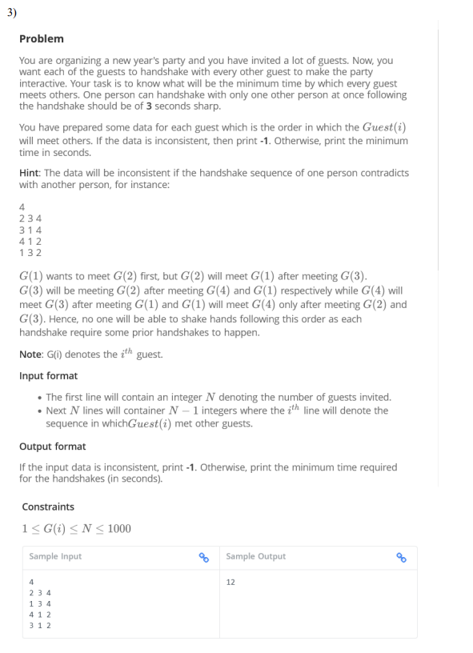

Code:
#include <iostream>
#include <vector>
#include <queue>

using namespace std;

int minimumTimeForHandshakes(int N, vector<vector<int>>& preferences) {
vector<vector<int>> adj(N + 1);
vector<int> indegree(N + 1, 0);

// Build the adjacency list and calculate indegrees
for (int i = 0; i < N; i++) {
for (int j = 0; j < preferences[i].size() - 1; j++) {
int u = preferences[i][j];
int v = preferences[i][j + 1];
adj[u].push_back(v);
indegree[v]++;
}
}

queue<int> q;
vector<int> topological_order;
vector<int> level(N + 1, 0);

// Initialize the queue with nodes having zero indegree
for (int i = 1; i <= N; i++) {
if (indegree[i] == 0) {
q.push(i);
level[i] = 1;
}
}

// Perform topological sort and calculate levels
while (!q.empty()) {
int u = q.front();
q.pop();
topological_order.push_back(u);

for (int v : adj[u]) {
indegree[v]--;
if (indegree[v] == 0) {
q.push(v);
level[v] = level[u] + 1;
}
}
}

// Check for cycles (inconsistent data)
if (topological_order.size() != N) {
return 0; // Return 0 for inconsistent data
}

// Find the maximum level
int max_level = 0;
for (int i = 1; i <= N; i++) {
max_level = max(max_level, level[i]);
}

return max_level * 3; // Each level takes 3 seconds
}

int main() {
int N;
cout << "Enter the number of guests: ";
cin >> N;

vector<vector<int>> preferences(N);

cout << "Enter the handshake sequence for each guest (0 to terminate input for a guest):\n";
for (int i = 0; i < N; i++) {
while (true) {
int guest;
cin >> guest;
if (guest == 0) break; // 0 indicates the end of input for this guest
preferences[i].push_back(guest);
}
}

int result = minimumTimeForHandshakes(N, preferences);

if (result == 0) {
cout << "Inconsistent handshake data\n";
} else {
cout << "Minimum time required: " << result << " seconds\n";
}

return 0;
}

Test Case 1:
Enter the number of guests: 2
Enter the handshake sequence for each guest (0 to terminate input for a guest):
1 0
2 0
Minimum time required: 3 seconds

Test Case 2 :
Enter the number of guests: 3
Enter the handshake sequence for each guest (0 to terminate input for a guest):
1 2 3 0
2 1 0
3 1 0
Inconsistent handshake data

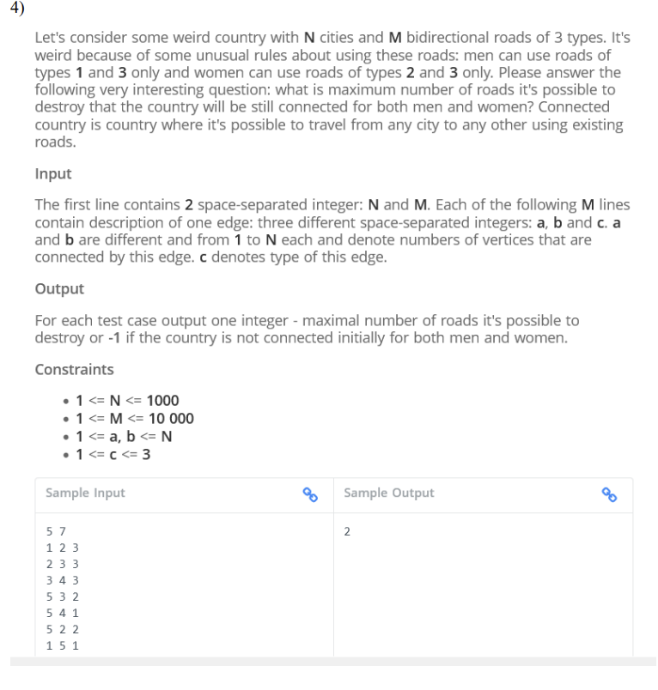

Idea:
This is a minimum spanning tree (MST) problem, where:
1. We need to create two separate spanning trees:
o One for men using roads of type 1 and 3.
o One for women using roads of type 2 and 3.
2. We also track the overall connectedness by combining roads of type 3 in both trees to maximize the number of roads we can remove.

Code:
#include <iostream>
#include <vector>
#include <tuple>

using namespace std;

class DisjointSet
{
public:
vector<int> parent, rank;

DisjointSet(int n)
{
parent.resize(n + 1);
rank.resize(n + 1, 0);
for (int i = 1; i <= n; i++)
parent[i] = i;
}

int find(int u)
{
if (parent[u] != u)
parent[u] = find(parent[u]);
return parent[u];
}

bool unite(int u, int v)
{
int rootU = find(u), rootV = find(v);
if (rootU == rootV)
return false;
if (rank[rootU] > rank[rootV])
{
parent[rootV] = rootU;
}
else if (rank[rootU] < rank[rootV])
{
parent[rootU] = rootV;
}
else
{
parent[rootV] = rootU;
rank[rootU]++;
}
return true;
}
};

int main()
{
int N, M;
cout << "Enter the number of cities (N) and roads (M): ";
cin >> N >> M;

vector<tuple<int, int, int>> edges;
cout << "Enter the roads (u, v, type):" << endl;
for (int i = 0; i < M; i++)
{
int u, v, type;
cin >> u >> v >> type;
edges.push_back(make_tuple(u, v, type));
}

DisjointSet men(N), women(N);

int totalEdges = 0;
int usedEdgesMen = 0, usedEdgesWomen = 0;

// Process type 3 edges first (both men and women)
for (auto [u, v, type] : edges)
{
if (type == 3)
{
bool connectedMen = men.unite(u, v);
bool connectedWomen = women.unite(u, v);
if (connectedMen || connectedWomen)
{
totalEdges++;
if (connectedMen)
usedEdgesMen++;
if (connectedWomen)
usedEdgesWomen++;
}
}
}

// Process type 1 (men) and type 2 (women) edges
for (auto [u, v, type] : edges)
{
if (type == 1)
{
if (men.unite(u, v))
{
totalEdges++;
usedEdgesMen++;
}
}
else if (type == 2)
{
if (women.unite(u, v))
{
totalEdges++;
usedEdgesWomen++;
}
}
}

// Check if all cities are connected for men and women
bool fullyConnectedMen = true, fullyConnectedWomen = true;
for (int i = 1; i <= N; i++)
{
if (men.find(i) != men.find(1))
fullyConnectedMen = false;
if (women.find(i) != women.find(1))
fullyConnectedWomen = false;
}

// Output the result
if (fullyConnectedMen && fullyConnectedWomen)
{
cout << "Maximum number of roads that can be destroyed: " << M - totalEdges << endl;
}
else
{
cout << "-1" << endl;
}

return 0;
}

Test Case 1:
Enter the number of cities (N) and roads (M): 5 7
Enter the roads (u, v, type):
1 2 3
2 3 3
3 4 3
5 3 2
5 4 1
5 2 2
1 5 1
Maximum number of roads that can be destroyed: 2

Test Case 2:
Enter the number of cities (N) and roads (M): 3 3
Enter the roads (u, v, type):
1 2 1
2 2 3
3 1 2
-1

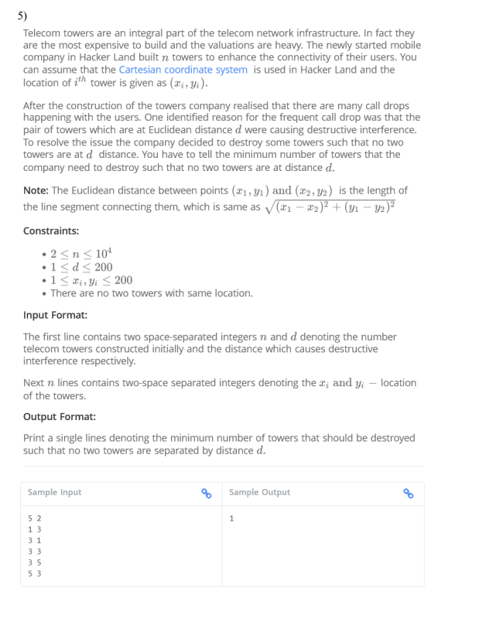
Code:
#include <iostream>
#include <vector>
#include <cmath>
#include <algorithm>

using namespace std;

struct Tower
{
int x, y;
};

bool canDestroy(const vector<Tower> &towers, int d, int k)
{
vector<bool> destroyed(towers.size(), false);
int count = 0;

for (int i = 0; i < towers.size(); i++)
{
if (destroyed[i])
continue;
count++;
for (int j = i + 1; j < towers.size(); j++)
{
if (destroyed[j])
continue;
int dx = towers[i].x - towers[j].x;
int dy = towers[i].y - towers[j].y;
if (dx * dx + dy * dy <= d * d)
{
destroyed[j] = true;
}
}
}

return towers.size() - count <= k;
}

int minTowersToDestroy(const vector<Tower> &towers, int d)
{
int left = 0, right = towers.size();
while (left < right)
{
int mid = left + (right - left) / 2;
if (canDestroy(towers, d, mid))
{
right = mid;
}
else
{
left = mid + 1;
}
}
return left;
}

int main()
{
int n, d;
cout << "Enter the number of towers (n) and the interference distance (d): ";
cin >> n >> d;

vector<Tower> towers(n);
cout << "Enter the coordinates of each tower (x y):" << endl;
for (int i = 0; i < n; i++)
{
cout << "Tower " << i + 1 << ": ";
cin >> towers[i].x >> towers[i].y;
}

int result = minTowersToDestroy(towers, d);
cout << "Minimum number of towers to destroy: " << result << endl;

return 0;
}

Test Case 1:
Enter the number of towers (n) and the interference distance (d): 5 2
Enter the coordinates of each tower (x y):
Tower 1: 1 3
Tower 2: 3 1
Tower 3: 3 3
Tower 4: 3 5
Tower 5: 5 3
Minimum number of towers to destroy: 1

Test Case 2:
Enter the number of towers (n) and the interference distance (d): 4 2
Enter the coordinates of each tower (x y):
Tower 1: 1 1
Tower 2: 1 3
Tower 3: 3 1
Tower 4: 3 3
Minimum number of towers to destroy: 2

Batch – T5
Assignment No. – 10
Title – Backtracking \ N Queens Problem
Student Name - Sharaneshwar Bharat Punjal
Student PRN - 23520011

Problem Statement:
1) Given an integer n, the task is to find all distinct solutions to the n-queens problem, where n queens are placed on an n×n chessboard such that no two queens can attack each other. Each solution is a unique configuration of n queens, represented as a permutation of [1,2,3,….,n]. The number at the ith position indicates the row of the queen in the ith column. For example, [3,1,4,2] shows one such layout.

Input: 4
Output: [2, 4, 1, 3 ], [3, 1, 4, 2]
Explaination: These are the 2 possible solutions.

Input: 1
Output: [1]
Explaination: Only one queen can be placed in the single cell available.

Input: An integer n, the size of the chessboard and the number of queens to place.
Output: All distinct configurations where n queens are placed on an n x n chessboard without any attacking each other.

Code:
#include <iostream>
#include <vector>
#include <cmath> // For abs()

using namespace std;

// Function to check if placing a queen at (row, col) is valid
bool is_valid(vector<int> &queens, int row, int col)
{
for (int i = 0; i < col; i++)
{
// Check for row and diagonal conflicts
if (queens[i] == row || abs(queens[i] - row) == abs(i - col))
{
return false;
}
}
return true;
}

// Backtracking function to solve N-Queens
void place_queens(int col, vector<int> &queens, vector<vector<int>> &solutions, int n)
{
if (col == n)
{
// All queens have been placed, add the solution to results
solutions.push_back(queens); // Copy the current configuration
return;
}

// Try placing a queen in every row for the current column
for (int row = 0; row < n; row++)
{
if (is_valid(queens, row, col))
{
queens[col] = row; // Place the queen
place_queens(col + 1, queens, solutions, n); // Move to the next column
}
}
}

// Function to solve N-Queens and return all solutions
vector<vector<int>> solveNQueens(int n)
{
vector<vector<int>> solutions; // To store all the valid solutions
vector<int> queens(n, -1); // To store the position of queens
place_queens(0, queens, solutions, n); // Start placing queens from column 0
return solutions;
}

// Function to print the solutions in 1-based index format
void print_solutions(const vector<vector<int>> &solutions)
{
for (const auto &sol : solutions)
{
for (int q : sol)
{
cout << q + 1 << " "; // Convert 0-based to 1-based indexing
}
cout << endl;
}
}

int main()
{
int n;
cout << "Enter the value of N: ";
cin >> n;

vector<vector<int>> solutions = solveNQueens(n);
cout << "Solutions for N = " << n << ":\n";
print_solutions(solutions);

return 0;
}

Test Case 1:
Enter the value of N: 4
Solutions for N = 4:
2 4 1 3
3 1 4 2

Test Case 2:
Enter the value of N: 5
Solutions for N = 5:
1 3 5 2 4
1 4 2 5 3
2 4 1 3 5
2 5 3 1 4
3 1 4 2 5
3 5 2 4 1
4 1 3 5 2
4 2 5 3 1
5 2 4 1 3
5 3 1 4 2

Test Case 3:
Enter the value of N: 7
Solutions for N = 7:
1 3 5 7 2 4 6
1 4 7 3 6 2 5
1 5 2 6 3 7 4
1 6 4 2 7 5 3
2 4 1 7 5 3 6
2 4 6 1 3 5 7
2 5 1 4 7 3 6
2 5 3 1 7 4 6
2 5 7 4 1 3 6
2 6 3 7 4 1 5
2 7 5 3 1 6 4
3 1 6 2 5 7 4
3 1 6 4 2 7 5
3 5 7 2 4 6 1
3 6 2 5 1 4 7
3 7 2 4 6 1 5
3 7 4 1 5 2 6
4 1 3 6 2 7 5
4 1 5 2 6 3 7
4 2 7 5 3 1 6
4 6 1 3 5 7 2
4 7 3 6 2 5 1
4 7 5 2 6 1 3
5 1 4 7 3 6 2
5 1 6 4 2 7 3
5 2 6 3 7 4 1
5 3 1 6 4 2 7
5 7 2 4 6 1 3
5 7 2 6 3 1 4
6 1 3 5 7 2 4
6 2 5 1 4 7 3
6 3 1 4 7 5 2
6 3 5 7 1 4 2
6 3 7 4 1 5 2
6 4 2 7 5 3 1
6 4 7 1 3 5 2
7 2 4 6 1 3 5
7 3 6 2 5 1 4
7 4 1 5 2 6 3
7 5 3 1 6 4 2

2) Given the dimension of a chess board (N x M), determine the minimum number of queens required to cover all the squares of the board. A queen can attack any square along its row, column or diagonals.
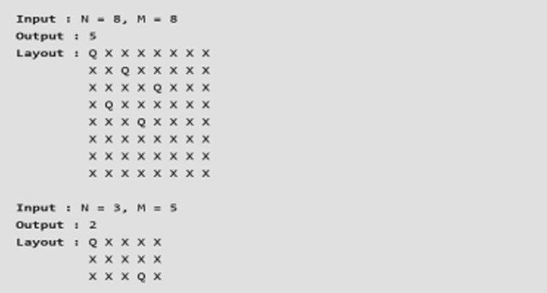

Code:
#include <iostream>
#include <vector>
using namespace std;

// Function to check if a position (row, col) is attacked by any queen
bool isAttacked(vector<vector<char>> &board, int row, int col, int N, int M)
{
// Check the current row and column for any queen
for (int i = 0; i < N; i++)
{
if (board[i][col] == 'Q')
return true;
}
for (int j = 0; j < M; j++)
{
if (board[row][j] == 'Q')
return true;
}

// Check diagonals
for (int i = row, j = col; i >= 0 && j >= 0; i--, j--)
{
if (board[i][j] == 'Q')
return true;
}
for (int i = row, j = col; i >= 0 && j < M; i--, j++)
{
if (board[i][j] == 'Q')
return true;
}
for (int i = row, j = col; i < N && j >= 0; i++, j--)
{
if (board[i][j] == 'Q')
return true;
}
for (int i = row, j = col; i < N && j < M; i++, j++)
{
if (board[i][j] == 'Q')
return true;
}

return false;
}

// Function to place the minimum number of queens on the board
void placeQueens(vector<vector<char>> &board, int N, int M)
{
int queensPlaced = 0;

// Try placing queens in an alternating pattern
for (int i = 0; i < N; i++)
{
for (int j = 0; j < M; j++)
{
if (!isAttacked(board, i, j, N, M))
{
board[i][j] = 'Q';
queensPlaced++;
}
}
}

// Output the board
cout << "Minimum number of queens required: " << queensPlaced << endl;
for (int i = 0; i < N; i++)
{
for (int j = 0; j < M; j++)
{
cout << board[i][j] << " ";
}
cout << endl;
}
}

int main()
{
int N, M;
cout << "Enter dimensions of the chessboard (N M): ";
cin >> N >> M;

vector<vector<char>> board(N, vector<char>(M, 'X'));

// Place queens and print the layout
placeQueens(board, N, M);

return 0;
}

Test Case 1
Enter dimensions of the chessboard (N M): 8 8
Minimum number of queens required: 5
Q X X X X X X X
X X Q X X X X X
X X X X Q X X X
X Q X X X X X X
X X X Q X X X X
X X X X X X X X
X X X X X X X X
X X X X X X X X

Test Case 2
Enter dimensions of the chessboard (N M): 5 5
Minimum number of queens required: 5
Q X X X X
X X Q X X
X X X X Q
X Q X X X
X X X Q X

3) Consider a N X N chessboard with a Queen and K obstacles. The Queen cannot pass through obstacles. Given the position (x, y) of Queen, the task is to find the number of cells the queen can move.

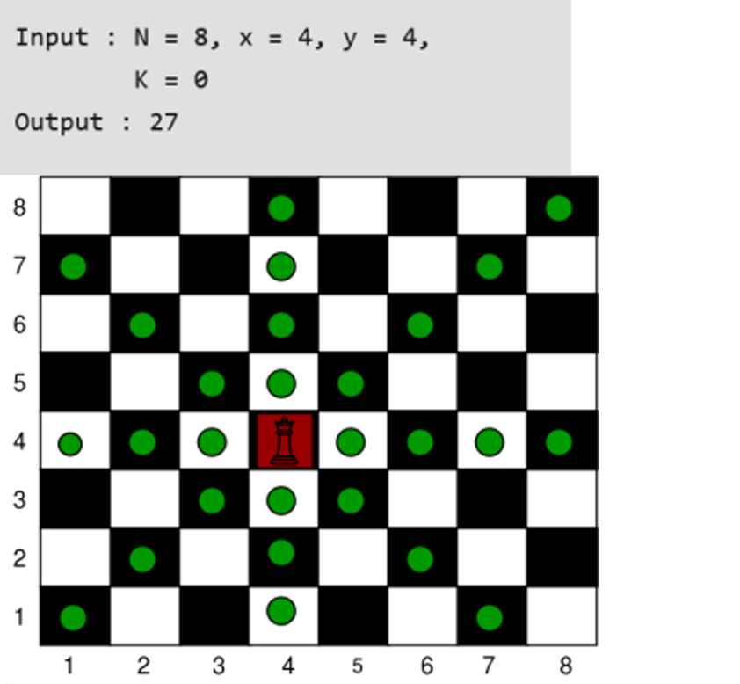

Code:
#include <iostream>
#include <vector>
#include <algorithm>
using namespace std;

// Function to calculate the number of cells the Queen can move
int countQueenMoves(int N, int Qx, int Qy, vector<pair<int, int>> &obstacles)
{
// Directions: up, down, left, right, top-left, top-right, bottom-left, bottom-right
int up = N - Qx;
int down = Qx - 1;
int left = Qy - 1;
int right = N - Qy;
int topLeft = min(N - Qx, Qy - 1);
int topRight = min(N - Qx, N - Qy);
int bottomLeft = min(Qx - 1, Qy - 1);
int bottomRight = min(Qx - 1, N - Qy);

// Adjust boundaries based on obstacles
for (auto &obs : obstacles)
{
int ox = obs.first, oy = obs.second;

// Same column (vertical movement)
if (oy == Qy)
{
if (ox > Qx)
{
up = min(up, ox - Qx - 1); // obstacle above
}
else
{
down = min(down, Qx - ox - 1); // obstacle below
}
}

// Same row (horizontal movement)
if (ox == Qx)
{
if (oy > Qy)
{
right = min(right, oy - Qy - 1); // obstacle to the right
}
else
{
left = min(left, Qy - oy - 1); // obstacle to the left
}
}

// Diagonal movements
if (abs(ox - Qx) == abs(oy - Qy))
{
if (ox > Qx && oy > Qy)
{
topRight = min(topRight, ox - Qx - 1); // obstacle top-right
}
else if (ox > Qx && oy < Qy)
{
topLeft = min(topLeft, ox - Qx - 1); // obstacle top-left
}
else if (ox < Qx && oy > Qy)
{
bottomRight = min(bottomRight, Qx - ox - 1); // obstacle bottom-right
}
else if (ox < Qx && oy < Qy)
{
bottomLeft = min(bottomLeft, Qx - ox - 1); // obstacle bottom-left
}
}
}

// Total possible moves
return up + down + left + right + topLeft + topRight + bottomLeft + bottomRight;
}

int main()
{
int N, K, Qx, Qy;

// Inputs
cout << "Enter the size of the board (N): ";
cin >> N;

cout << "Enter the Queen's position (Qx, Qy): ";
cin >> Qx >> Qy;

cout << "Enter the number of obstacles (K): ";
cin >> K;

vector<pair<int, int>> obstacles(K);
if (K > 0)
{
cout << "Enter the positions of obstacles (ox oy): " << endl;
for (int i = 0; i < K; i++)
{
cin >> obstacles[i].first >> obstacles[i].second;
}
}

int result = countQueenMoves(N, Qx, Qy, obstacles);
cout << "The number of cells the Queen can move to: " << result << endl;

return 0;
}

Test Case 1
Enter the size of the board (N): 8
Enter the Queen's position (Qx, Qy): 4 4
Enter the number of obstacles (K): 2
Enter the positions of obstacles (ox oy):
5 5
3 2
The number of cells the Queen can move to: 23

Test Case 2
Enter the size of the board (N): 8
Enter the Queen's position (Qx, Qy): 1 1
Enter the number of obstacles (K): 0
The number of cells the Queen can move to: 21

Test Case 3
Enter the size of the board (N): 8
Enter the Queen's position (Qx, Qy): 4 4
Enter the number of obstacles (K): 1
Enter the positions of obstacles (ox oy):
6 4
The number of cells the Queen can move to: 24

4) The N Queen is the problem of placing N chess queens on an N×N chessboard so that no two queens attack each other. For example, the following is a solution for 8 Queen problem.



Code:
#include <iostream>
#include <vector>
using namespace std;

class NQueens
{
private:
int N;
vector<vector<string>> solutions;

// Function to check if placing a queen at (row, col) is safe
bool isSafe(vector<string> &board, int row, int col)
{
// Check this row on left side
for (int i = 0; i < col; i++)
{
if (board[row][i] == 'Q')
return false;
}

// Check upper diagonal on left side
for (int i = row, j = col; i >= 0 && j >= 0; i--, j--)
{
if (board[i][j] == 'Q')
return false;
}

// Check lower diagonal on left side
for (int i = row, j = col; j >= 0 && i < N; i++, j--)
{
if (board[i][j] == 'Q')
return false;
}

return true;
}

// Helper function to solve the problem using backtracking
void solveNQueensUtil(vector<string> &board, int col)
{
// If all queens are placed
if (col == N)
{
solutions.push_back(board);
return;
}

// Try placing a queen in each row of this column
for (int i = 0; i < N; i++)
{
if (isSafe(board, i, col))
{
board[i][col] = 'Q'; // Place the queen
solveNQueensUtil(board, col + 1); // Recur for next column
board[i][col] = '.'; // Backtrack and remove the queen
}
}
}

public:
// Constructor to initialize board size
NQueens(int n) : N(n) {}

// Function to solve the N-Queens problem
vector<vector<string>> solveNQueens()
{
vector<string> board(N, string(N, '.'));
solveNQueensUtil(board, 0);
return solutions;
}
};

int main()
{
int N;
cout << "Enter the value of N: ";
cin >> N;

NQueens solver(N);
vector<vector<string>> result = solver.solveNQueens();

if (result.empty())
{
cout << "No solution exists for N = " << N << endl;
}
else
{
cout << "Number of solutions: " << result.size() << endl;
for (const auto &solution : result)
{
for (const string &row : solution)
{
cout << row << endl;
}
cout << endl;
}
}

return 0;
}

Test Case 1
Enter the value of N: 4
Number of solutions: 2
..Q.
Q...
...Q
.Q..

.Q..
...Q
Q...
..Q.

Test Case 2
Enter the value of N: 1
Number of solutions: 1
Q

Test Case 3
Enter the value of N: 2
No solution exists for N = 2

Test Case 4
Enter the value of N: 5
Number of solutions: 10

5) Given a valid sentence without any spaces between the words and a dictionary of valid English words, find all possible ways to break the sentence into individual dictionary words.

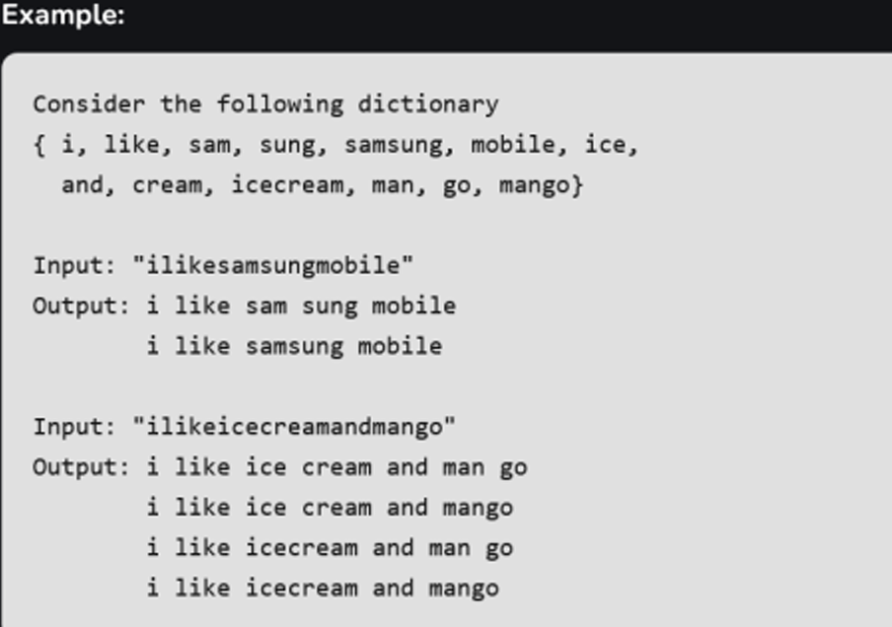

Code:
#include <iostream>
#include <unordered_set>
#include <vector>
using namespace std;

// Function to check if a word is present in the dictionary
bool dictionaryContains(string word, unordered_set<string> &dictionary)
{
return dictionary.find(word) != dictionary.end();
}

// Helper function to perform backtracking and find all word breaks
void wordBreakUtil(string s, unordered_set<string> &dictionary, string result, vector<string> &output)
{
// If we've reached the end of the string, add the result to the output
if (s.size() == 0)
{
output.push_back(result);
return;
}

// Try every prefix of the string
for (int i = 1; i <= s.size(); i++)
{
string prefix = s.substr(0, i);

// If the prefix is a valid word, proceed to check the remaining substring
if (dictionaryContains(prefix, dictionary))
{
string newResult = result + (result.empty() ? "" : " ") + prefix;
wordBreakUtil(s.substr(i), dictionary, newResult, output);
}
}
}

// Main function to find all word breaks
vector<string> wordBreak(string s, unordered_set<string> &dictionary)
{
vector<string> output;
wordBreakUtil(s, dictionary, "", output);
return output;
}

int main()
{
// Create a dictionary of valid words
unordered_set<string> dictionary = {"i", "like", "sam", "sung", "samsung", "mobile", "ice", "and", "cream", "icecream", "man", "go", "mango"};

// Input sentence without spaces
vector<string> inputs = {
"ilikesamsungmobile",
"ilikeicecreamandmango",
"samsungandmango",
"icecreamandmango"};

// Iterate over the inputs and get possible word breaks for each
for (const string &input : inputs)
{
vector<string> result = wordBreak(input, dictionary);
cout << "Possible segmentations for input \"" << input << "\":" << endl;
for (const string &sentence : result)
{
cout << sentence << endl;
}
cout << endl;
}

return 0;
}

Test Case 1
Possible segmentations for input "ilikesamsungmobile":
i like sam sung mobile
i like samsung mobile

Test Case 2
Possible segmentations for input "ilikeicecreamandmango":
i like ice cream and man go
i like ice cream and mango
i like icecream and man go
i like icecream and mango

Test Case 3
Possible segmentations for input "samsungandmango":
sam sung and man go
sam sung and mango
samsung and man go
samsung and mango

Test Case 4
Possible segmentations for input "icecreamandmango":
ice cream and man go
ice cream and mango
icecream and man go
icecream and mango

