Walchand College of Engineering, Sangli
Computer Science & Engineering
Third Year
Course: Design and analysis of algorithm Lab
Lab course coordinator:
Mrs A M Chimanna- Batch: - T1, T2,T3,T4
Assignment No.7
Greedy Method
1) Implement Kruskal’s algorithm & Prim's algorithm to find Minimum Spanning Tree (MST) of the given an undirected, connected and weighted graph.

Q) How many edges does a minimum spanning tree for above example?
Q) In a graph G. let the edge u v have the least weight. is it true that u v is always part of any minimum spanning tree of G?.Justify your answers.
Q) Let G be a graph and T be a minimum spanning tree of G. Suppose that the weight of an edge e is decreased. How can you find the minimum spanning tree of the modified graph? What is the runtime of your solution?
Q) Find order of edges for Kruskal's and Prim's?

2) From a given vertex in a weighted connected graph, implement shortest path finding Dijkstra's algorithm.

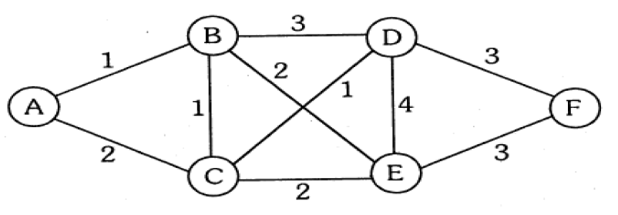

Q) Show that Dijkstra’s algorithm doesn’t work for graphs with negative weight edges
Q) Modify the Dijkstra’s algorithm to find shortest path.

