Exactly ✅ — the cron expression
* * * * *
does mean “run every minute.”
That’s why your scheduler (like cron, Jenkins, or another system) is warning you that it will execute once per minute — which is usually too frequent for most jobs (e.g., polling, backups, builds).
If your intent was to run once per hour, the correct cron syntax would be:
0 * * * *
Here’s what each position means:
Field | Meaning | Example
1st | Minute (0–59) | 0 = start of hour
2nd | Hour (0–23) | * = every hour
3rd | Day of month (1–31) | * = every day
4th | Month (1–12) | * = every month
5th | Day of week (0–6, Sun=0) | * = every day
So:
- * * * * * → every minute
- 0 * * * * → every hour
- 0 0 * * * → every day at midnight
Your message confirms that it last ran at 11:35 PM IST and will next run at 11:36 PM IST, which aligns perfectly with the “every minute” schedule.
Would you like me to help you adjust it to run hourly, daily, or on some other schedule (e.g., every 5 minutes or every Monday at midnight)?

Good — you’re talking about “Poll SCM” in Jenkins 👇
Let’s break it down clearly.

🧠 What “Poll SCM” means
Poll SCM (Source Code Management) in Jenkins tells Jenkins to check your source control (like GitHub, GitLab, Bitbucket, etc.) periodically to see if there are any new commits or changes.
If changes are found → Jenkins triggers a new build automatically.
It’s not the same as building every time by force — it only triggers when changes are detected.

⚙️ Where to find it
In your Jenkins job:
- Open your job → Configure
- Scroll to Build Triggers
- Tick ✅ Poll SCM
- Enter your cron schedule in the box (e.g., H/15 * * * *)

🕒 Common cron examples for Poll SCM
Expression | Meaning | Example use
* * * * * | Every minute | Too frequent, test only
H/5 * * * * | Every 5 minutes (hash-based spread to avoid load) | ✅ Recommended
H * * * * | Once every hour | Common setup
H 2 * * * | Once daily at around 2 AM | Nightly builds
H/10 * * * 1-5 | Every 10 mins, Monday–Friday | Workweek only
The H (hash) makes Jenkins pick a consistent but random offset, preventing all jobs from polling at the same time.

⚡ Example
If you set:
H/5 * * * *
→ Jenkins will poll your Git repository every 5 minutes.
If it detects a new commit → Jenkins triggers a build.

🧩 Tip
If you use webhooks (from GitHub or GitLab), you usually don’t need Poll SCM — webhooks notify Jenkins instantly on a push, which is more efficient.

Would you like me to show you the best cron expression for Poll SCM for your project (e.g., GitHub repo, small personal project, or production CI)?

Ah, now you’re asking about “Build periodically” in Jenkins, which is a bit different from Poll SCM. Let’s break it down clearly:

🧠 What “Build periodically” means
Build periodically lets Jenkins trigger a build on a fixed schedule, regardless of whether the SCM has changes or not.
- Think of it like a cron job for builds.
- It’s used when you want scheduled builds (e.g., nightly builds, weekly tests, or hourly reports).
- Unlike Poll SCM, it doesn’t check for code changes — it simply runs the job according to your schedule.

⚙️ Where to find it
- Open your Jenkins job → Configure
- Scroll to Build Triggers
- Tick ✅ Build periodically
- Enter your schedule using cron syntax, e.g.:
H 2 * * * # every day at ~2 AM (H randomizes minute for load distribution)
H 0 * * 1 # every Monday at ~midnight
H/15 * * * * # every 15 minutes

🕒 Examples of common schedules
Expression | Meaning
H 0 * * * | Daily at midnight
H 2 * * * | Daily at 2 AM
H 0 * * 1 | Every Monday at midnight
H/15 * * * * | Every 15 minutes
0 9-17 * * 1-5 | Every hour from 9 AM to 5 PM, Monday to Friday
Tip: Use H instead of a fixed minute to prevent all Jenkins jobs from running simultaneously, which reduces server load.

⚡ Difference between Poll SCM and Build Periodically
Feature | Poll SCM | Build Periodically
Triggered by | Changes in SCM | Fixed schedule
Checks SCM? | ✅ Yes | ❌ No
Use case | CI build on commit | Scheduled nightly/weekly build, reports, backups
Typical cron | H/5 * * * * | H 2 * * *

Build Periodically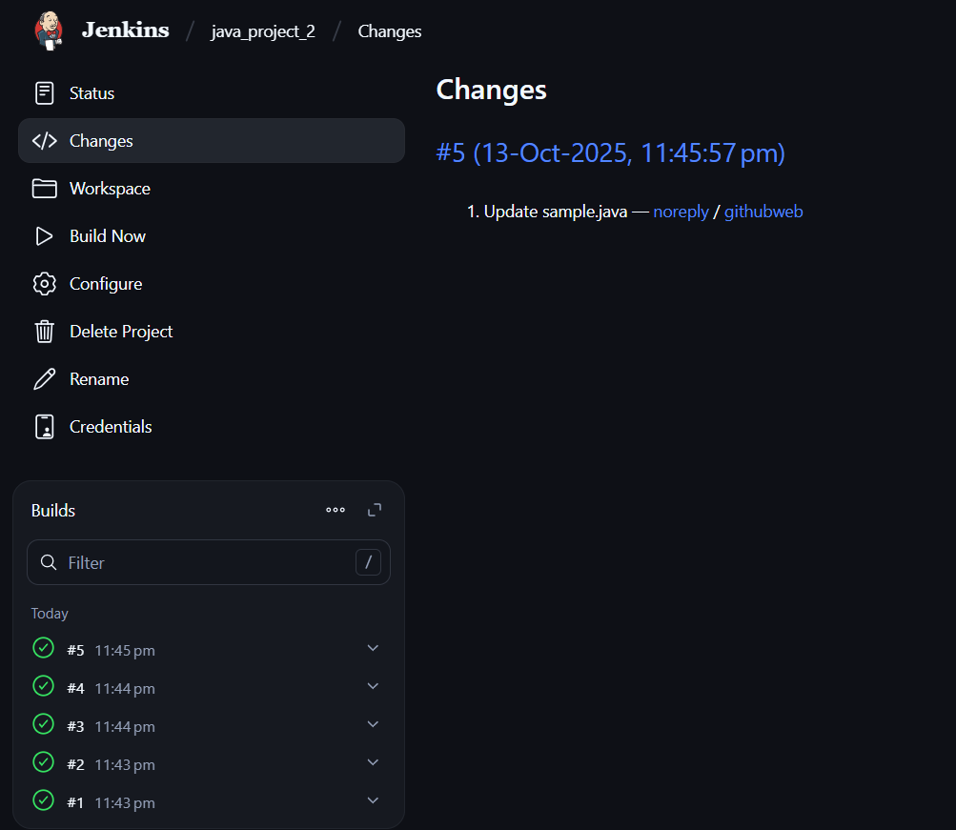

Check for main or master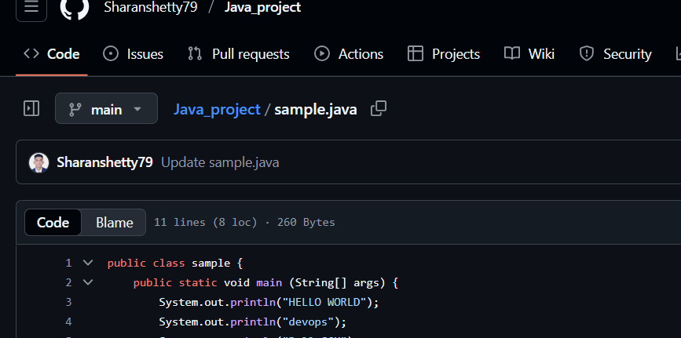
Poll scm

     

