AI ASSISTED CODING:
ASSIGNMENT 10.4:
NAME: SHARANYA THANUGULA
HT NO:2403A51401
BATCH:16
TASK 1:
Syntax and Error Detection:
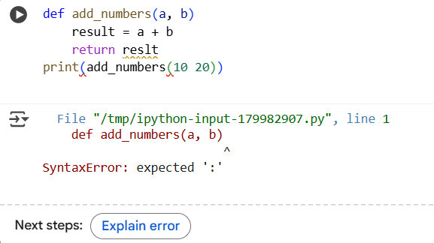
CORRECTED CODE:
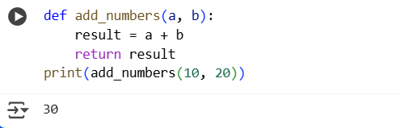
EXPLANATION:
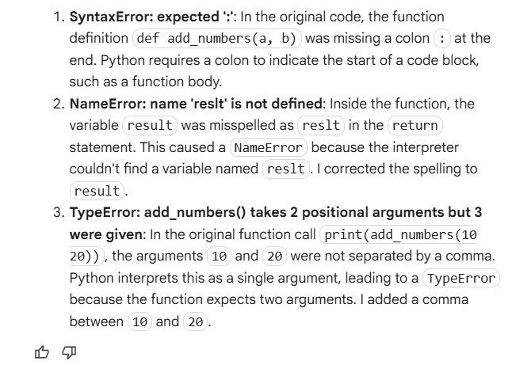
TASK 2:
Logical and Performance Issue Review.

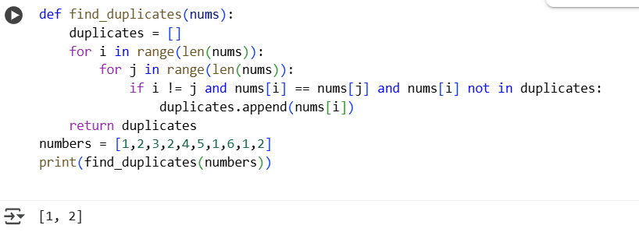
EFFICIENT CODE:
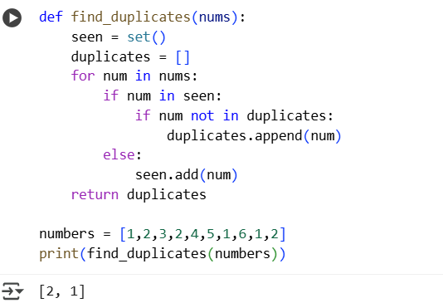
Explanation:
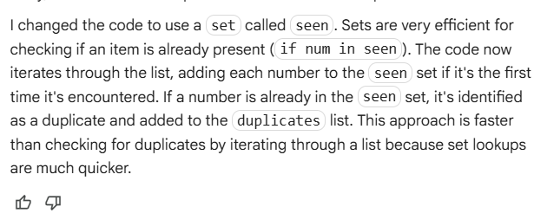
TASK 3:Code Refactoring for Readability.
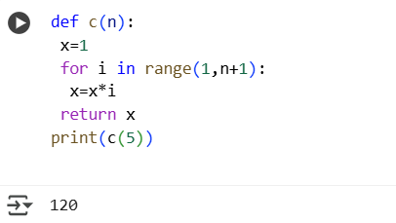
EFFICIENT CODE:
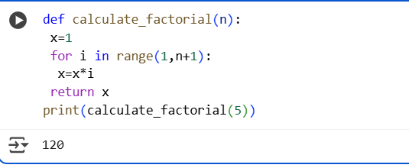
EXPLANATION:
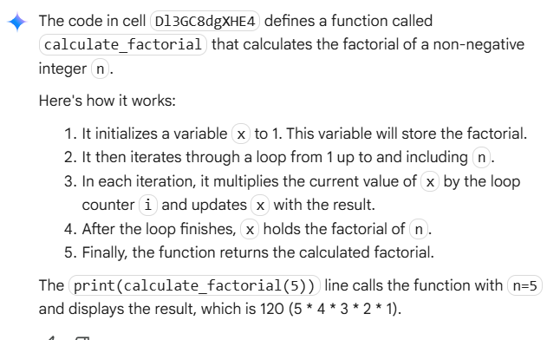
TASK 4:
Security and Error Handling Enhancement:
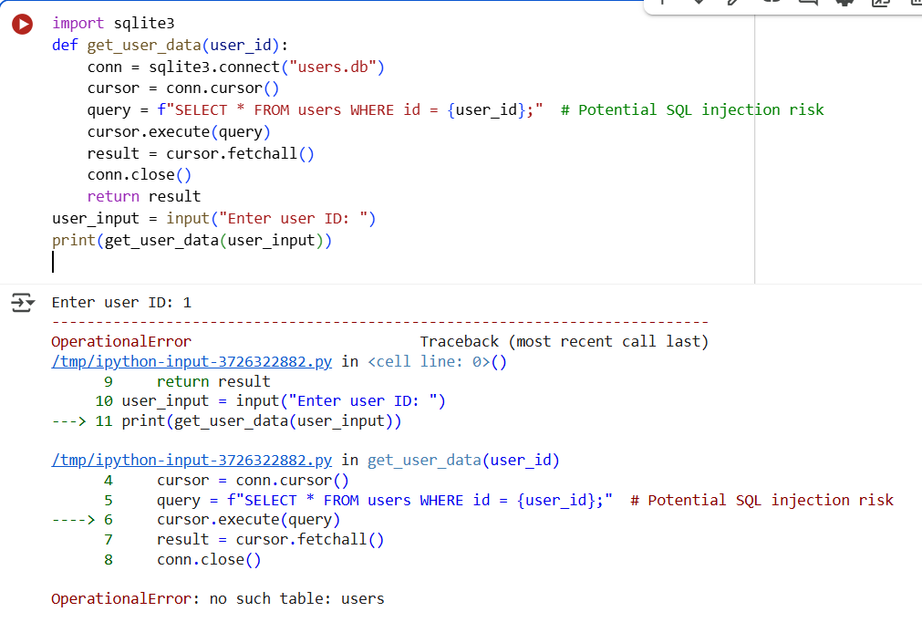
CORRECTED CODE:
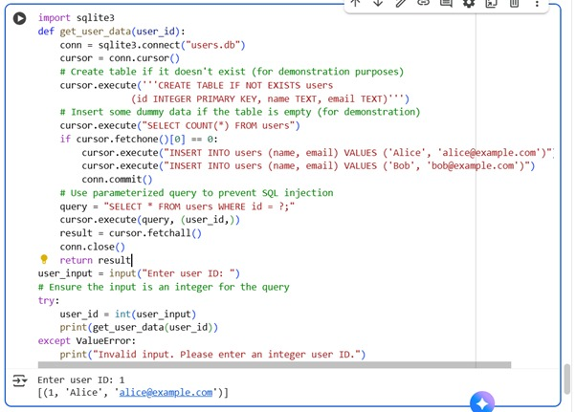
EXPLANATION:
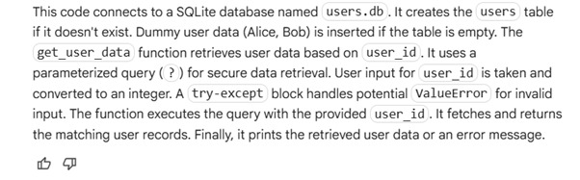

TASK 5: Automated Code Review Report Generation
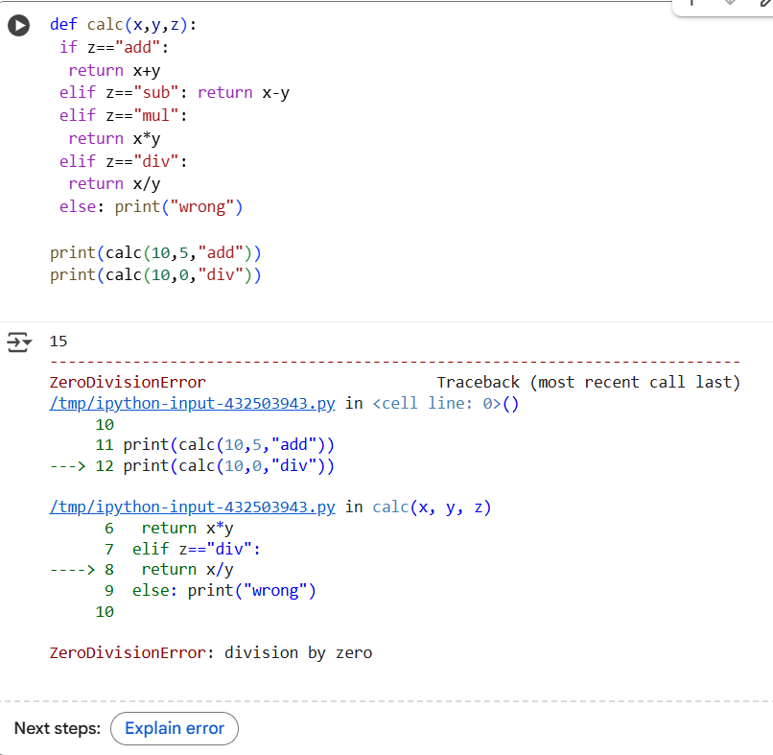
CORRECTED CODE:
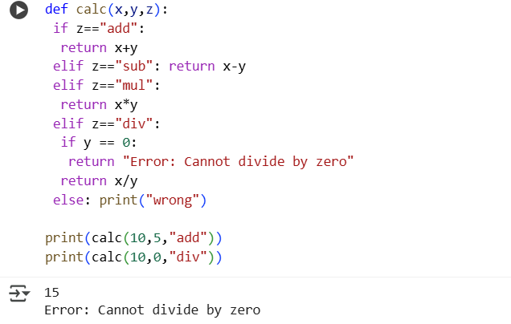
EXPLANATION:
