SCHOOLOFCOMPUTER SCIENCE AND ARTIFICIAL INTELLIGENCE |  |  |  |  | DEPARTMENTOFCOMPUTER SCIENCE ENGINEERING
ProgramName:B. Tech |  |  |  | AssignmentType: Lab |  |  | AcademicYear:2025-2026
CourseCoordinatorName |  |  |  | Venkataramana Veeramsetty
Instructor(s)Name
  Dr. V. Venkataramana (Co-ordinator)
  Dr. T. Sampath Kumar
  Dr. Pramoda Patro
  Dr. Brij Kishor Tiwari
  Dr.J.Ravichander
  Dr. Mohammand Ali Shaik
  Dr. Anirodh Kumar
  Mr. S.Naresh Kumar
  Dr. RAJESH VELPULA
  Mr. Kundhan Kumar
  Ms. Ch.Rajitha
  Mr. M Prakash
  Mr. B.Raju
  Intern 1 (Dharma teja)
  Intern 2 (Sai Prasad)
  Intern 3 (Sowmya)
  NS_2 ( Mounika)
CourseCode |  |  | 24CS002PC215 | CourseTitle |  | AI Assisted Coding
Year/Sem |  |  | II/I | Regulation |  | R24
DateandDay  of Assignment |  |  | Week6 - WednesDay | Time(s)
Duration |  |  | 2 Hours | Applicableto  Batches
AssignmentNumber:11.3(Presentassignmentnumber)/24(Totalnumberofassignments)
 | Q.No. | Question |  |  |  |  |  | ExpectedTime  to complete
 | 1 | Lab 11 – Data Structures with AI: Implementing Fundamental Structures  Lab Objectives  - To implement fundamental data structures with the assistance of AI tools.  - To understand how AI suggests different implementations and optimizations.  - To analyze the readability, correctness, and performance of AI-generated code.  - To reinforce problem-solving skills using AI-powered coding assistance.  Learning Outcomes  After completing this lab, students will be able to:  - Implement stack, queue, and linked list using Python with AI support.  - Use AI tools to optimize and refactor basic data structure operations.  - Compare multiple AI-suggested implementations for the same structure.  - Apply AI assistance to generate test cases for verifying data structure behavior.  - Demonstrate understanding of trade-offs in AI-generated solutions.  Task Description #1 – Stack class implementation  Task: Ask AI to implement a stack class with push(), pop(), peek() and is_empty() methods  Output :  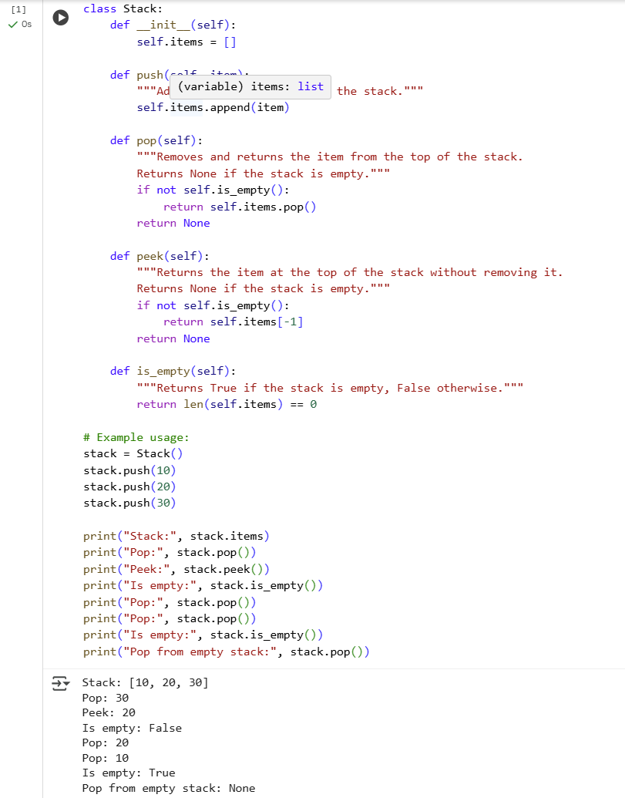  Explanation :  The init method initializes an empty list to store the stack elements. The push method adds an element to the end of the list (top of the stack). The pop method removes and returns the last element from the list if the stack is not empty. The peek method returns the last element without removing it, if the stack is not empty. The is_empty method checks if the list (stack) is empty.  Task Description #2 – Queue Implementation  Task: Use AI to generate a Queue class with enqueue(), dequeue(), and is_empty().  Output:  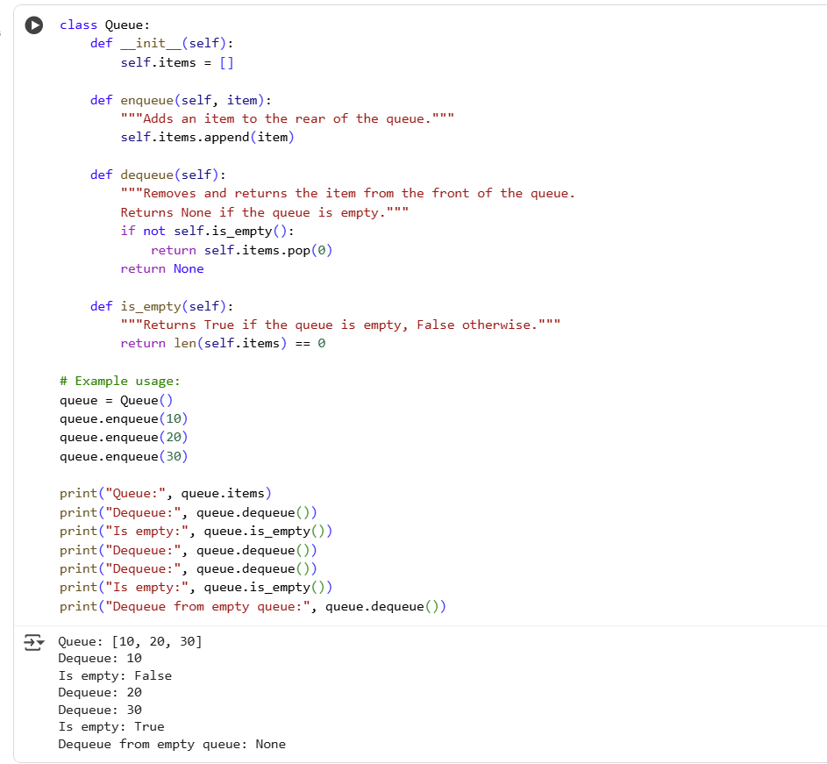  Explanation:  init creates an empty list to hold queue items. enqueue adds an item to the end of the list (rear of the queue). dequeue removes and returns the first item (front of the queue) if the queue isn't empty. is_empty checks if the list is empty.  Task Description #3 – Linked List Implementation  Task: Ask AI to create a singly linked list with insert_at_end(), insert_at_beginning(), and display().  Output:  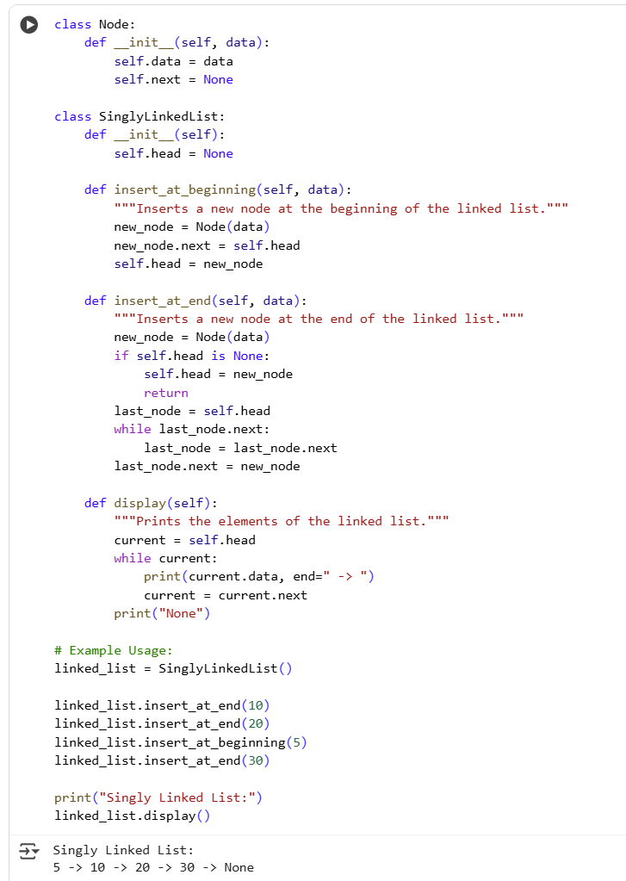  Explanation:  The Node class represents an element with data and a next pointer. The SinglyLinkedList class has a head to the first node. insert_at_beginning adds a new node at the start. insert_at_end adds a new node at the end by traversing the list. display iterates through the list and prints the data of each node.  Task Description #4 – Binary Search Tree (BST)  Task: Ask AI to generate a simple BST with insert() and inorder_traversal().  Output:  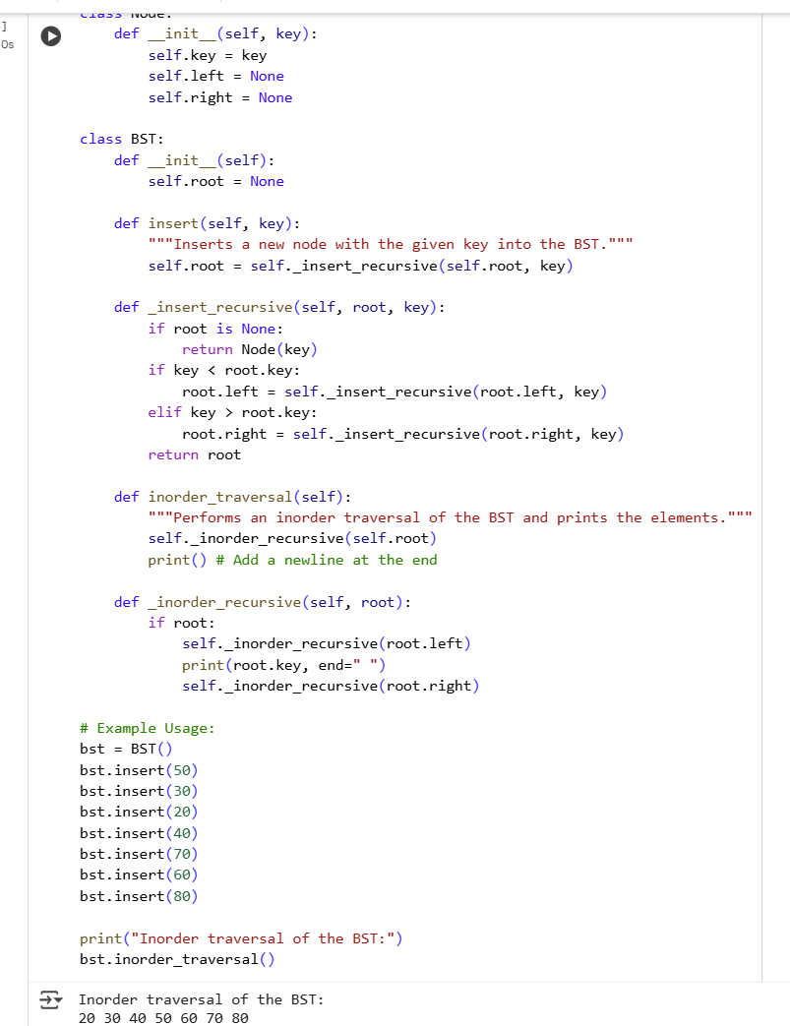  Explanation:  This code defines a Binary Search Tree (BST).  The Node class represents a node with a key and pointers to its left and right children. The BST class has a root node. The insert method adds a new node while maintaining the BST property (smaller keys go to the left, larger to the right) using a recursive helper function. The inorder_traversal method performs an inorder traversal (left, root, right) and prints the keys, resulting in a sorted output. |  |  |  |  |  | Week5 - Monday

