AI ASSISTED CODING:
ASSIGNMENT 12.4:
NAME:SHARANYA THANUGULA
HT NO:2403A51401
BATCH:16
TASK1:
Write a python program for bubble sort add doc string and inline comments consider one example.
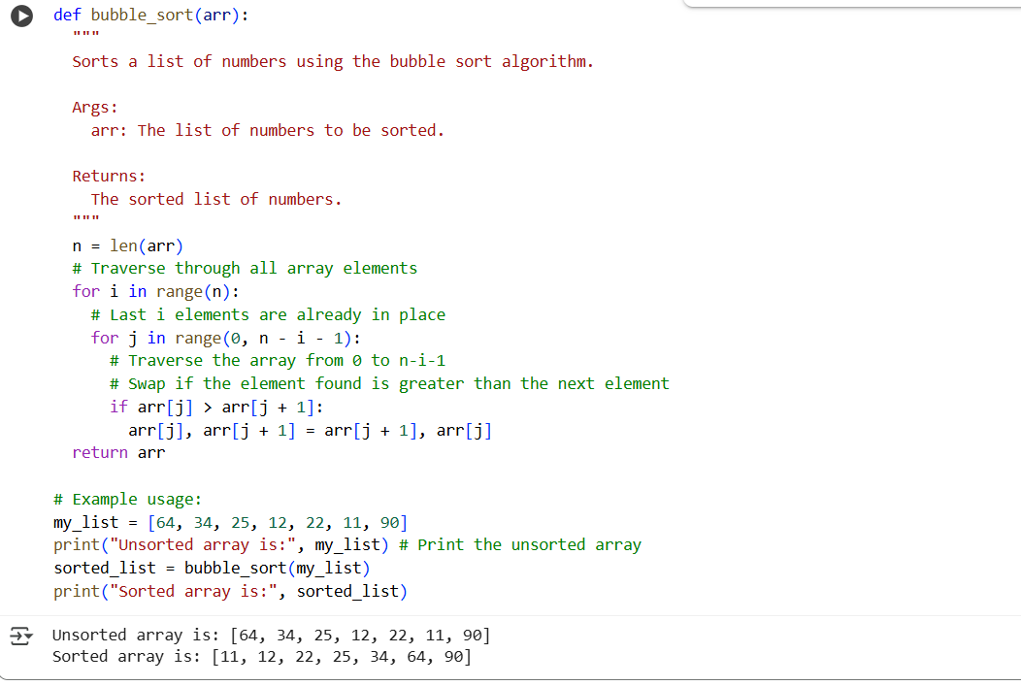

TASK2:
Suggest a more efficient algorithm for partially sorted arrays.
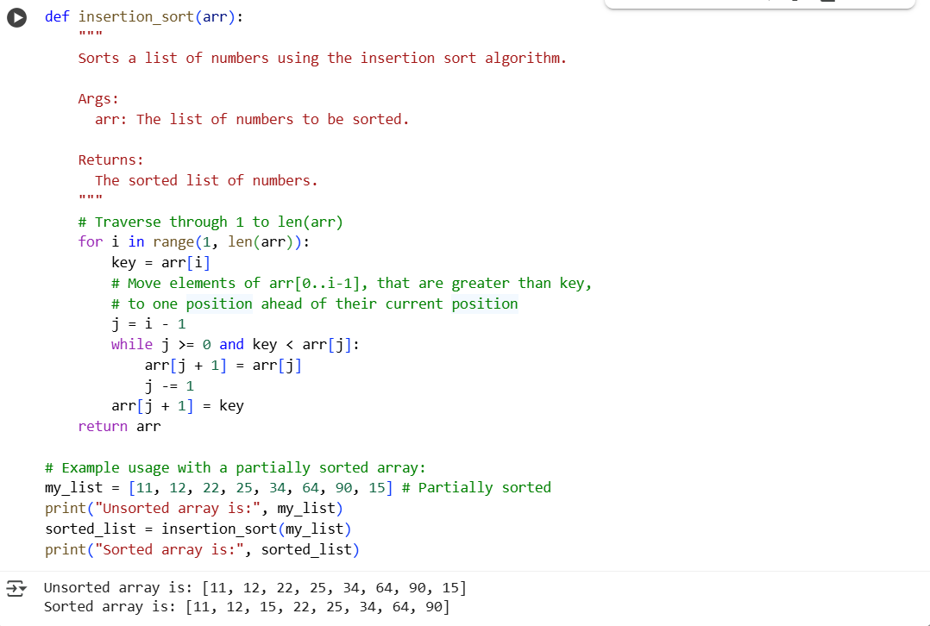
EXPLANATION:
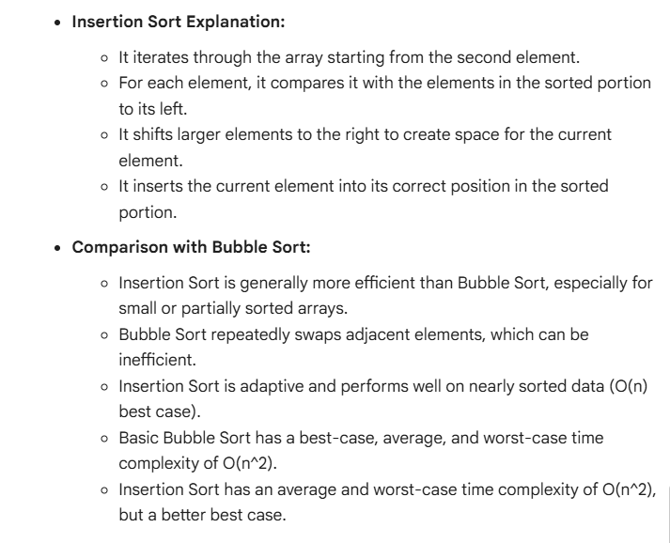

TASK3:
Generate a python program that implements the linear search and binary search with one example.
LINEAR SEARCH:
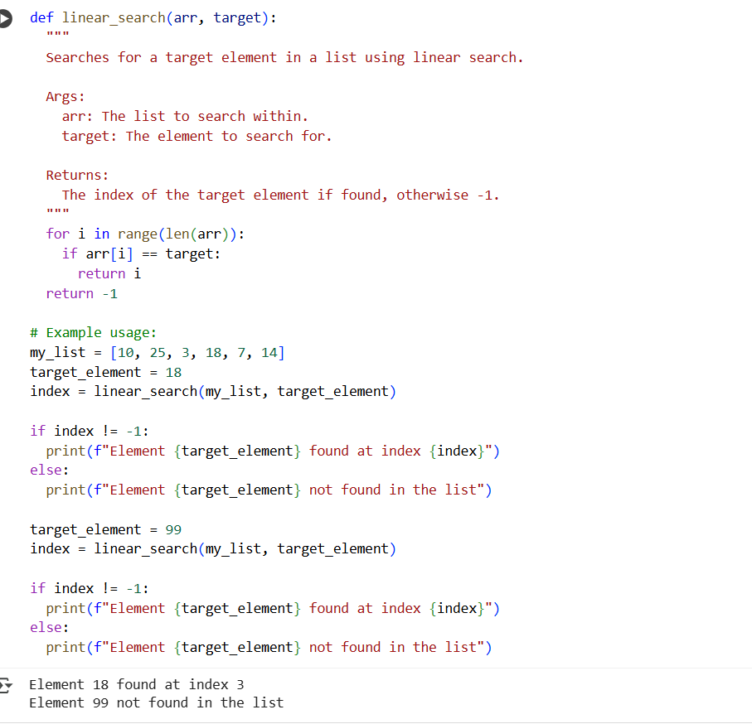

BINARY SEARCH:
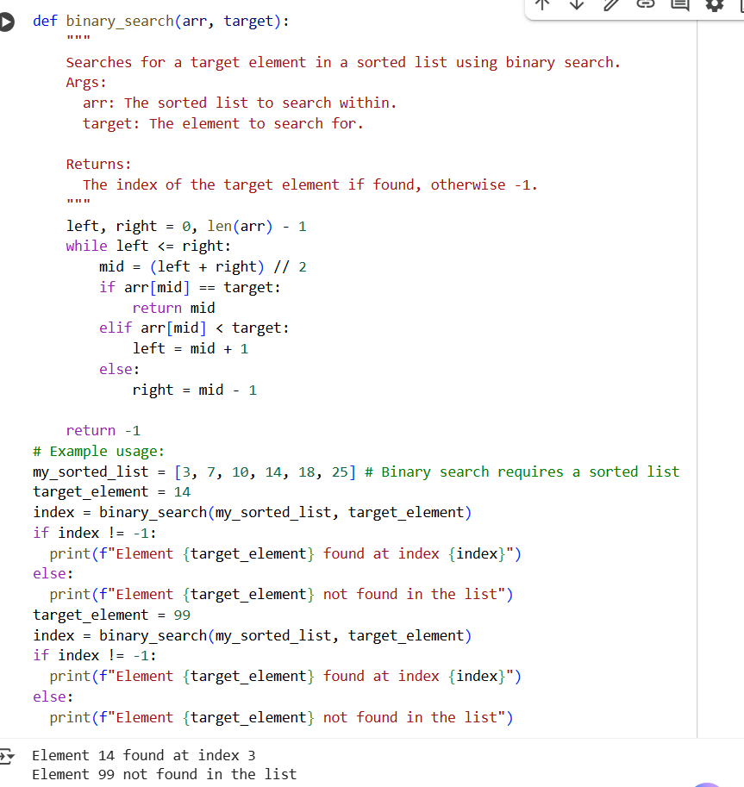

EXPLANATION:
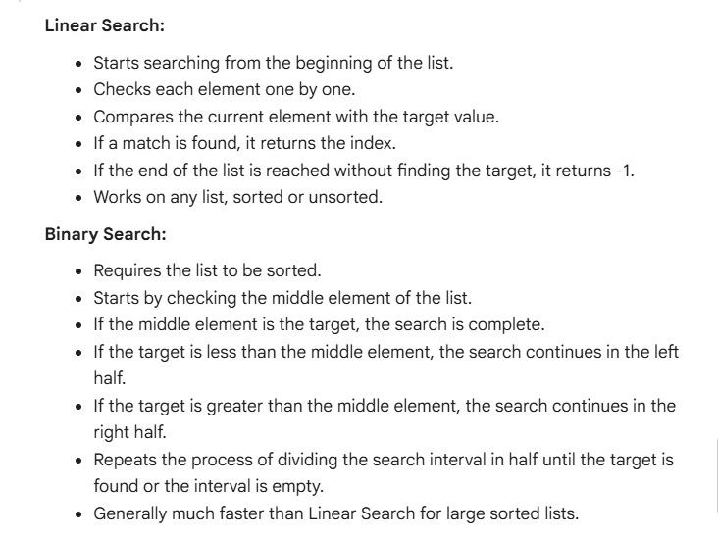

TASK 4:
Generate a python program for implementing quick sort and merge sort using recursion with one example.
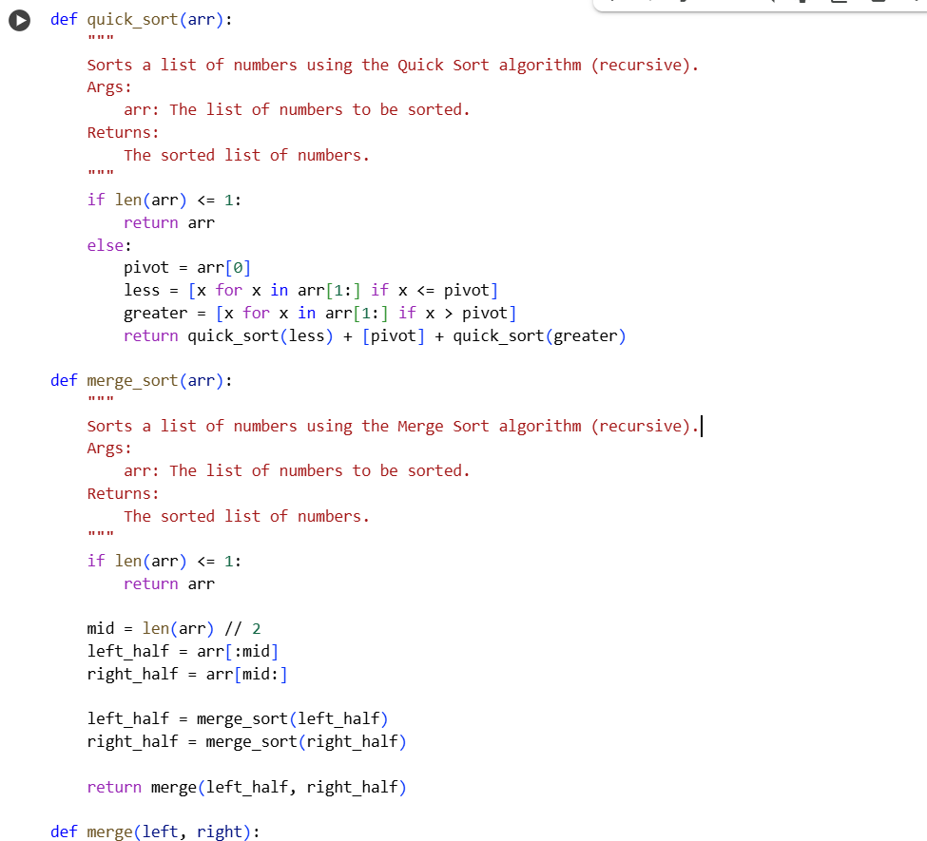
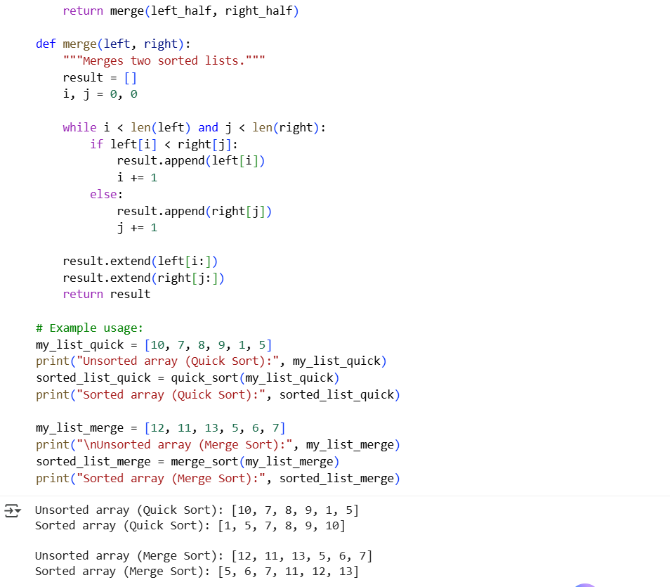

EXPLANATION:
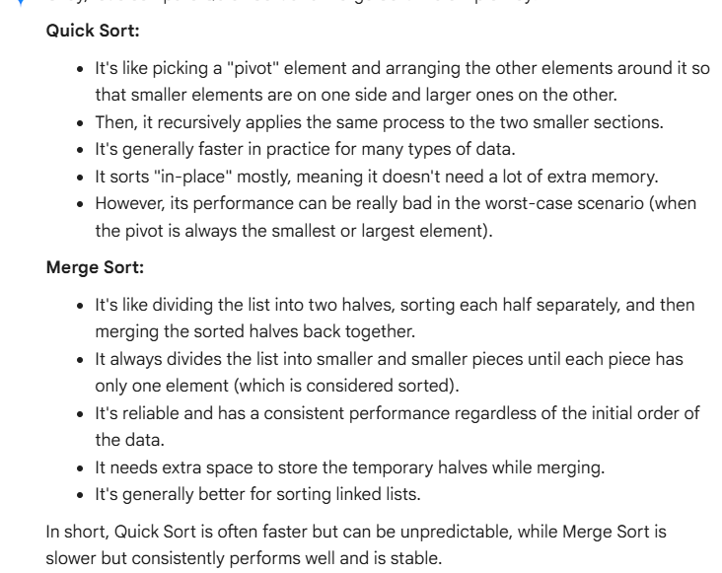
TASK 5:
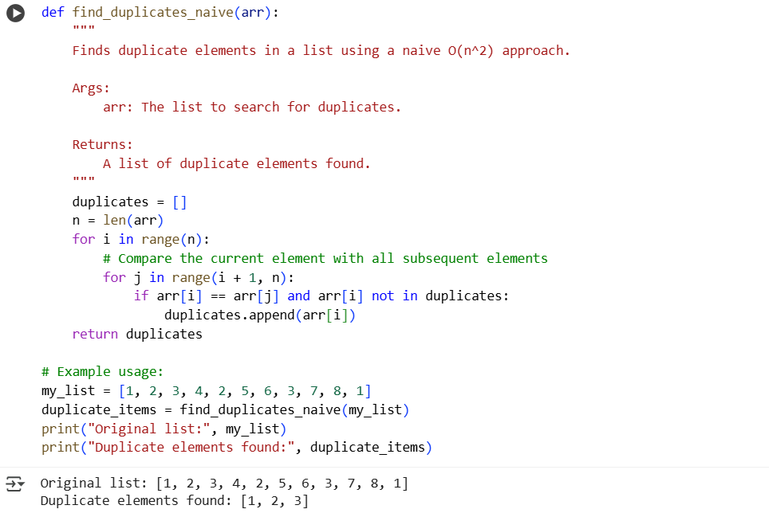
EXPLANATION:
