AI ASSISTED CODING:
LAB ASSIGNMENT 13.4
NAME: SHARANYA THANUGULA
HT NO:2403A51401
BATCH:16

TASK 1: Refactor repeated loops into a cleaner, more Pythonic approach.
Legacy code:
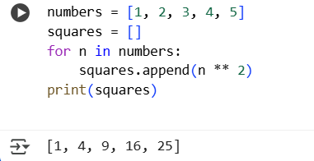
Refactored code:
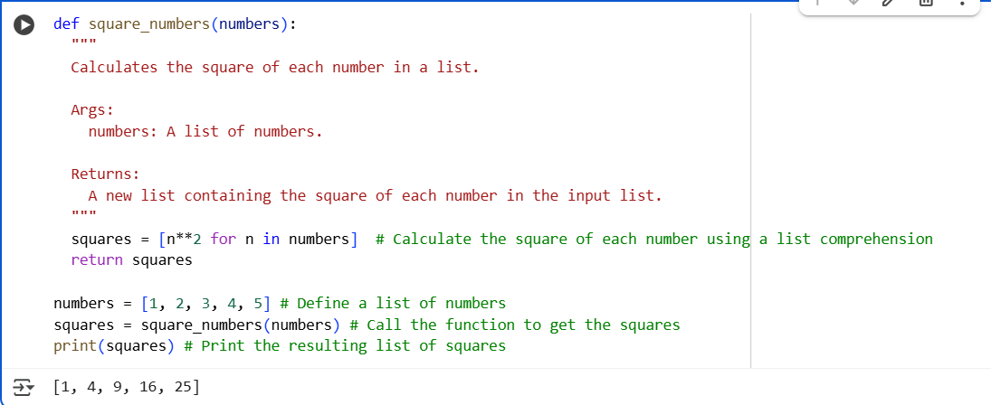

TASK 2: Refactor code with String Concentration.
Legacy code:
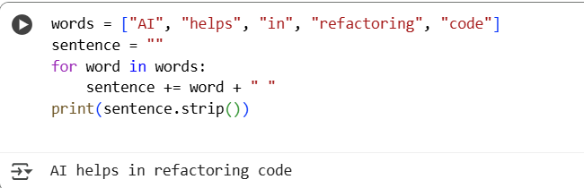
Refactored code:
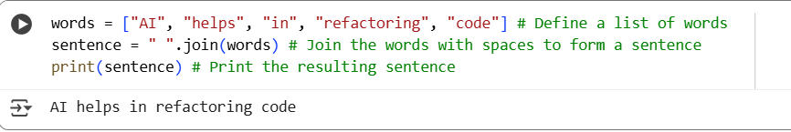

TASK 3:
Replace manual dictionary lookup with a safer method.
Legacy code:
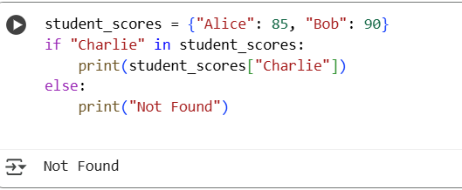

Refactored Code:
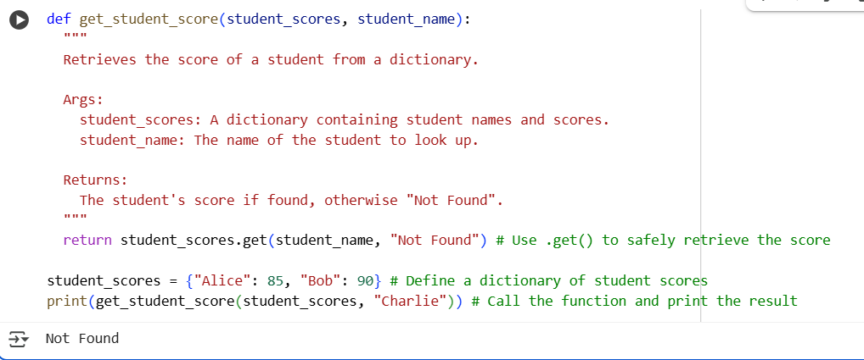

TASK 4:Refactor code with repetitive if-else blocks.
Legacy code:
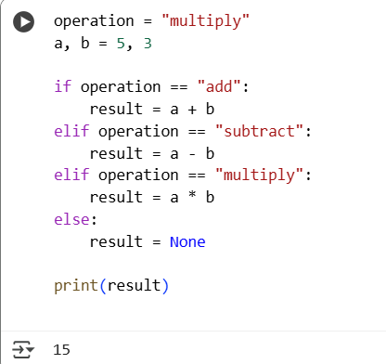

Refactored Code:
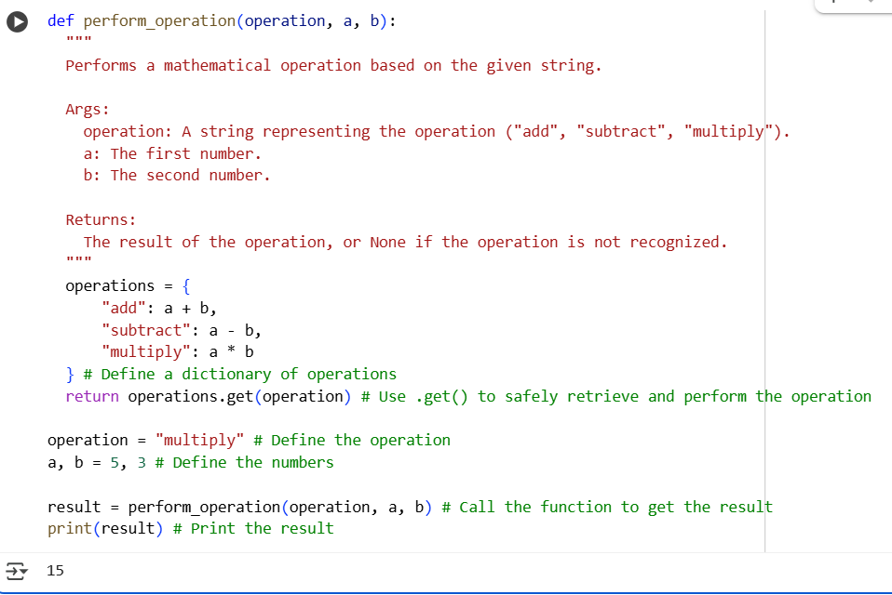

TASK 5: Optimize nested loops for searching
Legacy code:
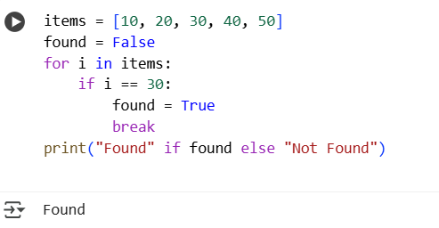

Refactored Code:
