AI ASSISTED CODING
LAB ASSIGNMENT-3
NAME: SHARANYA THANUGULA
HT NO:2403A51401
BATCH:16
Task1:
Program in python to find the compound interest using functions.
CODE:
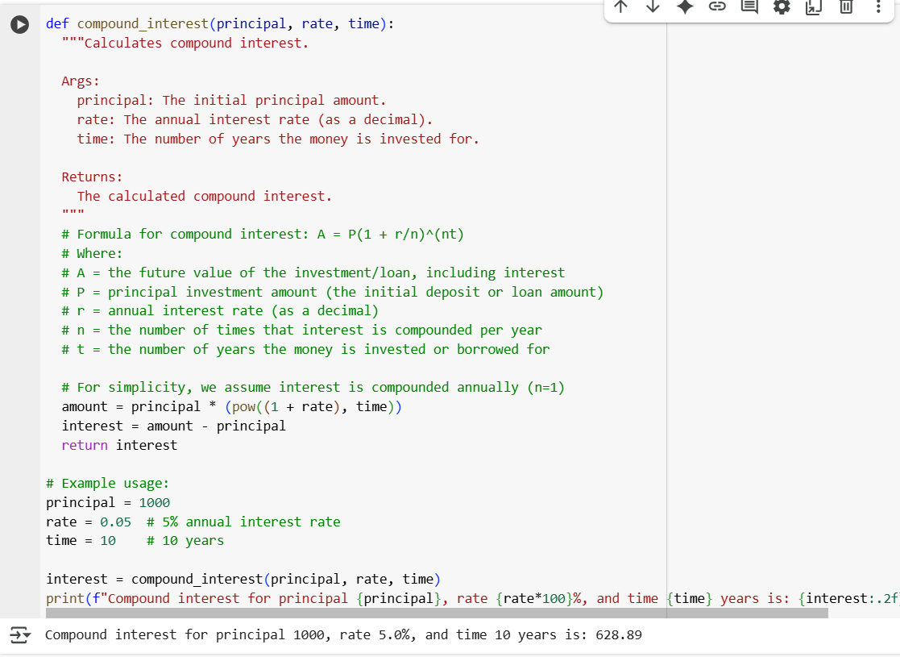

OUTPUT:

EXPLANATION:
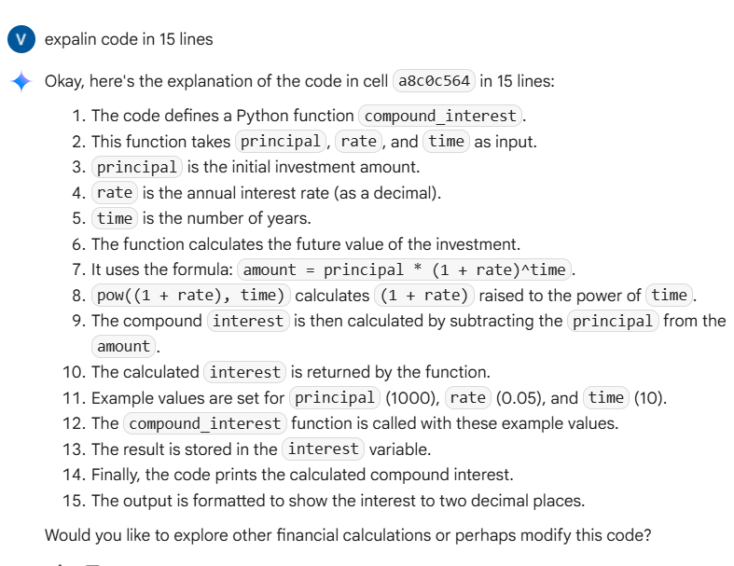

Task2:
Write a function to calculate average , median and mode of a list of numbers.

CODE:
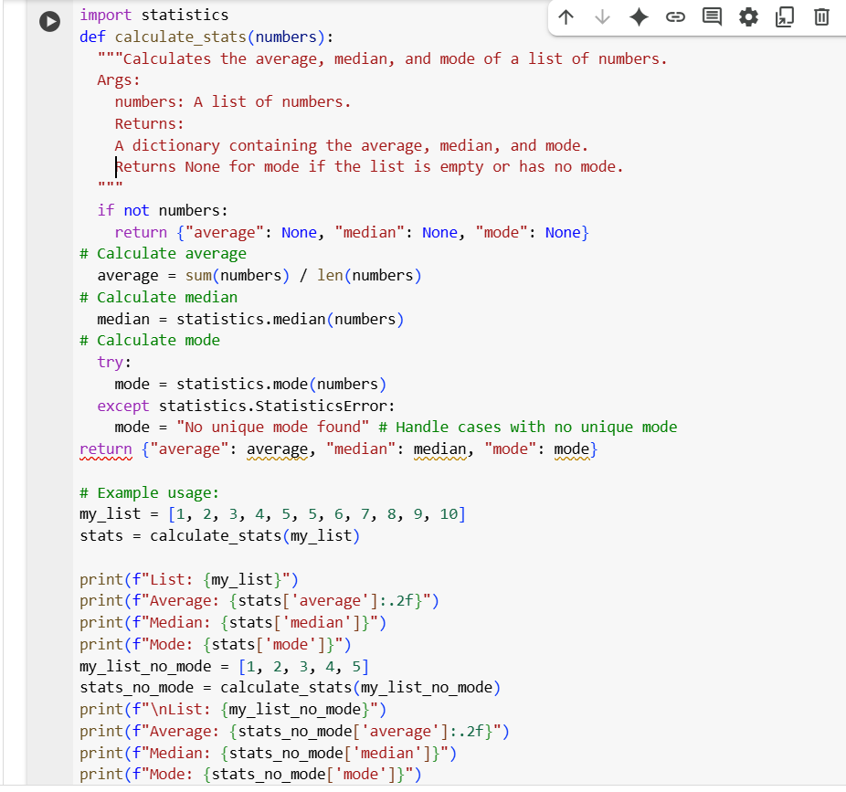
OUTPUT:
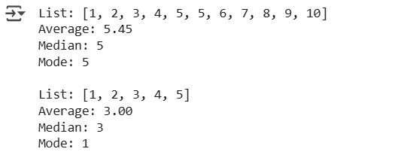

EXPLANATION:
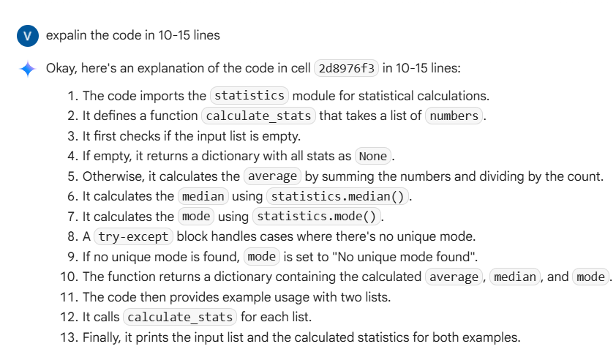
Task3:
Multiple examples of input-output to convert to binary(num) function.
CODE:
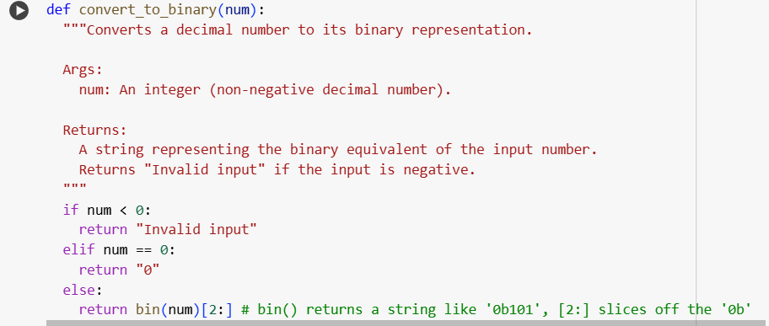

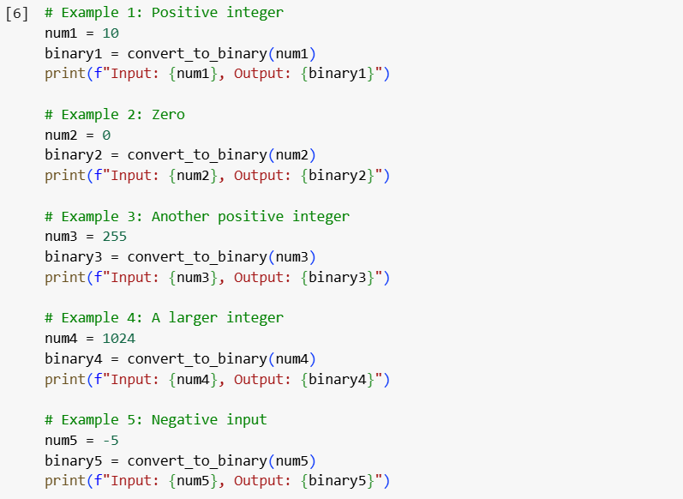

OUTPUT:
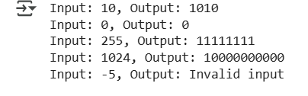

EXPLANATION:
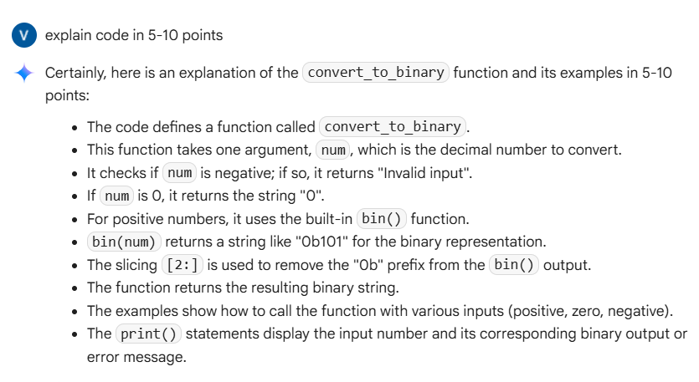
Task4:
An user interface for an hotel to generate bill based on customer requirements.

CODE:
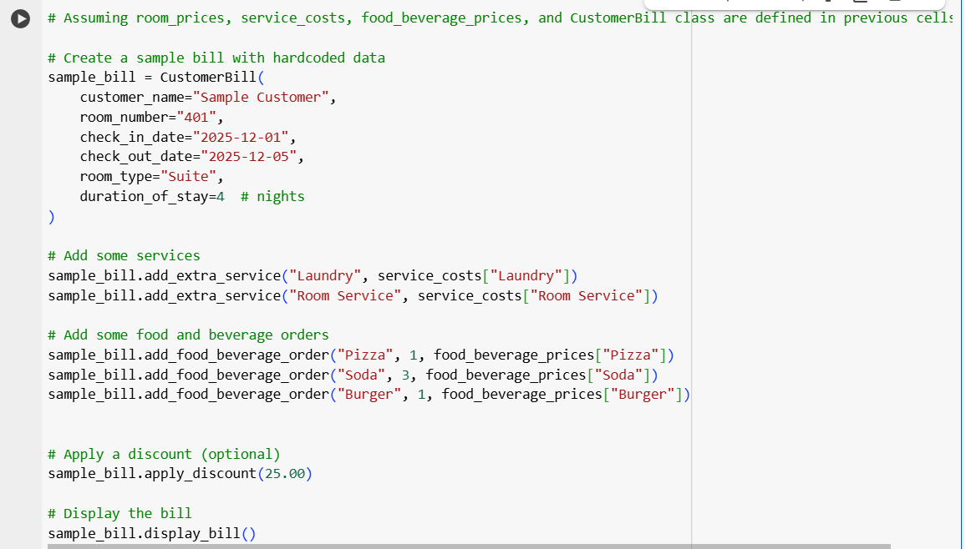
OUTPUT:
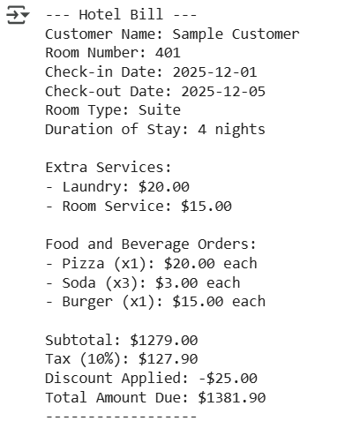

EXPLANATION:
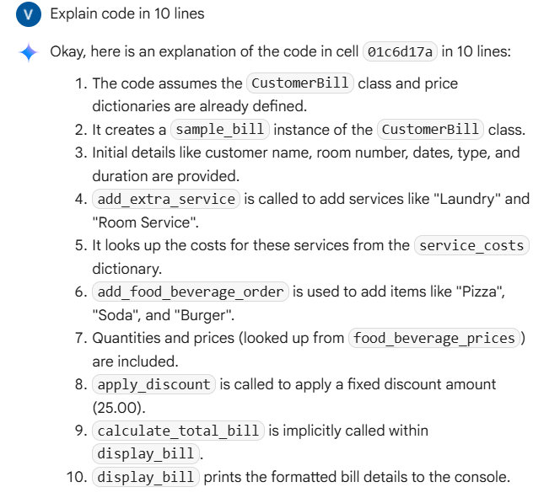

Task5:
Conversion of Fahrenheit to Celsius:
CODE:
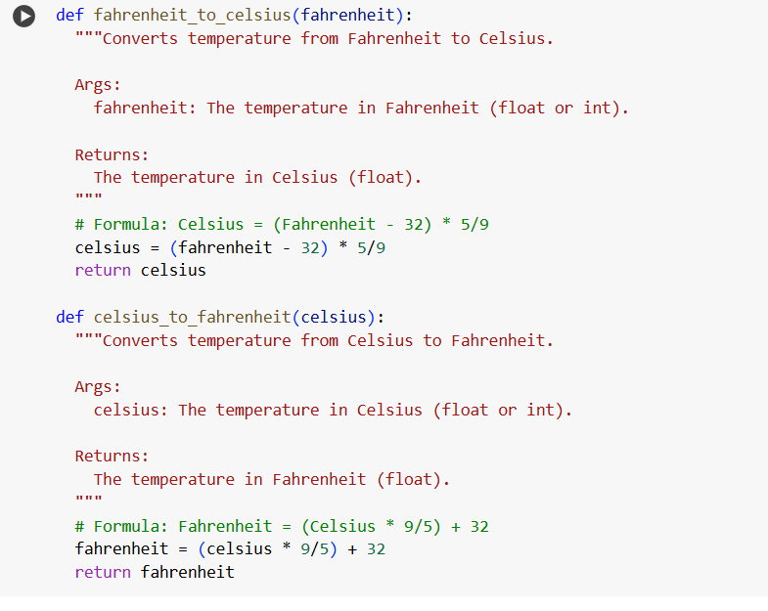

OUTPUT:
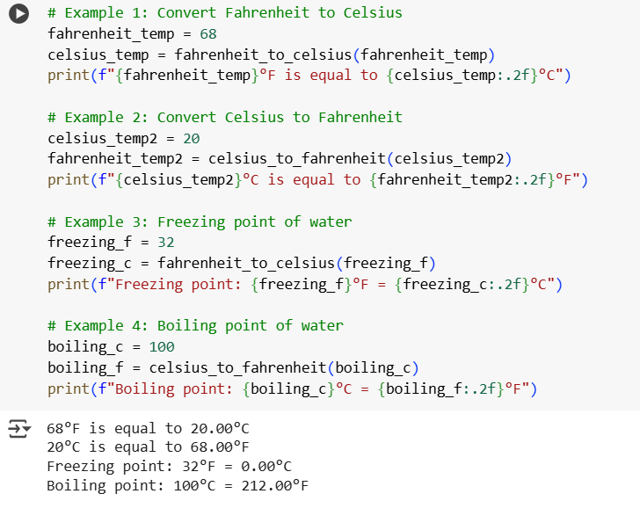EXPLANATION