AI ASSIGNMENT-4.1
Name : Sharanya Thanugula
Hall ticket No: 2403A51401
Batch:16
Task-1:
Write a Python function named validate_indian_mobile(number) that checks whether a given mobile number is valid according to Indian mobile number rules. The function must:
- Ensure the number starts with 6, 7, 8, or 9
- Ensure the number contains exactly 10 digits
- Return True if valid, otherwise False
Do not include any input-output examples. Just generate the function based on the above requirements.

Code:

Task-2:
Write a Python function named calculate_factorial(n) that returns the factorial of a given number n. The function must: - Return 1 when n is 0 (i.e., handle 0! correctly) - Return a message like "Factorial is not defined for negative numbers" when n is negative - Compute the factorial for positive integers using correct logic Example: Input: calculate_factorial(5) Output: 120
Code:
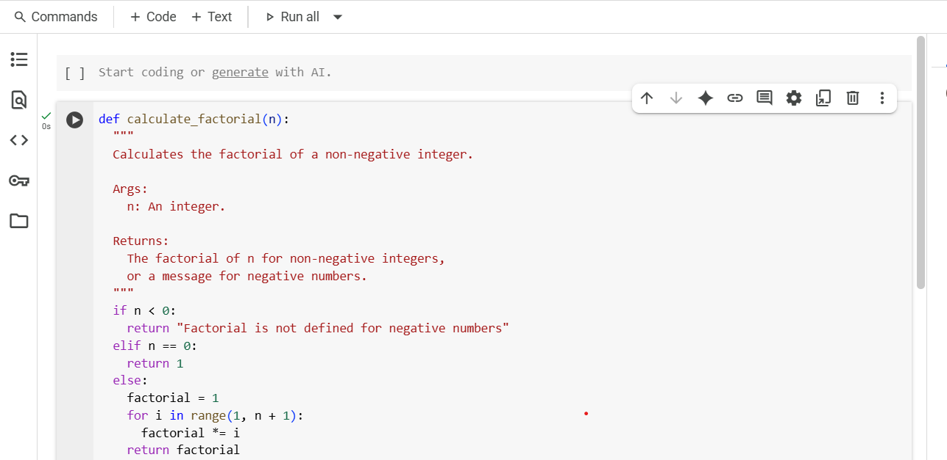
Output:
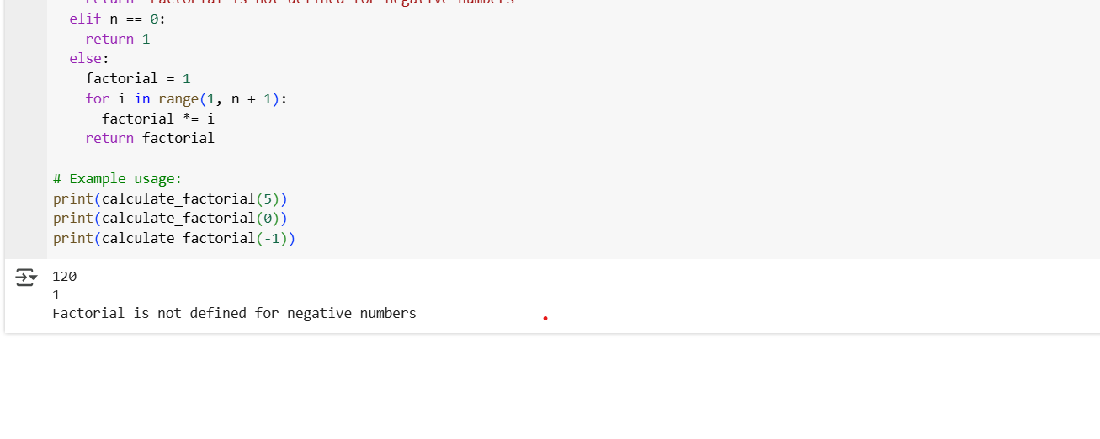
Explanation:
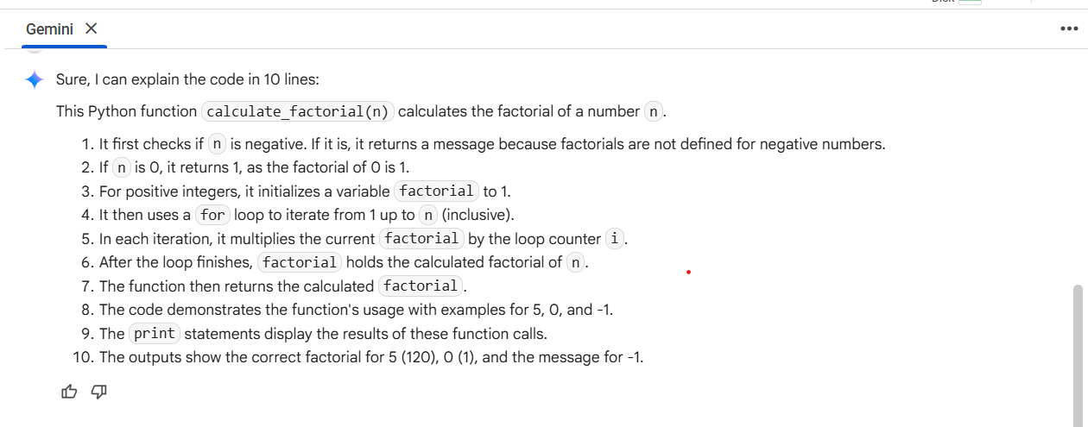
Task-3:
Write a Python function called extract_student_info(student_dict) that takes a nested dictionary representing student data and returns a dictionary with the student's full name, branch, and SGPA. Example 1 The input dictionary contains a "personal" section with "first_name" as "Amit" and "last_name" as "Verma". The "academic" section includes "branch" as "Computer Science" and "grades" with "SGPA" as 9.1. The expected output is: {'Full Name': 'Amit Verma', 'Branch': 'Computer Science', 'SGPA': 9.1} Example 2 The input dictionary contains "first_name" as "Neha" and "last_name" as "Singh" under "personal". The "academic" section includes "branch" as "Mechanical" and "SGPA" as 8.7 under "grades". The expected output is: {'Full Name': 'Neha Singh', 'Branch': 'Mechanical', 'SGPA': 8.7}
Code:
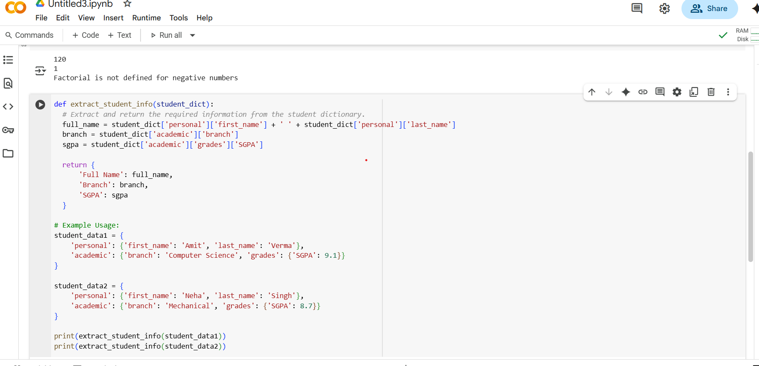
Output:
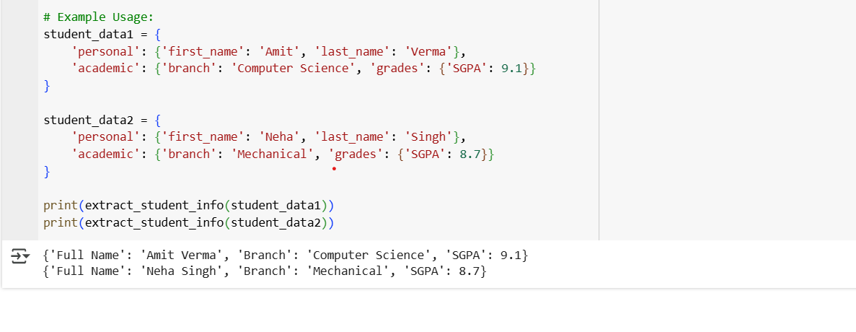
Explanation:
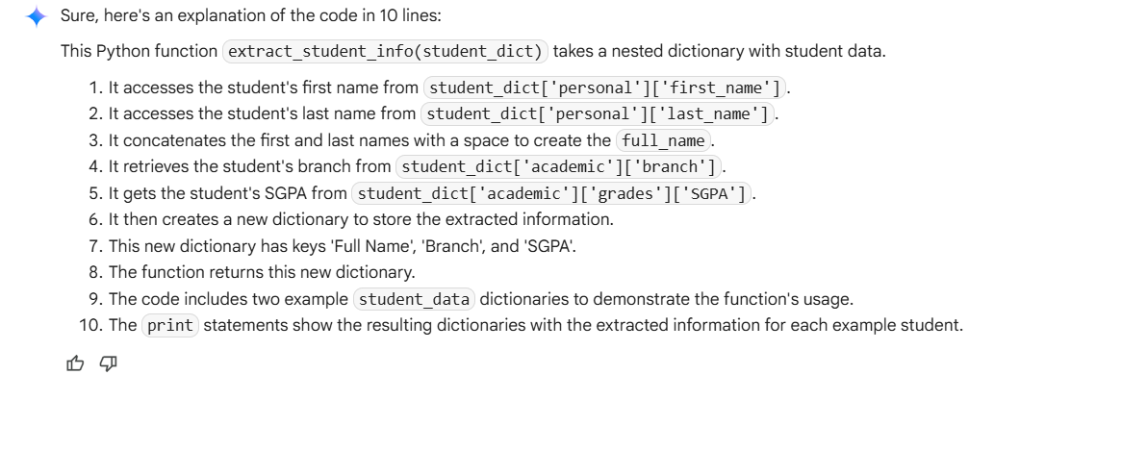
Task-4:
Generate Python functions using three different prompting styles—zero-shot, one-shot, and few-shot—to perform CSV file analysis. Each function should: - Read a .csv file - Return the total number of rows - Count the number of empty rows - Count the total number of words across the file 1, Zero-Shot Prompt Write a Python function that reads a CSV file and returns the total number of rows, the number of empty rows, and the total number of words in the file.2, One-Shot Prompt Example: Input: A CSV file with 5 rows, 1 of which is completely empty, and a total of 42 words across all cells. Output: {'Total Rows': 5, 'Empty Rows': 1, 'Word Count': 42} Now write a Python function that performs this analysis for any CSV file. 3, Few-Shot Prompt Example 1: Input: A CSV file with 10 rows, 2 empty rows, and 100 words. Output: {'Total Rows': 10, 'Empty Rows': 2, 'Word Count': 100} Example 2: Input: A CSV file with 3 rows, 0 empty rows, and 15 words. Output: {'Total Rows': 3, 'Empty Rows': 0, 'Word Count': 15} Now generate a Python function that works for similar CSV files and returns the correct analysis. >>Reflection After generating the functions, briefly compare the accuracy, clarity, and efficiency of the outputs from each prompting style. One-Shot Prompt Example: Input: A CSV file with 5 rows, 1 of which is completely empty, and a total of 42 words across all cells. Output: {'Total Rows': 5, 'Empty Rows': 1, 'Word Count': 42} Now write a Python function that performs this analysis for any CSV file. >> Few-Shot Prompt Example 1: Input: A CSV file with 10 rows, 2 empty rows, and 100 words. Output: {'Total Rows': 10, 'Empty Rows': 2, 'Word Count': 100} Example 2: Input: A CSV file with 3 rows, 0 empty rows, and 15 words. Output: {'Total Rows': 3, 'Empty Rows': 0, 'Word Count': 15} Now generate a Python function that works for similar CSV files and returns the correct analysis.
Code:
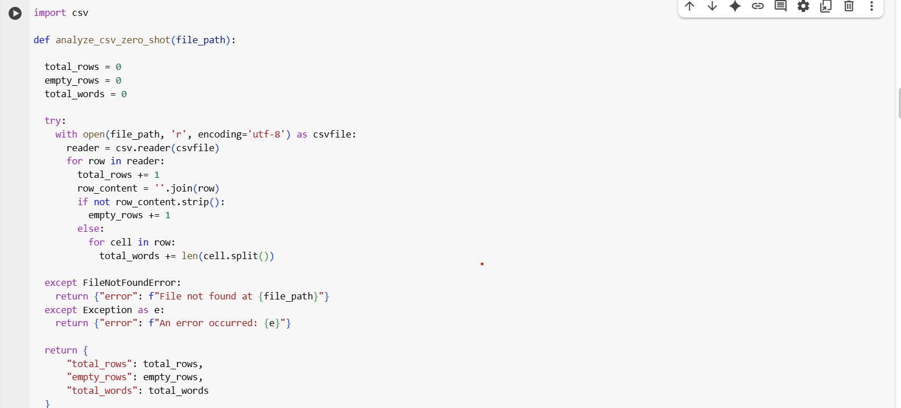
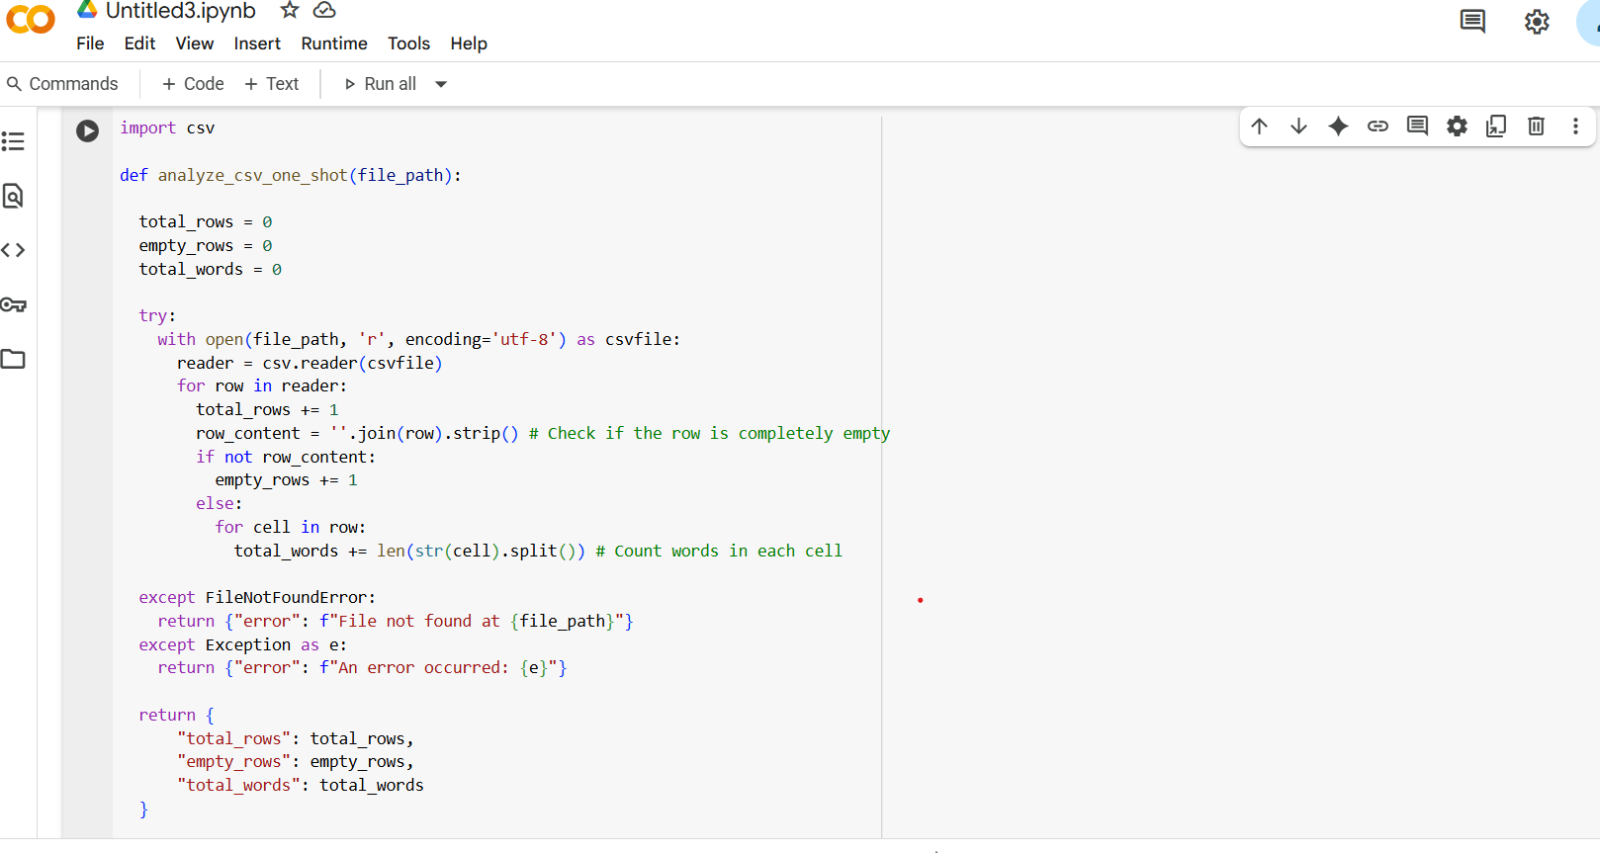
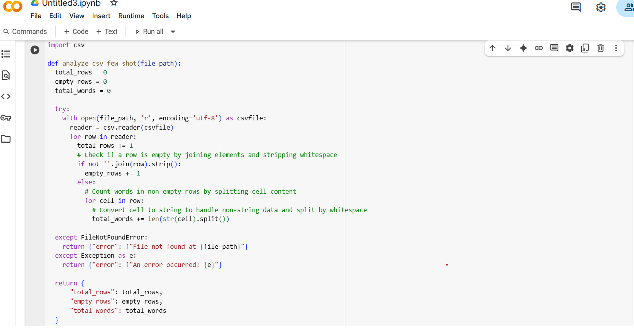
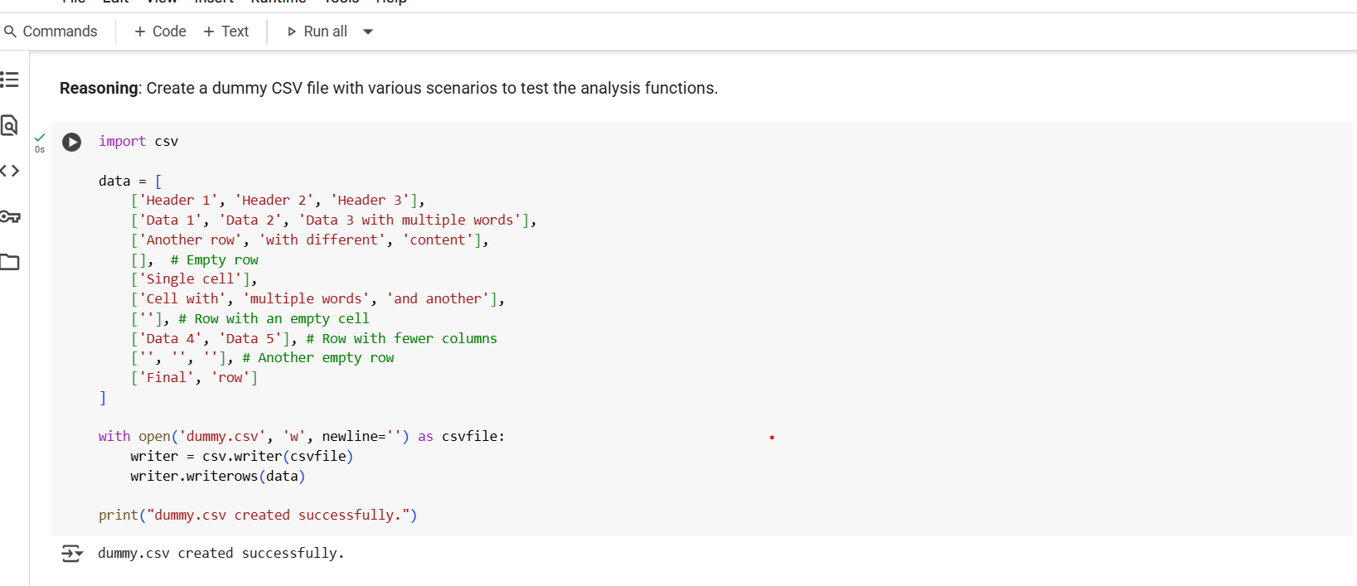
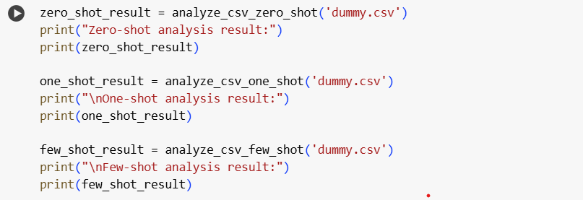
Output:
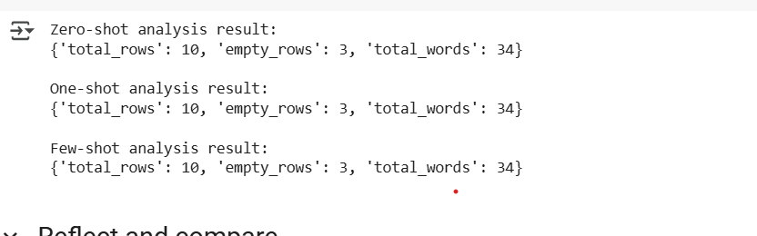
Explanation:
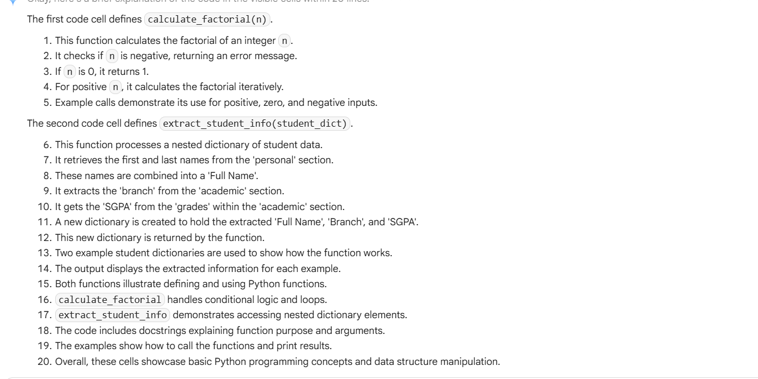
Task-5:
Write a Python function called most_frequent_word(text) that accepts a paragraph as input and returns the most frequently used word. The function must: - Convert all text to lowercase - Remove punctuation - Analyze word frequency - Return the word that appears most often Example 1 Input: "Data science is fun. Data is powerful. Science is evolving." Output: "is" Example 2 Input: "Python is great! Python is versatile. Python is popular." Output: "python" Example 3 Input: "AI tools are transforming industries. AI is the future. Tools help us adapt." Output: "ai" Now generate the function most_frequent_word(text) that works for these examples and similar ones
Code:
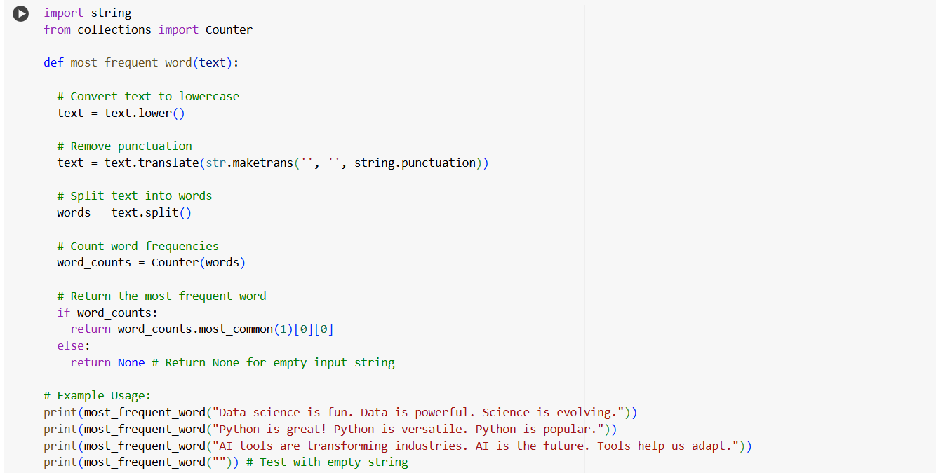
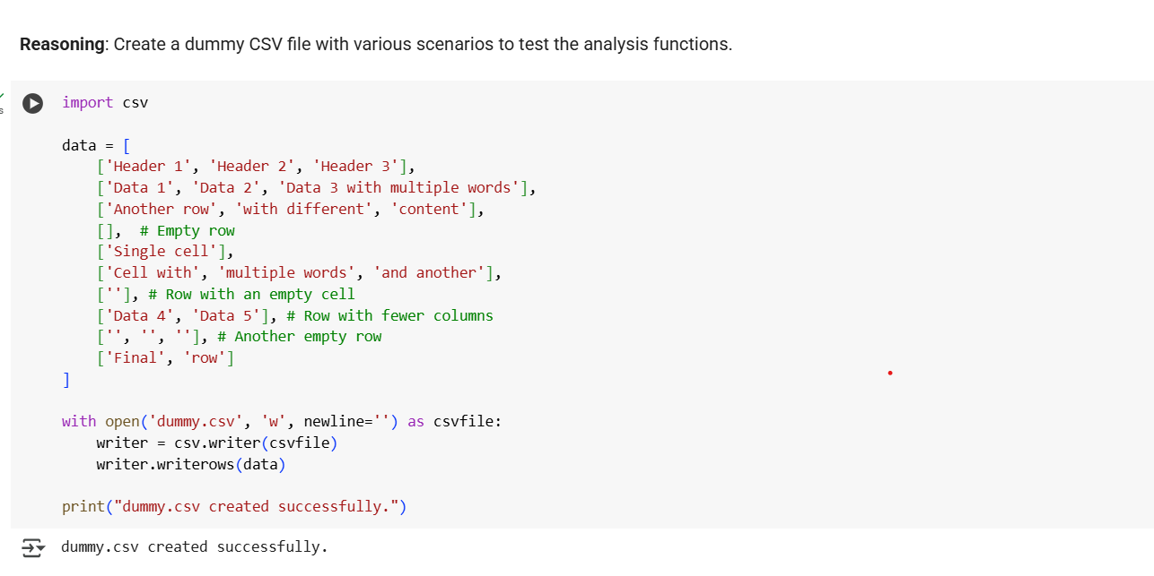
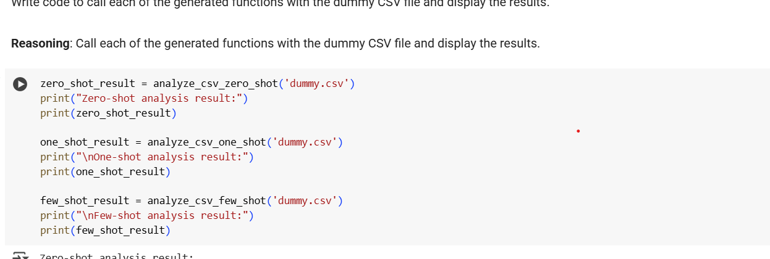Output:
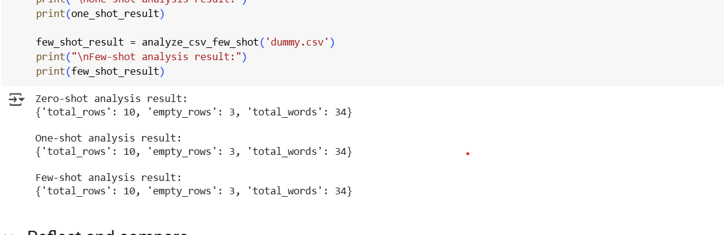
Explanation:
