ASSIGNMENT-9.3
Name : Sharanya Thanugula
Hall ticket No: 2403A51401
Batch:16
Task 1:
Generate a python code sum of even and odd numbers in the given list with out docstring and inline comment
--Without Docstring and Inline comment
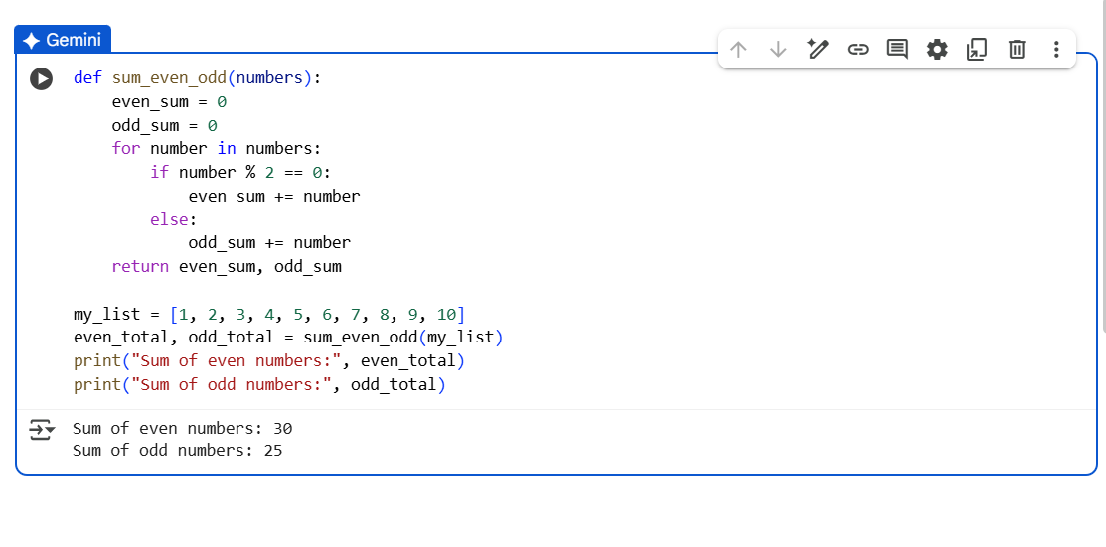
--With Docstring and Inline comment
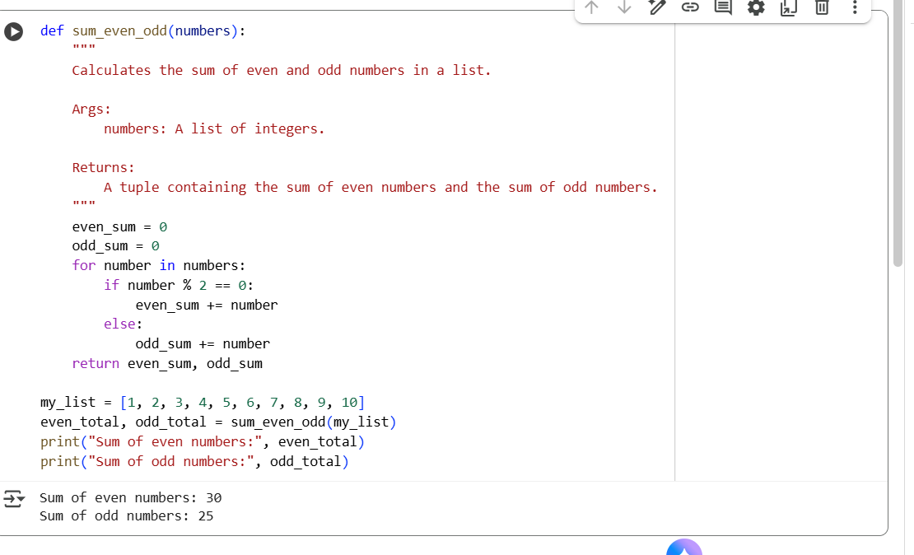
Task 2:
Generate a python code with class sru_student and attributes are name, roll no, hostel_status and fee_update method and display_datails method with out docstring and inline comment
--Without Docstring and Inline comment
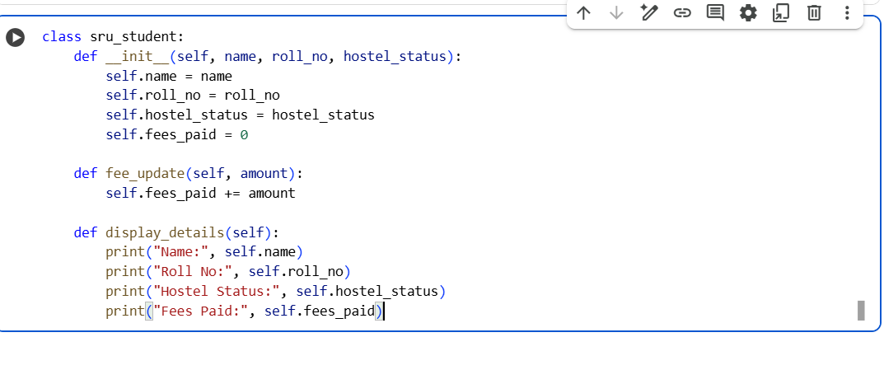
--With Docstring and Inline comment
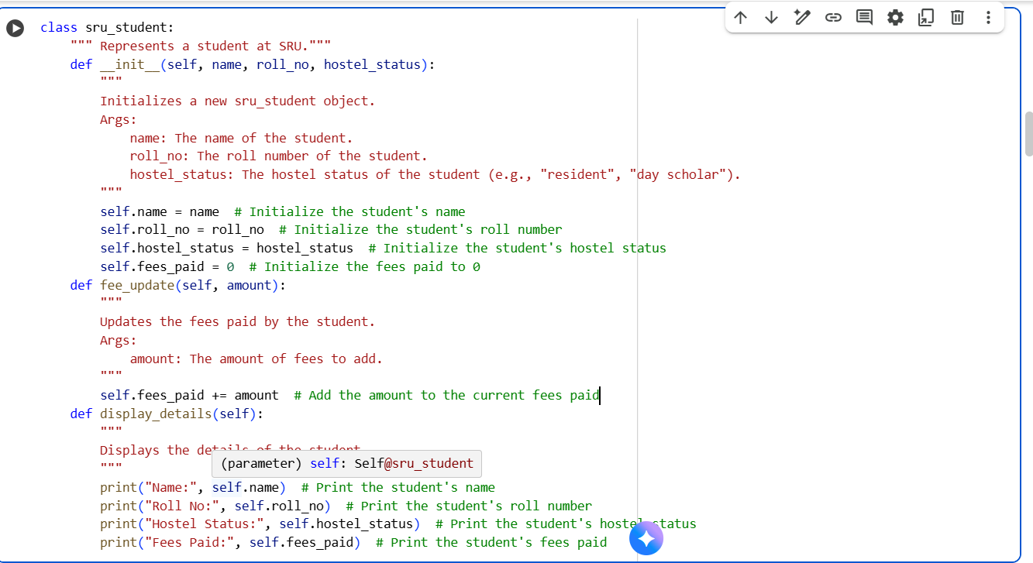
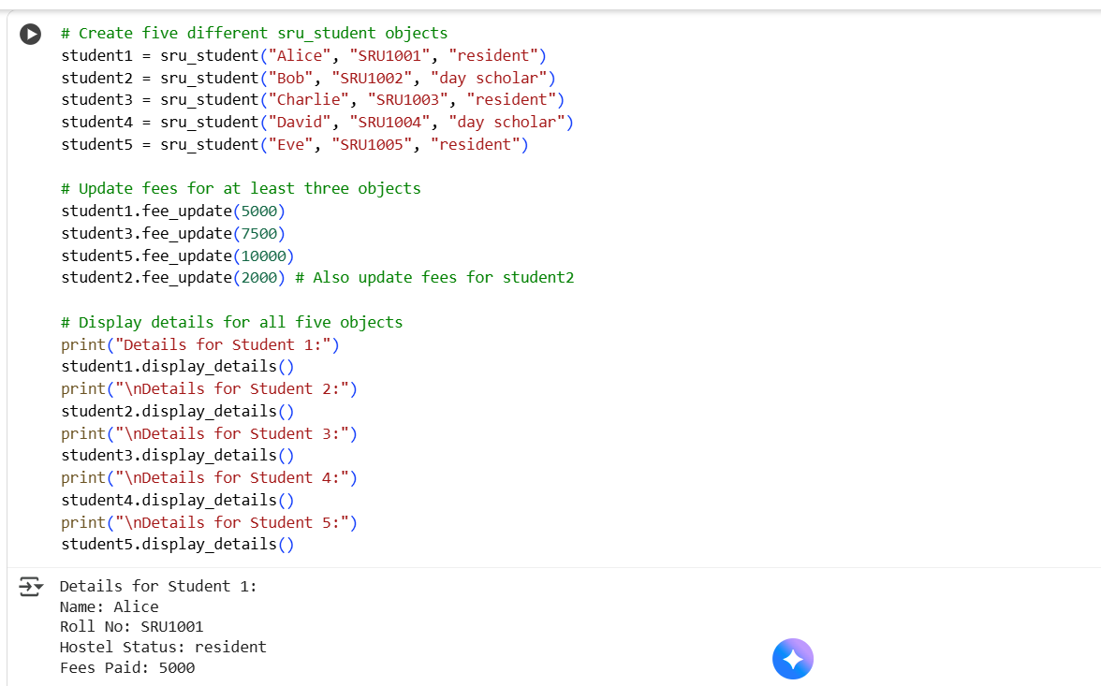

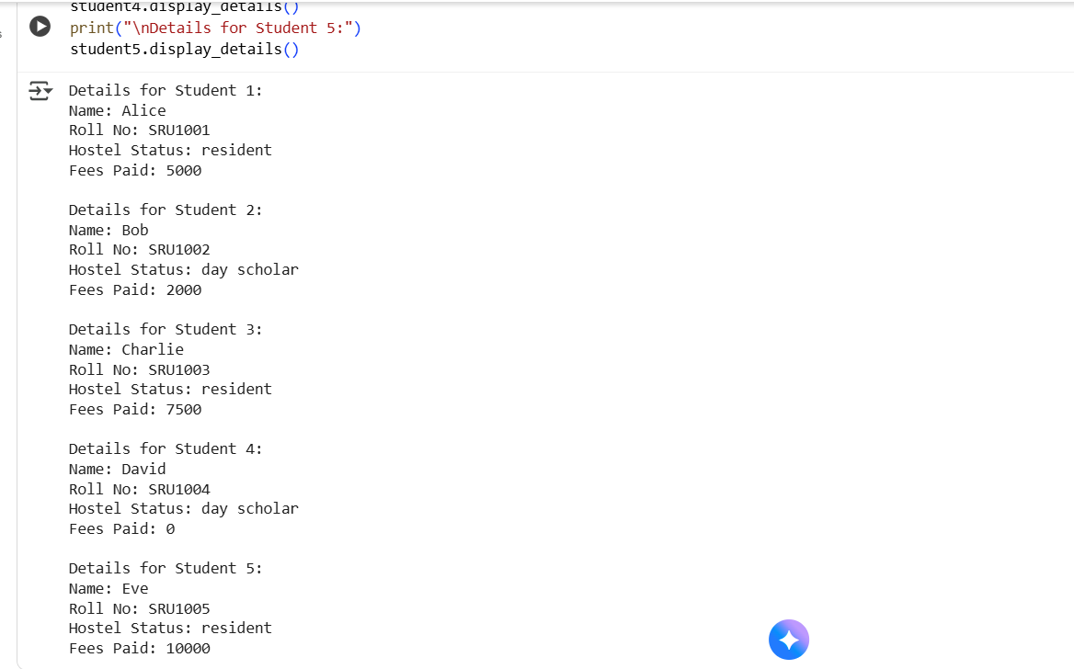

Task 3:
Generate python code for simple calculator with functions add, subtract, multiply, divide using numpy library without docstring and inline comment
--Without Docstring and Inline comment
