Synopsis
Project Title: BillNova – Smart Billing System

Introduction
BillNova is a desktop-based billing and inventory management system developed to simplify the billing process for small and medium-sized businesses. The system enables users to manage products, customers, invoices, and sales records through an easy-to-use interface. It reduces manual work, improves billing accuracy, and maintains digital records for future reference.

Objective & Scope of project
The main objective of this project is to develop an efficient billing application that automates invoice generation, maintains product inventory, stores customer information, and generates sales reports. The system aims to save time, minimize human errors, and improve business operations.
The project is suitable for:
- Grocery Stores
- Medical Shops
- Clothing Stores
- Electronic Shops
- Stationery Shops
- General Retail Businesses
The system can be further expanded to support multiple branches and online billing.

Technologies Used
- Frontend: HTML, CSS, Bootstrap, JavaScript
- Programming language: Python flask
- Backend:
- Database: MY SQL,
- Database management tool: MY SQL Workbench
- IDE: Visual Studio Code (VS Code)

Modules
- User Login and Authentication
- Customer Management
- Product Management
- Billing and Invoice Generation
- Inventory Management
- Sales History
- Report Generation

Features
- Secure login for authorized users.
- Add, update, delete, and search products.
- Maintain customer details.
- Automatic bill calculation with GST support.
- Generate and print invoices.
- Update stock automatically after each sale.
- Store sales records in the database.
- Search and view previous bills.

Expected Outcome
The system will provide a fast, reliable, and user-friendly billing solution that helps businesses manage sales and inventory efficiently. It will reduce paperwork, improve record management, and generate professional invoices.

SDLC Model Used – Incremental Model

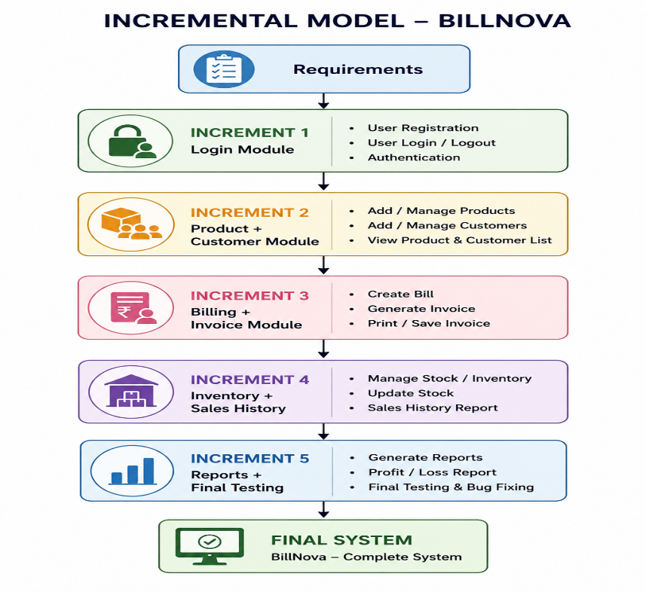
- The project follows the Incremental SDLC Model.
- The system is developed module by module instead of all at once.
- Each module is designed, implemented, and tested before moving to the next module.
- It helps in detecting and fixing errors at an early stage.
- New features can be added without affecting existing modules.
- This model is suitable for BillNova because it consists of independent modules such as Login, Product Management, Customer Management, Billing, Inventory, and Reports.
Advantages
- Fast and accurate bill generation.
- Reduces manual calculations and paperwork.
- Maintains customer and product records digitally.
- Automatically updates inventory after every sale.
- Generates professional invoices.
- Stores sales history for future reference.
- Easy to use with a simple and user-friendly interface.
- Saves time and improves overall business efficiency.
- Reduces the chances of human error.
- Can be upgraded with additional features in the future.
Limitations / Disadvantages
- Designed primarily for small and medium-sized businesses.
- Requires a computer system to operate.
- Data may be lost if regular database backups are not maintained.
- Internet-based features such as cloud storage and online synchronization are not available in the current version.
- Barcode scanning is not supported in the current implementation.
- Multi-user access with different permission levels is not available.
- Online payment gateway integration is not included.
- The system depends on proper maintenance of the MySQL database.

Future Scope
- Barcode scanner integration.
- QR code-based digital payments.
- Cloud database synchronization.
- Mobile application support.
- Analytics dashboard for business insights.
- Email and WhatsApp invoice sharing.
- Multi-user and role-based access control.

Conclusion
BillNova is designed to provide a complete billing and inventory solution for retail stores and small businesses. By automating billing and maintaining digital records, the system improves efficiency, accuracy, and customer service while reducing manual effort.

