Bitcoin Market Sentiment and Profitability Analysis

Submitted by: Sharanya Allam

## Introduction

The purpose of this analysis is to examine how the Fear and Greed Index affects Bitcoin’s market performance, specifically the net profit and loss (PnL) of the market. The Fear and Greed Index measures overall investor sentiment, ranging from extreme fear to extreme greed. By comparing different sentiment categories and running regression analysis, we aim to understand whether market emotions significantly influence Bitcoin returns.

## 2. Data Overview

The dataset includes the following key variables:  
- Date – Daily record of Bitcoin data  
- classification_cat – Market sentiment category (Fear, Greed, Extreme Greed, Neutral, Unknown)  
- market_net_pnl – Net profit/loss in the market  
- avg_size_usd – Average trade size in USD  
- trades_count – Number of trades executed  
  
After cleaning, the dataset contained 907 observations.

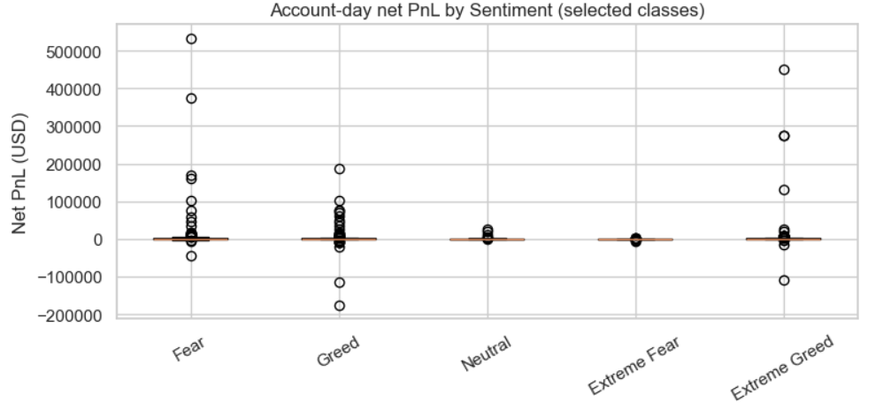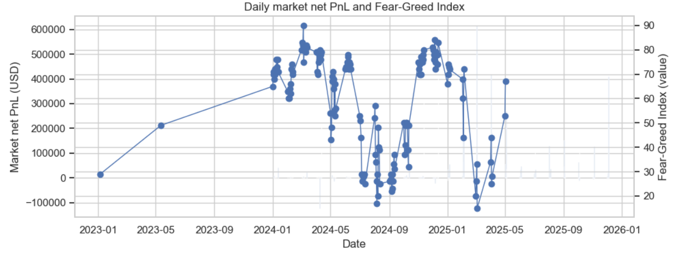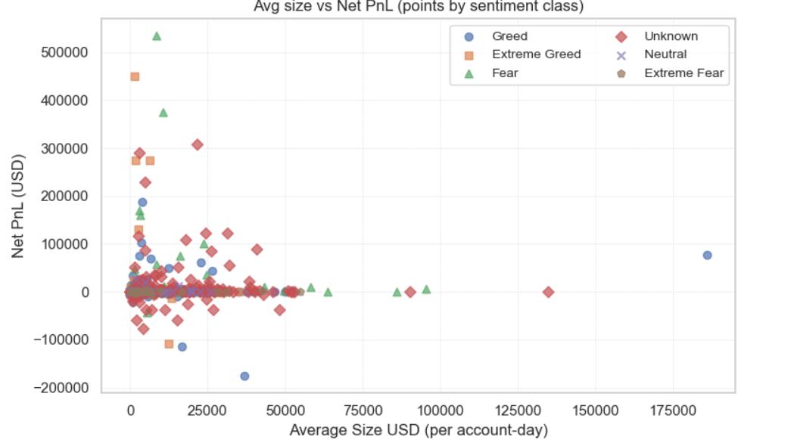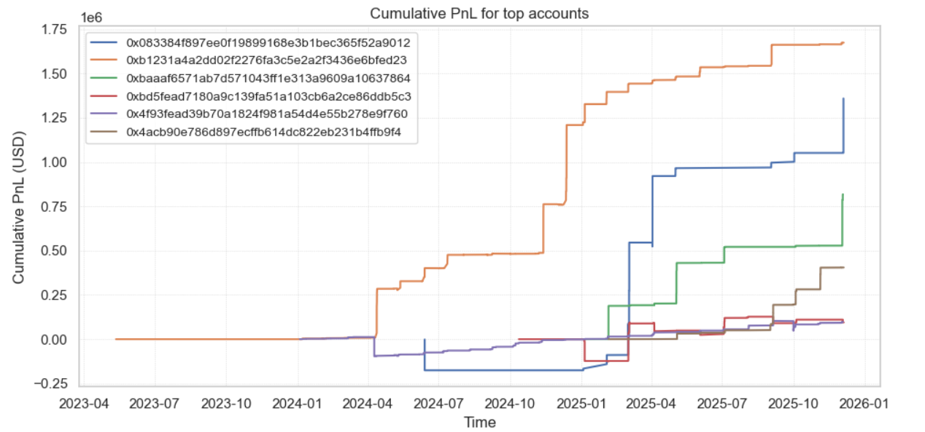

## 3. Descriptive Statistics

Fear observations: 157  
Greed observations: 191  
  
This suggests a slightly higher occurrence of greedy market conditions during the observed period.

## 4. Hypothesis Testing

### 4.1 Objective

To test whether there is a significant difference in Bitcoin market profitability between “Fear” and “Greed” periods.

### 4.2 Methods Used

• Independent Samples t-Test  
• Mann-Whitney U Test (non-parametric alternative)

### 4.3 Results

t-Test: t = 1.693, p = 0.0919  
Mann-Whitney U: p = 0.2165  
Both tests indicate no significant difference between Fear and Greed periods.

### 4.4 Conclusion

There is no statistically significant difference between average Bitcoin net PnL during Fear and Greed periods. Although greed periods show slightly higher profits, the evidence is insufficient to conclude a true difference.

## 5. Regression Analysis

### 5.1 Objective

To model the relationship between market_net_pnl (dependent variable) and explanatory factors such as sentiment category, average trade size, and trade count.

### 5.2 Model

Ordinary Least Squares (OLS) regression with robust standard errors.

### 5.3 Key Results

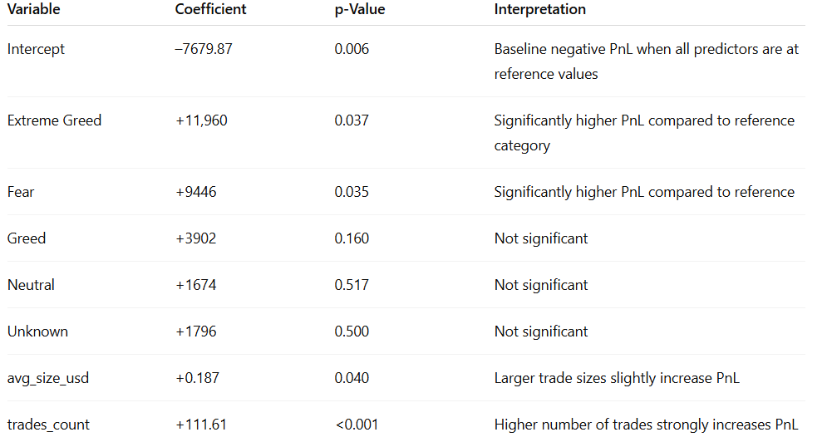

Intercept: -7679.87 (p=0.006)  
Extreme Greed: +11,960 (p=0.037)  
Fear: +9446 (p=0.035)  
Greed: +3902 (p=0.160)  
Neutral: +1674 (p=0.517)  
Unknown: +1796 (p=0.500)  
avg_size_usd: +0.187 (p=0.040)  
trades_count: +111.61 (p<0.001)  
  
Model Statistics:  
R² = 0.117, Adjusted R² = 0.110, F(7,899)=2.623, p=0.011, Observations=907.

### 5.4 Interpretation

The regression indicates that sentiment categories “Extreme Greed” and “Fear” are both associated with higher market profitability. The number of trades and average trade size are positively related to net profit. Despite significant coefficients, the model explains only about 11% of the variation in Bitcoin net PnL, suggesting other unobserved factors influence market performance.

## 6. Limitations

- The analysis assumes linear relationships and may not capture nonlinear sentiment effects.  
- Data is limited to a specific time period; results might differ in other market conditions.  
- External macroeconomic and policy influences are not included in the model.

## 7. Conclusion

This study explored the relationship between investor sentiment and Bitcoin market profitability. While Fear and Extreme Greed periods appear to yield higher returns, the statistical evidence is modest. Trading activity (number and size of trades) plays a more consistent role in determining market profits. Overall, sentiment influences Bitcoin markets but should be analyzed along with other technical and macroeconomic variables for accurate prediction.

**Thank you for the opportunity to work on this assignment. It was a valuable experience exploring the relationship between trader performance and market sentiment.**

**Candidate Details**

**Name:** Sharanya Allam  
**Position Applied:** Data Science Internship  
**Email:** sharanyaallam11@gmail.com  
**Phone:** 7661874215  
**Date:** 12-10-2025