WEEK 2
DASHBOARD PLANNING AND DESIGN STRATEGY
Online Retail Sales Analytics
Internship: Virtual Tableau Visualization Intern
Tool: Tableau Public
Dataset: Online Retail Dataset

1. Introduction
This week focuses on planning and documenting the design strategy for the Online Retail Sales Dashboard created using Tableau. The dashboard is based on the Exploratory Data Analysis (EDA) completed in Week 1. The design brings important sales information together in one view so that users can quickly understand business performance, trends, products, customers, and geographical patterns.

2. Dashboard Objective
The main objective of the dashboard is to provide a clear and simple overview of online retail sales performance. It is designed to help users monitor key metrics, identify trends, compare performance, and find unusual patterns.
- Monitor overall sales performance.
- Understand monthly sales trends.
- Compare sales across countries.
- Identify top-performing products.
- Identify high-value customers.
- Understand the relationship between quantity and sales.
- Identify unusual or extreme transactions.

3. Target Audience
Target User | Purpose
Business Managers | Monitor overall business and sales performance
Sales Teams | Analyze products, countries, and sales trends
Marketing Teams | Understand customers and product performance
Business Analysts | Identify trends, relationships, and unusual values

4. Key Performance Indicators (KPIs)
KPI | Purpose
Total Sales | Measures overall revenue generated
Total Orders | Shows the number of orders/invoices
Total Customers | Shows the number of customers
Total Quantity | Shows the total quantity of items sold

5. Planned Visualizations
Visualization | Chart Type | Purpose
Monthly Sales Trend | Line Chart | Shows how sales change over time and highlights high/low periods.
Sales by Country | Bar Chart | Compares sales performance across countries.
Top 10 Products | Horizontal Bar Chart | Identifies products generating the highest sales.
Top 10 Customers by Sales | Horizontal Bar Chart | Identifies customers contributing the most sales.
Quantity vs Sales | Scatter Plot | Shows the relationship between quantity and sales and helps identify unusual transactions.
Sales by Month and Country | Heatmap | Shows sales patterns across countries and months.

6. Existing Dashboard Layout
The following screenshot shows the dashboard developed from the Week 1 EDA. The layout follows a top-to-bottom information flow: KPIs first, followed by the overall trend, then detailed product, country, customer, and transaction analysis.
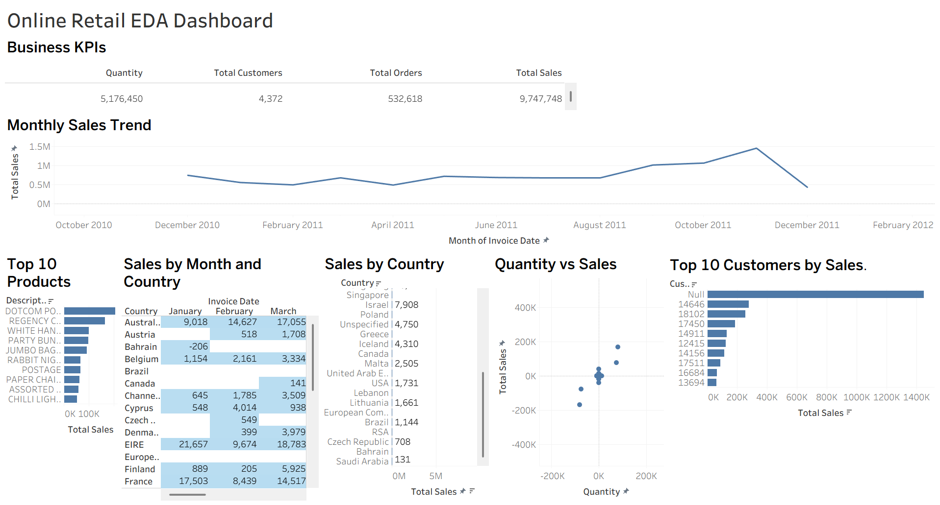
Figure 1. Online Retail EDA Dashboard

7. Dashboard Design Mock-up
The planned dashboard structure can be represented as follows:
┌─────────────────────────────────────────────────────────┐
│ ONLINE RETAIL SALES DASHBOARD │
├─────────────────────────────────────────────────────────┤
│ Total Sales │ Total Orders │ Customers │ Total Quantity │
├─────────────────────────────────────────────────────────┤
│ MONTHLY SALES TREND │
├───────────────────────┬─────────────────────────────────┤
│ TOP 10 PRODUCTS │ SALES BY COUNTRY │
├───────────────────────┼─────────────────────────────────┤
│ TOP CUSTOMERS │ QUANTITY vs SALES │
├───────────────────────┴─────────────────────────────────┤
│ SALES BY MONTH AND COUNTRY │
└─────────────────────────────────────────────────────────┘

8. Filters and Interactions
The dashboard is intended to support interactive analysis. The main planned filters and interactions are:
- Country filter – allows users to focus on a particular country.
- Invoice Date filter – allows users to analyze a selected time period.
- Product filter – allows users to focus on specific products.
- Chart selection – selecting a country, product, or other data point can be used to filter or highlight related views.
- Cross-dashboard interaction – changes made through filters should update the relevant charts so users can analyze the selected segment consistently.

9. Color and Visual Design Strategy
A simple and consistent design is used so that the dashboard remains easy to read. The design avoids unnecessary decoration and gives more visual importance to sales values and trends.
- Use a clean and uncluttered background.
- Use consistent colors across related charts.
- Use darker shades to represent higher sales values where appropriate.
- Keep chart titles clear and descriptive.
- Place KPI cards at the top for quick understanding.
- Avoid excessive colors, unnecessary labels, and decorative elements.

10. Visualization Rationale and Integration
The visualizations are arranged to support a logical analysis flow. KPI cards provide an immediate summary of performance. The monthly trend shows how sales change over time. Country and product charts support comparisons, while customer analysis highlights high-value customers. The scatter plot provides relationship and outlier information, and the heatmap gives a detailed country-by-month view.
Together, these visualizations allow users to move from an overall business view to detailed analysis without having to examine separate reports.

11. How the Design Improves User Understanding
- Important metrics are visible immediately through KPI cards.
- The line chart makes changes over time easy to recognize.
- Bar charts make rankings and country/product comparisons easy to understand.
- The scatter plot helps users recognize relationships and unusual values.
- The heatmap provides a compact view of patterns across two dimensions.
- Filters and interactions allow users to focus on information relevant to their question.

12. Design Based on Week 1 Findings
The dashboard design was guided by the findings from Week 1. The analysis showed that the United Kingdom contributes the largest share of sales, sales vary across months, a small group of products and customers contribute strongly to revenue, and the quantity-versus-sales analysis contains both positive relationships and unusual values. These findings influenced the inclusion of country, monthly, product, customer, and outlier-oriented visualizations.

13. Tools and Technologies
- Tableau Public – dashboard design and visualization
- Microsoft Excel – dataset handling and preparation
- Online Retail Dataset – source data for analysis

14. Expected Outcome
The planned design provides a single, easy-to-understand dashboard for exploring online retail performance. It is intended to support quick monitoring, comparison, trend analysis, and identification of important business patterns.

15. Conclusion
Week 2 focused on documenting the dashboard planning and design strategy based on the EDA completed in Week 1. The dashboard combines KPIs, trends, comparisons, customer and product analysis, and interactive filtering in a structured layout. This design serves as a blueprint for presenting the retail analysis clearly and supporting data-driven business decisions.

