VIRTUAL TABLEAU VISUALIZATION INTERN
Week 1: Exploratory Data Analysis and Insight Generation
Online Retail Sales Dataset

Prepared using: Tableau Public
Analysis type: Exploratory Data Analysis (EDA)
Dataset: Online Retail
Deliverable: Week 1 Detailed Analysis Report

Prepared for Virtual Tableau Visualization Internship

1. Executive Summary
This report presents the exploratory data analysis (EDA) performed on an Online Retail transaction dataset using Tableau. The objective was to understand the structure of the dataset, examine sales trends, compare countries and products, investigate customer contribution, explore the relationship between quantity and sales, identify unusual transactions, and prepare an interactive EDA dashboard.
The analysis produced a set of Tableau worksheets and a consolidated dashboard. The dashboard currently shows total quantity of 5,176,450, total customers of 4,372, and total sales of 9,747,748 based on the current workbook view. The country analysis shows a very strong concentration of sales in the United Kingdom, while the monthly trend shows a pronounced increase during the later part of 2011, with November 2011 reaching approximately 1.46 million in sales.

2. Objectives
- Select and explore a publicly available retail transaction dataset.
- Understand the main variables and their roles in sales analysis.
- Use Tableau visualizations to identify trends, comparisons, relationships, and unusual observations.
- Generate business-oriented insights from the exploratory analysis.
- Develop an interactive Tableau dashboard that summarizes the major findings.
- Document the analytical approach, observations, and areas requiring further investigation.

3. Dataset Description
The Online Retail dataset contains transaction-level records from an online retail business. It includes invoice information, product identifiers and descriptions, quantities, transaction dates, unit prices, customer identifiers, and customer countries. These fields provide both transactional and dimensional information suitable for exploratory analysis in Tableau

3.1 Dataset Variables
Variable | Type | Purpose in EDA
Invoice No | Categorical / Identifier | Identifies an invoice or transaction.
Stock Code | Categorical / Identifier | Identifies the product.
Description | Categorical | Provides the product description.
Quantity | Numerical | Measures units involved in a transaction.
Invoice Date | Date & Time | Supports time-series and seasonal analysis.
Unit Price | Numerical | Represents price per unit.
Customer ID | Categorical / Identifier | Supports customer-level analysis.
Country | Categorical | Supports geographic comparison.

3.2 Key Calculated Measure
A calculated field named Total Sales was created in Tableau using the formula:
[Quantity] × [Unit Price]
This measure was used as the main revenue/sales metric throughout the exploratory analysis.

4. Methodology
1. Connected the Excel Online Retail workbook to Tableau Public.
2. Reviewed the available fields and assigned appropriate dimensions, measures, and date roles.
3. Created the Total Sales calculated field.
4. Built individual worksheets for time, geography, products, customers, relationships, heatmap analysis, and outlier exploration.
5. Created KPI summaries for quantity, customers, orders/transactions, and sales.
6. Combined the major worksheets into an Online Retail EDA Dashboard.
7. Reviewed the resulting charts to identify trends, unusual values, and potential business questions.

5. Exploratory Data Analysis

5.1 Monthly Sales Trend
A continuous monthly time-series line chart was created using Invoice Date and Total Sales. The chart shows substantial variation over the observed period. Sales are relatively lower during the early months of 2011, followed by a stronger upward movement from approximately September 2011. The highest visible monthly sales occur in November 2011 at approximately 1.46 million, followed by a sharp decrease in December 2011 to roughly 0.43 million.
Business interpretation: The strong late-year increase suggests possible seasonal purchasing behavior. Further analysis should determine whether the increase was driven by more customers, larger order quantities, particular products, or promotional activity.
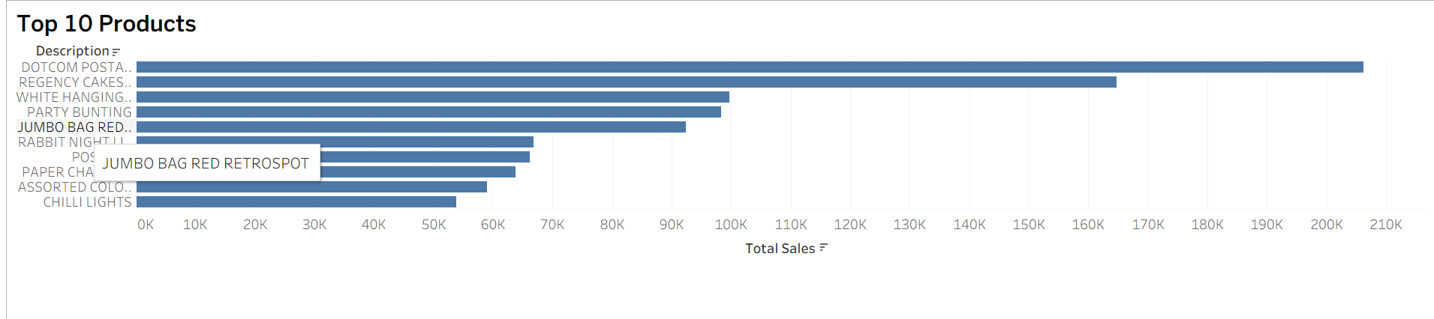
Figure 1. Monthly Sales Trend

5.2 Sales by Country
A descending bar chart was used to compare total sales across countries. The United Kingdom is the dominant market in the current analysis, with approximately 8,187,806 in total sales. The Netherlands follows at approximately 284,662, while Germany contributes approximately 221,698. This indicates that sales are highly concentrated geographically.
Business interpretation: The company appears to depend heavily on the United Kingdom market. This creates an opportunity to investigate international expansion while also assessing whether the lower-sales markets have sufficient customer demand, product availability, or marketing support.
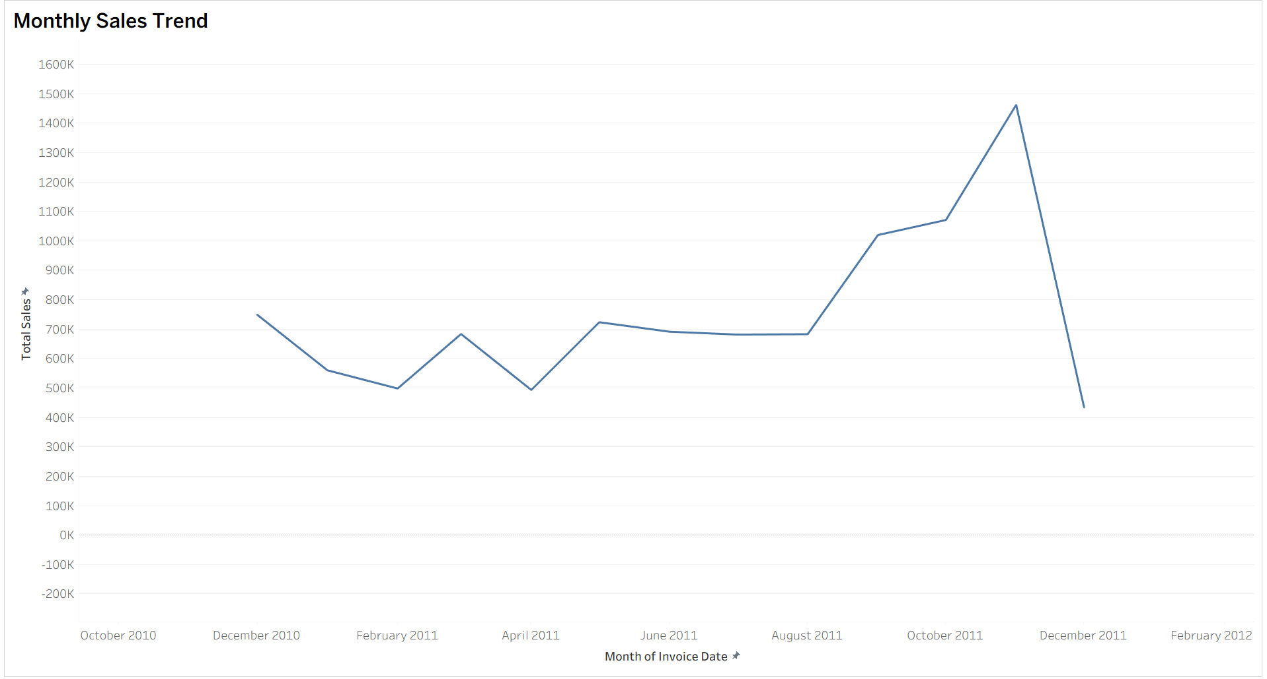
Figure 2. Sales by Country

5.3 Top 10 Products
The Top 10 Products worksheet ranks products by total sales. DOTCOM POSTAGE is the leading product/service in the current visualization, contributing approximately 205K in sales. REGENCY CAKES... is the next major contributor at approximately 165K, followed by several other products in the roughly 60K–100K range.
Business interpretation: A relatively small group of products contributes a meaningful portion of sales. These high-performing products can be investigated further for inventory planning, cross-selling, repeat purchases, and seasonal demand.
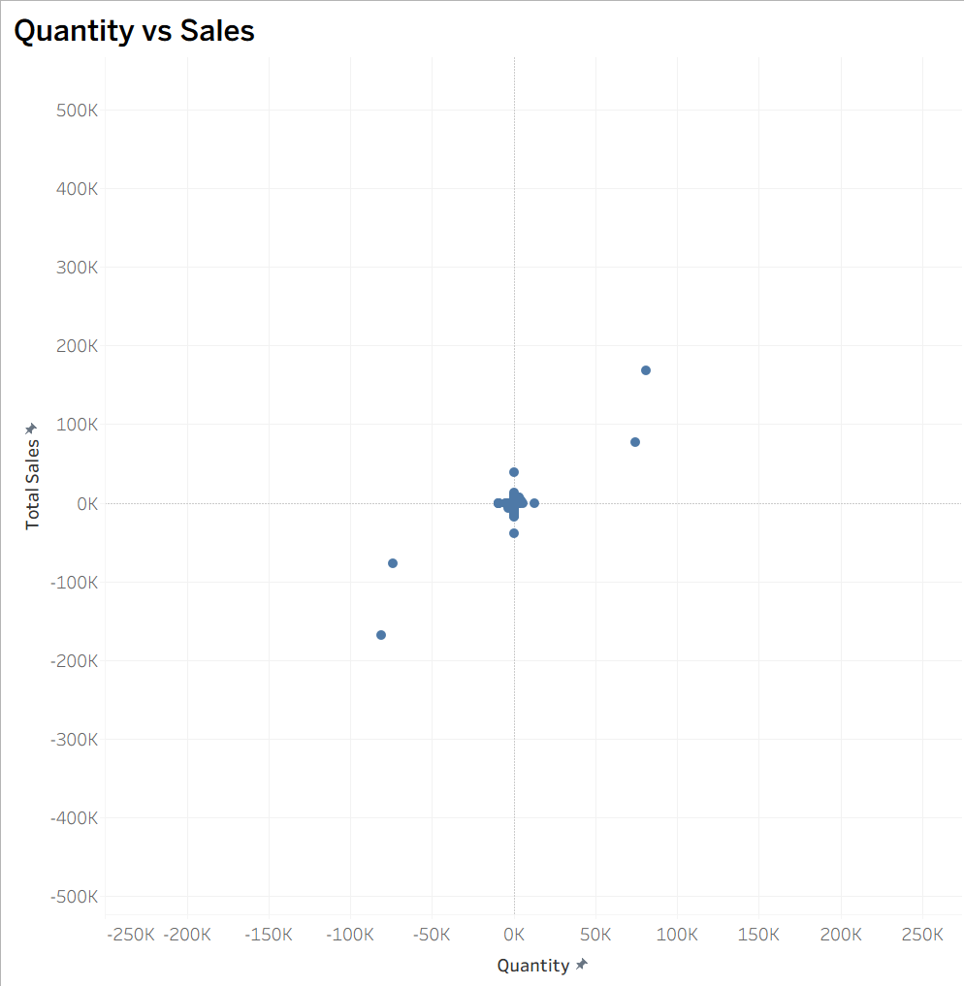
Figure 3. Top 10 Products by Total Sales

5.4 Top 10 Customers by Sales
A customer-level bar chart was created to identify high-value customers. The current workbook view contains a Null customer category with a very large sales value. This is a data-quality issue that should be excluded from customer ranking before the final submission. Among the identified customer IDs, customer 14646 is one of the largest contributors.
Business interpretation: Customer concentration should be examined to determine the contribution of high-value customers and to support retention and customer segmentation strategies.
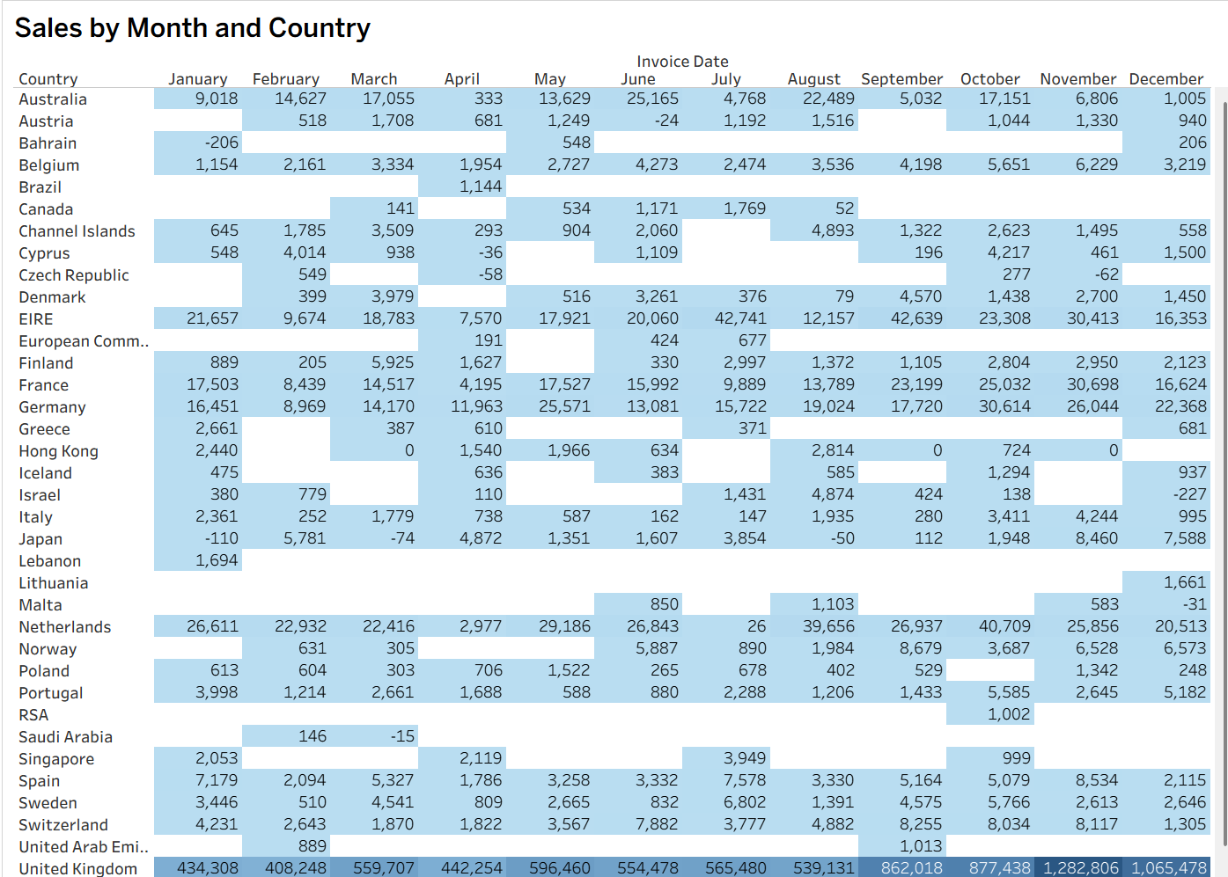
Figure 4. Top 10 Customers by Sales (current workbook view; Null should be excluded)

5.5 Quantity vs Sales Relationship
A scatter plot was created with Quantity on the horizontal axis and Total Sales on the vertical axis. The observations show a generally positive relationship: larger quantities are generally associated with larger sales values. However, several observations are far from the main cluster.
The plot also contains negative quantity and negative sales observations. These may represent returns, cancellations, credit transactions, or other special transaction types rather than ordinary sales. They should therefore be investigated during the data-cleaning stage.
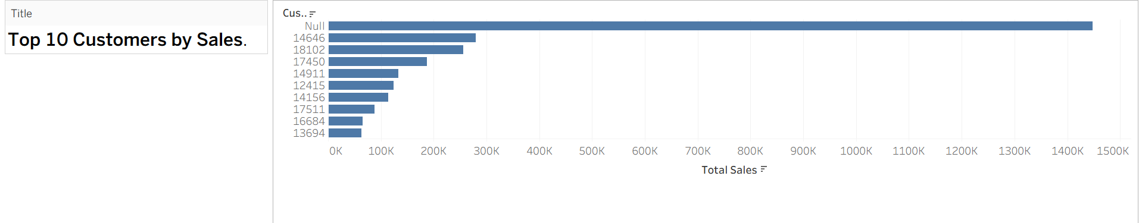
Figure 5. Quantity vs Sales

5.6 Monthly Country Sales Heatmap
A heatmap was created using Country as rows, Invoice Date by month as columns, and Total Sales as the color intensity. The visualization allows seasonal and geographic patterns to be examined simultaneously.
For example, the United Kingdom shows particularly high monthly sales toward the end of 2011. The November value is approximately 1,282,806, followed by approximately 1,065,478 in December. This supports the overall monthly trend and highlights the importance of the UK market in the late-year sales increase.
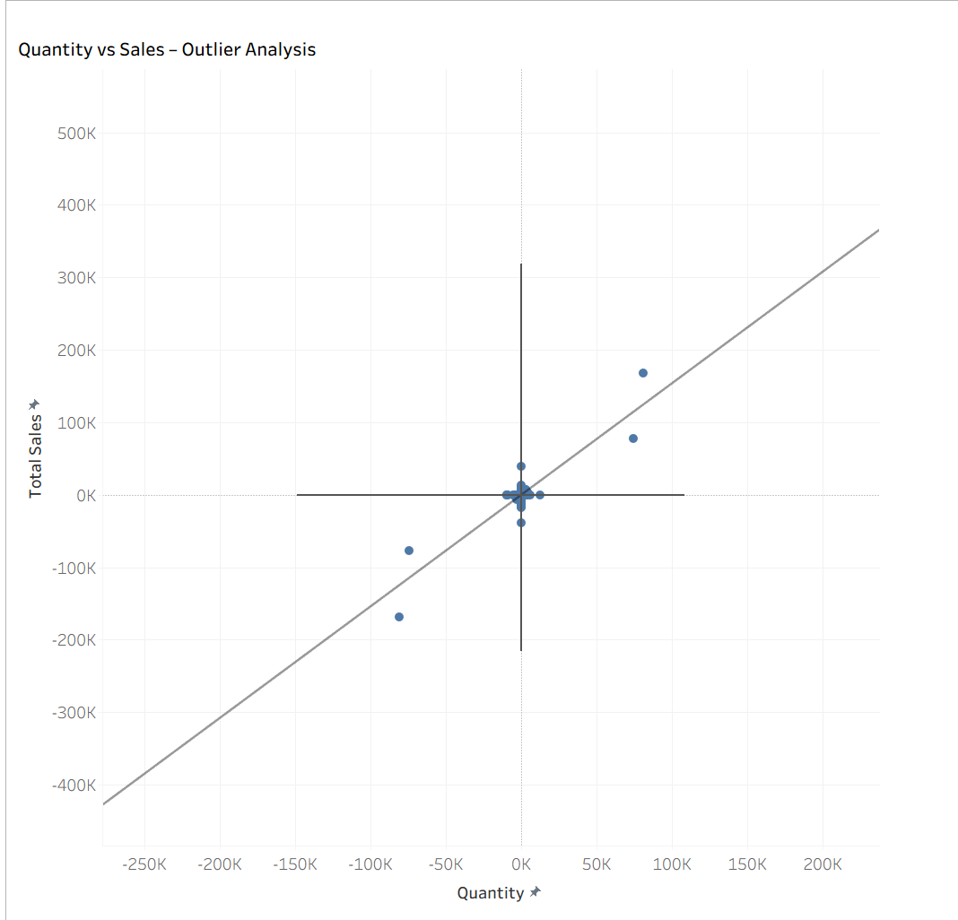
Figure 6. Sales by Month and Country Heatmap

5.7 Outlier Analysis
A dedicated Quantity vs Sales outlier view was created by using the scatter plot with a linear trend line. The majority of observations are concentrated around the central region, while several points lie substantially away from this cluster. Positive extreme observations indicate unusually large quantities and sales, whereas negative extreme observations may correspond to returns or cancellations.
These observations should not automatically be treated as errors. They require investigation to determine whether they are legitimate bulk purchases, customer returns, cancellations, or data-quality issues.
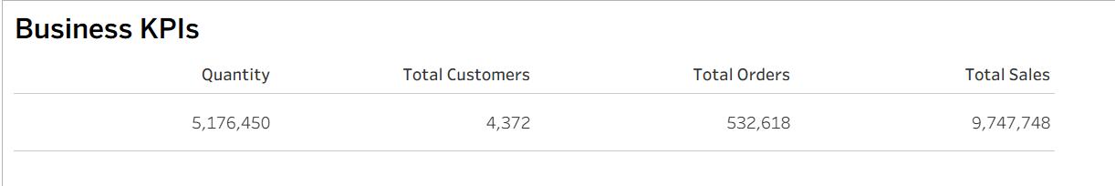
Figure 7. Quantity vs Sales – Outlier Analysis

6. KPI Summary
The dashboard provides a high-level summary of the dataset. The current workbook displays the following values:
KPI | Current Dashboard Value
Total Quantity | 5,176,450
Total Customers | 4,372
Total Sales | 9,747,748
Total Orders / Transaction Count | 532,618*
* Important validation note: the current dashboard shows 532,618 under Total Orders. Before final submission, this KPI should be verified as a unique invoice count using COUNTD([Invoice No]) rather than a row/transaction count. The report therefore treats this number as the current workbook value, not as a confirmed number of unique orders.
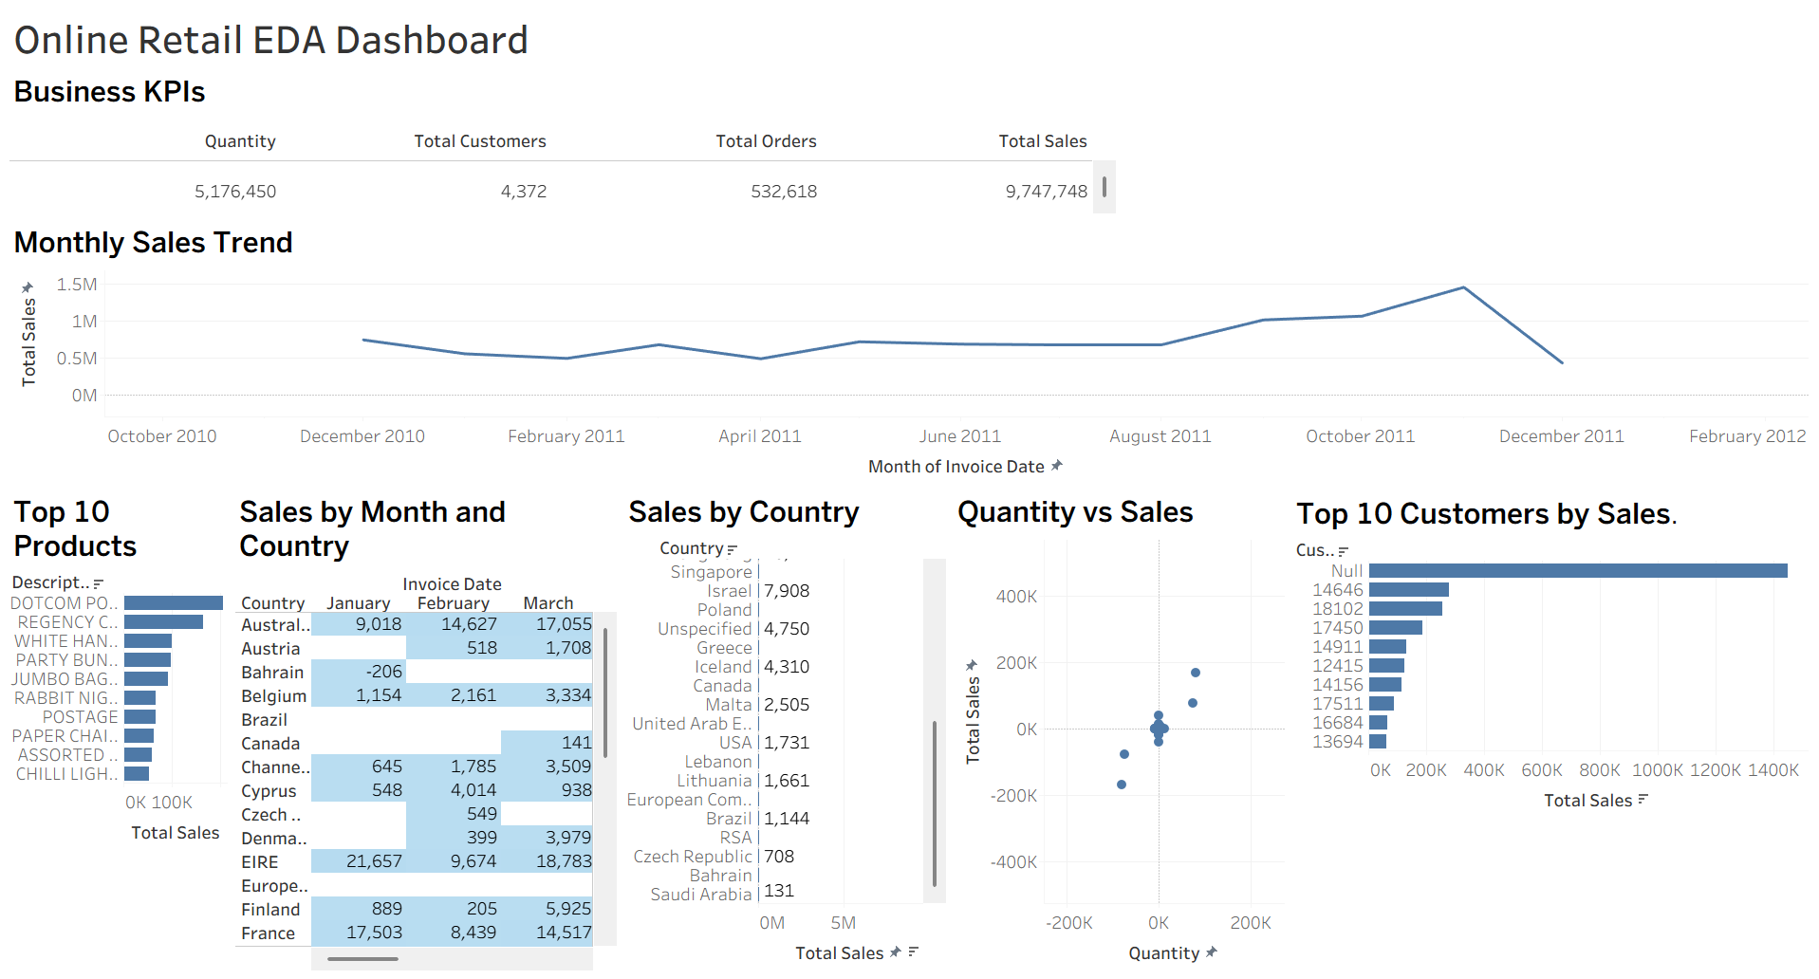
Figure 8. Business KPI View

7. Key Business Insights
- Sales are highly concentrated in the United Kingdom, making it the primary market in the analyzed dataset.
- Monthly sales strengthen considerably in the second half of 2011 and peak around November 2011.
- A limited group of products contributes strongly to total sales, indicating potential high-performing product groups.
- The quantity-sales relationship is broadly positive, but extreme observations indicate the presence of unusual transactions.
- Negative quantity and sales values are visible and may represent returns, cancellations, or other non-standard transactions.
- High-value customers can make a substantial contribution to revenue, supporting the need for customer segmentation and retention analysis.
- The heatmap confirms that geographic and seasonal effects can be studied together and may help with inventory and campaign planning.

8. Business Implications
- Inventory planning can be aligned with months showing stronger demand.
- Marketing and promotional activity can be investigated around high-sales periods.
- The United Kingdom should remain a key market while lower-performing countries can be evaluated for expansion opportunities.
- High-performing products should be monitored for stock availability and potential cross-selling opportunities.
- High-value customers can be targeted for retention programs and personalized offers.
- Unusual and negative transactions should be classified before they are used for predictive or financial decision-making.

9. Areas for Further Investigation
- Calculate unique orders using COUNTD(Invoice No) and distinguish ordinary invoices from cancelled invoices.
- Investigate negative quantities and negative sales to classify returns and cancellations.
- Analyze missing Customer ID values and determine their effect on customer-level metrics.
- Calculate average order value and average quantity per order.
- Analyze sales by product category if a reliable category mapping is available.
- Compare repeat versus one-time customers.
- Investigate why November 2011 has the highest sales and identify the products and countries responsible.
- Perform more detailed country-level profitability analysis if cost data becomes available.

10. Data Quality Considerations
The EDA identified several issues that should be considered before downstream analysis. The scatter plot contains negative quantities and negative sales, which may indicate returns or cancellations. The customer chart also contains a Null customer category. These records should be handled explicitly rather than silently removed. The current Total Orders KPI also requires validation to ensure it represents unique invoices.

11. Final Tableau Dashboard
The final dashboard combines the KPI summary, monthly sales trend, top products, sales by country, quantity-sales relationship, top customers, and the monthly-country heatmap. The dashboard is designed to allow a reader to move from an overall business summary to detailed exploratory views.
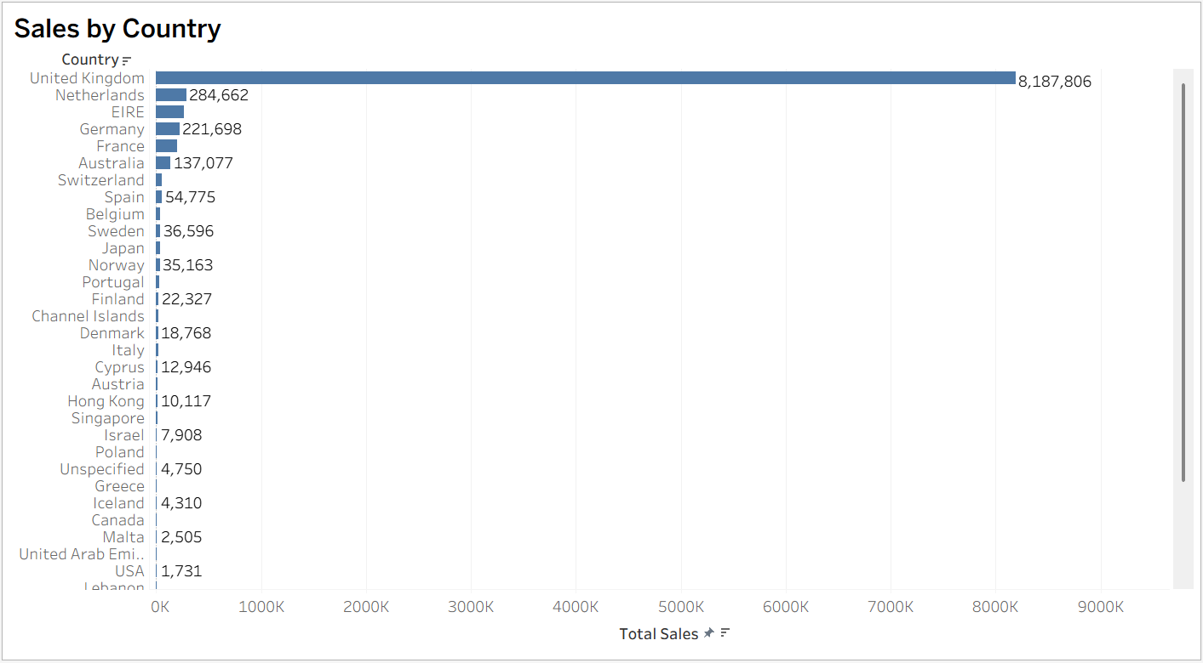
Figure 9. Online Retail EDA Dashboard

12. Tools and Technologies
- Tableau Public – data connection, exploratory analysis, calculated fields, visualizations, and dashboard creation.
- Microsoft Excel (.xlsx) – source dataset format.
- Tableau calculated fields – used to derive Total Sales and KPI measures.
- Charts used – line chart, horizontal bar charts, scatter plot, heatmap, and KPI cards.

13. Conclusion
The Week 1 exploratory analysis successfully demonstrated how Tableau can be used to understand a retail transaction dataset and convert raw records into business-oriented visual insights. The analysis identified strong geographic concentration, a pronounced late-2011 sales increase, high-performing products and customers, a positive quantity-sales relationship, and unusual transactions requiring further investigation.
The resulting dashboard provides a clear starting point for deeper analysis. Before using the dashboard for final business reporting, the Total Orders KPI should be corrected/validated as a unique invoice count and the Null customer category should be excluded from customer rankings. These validation steps will improve the accuracy and professionalism of the final submission.

14. References
1. Online Retail dataset – publicly available retail transaction dataset used for the Tableau analysis.
2. Tableau Public – used for data visualization, exploratory analysis, calculated fields, and dashboard development.

15. Submission Checklist
- Dataset selected and connected in Tableau.
- Variables reviewed and documented.
- Total Sales calculated using Quantity × Unit Price.
- Trend, comparison, relationship, heatmap, and outlier analyses completed.
- KPI summary created.
- Interactive EDA dashboard created.
- Screenshots included in this report.
- Total Orders KPI should be validated using unique Invoice No before final submission.
- Null customer category should be excluded from the Top 10 Customer visualization before final submission.

