**ITSoft Training Application**

**REPORT**

**PHOTOLEARN APP**

Solutions by Full Time Team 3

Members:

Geng Hui

Sharanya Menon

Suganthi Sugumar

Toshi Mishra

Xiang Xuemeng

1. **UML Class Diagram**



1. **Assumptions**
2. Only Multiple-Choice Questions(MCQs) are added by the Trainer.
3. Trainer is not allowed to delete a learning Item created by a participant. She/he can delete the Learning Title and Learning Session.
4. A participant can attempt the quiz in both edit and view modes of learning session.
5. Permissions to access storage, camera and location are granted by the user. The app may show some anomalous behavior in absence of these permissions.
6. **Instruction**

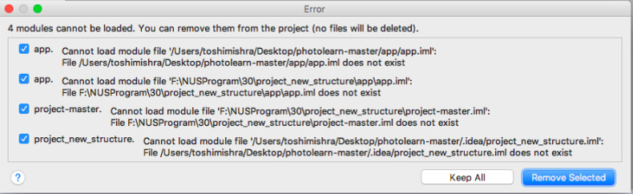

* Please remove the files listed above
* Connect to firebase with firebase assistant, so it will create google-services.json file
* Enable authentication services, Realtime Database and also storage services in firebase
* Build the project
* Run the app